
Worksheet I: Quadratic graphs

Each image consists of a parabola, a straight line and an identified region on the x-axis. What do you notice about each image? Write down your ideas on this sheet.

A
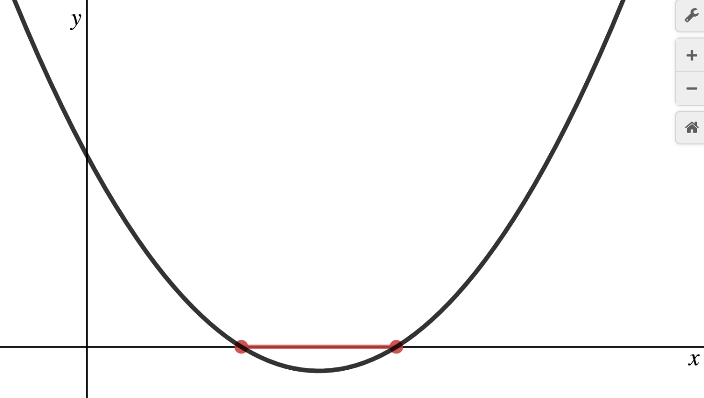

B 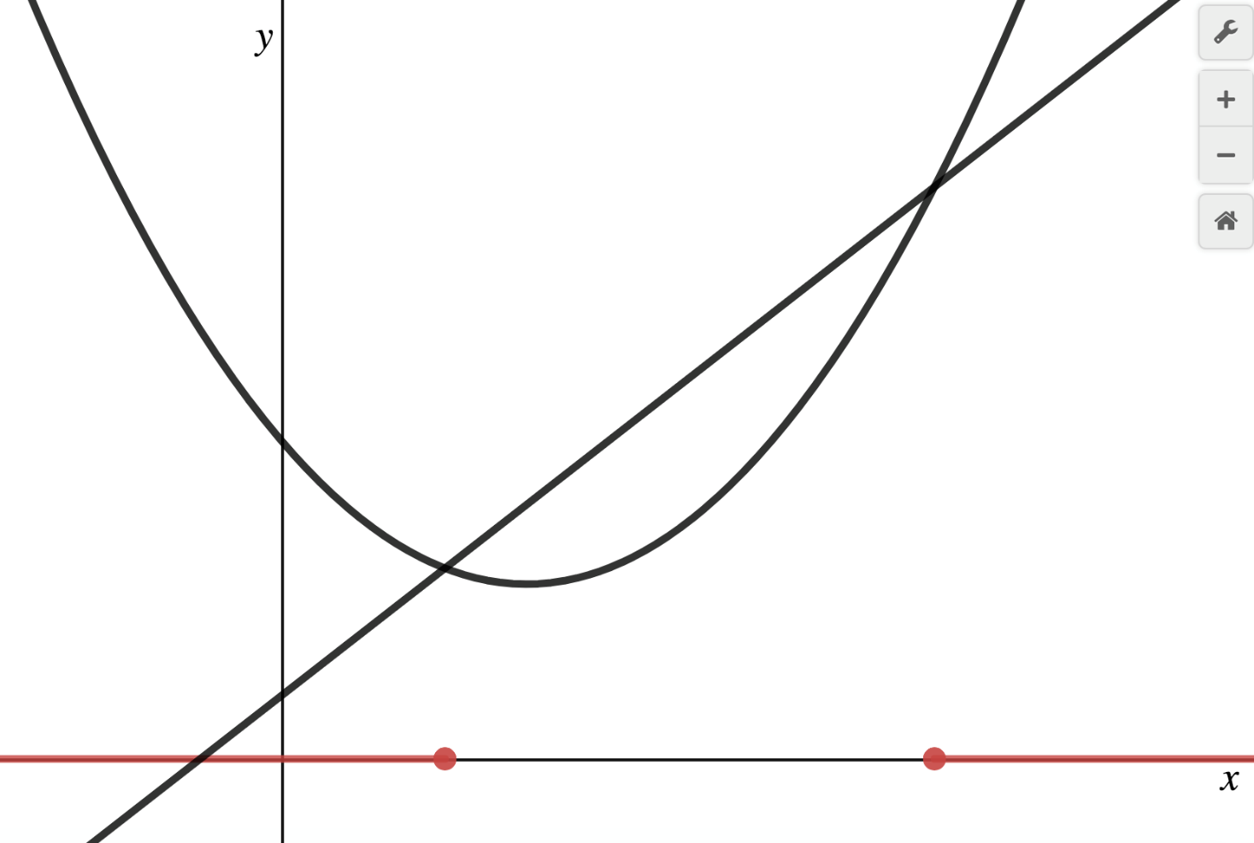
Worksheet I: Quadratic graphs continued

C
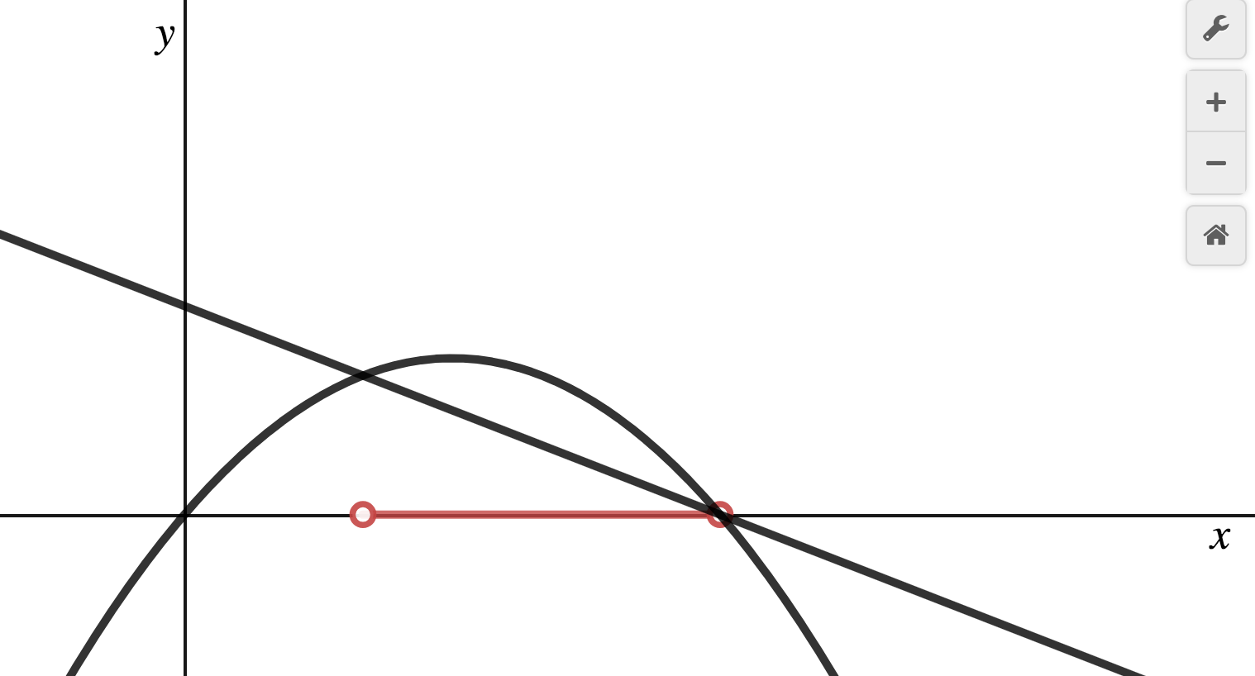

D
