
Worksheet B: Completing the square
1) Factorise by completing the square

$x^{2}-10x=$

What constant needs to be subtracted to compensate for the completed corner of the square?

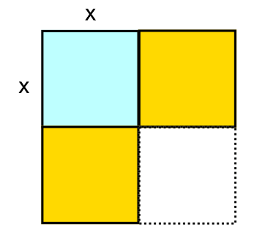

2) Factorise by completing the square

$x^{2}-22x=$

What constant needs to be subtracted to compensate for the completed corner of the square?

3) Factorise by completing the square

$x^{2}-bx=$

What constant needs to be subtracted to compensate for the completed corner of the square?

