
Worksheet B(ii): Vector paths
Part I
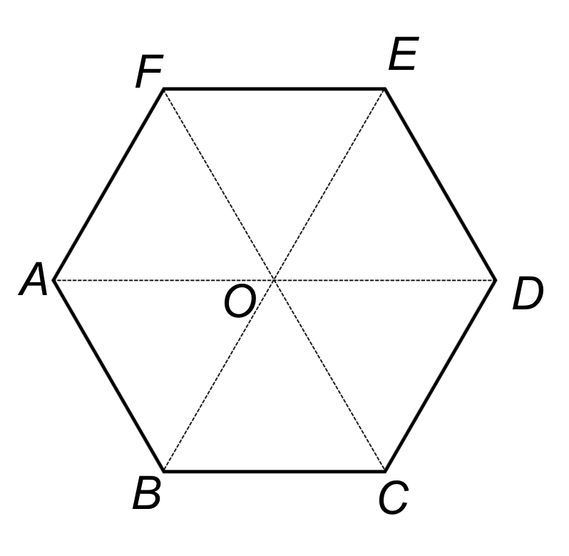
Part II

Using the diagram above, answer the following questions. Let $\vec{AF}$ = a and$\vec{BC}$ = b.

1) Show that $\vec{AE}$ is parallel to $\vec{DB}$.

2) The point M is half-way between O and E. Find the vector $\vec{AM}$ in terms of the vectors a and b.

3) The point P is half-way between C and E. Find the vector $\vec{MP}$ in terms of the vectors a and b.

4) The point N is along ED so that N splits ED in the ratio 2:3 (i.e. EN:ND = 2:3). Find the vector $\vec{BN}$ in terms of the vectors a and b.

