Worksheet: Story arc planner
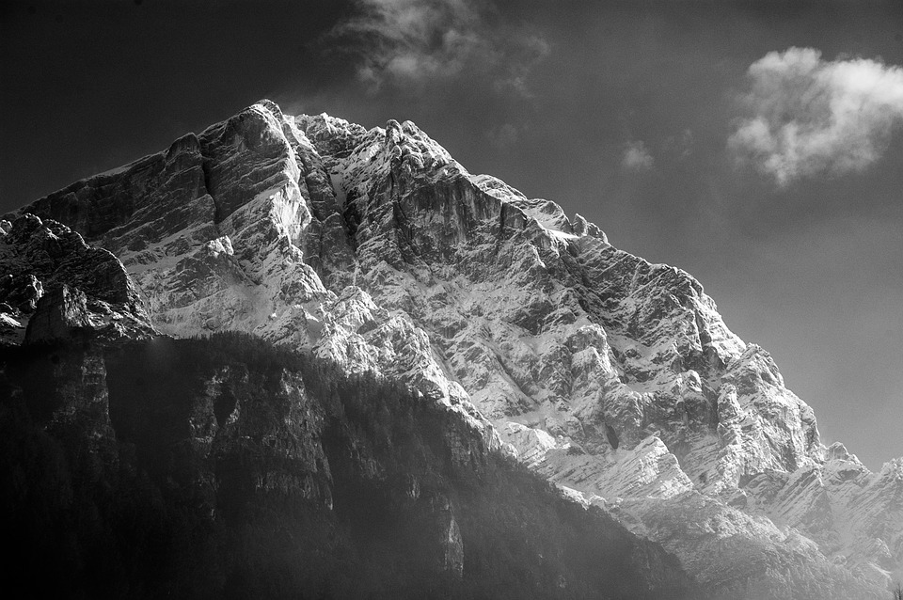
Story arc planner
Exposition

Climax

Resolution

Conflict/event

