
Worksheet J: Horse and cart problem
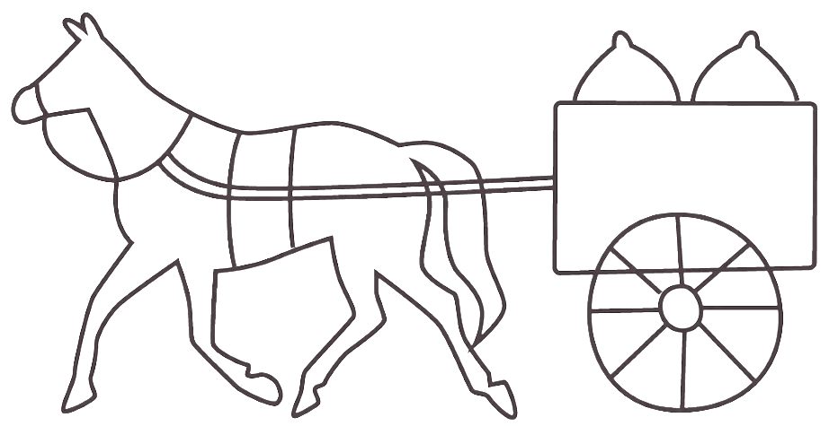
A farmer attaches his horse to his cart one day, and climbs up on the cart with his son.
The farmer’s son says, ‘I learnt in school yesterday about Newton’s laws of motion. Did you know that Newton's third law says that every action force has an equal and opposite reaction force?’.
‘Yes, I do’ says the farmer.
‘Newton's third law says that if the horse pulls on the cart, the cart exerts an equal and opposite force on the horse. Don't you agree?’, asks the son.
‘Yes... but...’
‘If these two forces are equal and opposite, they will cancel, so that the net force is zero, right?’, argues the son.
‘Well, I suppose so,’ says the farmer.
‘The net force is always the important thing. If the net force is zero, then Newton's second law (and Newton's first law, too) says that the acceleration of the wagon must be zero.’
‘Yes.’, says the farmer, but let's get going!’
‘But that's the point!’, says the son, ‘If the wagon's pull is always equal and opposite to my pull, then the net force will always be zero, so the wagon can never move! Since it is at rest, it must always remain at rest!
Newton's laws are correct, and horses can pull wagons. What is the error in the son’s argument?

