

Teacher Pack
Normal Distribution
Cambridge International AS & A Level
Mathematics 9709

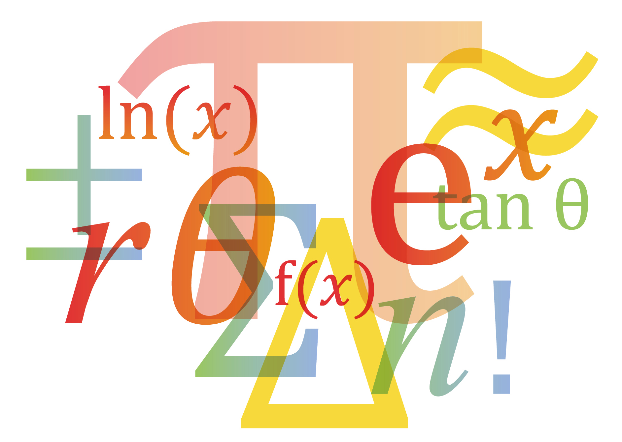

© Cambridge University Press & Assessment 2025
Cambridge Assessment International Education is part of Cambridge University Press & Assessment. Cambridge University Press & Assessment is a department of the University of Cambridge.

Cambridge University Press & Assessment retains the copyright on all its publications. Registered centres are permitted to copy material from this booklet for their own internal use. However, we cannot give permission to centres to photocopy any material that is acknowledged to a third party even for internal use within a centre.
Contents
Contents 3
Introduction 5
Lesson preparation 6
Lesson 1: Modelling Continuous Random Variables 9
Lesson 2: Calculating Probabilities by Standardising 11
Lesson plan 3: Normal Approximation to the Binomial Distribution 13
Lesson reflection 15
Worksheets and answers 16
Worksheet A: Sketches of Normal curves 17
Worksheet A: Answers 19
Worksheet B: 20
Exploring Probabilities with Technology 20
Worksheet B: ANSWERS 21
Exploring Probabilities with Technology 21
Worksheet C: Using standard normal $Z$ tables 22
Worksheet C: Using standard normal $Z$ tables 23
Worksheet D: 24
Calculating Probabilities by Standardising 24
Worksheet D: 25
Calculating Probabilities by Standardising 25
Worksheet E: 26
Approximations and Continuity Corrections 26
Worksheet E: Answers 27
Approximations and Continuity Corrections 27
Worksheet F: 28
Normal approximation to the binomial distribution 28
Worksheet F: ANSWERS 29
Normal approximation to the binomial distribution 29

Icons used in this pack:
 | Teacher preparation
 | Lesson plan
 | Lesson resource
 | Lesson reflection

Introduction
This pack will help you to develop your learners’ skills in mathematical thinking and mathematical communication, which are essential for success at AS & A Level and in further education.

Mathematical thinking and communication will be developed by focussing on:
These link to the course Assessment Objectives (AOs) which you can find in detail in the syllabus:
A01 Knowledge and understanding

A02 Application and communication

- Conceptual understanding – the ‘why’ behind the ‘what’
- Strategic competence – forming and solving problems
- Adaptive reasoning – explanations, justifications and deductive reasoning

Throughout all activities, the learners will also develop:
- Procedural fluency – know when, how and which rules to use
- Positive disposition – believe maths can be learned, applied and is useful
- Their skills in writing mathematically – writing working & proofs

Each Teacher Pack contains one or more lesson plans and associated resources, complete with a section of preparation and reflection.

Each lesson is designed to be an hour long but you should adjust the timings to suit the lesson length available to you and the needs of your learners.

Important note
Our Teacher Packs have been written by classroom teachers to help you deliver topics and skills that can be challenging. Use these materials to supplement your teaching and engage your learners. You can also use them to help you create lesson plans for other topics.

This content is designed to give you and your learners the chance to explore a more active way of engaging with mathematics that encourages independent thinking and a deeper conceptual understanding. It is not intended as specific practice for the examination papers.

The Teacher Packs are designed to provide you with some example lessons of how you might deliver content. You should adapt them as appropriate for your learners and your centre. A single pack will only contain at most four lessons, it will not cover a whole topic. You should use the lesson plans and advice provided in this pack to help you plan the remaining lessons of the topic yourself.

Lesson preparation
This Teacher Pack will cover the following syllabus content.
Candidate should be able to: | Notes and examples
- understand the use of a normal distribution to model a continuous random variable, and use normal distribution tables. | Sketches of normal curves to illustrate distributions or probabilities may be required.
- solve problems concerning a variable X, where X ~ N(μ,σ²) including: finding the value of P(X > x₁), or a related probability, given the values of x₁, μ, σ. | for calculations involving standardisation, full details of the working should be shown, e.g.  Z = $\frac{(X-μ) }{σ}.$
- recall conditions under which the normal distribution can be used as an approximation to the binomial distribution, and use this approximation, with a continuity correction, in solving problems. | n sufficiently large to ensure that both np > 5 and nq > 5.

Dependencies
For all lesson plans in this Teacher Pack, knowledge from the following 9709 syllabus content is required.
Candidate should be able to: | Notes and examples
- Draw and be able to interpret histograms.
- Understand and use mean and standard deviation.
- Evaluate probability in simple cases.

- Use formula for probabilities of the binomial distribution, and recognise situations where this is an appropriate model.

Prior knowledge and skills
For all lessons, it is assumed that learners have already completed Cambridge IGCSETM Mathematics 0580, or a course at an equivalent level. See the syllabus for more details of the expected prior knowledge for taking Cambridge International AS & A Level Mathematics 9709.
When planning any lesson, make a habit of always asking yourself the following questions about your learners’ prior knowledge and skills:
- Do I need to re-teach this or do learners just need some practice?
- Is there an interesting activity that will efficiently achieve this?

Key learning objectives

The following list represents the main underlying concepts that you should make sure your learners have understood by the end of this topic.
- Deciding whether a Normal distribution is an appropriate model
- Sketching normal curves to illustrate distributions
- Using technology to find probabilities
- Calculating probabilities by standardising and using tables MF19
- Understanding the conditions for and applying a normal approximation to the binomial distribution

Why this topic matters

This topic introduces one of the most important distributions in statistics. Many real-life situations can be modelled using the Normal distribution. A secure understanding of this distribution is required to confidently solve problems in a wide range of contexts for continuous random variables. The distribution is also used in Probability and Statistics 2; to carry out hypothesis tests.

Key terminology and notation
Your learners will need to be confident with the following terminology and notation.
Continuous random variable Any variable that can be measured on a continuous scale eg length, mass, time
Histogram A visualisation of a dataset, where data is grouped and
frequency is proportional to area

$X \sim N (μ, σ^{2})$ $X$ is distributed normally, with mean $μ$ and standard deviation $σ.$
$P\left(x_{1}≤X≤x_{2}\right)$ The probability that $x$ lies between two values $x_{1}$ and $x_{2}$.
$X\sim B(n,p)$ $X$is distributed binomially, with probability $p$ over $n$ trials.

Lesson progression
The first two lessons can be delivered one after the other, at the start of teaching for this topic. The third lesson should be delivered towards the end of teaching for this topic, once all calculations with the normal distribution have been covered and practised.
Lesson 1. The first lesson should be used as an introduction to the Normal distribution and covers the fundamental concept of modelling real-life situations. It gives learners a dynamic understanding, that will underpin development of one of the most important distributions in statistics.
The lesson begins by considering some research data, looking at histograms for samples that get larger and larger. The normal distribution is then proposed as a good model for this data.
Key features of the normal distribution are described and shown visually, and the relationship with finding probabilities from area is established visually. Learners are encouraged to draw simple sketches at every stage, and to use appropriate notation.
In this first lesson, learners will need to have to access to suitable technology, to find probabilities without the need for any calculations. A resource has been created using DESMOS, to support teachers/learners. This can be used to demonstrate some of the activities if learners do not have access to any technology in the classroom.
Lesson 2. The second lesson moves onto calculations that involve standardising, where $Z=\frac{X-μ}{σ}$. Crucially for 9709, learners are expected to always standardise to obtain probabilities by considering Z-scores. Tables MF19 are used, although learners can also use the Z-distribution on a calculator, as long as their calculator meets the requirements of the 9709 syllabus. Note that in examinations “candidates are expected to show all necessary working; no marks will be given for unsupported answers from a calculator.”
Once they are secure in their understanding of the Normal distribution, and have had sufficient practice of a wide range of problems, then lesson 3 should be delivered.
Lesson 3. This lesson demonstrates how we can use the Normal distribution as an approximation to the binomial distribution for a discrete random variable, when certain conditions are met.

Going forward

Following the first 2 lessons, learners will need to build skills through extensive instruction and practice for all applications of the Normal distribution. Lesson 3 should come towards the end of teaching of this topic.

Lesson 1: Modelling Continuous Random Variables
Preparation | - Read through the PowerPoint and ensure that you are familiar with the worked examples. Make sure that you are familiar with the technology that you will ask learners to use eg DSMOS, web applications, calculators with statistical distribution menus.
Resources | - PowerPoint presentation  - Spreadsheet data for the swallowtail butterfly  - Worksheets A and B  - Raspberry dataset for any extension work
Learning objectives | By the end of the lesson:  - all learners should be able to describe when a normal distribution is an appropriate model, sketch a distribution and understand that probability is proportional to area  - most learners should be able to use technology to visualise probabilities  - some learners should be able to use technology to find any probabilities for any normal distribution

Dependencies

Learners will need to have completed section 5.1 of the syllabus; Representation of Data. They will also need to have completed the binomial distribution in section 5.4; Discrete random variables.

Timings | Activity
10 mins | Starter/Introduction  The swallowtail butterfly  The opening slides describe some research data for the tail-length of the swallowtail butterfly. The spreadsheet has also been provided and includes a reference to the original research.  Ask learners for observations on the first histogram for 12 butterflies. Discuss any relevant observations and encourage the use of simple technical descriptions using language from section 5.1 Representation of Data.  Play the video clip. Ask learners to discuss the effect on the histograms as the sample size get larger. This is a good opportunity to use Think Pair Share. The graphs are also available in DESMOS. Encourage learners to think about why the histogram begins to form a bell shape, when more data is included. Encourage the use of technical descriptions linked to the context, butterfly tail-lengths.
40 mins | Main lesson  The Normal distribution model  The next slide explores how we can fit a Normal distribution to this dataset. Explain that the curve is a function calculated using a formula, but knowledge of the formula is not required. The main features to be aware of are the bell shape and the symmetry. The exact shape of the curve depends only on the values of mean and standard deviation used in the model.  Make sure that learners understand the notation $X \sim N (μ, σ^{2})$.  Sketching Normal Curves  Show the slide and ask students to complete Worksheet A. Students work independently or in small groups to consolidate learning through discussion and activity. Feedback as required to emphasise key learning points.  Areas and Probabilities  Work through the slides. The first slide gives area approximations that apply to all normal distributions; one, two, three standard deviations from the mean. Relate these back to the butterfly context to give a secure understanding of the context of the modelling.  The next slides show how can we represent any areas as probabilities, using raspberry masses for context. The main focus is on identifying relevant areas with a sketch and using technology (rather than calculations) to obtain probabilities. Tell learners that calculations will be explained in the next lesson.  Set worksheet B as Think Pair Share or independent work.  Note. Direct learners to use appropriate technology once they have drawn a sketch of the area they are trying to determine. Feedback as required on the quality of sketches, reasonableness of answers and any issues with using technology.  Additional questions can be set or demonstrated, for any distribution with a different mean and standard deviation, for exploring probabilities using technology.
  Challenge: The most able learners could be encouraged to explore the Swallowtails dataset, using Excel or DESMOS to create histograms from samples or the whole dataset. Another real dataset on raspberry mass has also been provided with this resource pack, and could also be explored to verify a normal distribution would be an appropriate model.
  Support: Work closely with students to consolidate their sketching skills, reinforcing the position of the mean and the spread of values in relation to the standard deviation, or assist them in using technology.
10 mins | Plenary  Revisit key issues that have come up through the lesson  or  Use the True/False slide to explore understanding of the normal distribution.

Reflection | Reflect on your lesson, use the Lesson reflection notes to help you.

Lesson 2: Calculating Probabilities by Standardising
Preparation | Read through the PowerPoint and ensure that you are familiar with the worked examples.
Resources | - PowerPoint presentation  - Worksheets C and D  - Tables MF19
Learning objectives | By the end of the lesson:  - all learners should be able to be able to calculate probabilities for the Z distribution using tables MF19  - most learners should be able to standardise to calculate probabilities for values of $X$above the mean for any normal distribution  - some learners should be able to calculate cumulative probabilities in a wide range of situations

Dependencies

Learners must have a good understanding of the key features of a normal distribution from lesson 1, and be confident in drawing sketches of distributions. They should be able to identify relevant areas on the distribution, to support probability calculations.

Common misconceptions
Misconception | Problems this can cause | An example way to resolve the misconception
Using variance rather than standard deviation when standardising | This will not lead to correct Z scores | Encourage learners to state clearly the mean $μ= ..$ and standard deviation $σ= ..$  for each normal distribution, before stating and using $Z=\frac{X-μ}{σ}$

Timings | Activity
10 mins | Starter/Introduction  Introduce the Z distribution  Ask learners to recall the key features of a normal distribution:  - symmetrical  - bell-shaped  - centred on the mean  - standard deviation represents the spread  Begin to show the first slide (which is animated), to introduce the Standard Normal Distribution.  Think Pair Share. Ask learners to draw a sketch of the $Z$distribution, and to mark values on the horizontal axis.  Show the remainder of the slide, to emphasise the features of the Z distribution and how areas are given in the tables MF19.
40 mins | Main lesson  Using standard normal $\left(Z\right)$ tables  Work carefully through slides 3, 4, 5 to explain how the tables are used to obtain areas.  Explain and demonstrate how the tables are used to cover all possible situations for cumulative probabilities. Introduce the use of $ϕ$ as a shorthand notation.  Set Worksheet C as practice. Think Pair Share or working independently as appropriate.  Standardising  Show slides 7, 8, 9 to indicate how any normal distribution can be transformed onto the $Z$ distribution. Learners need to be confident in applying the transformation $Z=\frac{X-μ}{σ}$, to obtain appropriate areas using the $Z$distribution.  Emphasise correct use of tables MF19. For 9709, learners are expected to always standardise to obtain probabilities by considering Z-scores. Please make it clear that in examinations, candidates are expected to show all necessary working; no marks will be given for unsupported answers from a calculator.”  Learners with appropriate calculator menus may also wish to explore using the cumulative distribution for $Z$ with $μ=0, σ=1$.  Set Worksheet D as practice. Think Pair Share or working independently as appropriate.
  Challenge: Some learners can be challenged to explore using the tables in reverse, to calculate $Z$ values from probability statements:
  eg For $Z \sim N \left(0, 1^{2}\right)$ find $a$ such that $P\left(Z≤a\right)=0.75$
  eg For $Z \sim N \left(0, 1^{2}\right)$ find $b$ such that $P\left(Z≤b\right)=0.95$
  Support: Encourage the use of sketches to reinforce the use of areas in each situation.
10 mins | Plenary  Ask learners to discuss / debate the two examples on the slide. What mistakes have been made?  Explore any misconceptions

Reflection | Reflect on your lesson, use the Lesson reflection notes to help you.

Lesson plan 3: Normal Approximation to the Binomial Distribution
Preparation | Read through the PowerPoint and ensure that you are familiar with the worked examples.
Resources | - PowerPoint presentation  - Worksheets E and F  - Tables MF19
Learning objectives | By the end of the lesson:  - all learners should be able to determine mean and variance for an approximate normal distribution  - most learners should be able to calculate probabilities using correct continuity corrections  - some learners should be able to solve problems in a wide range of real-life contexts

Dependencies

Learners need to recall the mean and variance of a binomial distribution. Learners need to be confident at solving problems with the normal distribution from earlier lessons in this topic.

Common misconceptions
Misconception | Problems this can cause | An example way to resolve the misconception
Constructing a wrong continuity correction. | Loss of accuracy in answers. | Ensure students to do a simple sketch when deciding whether to add or subtract $0.5$to the value of $X$ being considered.

Timings | Activity
10 mins | Starter/Introduction  Shapes of Distributions  Use the opening slide to remind learners about the binomial distribution:  - Fixed number of trials $(n)$  - Probability of success $(p)$  Think pair share. Ask learners to verify any of the probabilities shown on slide 2 for $X\sim B\left(20,0.1\right).$  Play the video and discuss how the shape of a binomial distribution changes for different values of $p.$ Make connections with earlier learning:  - Shape of a normal distribution  - Parameters for the normal distribution
40 mins | Main lesson  Normal Approximation to the Binomial  Use slides 3 and 4 to justify using a normal approximation to model the binomial distribution:  - Conditions to be met  - Calculation of mean and variance (and hence standard deviation)  Emphasise the focus on evaluating cumulative probabilities.  Continuity Corrections  Use slides 5 and 6 to introduce continuity corrections. Explain that we need to make the $±0.5$ correction to allow us to model the discrete variable on a continuous horizontal scale.  Set Worksheet E as practice. Think Pair Share or working independently as appropriate. Encourage sketches to support decision-making about continuity corrections.  Examples  Show the slides with the two worked examples, which draw all the elements together:  - Calculating $np$ and $npq$  - Applying continuity corrections  - standardising using $Z=\frac{X-μ}{σ}$  Explore any questions before setting worksheet F.  Set Worksheet F as practice. Think Pair Share or working independently as appropriate.
  Challenge: Challenge the most able learners to explore the loss of accuracy if continuity corrections are omitted or wrong. They could also use technology to check their workings.
  Support: Encourage learners to do a simple sketch to support decision-making with continuity corrections.
10 mins | Plenary  Revisit key ideas and challenge any misconceptions that have come up  or  Show the slide and ask learners to explain which statements are true or false.

Reflection | Reflect on your lesson, use the Lesson reflection notes to help you.

Lesson reflection
As soon as possible after the lesson you need to think about how well it went.

One of the key questions you should always ask yourself is:

Did all learners get to the point where they can access the next lesson? If not, what will I do?

Reflection is important so that you can plan your next lesson appropriately. If any misconceptions arose or any underlying concepts were missed, you might want to use this information to inform any adjustments you should make to the next lesson.

It is also helpful to reflect on your lesson for the next time you teach the same topic. If the timing was wrong or the activities did not fully occupy the learners this time, you might want to change some parts of the lesson next time. There is no need to re-plan a successful lesson every year, but it is always good to learn from experience and to incorporate improvements next time.

To help you reflect on your lesson, answer the most relevant questions below.

Were the lesson objectives realistic?
What did the learners learn today? Or did they learn what was intended? Why not?
What proportion of the time did we spend on the most important topics?
Were there any common misconceptions?
What do I need to address next lesson?
What was the learning atmosphere like?
Did my planned differentiation work well?
How could I have helped the lowest achieving learners to do more?
How could I have stretched the highest achieving learners even more?
Did I stick to timings?
What changes did I make from my plan and why?

Summary evaluation
What two things went really well? (Consider both teaching and learning.)
What two things would have improved the lesson? (Consider both teaching and learning.)
What have I learned from this lesson about the class or individuals that will inform my next lesson?

Worksheets and answers

 | Worksheet | Answers
For use with Lesson 1:
A: Sketches of Normal curves | x | x
B: Exploring Probabilities with Technology | x | x
For use with Lesson 2:
C: Using standard normal (Z) tables | x | x
D: Calculating Probabilities by Standardising | x | x
For use with Lesson 3:
E: Approximations and Continuity Corrections | x | x
F: Normal approximation to the binomial distribution | x | x


Worksheet A: Sketches of Normal curves
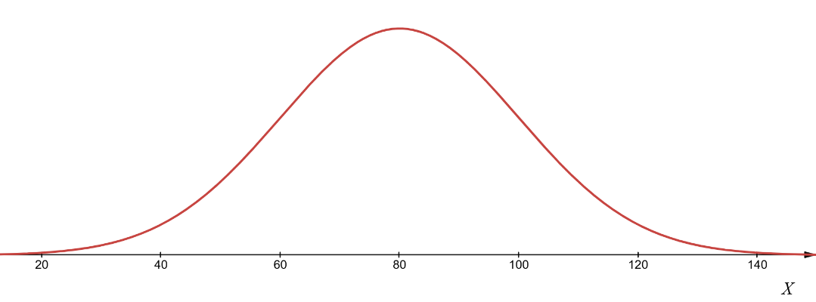
Write down the mean and standard deviation of each distribution and state as: $X \sim N \left(μ, σ^{2}\right)$
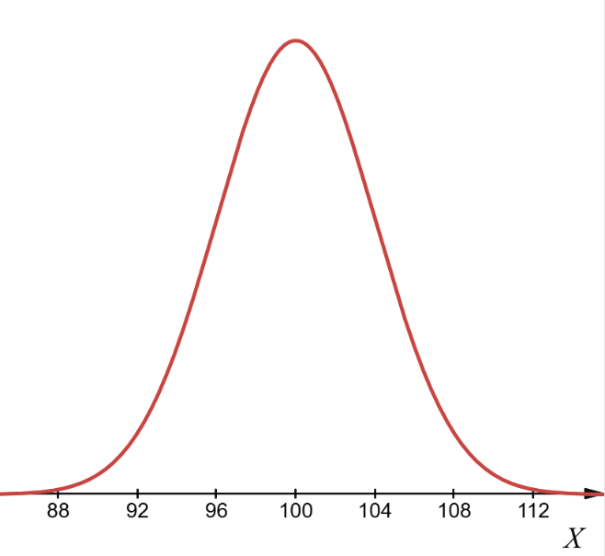
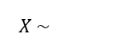
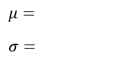

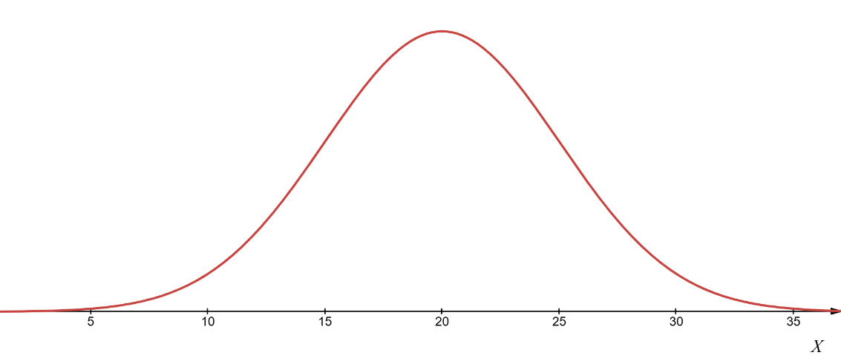
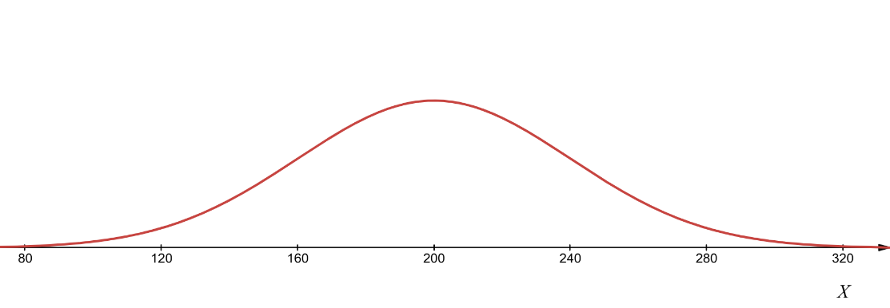

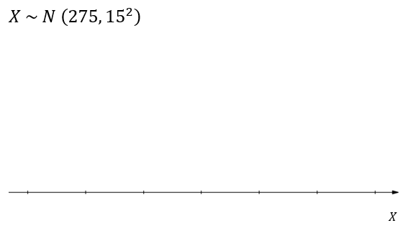
Sketch each Normal distribution, labelling the horizontal axis.
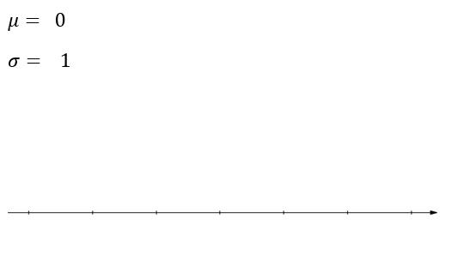
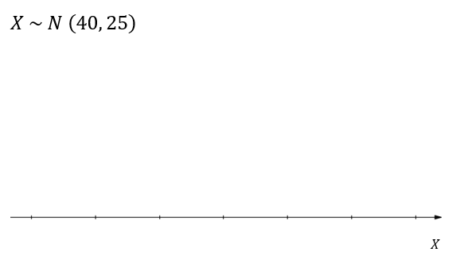
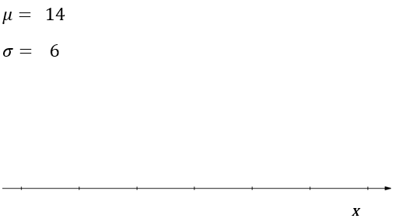

Worksheet A: Answers
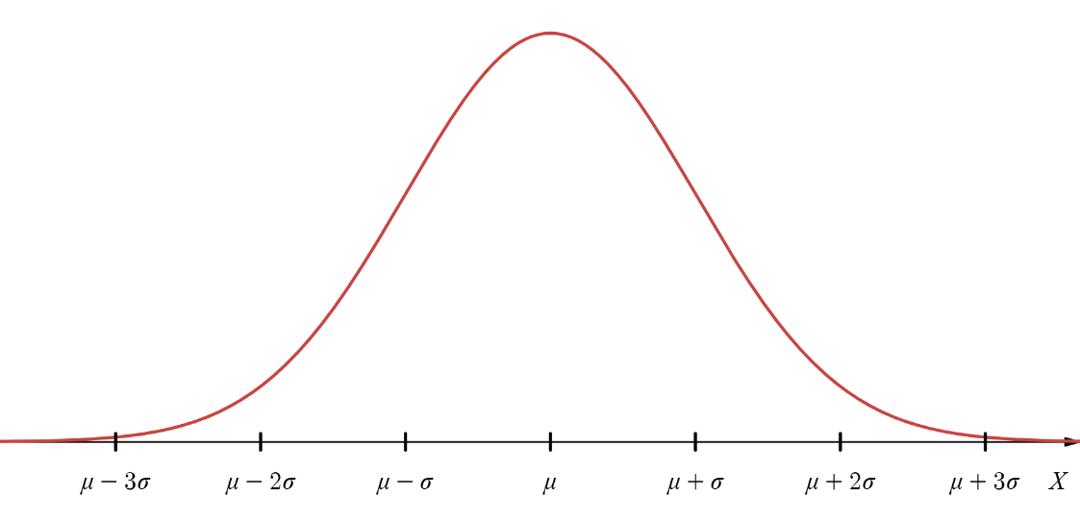
$μ= 80$
$$σ= 20$$
$X\sim N\left(80, {20}^{2}\right)$ or $X\sim N\left(80, 400\right)$

$μ= 100$
$$σ= 4$$
$X\sim N\left(100, 4^{2}\right)$ or $X\sim N\left(100, 16\right)$
Each sketch should be:
- bell shaped
- symmetrical
- centred on the mean
With values marked on the horizontal axis at the mean and $±1σ$ intervals
Note: The vertical scale is arbitrary
$μ= 200$
$σ= 40$
$X\sim N\left(200, {40}^{2}\right)$ or $X\sim N\left(200, 1600\right)$

$μ= 20$
$σ= 5$
$X\sim N\left(20, 5^{2}\right)$ or $X\sim N\left(20,25\right)$

Worksheet B:
Exploring Probabilities with Technology
Write down the mean and standard deviation of this distribution:
$X \sim N({300,25}^{2})$ $μ=$ $σ=$
For each question draw a simple sketch of the distribution showing the required area.
Use appropriate technology to determine the required probability.
Question | Sketch | Probability from using technology
Q1
$$P(270≤X≤305)$$
Q1
$$P(290≤X≤340)$$
Q3
$$P(X≤310)$$
Q4
$$P(X≥325)$$
Q5
$P(X≤260)$ or
$$P(X≥ 340)$$

Worksheet B: ANSWERS
Exploring Probabilities with Technology
Write down the mean and standard deviation of this distribution:
$X \sim N({300,25}^{2})$ $μ=300$ $σ= 25$
For each question draw a simple sketch of the distribution showing the required area.
Use appropriate technology to determine the required probability.
Question | Sketch | Probability from using technology
Q1  $$P(270≤X≤305)$$ | 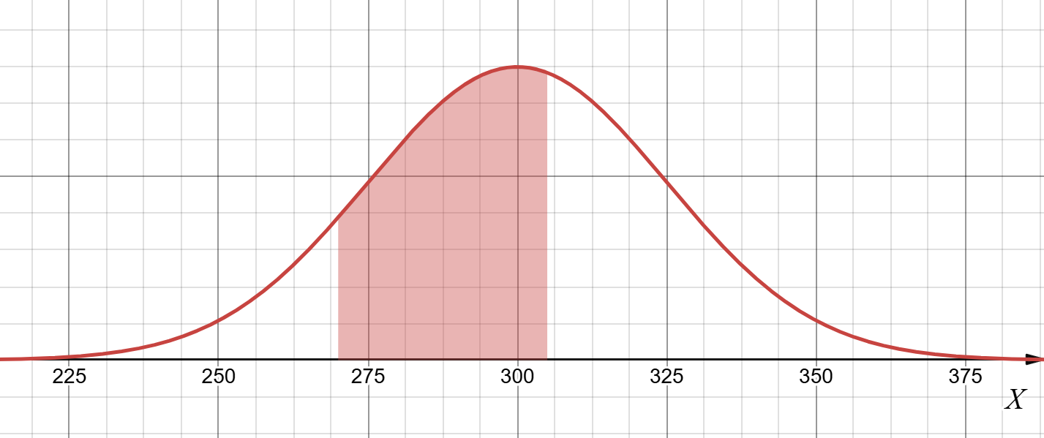 | $$0.464$$
Q1  $$P(290≤X≤340)$$ | 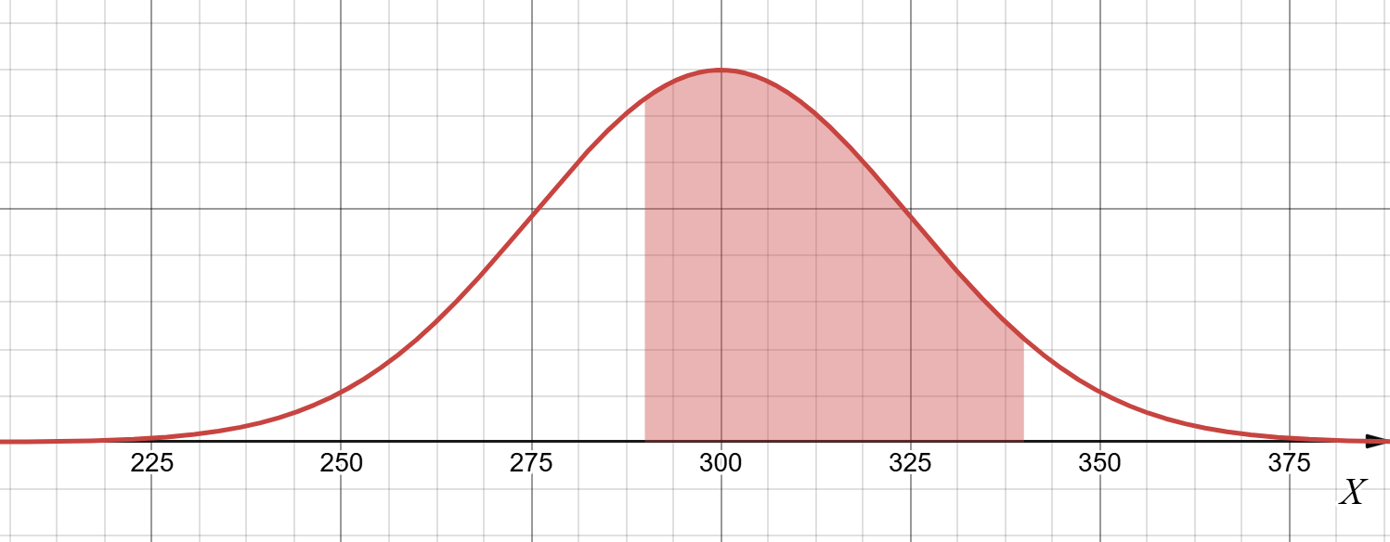 | $$0.601$$
Q3  $$P(X≤310)$$ | 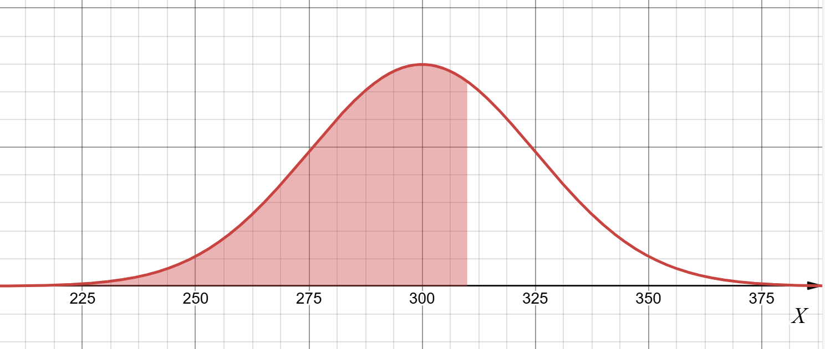 | $$0.655$$
Q4  $$P(X≥325)$$ | 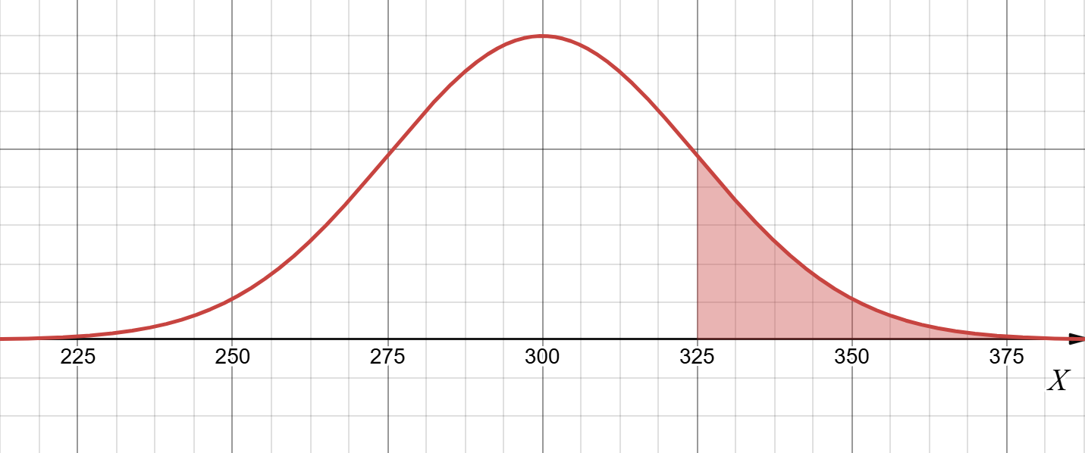 | $$0.159$$
Q5  $P(X≤260)$ or  $$P(X≥ 340)$$ | 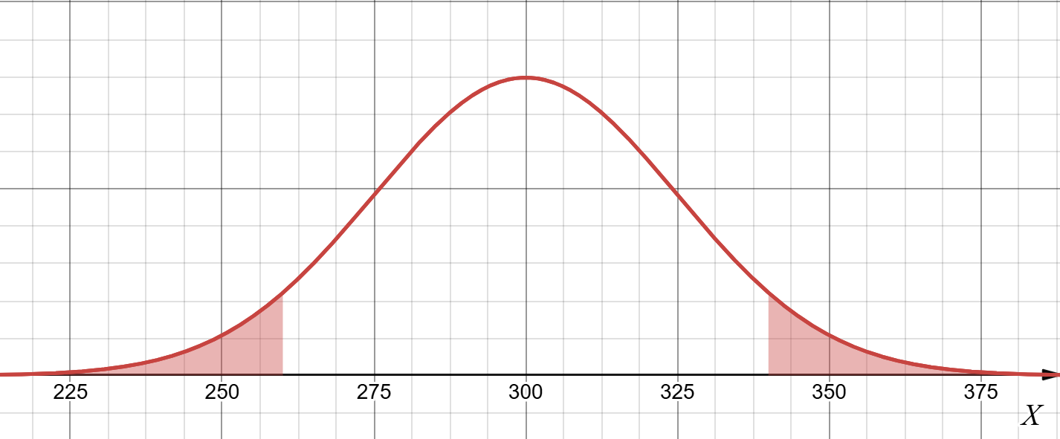 | $$0.890$$

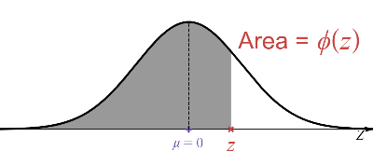
Worksheet C: Using standard normal $\left(Z\right)$ tables
$Z \sim N({0,1}^{2})$ $μ=0$ $σ= 1$

For each question draw a simple sketch of the distribution showing the required area.
Question | Sketch | Readings and calculations
Q1
$$P(Z≤1.45)$$
Q1
$$P(Z≥0.825)$$
Q3
$$P(Z≤-1.96)$$
Q4
$$P(Z≥-0.5)$$
Q5
$$P(-1.13≤Z≤1.852)$$
Q6
$P(Z≤-2)$ or $P(Z≥2)$

Worksheet C: Using standard normal $\left(Z\right)$ tables
$Z \sim N({0,1}^{2})$ $μ=0$ $σ= 1$

For each question draw a simple sketch of the distribution showing the required area.
Question | Sketch | Readings and calculations
Q1  $$P(Z≤1.45)$$ |  | 0.9265
Q1  $$P(Z≥0.825)$$ |  | 0.2047
Q3  $$P(Z≤-1.96)$$ |  | 0.0250
Q4  $$P(Z≥-0.5)$$ |  | 0.6915
Q5  $P(-1.13≤Z≤1.852)$ |  | 0.8387
Q6  $P(Z≤-2)$ or $P(Z≥2)$ |  | 0.0456

Worksheet D:
Calculating Probabilities by Standardising
Question | Answer
Q1
$X\sim N(84, 8^{2})$ $μ= σ=$
Q1a
$$P(X≤86)$$
Q1b
$$P(X≥95)$$
Q1c
$$P(86≤X≤100)$$

Question | Answer
Q2
$X\sim N(18, {3.4}^{2})$ $μ= σ=$
Q2a
$P(X≤15)$
Q2b
$$P(X≥12)$$
Q2c
$$P(16.3≤X≤24.8)$$

Worksheet D:
Calculating Probabilities by Standardising
Question | Answer
Q1
$X\sim N(84, 8^{2})$ $μ= σ=$
Q1a  $$P(X≤86)$$ | $0.5987$
Q1b  $$P(X≥95)$$ | $0.0845$
Q1c  $$P(86≤X≤100)$$ | $0.3785$

Question | Answer
Q2
$X\sim N(18, {3.4}^{2})$ $μ= σ=$
Q2a  $P(X≤15)$ | $0.1889$
Q2b  $$P(X≥12)$$ | $0.9612$
Q2c  $$P(16.3≤X≤24.8)$$ | $0.6687$

Worksheet E:
Approximations and Continuity Corrections

Question | Binomial model | Mean and Variance | Approx Normal model
Q1 | $$X\sim B(60,0.2)$$ | $$mean: np=$$  $$variance: npq=$$ | $$X\sim N( , )$$
Q2 | $$X\sim B(40,0.5)$$
Q3 | $$X\sim B(140,0.3)$$

Question | Probability | 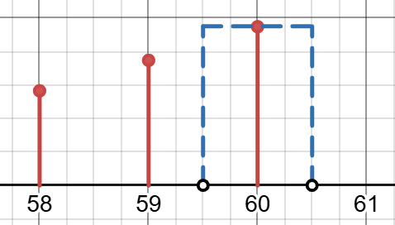  Continuity Correction
Q4 | $$P(X≤60)$$ | $→ cc → P\left(X \right)$
Q5 | $$P(X>42)$$
Q6 | $$P(X≥33)$$
Q7 | $$P\left(X<81\right)$$
Q8 | $$P(20≤X≤50)$$
Q9 | $$P(20<X<50)$$

Worksheet E: Answers
Approximations and Continuity Corrections

Question | Binomial model | Mean and Variance | Approx Normal model
Q1 | $$X\sim B(60,0.2)$$ | $$mean: np=$$  $$variance: npq=$$ | $$X\sim N(12 , 9.6 )$$
Q2 | $$X\sim B(40,0.5)$$ |  | $$X\sim N(20 , 10 )$$
Q3 | $$X\sim B(140,0.3)$$ |  | $$X\sim N(42 , 29.4 )$$

Question | Probability | Continuity Correction
Q4 | $$P(X≤60)$$ | $$→ cc → P\left(X ≤60.5\right)$$
Q5 | $$P(X>42)$$ | $$→ cc → P\left(X≥42.5\right)$$
Q6 | $$P(X≥33)$$ | $$→ cc → P\left(X≥32.5\right)$$
Q7 | $$P\left(X<81\right)$$ | $$→ cc → P\left(X ≤80.5\right)$$
Q8 | $$P(20≤X≤50)$$ | $$→ cc → P\left(19.5≤X ≤50.5\right)$$
Q9 | $$P(20<X<50)$$ | $$→ cc → P\left(20.5≤X ≤49.5\right)$$

Worksheet F:
Normal approximation to the binomial distribution
In each question use a normal approximation to calculate the required probability.
Question | Binomial model | Normal approximation and calculations
Q1 | $$X\sim B(200, 0.2)$$  $$P(X≤44)$$
Q2 | $$X\sim B(80, 0.25)$$  $$P(X<25)$$
Q3 | $$X\sim B(60, 0.3)$$  $$P(X≥12 )$$
Q4 | $$X\sim B(400, 0.1)$$  $$P(35<X<45)$$

Q5 | Ling is a candidate in an election. He received 70% of the votes. A random sample of 120 voters is chosen.  Use an approximation to find the probability that between 85 and 95 inclusive voted for Ling.

Worksheet F: ANSWERS
Normal approximation to the binomial distribution
In each question use a normal approximation to calculate the required probability.
Question | Binomial model | Normal approximation and calculations
Q1 | $$X\sim B(200, 0.2)$$  $$P(X≤44)$$ | $np=40$ $npq=32$  $$→cc P\left(X≤44.5\right) =P\left(Z≤\frac{44.5-40}{\sqrt{32}}\right)=ϕ\left( 0.795\right)$$  $= 0.787$
Q2 | $$X\sim B(80, 0.25)$$  $$P(X<25)$$ | $np=20$ $npq=15$  $$→cc P\left(X≤24.5\right) =P\left(Z≤\frac{24.5-20}{\sqrt{15}}\right)=ϕ\left( 1.162\right)$$  $= 0.877$
Q3 | $$X\sim B(60, 0.3)$$  $$P(X≥12 )$$ | $np=18$ $npq=12.6$  $$→cc P\left(X≥11.5\right) =P\left(Z≥\frac{11.5-18}{\sqrt{12.6 }}\right)=P(Z≥-1.831)$$  $=ϕ\left( 1.831\right) = 0.967$
Q4 | $$X\sim B(400, 0.1)$$  $$P(35<X<45)$$ | $np=40$ $npq=36$  $$→cc P\left(35.5≤X≤44.5\right) =P\left(\frac{39.5-40}{\sqrt{36}}≤Z≤\frac{44.5-40}{\sqrt{36}}\right)$$  $=ϕ\left( 0.75\right)-ϕ\left(-0.083\right)= 0.7734-\left(1-0.5331\right)=0.307$

Q5 | Ling is a candidate in an election. He received 70% of the votes. A random sample of 120 voters is chosen.  Use an approximation to find the probability that between 85 and 95 inclusive voted for Ling.  $X\sim B(120, 0.7)$ $np=84$ $npq=25.2$ $→cc P\left(85.5≤X≤95.5\right)$  $P\left(\frac{85.5-84}{\sqrt{25.2}}≤Z≤\frac{95.5-84}{\sqrt{25.2}}\right) = ϕ\left( 2.291\right)-ϕ\left(0.299\right) = 0.9890-0.6176= 0.371$

Cambridge Assessment International Education
The Triangle Building, Shaftesbury Road, Cambridge, CB2 8EA, United Kingdom
t: +44 1223 553554
e: info@cambridgeinternational.org www.cambridgeinternational.org

© Cambridge University Press & Assessment 2025

