

Teacher Pack
Complex Numbers
Cambridge International AS & A Level
Mathematics 9709

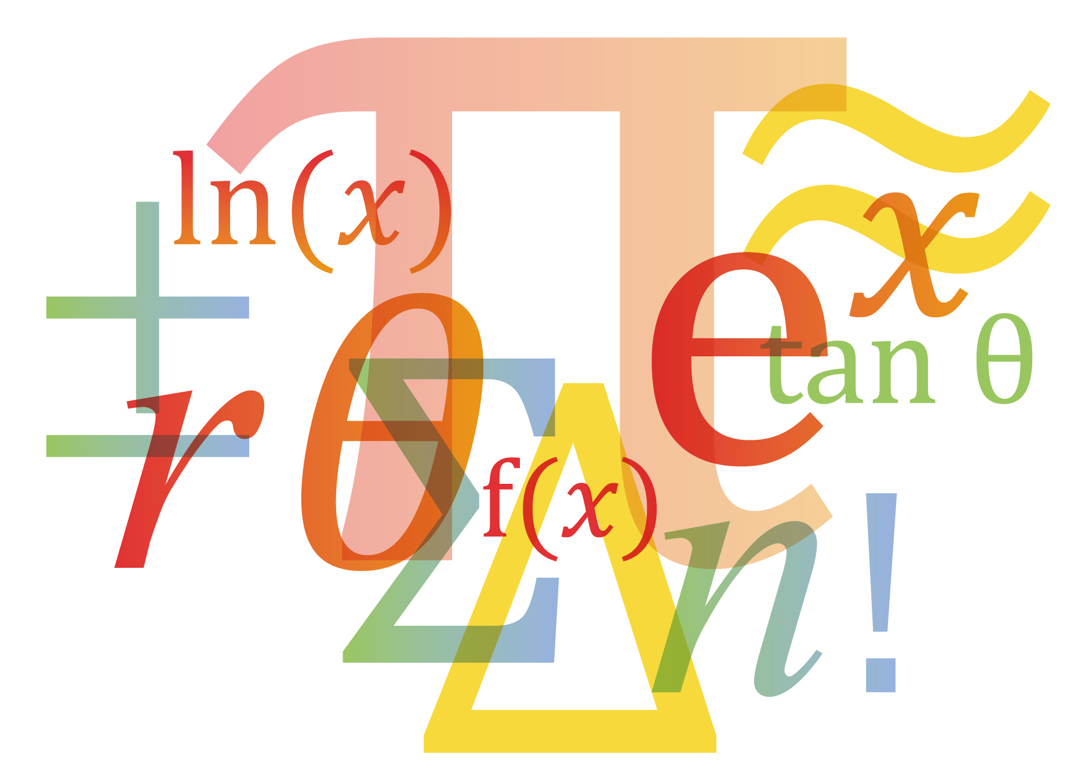

© Cambridge University Press & Assessment 2025
Cambridge Assessment International Education is part of Cambridge University Press & Assessment. Cambridge University Press & Assessment is a department of the University of Cambridge.

Cambridge University Press & Assessment retains the copyright on all its publications. Registered centres are permitted to copy material from this booklet for their own internal use. However, we cannot give permission to centres to photocopy any material that is acknowledged to a third party even for internal use within a centre.
Contents
Contents 3
Introduction 5
Lesson preparation 6
Lesson 1: Introduction to Complex Number 9
Lesson plan 2: Polynomial Function with Complex Root 11
Lesson plan 3: Argand Diagram and Other Forms of Complex Numbers 13
Lesson plan 4: Locus in Argand Diagram 16
Planning your own lessons 18
Lesson reflection 19
Worksheets and answers 20
Worksheet A: Basic Algebra of Complex Numbers 21
Worksheet B: Simultaneous Linear Equation 22
Worksheet C: Polynomial with Complex Roots 23
Worksheet D: Square Roots of Complex Numbers 24
Worksheet E: Modulus and Argument 25
Worksheet F: Product and Division in Polar Form 26
Worksheet G: Locus in Argand Diagram 27
Worksheet A: Answers 28
Worksheet B: Answers 30
Worksheet C: Answers 31
Worksheet D: Answers 32
Worksheet E: Answers 33
Worksheet F: Answers 35
Worksheet G: Answers 36

Icons used in this pack:
 | Teacher preparation
 | Lesson plan
 | Lesson resource
 | Lesson reflection

Introduction
This pack will help you to develop your learners’ skills in mathematical thinking and mathematical communication, which are essential for success at AS & A Level and in further education.

Mathematical thinking and communication will be developed by focussing on:
These link to the course Assessment Objectives (AOs) which you can find in detail in the syllabus:
A01 Knowledge and understanding

A02 Application and communication

- Conceptual understanding – the ‘why’ behind the ‘what’
- Strategic competence – forming and solving problems
- Adaptive reasoning – explanations, justifications and deductive reasoning

Throughout all activities, the learners will also develop:
- Procedural fluency – know when, how and which rules to use
- Positive disposition – believe maths can be learned, applied and is useful
- Their skills in writing mathematically – writing working & proofs

Each Teacher Pack contains one or more lesson plans and associated resources, complete with a section of preparation and reflection.

Each lesson is designed to be an hour long but you should adjust the timings to suit the lesson length available to you and the needs of your learners.

Important note
Our Teacher Packs have been written by classroom teachers to help you deliver topics and skills that can be challenging. Use these materials to supplement your teaching and engage your learners. You can also use them to help you create lesson plans for other topics.

This content is designed to give you and your learners the chance to explore a more active way of engaging with mathematics that encourages independent thinking and a deeper conceptual understanding. It is not intended as specific practice for the examination papers.

The Teacher Packs are designed to provide you with some example lessons of how you might deliver content. You should adapt them as appropriate for your learners and your centre. A single pack will only contain at most four lessons, it will not cover a whole topic. You should use the lesson plans and advice provided in this pack to help you plan the remaining lessons of the topic yourself.

Lesson preparation
This Teacher Pack will cover the following syllabus content.
Candidate should be able to: | Notes and examples
- understand the idea of a complex number, recall the meaning of the terms real part, imaginary part, modulus, argument, conjugate, and use the fact that two complex numbers are equal if and only if both real and imaginary parts are equal | Notations $\operatorname{Re}{z}$, $\operatorname{Im}{z}$, $|z|$, $\arg{z}$, $z^{*}$ should be known. The argument of a complex number will usually refer to an angle $θ$ such that $-π<θ≤π$, but in some cases the interval $0≤θ<2π$ may be more convenient. Answers may use either interval unless the question specifies otherwise.
- carry out operations of addition, subtraction, multiplication and division of two complex numbers expressed in Cartesian form $x + iy$ | For calculations involving multiplication or division, full details of the working should be shown.
- use the result that, for a polynomial equation with real coefficients, any non-real roots occur in conjugate pairs | e.g. in solving a cubic or quartic equation where one complex root is given.
- represent complex numbers geometrically by means of an Argand diagram
- carry out operations of multiplication and division of two complex numbers expressed in polar form $re^{iθ}=r\left(\cos{θ}+i\sin{θ}\right)$ | Including the results $\left|z_{1}z_{2}\right|=\left|z_{1}\right|\left|z_{2}\right|$and $\arg\left(z_{1}z_{2}\right)=\arg{z_{1}}+\arg{z_{2}}$, and corresponding results for division.
- find the two square roots of a complex number | e.g. the square roots of $5 + 12i$ in exact Cartesian form. Full details of the working should be shown.
- understand in simple terms the geometrical effects of conjugating a complex number and of adding, subtracting, multiplying and dividing two complex numbers
- illustrate simple equations and inequalities involving complex numbers by means of loci in an Argand diagram | e.g. $|z – a|<k,$ $|z – a|=|z – b|$, $\arg{(z – a)}=α$.

Prior knowledge and skills
For all lessons, it is assumed that learners have already completed Cambridge IGCSETM Mathematics 0580, or a course at an equivalent level. See the syllabus for more details of the expected prior knowledge for taking Cambridge International AS & A Level Mathematics 9709.
When planning any lesson, make a habit of always asking yourself the following questions about your learners’ prior knowledge and skills:
- Do I need to re-teach this or do learners just need some practice?
- Is there an interesting activity that will efficiently achieve this?

Key learning objectives

The following list represents the main underlying concepts that you should make sure your learners have understood by the end of this topic.
- understand the idea of a complex number, recall the meaning of the terms real part, imaginary part, conjugate, modulus and argument
- use the fact that two complex numbers are equal if and only if both real and imaginary parts are equal
- carry out operations of addition, subtraction, multiplication and division of two complex numbers expressed in Cartesian form $x+iy$
- use the result that, for a polynomial equation with real coefficients, any non-real roots occur in conjugate pairs
- find the two square roots of a complex number
- represent complex numbers geometrically by means of an Argand diagram
- carry out operations of multiplication and division of two complex numbers expressed in the polar form $r\left(\cos{θ}+i\sin{θ}\right)=re^{iθ}$
- illustrate simple equations and inequalities involving complex numbers by means of loci in an Argand diagram

Why this topic matters

Complex numbers are an essential part of mathematics because they extend the concept of real numbers and provide a deeper understanding of algebra, geometry, and calculus.

1. Solving Polynomial Equations

2. Enhancing Understanding of Algebra

3. Applications in Geometry & Trigonometry

4. Use in Calculus & Differential Equations in Euler’s formula and Fourier Transformation in Signal Processing

5. Preparation for Higher Mathematics & STEM Fields: for example, in complex analysis, AC circuit and fluid dynamics

Key terminology and notation
Your learners will need to be confident with the following terminology and notation.

Real Part: $a$ is called the real part of the complex number $a+bi$

Imaginary Part: $b$ is called the imaginary part of the complex number $a+bi$

Conjugate: $a-bi$ is called the conjugate of $z=a+bi$, denoted as $z^{*}=a-bi$

Modulus: magnitude of the vector ($r$ or $\left|z\right|$) in Argand Diagram

Argument: angle of vector formed with positive $x$ axis ($θ$ or $\arg{z}$) in Argand Diagram

Cartesian Form: $z=a+bi$

Polar Form: $z=r\left(\cos{θ}+i\sin{θ}\right)$

Locus: the region where the set of points with specific properties locate

Lesson progression

Lesson 1 covers the basic terminology and definition of complex number and its algebra, including addition, subtraction, multiplication and division. Lesson 2 then move onto the polynomial function and its roots with conjugate pair theorem. Lesson 3 is about expressing complex number geometrically in Argand diagram with modulus and argument. Polar form of complex number is introduced and product and division in polar form is explained. Lesson 4 focuses on the locus of complex number in Argand diagram, which is an very important type question in the A Level mathematics examination.

Going forward
This topic is important in further university study in mathematics or physics.

Lesson 1: Introduction to Complex Number
Preparation
Resources | - White Board  - Lesson 1 slides  - Worksheet 1a and 1b
Learning objectives | By the end of this lesson, all learners should be able to:  - understand the idea of a complex number, recall the meaning of the terms real part, imaginary part, and conjugate;  - use the fact that two complex numbers are equal if and only if both real and imaginary parts are equal  - carry out operations of addition, subtraction, multiplication of two complex numbers expressed in Cartesian form $x+iy$.  By the end of this lesson, most learners should be able to:  - understand the idea of a complex number, recall the meaning of the terms real part, imaginary part, and conjugate;  - use the fact that two complex numbers are equal if and only if both real and imaginary parts are equal  - carry out operations of addition, subtraction, multiplication and division of two complex numbers expressed in Cartesian form $x+iy$

Dependencies

For all lesson plans in this Teacher Pack, knowledge from the following 9709 syllabus content is useful and/or required.
Candidate should be able to: | Notes and examples
- solve quadratic equations in one unknown | By factorising, completing the square and using the  formula.

Timings | Activity
5 min | Starter/Introduction  Teach this lesson use the Lesson 1 slides.  As a starter, display side 2 and ask the learner this question, Solve $x^{2}+1=0$
45 min | Main lesson  Part I:  Display slide 3 and stress on the definition of $i^{2}=-1$.  Real part and imaginary part are important concepts and make sure all learners understand that both of them refer to the real number a and b.  Go over slides 4~5 of the addition, subtraction and multiplication of complex number. Emphasise on all the bracket expansion formula can be used in complex number. Guide them on how to expand the bracket during teaching of products.  Example on slides 6 and 7 should be accessible and straightforward to all learners.  Display slide 8 and 9 with the conjugate and the division. Depend on the student level, division could be challenging for the weaker learners. Link this to rationalisation of the denominator in surds (pure math 1) if possible, which might remediate the problem.  With teacher’s guidance, the example on slide 10 and 11 should be accessible to most learners.  Give the learner worksheet 1a for 15~20 minutes. It is worth to go over the last question in the worksheet 1a.  Part II:  Though trivial, it is worth to mention the identical complex number in slide 12 and its meaning and application in solving the simultaneous equation of complex numbers. Most of the learners will find it tedious until they have seen how to apply it on slide 13.  Give the learner worksheet 1b for 10~15 minutes. The two questions are very challenging so leave the unfinished questions as homework.
  Challenge: ask them is there any difference between $i^{2}=-1$ and $i=\sqrt{-1}$
  Support: This example must be explained in detail. Make sure that you guide the learners on this example because they will soon get lost on the complicated process.
5 min | Plenary  Wrap up: Slide 14  True or false questions and refresh their minds from doing complex number questions. Some of them could be confusing.

Reflection | Reflect on your lesson, use the Lesson reflection notes to help you.

Lesson plan 2: Polynomial Function with Complex Root
Preparation
Resources | - White Board  - Lesson 2 slides  - Worksheet 2a, 2b
Learning objectives | By the end of the lesson:  - use the result that, for a polynomial equation with real coefficients, any non-real roots occur in conjugate pairs  - find the two square roots of a complex number

Dependencies

For all lesson plans in this Teacher Pack, knowledge from the following 9709 syllabus content is useful and/or required.
Candidate should be able to: | Notes and examples
- solve quadratic equations in one unknown | By factorising, completing the square and using the  formula.

Timings | Activity
5 min | Starter/Introduction  If you need to go over the worksheet 1b, consider to take 5~10 minutes out from this class and address them.  Show slide 2 and 3, review the quadratic formula and the discriminant with learners, then link the lesson 1 material to here.  If learners struggled with the quadratic formula (which they should not), consider go over one example with them.
45 min | Main lesson  Part I:  Show learners the example on slide 3, ask them to apply the quadratic formula first and see whether they could figure out the answer by themselves. This question should be straightforward.  After obtaining the 2 solutions, ask them the relationship between the answer. Stronger learners should be able to answer that 2 solutions are conjugate pairs of each other.  Distribute the worksheet 2a and solve question 1. Ask them what they find the relationship between the 2 solutions again. Let them guess the conjugate pair theorem.  Transition smoothly to conjugate pair theorem. Show them the example on slides 6~8. Review long division if necessary.  Ask the leaners to finish question 2 on the worksheet 2a.  Part II:  The square root of complex number should be accessible for all learners.  Link this to the lesson 1: multiplication of the complex number. Show them the example on slide 10~11.  The solving of $x$ and $y$ can be challenging for some of the learners. If they have to use the substitution, allow them. Direct observation is straightforward and ask them to try integers solutions first.  Remind them there must be 2 roots! Exactly the same with $x^{2}=9$.  Distribute worksheet 2b and ask them to finish in class.
  Challenge: The stronger learners should be able to understand the approach 2 on slide 8. (approach 2 on slide 8 is optional).
  Challenge: the question 2 on worksheet 2b is optional only for the stronger learners.
5 min | Plenary  Wrap up: Slide 12  Link to the Argand diagram which is to be taught in Lesson 3.

Reflection | Reflect on your lesson, use the Lesson reflection notes to help you.

Lesson plan 3: Argand Diagram and Other Forms of Complex Numbers
Preparation
Resources | - White Board  - Lesson 3 slides  - Worksheet 3a, 3b
Learning objectives | By the end of this lesson, all learners should be able to:  - understand the idea of modulus and argument  - represent complex numbers geometrically by means of an Argand diagram  By the end of this lesson, most learners should be able to:  - understand the idea of modulus and argument  - represent complex numbers geometrically by means of an Argand diagram  - carry out operations of multiplication and division of two complex numbers expressed in the polar form $r\left(\cos{θ}+i\sin{θ}\right)=e^{iθ}$  By the end of this lesson, some learners should be able to:  - understand the idea of modulus and argument  - represent complex numbers geometrically by means of an Argand diagram  - carry out operations of multiplication and division of two complex numbers expressed in the polar form $r\left(\cos{θ}+i\sin{θ}\right)=re^{iθ}$  - understand in simple terms the geometrical effects of multiplying and dividing two complex numbers

Dependencies

For all lesson plans in this Teacher Pack, knowledge from the following 9709 syllabus content is useful and/or required.
Candidate should be able to: | Notes and examples
- carry out addition and subtraction of vectors, and interpret these operations in geometrical terms
- calculate the magnitude of a vector

Timings | Activity
5 min | Starter/Introduction  Show them slide 1 to remind the learners about definition of angles in coordinates and unit circles. This lesson requires them to be familiar with the trigonometric functions and special angle values. Review with them if they need.
65 min | Main lesson  Part I:  Show them slides 2~4. Link with the probing question at the end of Lesson 2, expressing the complex number on the complex plane (just a normal xy plane). More examples could be given to the students to remind them how to draw vectors in different coordinates. The definition of modulus and argument is key, using easy words to define those complicated terms. For example, modulus is the length and argument is the angle, which will help the learners to be less “afraid of” the math terminologies.  Show learners about the example on slide 6 and go over the 2 questions in details. Then, ask them to complete the question 1 on the worksheet 3a. Remind them again about the importance of drawing the complex number on the Argand diagram before they calculate the argument.  Part II:  Show slide 8 and illustrate the polar form of the complex number by drawing the diagram, especially when illustrating $x=r\cos{θ}$ and $y=r\sin{θ}$. Show slide 9~10 and go over the questions with the special angles. Then, ask them to complete the question 2 on the worksheet 3a.  Slide 11 and 12 are the same rule in the different way. Choose one to show the learners – whichever one works for you. These rules could be challenging to understand. It is better to review these rules after learning of the $re^{iθ}$ form. (slide 17 is put in the teacher resource for this purpose)  Slide 13~15 is challenging for most of the leaners – understanding the product and division of complex number geometrically. Remind them the meaning of modulus and argument – modulus is the length and argument is the angle. Therefore, increase in modulus means length enlargement and increase of angle means rotation anticlockwise (vice versa). Use the Argand diagram on slide 15 to illustrate.  Part III:  Show slide 16 and 18. Learners does not have to know the de Moivre’s theorem, but they need to know $re^{iθ}=r\left(\cos{θ}+i\sin{θ}\right)$. Slide 18 proof can be used for leaners to explore by themselves but in this lesson, we hardly have any time for doing this.  Show slide 19~20. If learners can figure out the correct modulus and argument, then they would not have problem of calculating the power.  Ask them to finish question 2 on worksheet 3b as homework if no time left.
  Challenging: Remind them that the calculation of the argument (slide 4) has different modification by $π$ is because of the domain of argument is from $-π<\arg{z}≤π$. It is very important for them to draw the complex number if the questions ask them to find the argument because $\tan^{-1}{x}∈\left[-\frac{π}{2},\frac{π}{2}\right]$.
  Support: If all learners still seem to struggle, skip this part and skip Question 1 on the worksheet 3b.
5 min | Plenary  There is hardly any time left for the wrap up.  Review the definition of modulus and argument and the product and division of complex numbers.

Reflection | Reflect on your lesson, use the Lesson reflection notes to help you.

Lesson plan 4: Locus in Argand Diagram
Preparation
Resources | - White Board  - Lesson 4 slides  - Worksheet 4
Learning objectives | By the end of this lesson, most learners should be able to:  - illustrate simple equations and inequalities involving complex numbers by means of loci in an Argand diagram

Dependencies

Learners need to know representing angles and presenting vector from IGCSE mathematics. Learners are required to understand the material in lesson 1, and 3.

Timings | Activity
15 min | Starter/Introduction  Teach this lesson use the Lesson 4 slides.  Show slide 2, and review the Argand Diagram, modulus, and argument with learners.
45 min | Main lesson  Part I:  Slide 3 and 4 demonstrates the basic form of locus, including the real part, imaginary part and the argument. Make sure all learners are able to represent these in the Argand diagram.  Slide 5 link the geometric meaning of subtraction in complex number with the vectors. Therefore, slide 6 demonstrates the type II of locus in the form of $\arg\left(z-w\right)=θ$. This starts to be challenging and for the weak students they might have to memorise this conclusion.  Part II:  Slide 7~10 is going to be illustrating the locus in the form of $\left|z-w\right|=\left|z-p\right|$ and $\left|z-w\right|≤r$. It is very important for the learners to understand the reason why the locus is perpendicular bisector between WP and a circle correspondingly. Therefore, a full detailed explanation is provided in the slides. Having said that, it is difficult for the learners without strong vector background to visualise it. Therefore, an algebraic approach is also provided in slide 9 and 10. The proof on those two slides can be used if the learners is weak in geometry but strong in algebra.  Part III:  Slides 11~17 are all about exam style questions. This locus type of question is very common in the Cambridge A level math exam. Therefore, it is very important for teachers to prepare students in familiarisation of exam style questions. You could alter the question if you think there are more proper practice questions for your students.  After going over at least 2 examples, distribute the worksheet 4 and ask the learners to finish them in class. This worksheet is very challenging. Most students should be able to access the first question.
5 min | Plenary  Address any question arises during worksheet 4  Present slide 18 and ask the learners to note down all the different possible type of locus question in the exam.

Reflection | Reflect on your lesson, use the Lesson reflection notes to help you.
How the learners react with the difficulty of question in worksheet 4?
How the learners react with maximum argument part in the worksheet 4?

Planning your own lessons
You now need to plan lessons to cover the following bullet points:

Candidate should be able to: | Notes and examples
- use algebraic methods to solve problems involving lines and circles | Including use of elementary geometrical properties of circles, e.g. tangent perpendicular to radius, angle in a semicircle, symmetry.  Implicit differentiation is not included.
- understand the relationship between a graph and  its associated algebraic equation, and use the  relationship between points of intersection of  graphs and solutions of equations. | e.g. to determine the set of values of k for which the line y = x + k intersects, touches or does not meet a quadratic curve.

Follow the structure of the Skills Pack, and use techniques from the ‘How to’ guides, to create your own engaging lessons to cover these bullet points. Consider what preparation you need for each lesson: what prior knowledge is needed, what are the key objectives, what are the dependencies, what common misconceptions are there, and so on.

Below, we have provided an outline of some activities and approaches you might like to try.

Lesson x: Solving problems with lines and circles
Common misconceptions:
Starter: You could try …
Main: You could use resource xxxxx and have a class discussion about y ….
Plenary: You could try …

Lesson y: The relationship between a graph and its algebraic equation
Common misconceptions:
Starter: You could try …
Main: You could use resource xxxxx and have a class discussion about y ….
Plenary: You could try …

You will find some other activity suggestions in the Scheme of Work.

Lesson reflection
As soon as possible after the lesson you need to think about how well it went.

One of the key questions you should always ask yourself is:

Did all learners get to the point where they can access the next lesson? If not, what will I do?

Reflection is important so that you can plan your next lesson appropriately. If any misconceptions arose or any underlying concepts were missed, you might want to use this information to inform any adjustments you should make to the next lesson.

It is also helpful to reflect on your lesson for the next time you teach the same topic. If the timing was wrong or the activities did not fully occupy the learners this time, you might want to change some parts of the lesson next time. There is no need to re-plan a successful lesson every year, but it is always good to learn from experience and to incorporate improvements next time.

To help you reflect on your lesson, answer the most relevant questions below.

Were the lesson objectives realistic?
What did the learners learn today? Or did they learn what was intended? Why not?
What proportion of the time did we spend on the most important topics?
Were there any common misconceptions?
What do I need to address next lesson?
What was the learning atmosphere like?
Did my planned differentiation work well?
How could I have helped the lowest achieving learners to do more?
How could I have stretched the highest achieving learners even more?
Did I stick to timings?
What changes did I make from my plan and why?

Summary evaluation
What two things went really well? (Consider both teaching and learning.)
What two things would have improved the lesson? (Consider both teaching and learning.)
What have I learned from this lesson about the class or individuals that will inform my next lesson?

Worksheets and answers

‘ | Worksheet | Answers
For use with Lesson 1
A: Basic Algebra of Complex Numbers | x | x
B: Simultaneous Linear Equation | x | x
For use with Lesson 2:
C: Polynomial with Complex Roots | x | x
D: Square Roots of Complex Numbers | x | x
For use with Lesson 3: | x | x
E: Modulus and Argument | x | x
F: Product and Division in Polar Form | x | x
For use with Lesson plan 4:
G: Locus in Argand Diagram | x | x

Worksheet A: Basic Algebra of Complex Numbers
- Given the complex numbers $z_{1}=1-3i$, $z_{2}=4+i$ and $z_{3}=-2+3i$, then find the following:
$$z_{3}^{2}-2z_{1}$$

- Given the complex numbers $z_{1}=2+i$, $z_{2}=2-5i$ and $z_{3}=-1+2i$, then find
$$\frac{2z_{1}-3z_{2}}{z_{3}}$$

- Find $z∈C$ that satisfies the equation $\frac{z+2}{1-i}=\frac{z-3i}{2+i}$.

Worksheet B: Simultaneous Linear Equation
- Solve the simultaneous equations for $z,w∈C$
$$\frac{w}{z}=3-i$$
$$z^{*}+2w=4+7i$$

- Solve the simultaneous equations for $w,v∈C$
$$v+iw=4-2i$$
$$\left(1+3i\right)v-w=5+i$$

Worksheet C: Polynomial with Complex Roots
- Solve the quadratic equation $z^{2}+4z+13=0$

- Given that $z=1+i$ is a root of $z^{4}+3z^{2}-6z+10=0$. Hence, find all the roots of this equation.

Worksheet D: Square Roots of Complex Numbers
- Find the square root of the complex number $-3+4i$

- Find the square root of the complex number $7-24i$

Worksheet E: Modulus and Argument
Show the full procedures:
- Find the modulus and argument for the following complex numbers.
- $-12-5i$
- $\sqrt{3}-i$
- $-2+2i$

- Draw $2\operatorname{cis}\left(-\frac{π}{4}\right)$and $3\operatorname{cis}\left(-\frac{5π}{6}\right)$in Argand diagram and convert them into Cartesian form $z=a+bi$

Worksheet F: Product and Division in Polar Form

- Interpret the geometric meaning when a complex number is divided by $w=\frac{1}{2}+\frac{\sqrt{3}}{2}i$.

- By expressing $2-2\sqrt{3}i$ in the form of $re^{iθ}$ first, and hence find ${\left(2-2\sqrt{3}i\right)}^{5}$.

Worksheet G: Locus in Argand Diagram
Question 1
On a sketch of an Argand diagram, shade the region whose points represent complex numbers $z$ satisfying both the inequalities $\left|z-3i\right|≤1$ and $\operatorname{Re}{z}≤0$, where $\operatorname{Re}{z}$ denotes the real part of $z$.
Find the greatest value of $\arg{z}$ for points in this region, giving your answer in radians correct to 2 decimal places. (2018 w P32 Q9)

Question 2
On an Argand diagram, shade the region whose points represent complex numbers $z$ satisfying the inequalities $-\frac{1}{3}π≤\arg\left(z-1-2i\right)≤\frac{1}{3}π$ and $\operatorname{Re}{z}≤3$, where $\operatorname{Re}{z}$ denotes the real part of $z$.
Calculate the least value of $\arg{z}$ for points in the region. Give your answer in radians
correct to 3 decimal places. (2023 m P32 Q2)

Worksheet A: Answers
- Given the complex numbers $z_{1}=1-3i$, $z_{2}=4+i$ and $z_{3}=-2+3i$, then find the following:
$$z_{3}^{2}-2z_{1}$$
$$={\left(-2+3i\right)}^{2}-2\left(1-3i\right)$$
$$=4+9i^{2}-12i-2+6i$$
$$=4-9-2-6i$$
$$=-7-6i$$

- Given the complex numbers $z_{1}=2+i$, $z_{2}=2-5i$ and $z_{3}=-1+2i$, then find
$$\frac{2z_{1}-3z_{2}}{z_{3}}$$
$$=\frac{2\left(2+i\right)-3\left(2-5i\right)}{-1+2i}$$
$$=\frac{-2+17i}{-1+2i}$$
$$=\frac{\left(-2+17i\right)（-1-2i）}{\left(-1+2i\right)（-1-2i）}$$
$$=\frac{2+4i-17i-34i^{2}}{5}$$
$$=\frac{36-13i}{5}$$

- Find $z∈C$ that satisfies the equation $\frac{z+2}{1-i}=\frac{z-3i}{2+i}$.
$$\left(z+2\right)\left(2+i\right)=\left(1-i\right)\left(z-3i\right)$$
$$2z+iz+4+2i=z-3i-iz+3i^{2}$$
$$2z+iz-z+iz=-3i-3-4-2i$$
$$z+2zi=-7-5i$$
$$\left(1+2i\right)z=-7-5i$$
$$z=\frac{-7-5i}{1+2i}=\frac{\left(-7-5i\right)\left(1-2i\right)}{\left(1+2i\right)\left(1-2i\right)}$$
$$z=\frac{-7+14i-5i+10i^{2}}{5}$$
$$z=\frac{-17+9i}{5}$$

Worksheet B: Answers
- Solve the simultaneous equations for $z,w∈C$
$$\frac{w}{z}=3-i$$
$$z^{*}+2w=4+7i$$

Let $z=a+bi$, $w=\left(3-i\right)\left(a+bi\right)=3a-ia+3bi-bi^{2}=\left(3a+b\right)+\left(3b-a\right)i$
$$z^{*}=a-bi$$
$$a-bi+2\left[\left(3a+b\right)+\left(3b-a\right)i\right]=4+7i$$
$$a-bi+\left(6a+2b\right)+\left(6b-2a\right)i=4+7i$$
$$\left(7a+2b\right)+\left(5b-2a\right)i=4+7i$$
Therefore,
$$\left\{\begin{aligned}7a+2b=4 \\ 5b-2a=7\end{aligned}\right.$$
$$a=\frac{2}{13}, b=\frac{19}{13}$$

- Solve the simultaneous equations for $w,v∈C$
$$v+iw=4-2i$$
$$\left(1+3i\right)v-w=5+i$$

Multiply equation 1 with $i$: $iv-w=4i+2$, this is equation 3
Use equation 2 minus equation 3: $\left(1+2i\right)v=3-3i$
$$v=\frac{3-3i}{1+2i}=-\frac{3}{5}-\frac{9}{5}i$$
$$-\frac{3}{5}-\frac{9}{5}i+iw=4-2i$$
$$iw=\frac{23}{5}-\frac{1}{5}i$$
$$w=-\frac{1}{5}-\frac{23}{5}i$$

Worksheet C: Answers
- Solve the quadratic equation $z^{2}+4z+13=0$
$$z=\frac{-4±\sqrt{4^{2}-4×13}}{2}=\frac{-4±\sqrt{-36}}{2}$$
$$z=\frac{-4±6i}{2}=-2±3i$$
$z_{1}=-2+3i$ and $z_{2}=-2-3i$

- Given that $z=1+i$ is a root of $z^{4}+3z^{2}-6z+10=0$. Hence, find all the roots of this equation.

According to the conjugate pair theorem, $z=1-i$ is also going to be a root.
Therefore, $\left[z-\left(1+i\right)\right]\left[z-(1-i)\right]=z^{2}-2z+2$ is going to be a factor of $z^{4}+3z^{2}-6z+10=0$.
By long division:
$$z^{4}+3z^{2}-6z+10=\left(z^{2}-2z+2\right)\left(z^{2}+2z+5\right)=0$$
Therefore, $z^{2}+2z+5=0$
$$z=\frac{-2±\sqrt{-16}}{2}=\frac{-2±4i}{2}=-1±2i$$
$$z_{1}=1+i, z_{2}=1-i, z_{3}=-1+2i, z_{4}=-1-2i$$

Worksheet D: Answers
- Find the square root of the complex number $-3+4i$

$${\left(x+yi\right)}^{2}=x^{2}-y^{2}+2xyi=-3+4i$$
$$\left\{\begin{aligned}x^{2}-y^{2}=-3 \\ 2xy=4\end{aligned}\right.$$
By observation:
$$\left\{\begin{aligned}x=1 \\ y=2\end{aligned}\right. or \left\{\begin{aligned}x=-1 \\ y=-2\end{aligned}\right.$$
$$1+2i or-1-2i$$

- Find the square root of the complex number $7-24i$

$${\left(x+yi\right)}^{2}=x^{2}-y^{2}+2xyi=7-24i$$
$$\left\{\begin{aligned}x^{2}-y^{2}=7 \\ 2xy=-24\end{aligned}\right.$$
By observation:
$$\left\{\begin{aligned}x=4 \\ y=-3\end{aligned}\right. or \left\{\begin{aligned}x=-4 \\ y=3\end{aligned}\right.$$
$$4-3i or-4+3i$$

Worksheet E: Answers
- Find the modulus and argument for the following complex numbers.
- $-12-5i$
- $\sqrt{3}-i$
- $-2+2i$

$-12-5i$ is in quadrant 3.
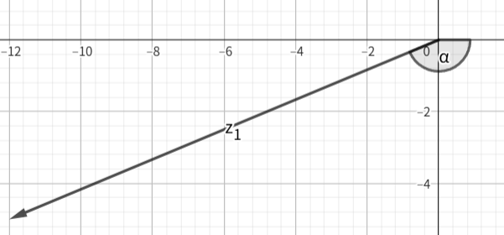
$$r=\sqrt{{\left(-12\right)}^{2}+{\left(-5\right)}^{2}}=13$$
$$\arg{z}=\arctan\left(-\frac{5}{-12}\right)≈0.395$$
By modification, $\arg{z}=0.395-π≈-2.75$

$\sqrt{3}-i$ is in quadrant 4.
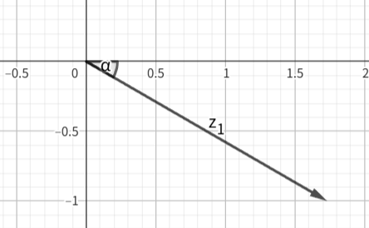
$$r=\sqrt{{\left(\sqrt{3}\right)}^{2}+{\left(-1\right)}^{2}}=2$$
$$\arg{z}=\arctan\left(-\frac{1}{\sqrt{3}}\right)=-\frac{π}{6}$$

$-2+2i$ is in quadrant 2.
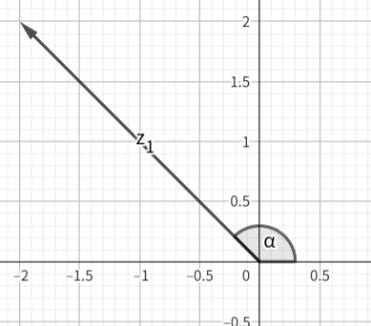
$$r=\sqrt{{\left(-2\right)}^{2}+{\left(2\right)}^{2}}=2\sqrt{2}$$
$$\arg{z}=\arctan\left(\frac{2}{-2}\right)=-\frac{π}{4}$$
By modification, $\arg{z}=-\frac{π}{4}+π=\frac{3π}{4}$

- Draw $2\operatorname{cis}\left(-\frac{π}{4}\right)$and $3\operatorname{cis}\left(-\frac{5π}{6}\right)$in Argand diagram and convert them into Cartesian form $z=a+bi$
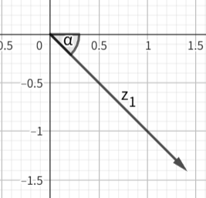
$$2\operatorname{cis}\left(-\frac{π}{4}\right)=2\cos\left(-\frac{π}{4}\right)+2i\sin\left(-\frac{π}{4}\right)=2×\frac{\sqrt{2}}{2}+2i\left(-\frac{\sqrt{2}}{2}\right)=\sqrt{2}-\sqrt{2}i$$

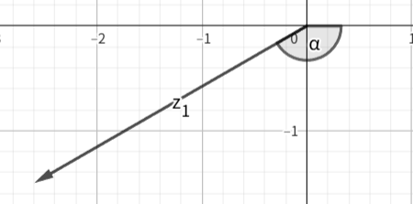
$$3\operatorname{cis}\left(-\frac{5π}{6}\right)=3\cos\left(-\frac{5π}{6}\right)+3i\sin\left(-\frac{5π}{6}\right)=3×\left(-\frac{\sqrt{3}}{2}\right)+3i\left(-\frac{1}{2}\right)=-\frac{3\sqrt{3}}{2}-\frac{3}{2}$$

Worksheet F: Answers
- Interpret the geometric meaning when a complex number is divided by $w=\frac{1}{2}+\frac{\sqrt{3}}{2}i$.

$$w=\frac{1}{2}+\frac{\sqrt{3}}{2}i$$
$$r=\sqrt{{\left(\frac{1}{2}\right)}^{2}+{\left(\frac{\sqrt{3}}{2}\right)}^{2}}=1$$
$$\arg{w}=\arctan\left(\frac{\frac{\sqrt{3}}{2}}{\frac{1}{2}}\right)=\arctan\left(\sqrt{3}\right)=\frac{π}{3}$$
$$w=1×e^{i\left(\frac{π}{3}\right)}=e^{i\left(\frac{π}{3}\right)}$$
Therefore, any complex number $z=re^{iθ}$ is divided by $w=e^{i\left(\frac{π}{3}\right)}$,
$$\frac{z}{w}=\frac{re^{iθ}}{e^{i\left(\frac{π}{3}\right)}}=re^{i\left(θ-\frac{π}{3}\right)}$$
The modulus of $z$ does not change but the argument of $z$ will decrease by $\frac{π}{3}$. (Rotation clockwise for $\frac{π}{3}$)

- By expressing $2-2\sqrt{3}i$ in the form of $re^{iθ}$ first, and hence find ${\left(2-2\sqrt{3}i\right)}^{5}$.
$$r=\sqrt{{\left(2\right)}^{2}+{\left(-2\sqrt{3}\right)}^{2}}=4$$
$$\arg{z}=\arctan\left(\frac{-2\sqrt{3}}{2}\right)=\arctan\left(-\sqrt{3}\right)=-\frac{π}{3}$$

$$2-2\sqrt{3}i=4e^{i\left(-\frac{π}{3}\right)}$$
$${\left(2-2\sqrt{3}i\right)}^{5}={\left(4e^{i\left(-\frac{π}{3}\right)}\right)}^{5}=4^{5}e^{i\left(-\frac{5π}{3}\right)}=1024e^{i\left(\frac{π}{3}\right)}$$
$$=1024\cos\left(\frac{π}{3}\right)+1024i\sin\left(\frac{π}{3}\right)$$
$$=512+512\sqrt{3}i$$

Worksheet G: Answers
Question 1
On a sketch of an Argand diagram, shade the region whose points represent complex numbers $z$ satisfying both the inequalities $\left|z-3i\right|≤1$ and $\operatorname{Re}{z}≤0$, where $\operatorname{Re}{z}$ denotes the real part of $z$.
Find the greatest value of $\arg{z}$ for points in this region, giving your answer in radians correct to 2 decimal places. (2018 w P32 Q9)

$\left|z-3i\right|≤1$ means a circle center at $\left(0,3\right)$ with radius $1$.
$\operatorname{Re}{z}≤0$ means $x≤0$

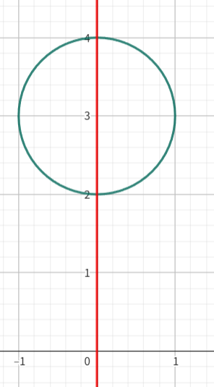

$$\sin{θ}=\frac{1}{3}$$
$$θ≈0.3398$$
Maximum argument is $0.3398+\frac{π}{2}≈1.91$

Question 2
On an Argand diagram, shade the region whose points represent complex numbers $z$ satisfying the inequalities $-\frac{1}{3}π≤\arg\left(z-1-2i\right)≤\frac{1}{3}π$ and $\operatorname{Re}{z}≤3$, where $\operatorname{Re}{z}$ denotes the real part of $z$.
Calculate the least value of $\arg{z}$ for points in the region. Give your answer in radians
correct to 3 decimal places. (2023 m P32 Q2)

$-\frac{1}{3}π≤\arg\left(z-1-2i\right)≤\frac{1}{3}π$ means the argument with respect to $\left(1,2\right)$
$\operatorname{Re}{z}≤3$ means $x≤3$
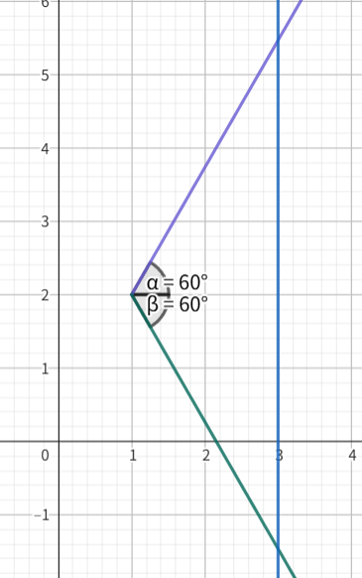

$$\tan{θ}=\frac{2}{1}$$
$$θ≈1.11$$

Cambridge Assessment International Education
The Triangle Building, Shaftesbury Road, Cambridge, CB2 8EA, United Kingdom
t: +44 1223 553554
e: info@cambridgeinternational.org www.cambridgeinternational.org

© Cambridge University Press & Assessment 2025

