

Teaching Pack
Understanding bearings
Cambridge IGCSETM
Mathematics 0580

This Skills Pack can also be used with the following syllabuses:
• Cambridge IGCSE™ (9–1) Mathematics 0980
• Cambridge IGCSE™ International Mathematics 0607
• Cambridge O Level Mathematics 4024

© Cambridge University Press & Assessment 2022
Cambridge Assessment International Education is part of Cambridge University Press & Assessment. Cambridge University Press & Assessment is a department of the University of Cambridge.

Cambridge University Press & Assessment retains the copyright on all its publications. Registered centres are permitted to copy material from this booklet for their own internal use. However, we cannot give permission to centres to photocopy any material that is acknowledged to a third party even for internal use within a centre.
Contents
Introduction 4
Skill: Understanding bearings 5
Common misconceptions: Understanding Bearings 7
Lesson 1: Angle Facts 8
Lesson 2: Bearings, Compass points and angle facts 10
Lesson 3: Trigonometry and bearings 14
Worksheets and answers 16

Icons used in this pack:
 | Lesson
 | Video
 | Assessment opportunity

Introduction
This pack will help you to develop your learners’ mathematical skills as defined by assessment objective 1 (AO1 Knowledge and understanding of mathematical techniques) in the course syllabus.

Important note
Our Skills Packs have been written by classroom teachers to help you deliver topics and skills that can be challenging. Use these materials to supplement your teaching and engage your learners. You can also use them to help you create lesson plans for other skills.

This content is designed to give you and your learners the chance to explore mathematical skills. It is not intended as specific practice for exam papers.

This is one of a range of Teaching Packs. Each pack is based on one mathematical topic with a focus on specific mathematical techniques. The packs can be used in any order to suit your teaching sequence.

In this pack you will find the lesson plans and worksheets for learners you will need to successfully complete the teaching of this mathematical skill.

Skill: Understanding bearings
This Teaching Pack links to the following syllabus content (see syllabus for detail):
- C6.1 Interpret and use three-figure bearings.
- E6.1 Interpret and use three-figure bearings.

For assessments from 2025
- C/E4.3 Use and interpret three-figure bearings.
Draw and interpret scale drawings.

The pack covers the following mathematical skills, adapted from AO1: Demonstrate knowledge and understanding of mathematical techniques (see syllabus for assessment objectives):
- organising, processing and presenting information accurately in written, tabular, graphical and diagrammatic forms
- using geometrical instruments to measure and to draw to an acceptable degree of accuracy
- recognising and using spatial relationships in two and three dimensions.

For assessments from 2025
AO1: Knowledge and understanding of mathematical techniques
- organise, process, present and understand information in written form, tables, graphs and diagrams
- measure and draw using geometrical instruments to an appropriate degree of accuracy
- recognise and use spatial relationships in two and three dimensions.

Prior knowledge
Knowledge from the following syllabus topics is useful for this unit
C4.7 Calculate unknown angles using the following geometrical properties. - angles at a point - angles at a point on a straight line and intersecting straight lines - angles formed within parallel lines - angle properties of triangles and quadrilaterals - angle in a semicircle
C6.2 Apply Pythagoras’ theorem and the sine, cosine and tangent ratios for acute angle to the calculation of a side or of an angle of a right- angled triangle
E6.4 Solve problems using sine and cosine rules for any triangle.

For assessments from 2025
- C/E4.6 Calculate unknown angles and give simple explanations using the following geometrical properties:
- sum of angles at a point = 360°
- sum of angles at a point on a straight line = 180°
- vertically opposite angles are equal
angle sum of a triangle = 180° and angle sum of a quadrilateral = 360°
Calculate unknown angles and give geometric explanations for angles formed within parallel lines:
- corresponding angles are equal
- alternate angles are equal
- co-interior (supplementary) angles sum to 180°
Know and use angle properties of regular polygons
- C/E4.7 Calculate unknown angles and give explanations using the following geometrical properties of circles:
- angle in a semicircle = 90°
- angle between tangent and radius = 90°
- C/E6.1 Know and use Pythagoras’ theorem
- C/E6.2 Know and use the sine, cosine and tangent ratios for acute angles in calculations involving sides or angles of a right- angled triangle
Solve problems in two dimensions using Pythagoras’ theorem and trigonometry
- E6.5 Use the sine and cosine rules in calculations involving lengths and angles for any triangle.

Before you begin
This Teaching Pack includes a Teacher Introduction video to which you should refer before
using the resources in this pack. The video is available to watch in Resource Plus within the topic section relevant to this Teaching Pack.
Common misconceptions: Understanding bearings
The first step to understanding bearings is to have a secure and confident understanding of angle as a measure rotation. Angles have two aspects, a static visual one, and a dynamic one. When angles are first introduced most learners focus on the two arms making a corner (vertex), with a gap between then. This is a static visual image of an angle. The next stage is to appreciate angle as a measure of turn, in other words that the size of an angle is the amount of turn between the straight lines. An understanding of angle in both these senses is important. Two misconceptions that often occur are that learners are distracted by the length of the 'arms', or by the orientation of the angle. If learners have these misconceptions about angle, this is likely to impact on their ability to work with bearings.
Once learners have overcome these basic misconceptions in terms of angle, they then need to understand that bearings are simply a specific application of angle, where the measure of turn is always taken clockwise from a fixed direction which is North. In other words, one of the arms of the angle in the static view always points in the same direction i.e. North. Even when they appreciate this as the starting point for a problem involving bearings learners can fail to realise that in multistep problems, for each new step in the problem, the bearing must once again be taken from North.
The reason they fail to secure this understanding may be because they do not appreciate why it is important, in real life, to have an agreed convention on the way we measure and share bearings. The importance of this can be demonstrated using simple practical demonstrations that show the consequences of not taking bearings according to an agreed set of conventions. This failure to understand the real-life implications may also be a significant factor in why learners often forget that bearings need to be given as three figures. It is also simple to demonstrate how errors and mistakes can arise in translation without this additional convention. It is important to stress that these ways of measuring and sharing bearings are conventions, but that they are conventions that without which there would be serious real-life consequences.
In many cases the dynamic geometry software packages used in the classroom do not enable teachers to always represent bearings as 3-figures and this can be confusing for learners.

Lesson 1: Angle Facts

Resources |  | - Whiteboard  - Lesson 1: Angle facts presentation  - Worksheet 1a.
Learning objectives |  | By the end of the lesson:  - all learners should be able to explain confidently that angle is a measure of turn.  - most learners should be able to solve simple problems involving angle independently and more complicated problems with support.  - some learners will be able to solve more complicated angle problems independently.
Timings | Activity
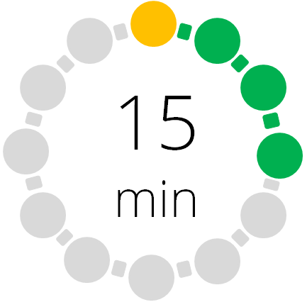 | Starter/Introduction  Teach this lesson using Lesson 1: Angle facts presentation. Ideally, this should be a non-calculator lesson.  Show your learners Slide 1. Learners need to make as many observations as they can about the two diagrams on the slide. Encourage learners to explain these observations. For example, z is equal to c because they are corresponding angles, w is equal to y because they are opposite angles, x and y sum to 180° because the sum of angles at a point on a straight line equal 180°, etc.
   | Main lesson  When working with bearings learners will need to use their understanding of angle as a measure of turn, and apply their knowledge of angle facts so this lesson secures this understanding by revisiting/consolidating this.  Ask learners how they would define what an angle is? Learners need to appreciate angle as a measure of turn, in other words that the size of an angle is the amount of turn between the straight lines. You can demonstrate this static and dynamic aspect of angle by writing or drawing an angle on the board, and then asking volunteers to turn through the angles demonstrated on the board.  As this is a consolidation/revision lesson in preparation for the introduction of bearings in the next two lessons, learners can now move straight to the worksheet. Worksheet 1a: Angle facts.  Differentiation: Extended learners should be able to tackle all the questions on this worksheet independently. To enable all learners to access the problems you can support learners using grouping and also guided group work. For the more complicated problems you could provide part completed examples or hints that learners can use.  Note that you may find extended learners move more quickly through this lesson in which case it can be combined as an introduction to lesson 2.
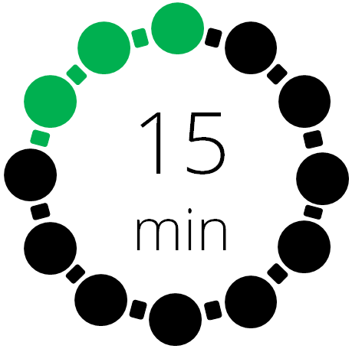 | Plenary  “How can you use the fact that the sum of angles at a point on a straight line is 180° to explain why the angles at a point are 360°?”  Learners should be able to use diagrams, and their knowledge of angle as a measure of turn, to demonstrate their response to this question.

Lesson 2: Bearings, Compass points and angle facts
Resources |  | - Whiteboard  - Lesson 2: Bearings, compass points and angle facts presentation  - GeoGebra file Writing and estimating bearings  - GeoGebra file Example slide 16  - Optional activity GeoGebra file Air traffic controller  - Class set of compasses  - Map of school and/or local area  - Worksheets 2a, 2b, 2c, 2d, 2e.
Learning objectives |  | By the end of the lesson:  - all learners should be able to identify the basic points on a 16-point compass along with their bearings  - most learners should be able to solve problems involving parallel lines and bearings  - some learners will be able to recognise generic rules when working with parallel lines and bearing.
Timings | Activity
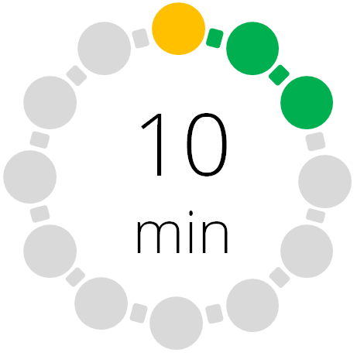 | Note there are several variations on how this lesson might be developed, and options to extend or reduce the time spent on some of the activities, depending on the learners that you are working with, and whether you intend to extend them to lesson three. There are three optional activities, each of which may take between 15 minutes and an hour. Therefore, it is suggested that the time taken for this lesson may vary from one lesson to 2 or 3 lessons, depending on the learners you are working with. The suggested times are linked to the core material.  Starter/Introduction  Teach this lesson using Lesson 2: Bearings, compass points and angle facts presentation. Ideally, this is a non-calculator lesson until the final slide when finding the angle using trigonometry is required.  Slide 2 Ask learners to find the missing angles in this diagram using Worksheet 2a Missing angles. Stress the importance of justifying each step using information provided in the diagram, and appropriate angle facts. Make sure that learners understand the importance of linking the explanation with the appropriate point on the diagram. These two things are demonstrated in the solution which is on Slide 3.
  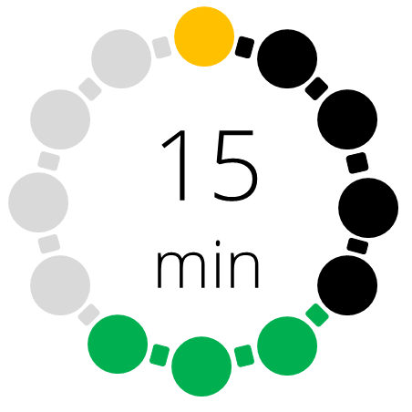  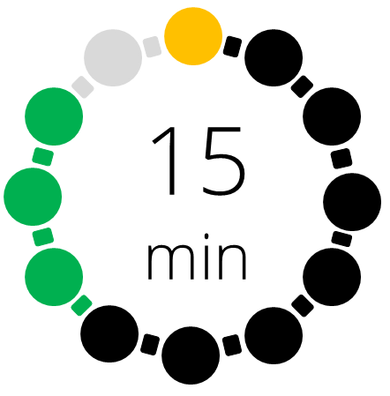 | Main lesson  Show your learners Slides 4 and 5. These slides introduce the way we measure and write bearings. It also introduces some of the named points on a compass, and provides a brief background of why and how these points are named.  Slide 6 introduces the 16-point compass. Go through the points illustrated on the slide. Remember to stress whenever possible that a bearing is an angle (measure of turn) that is always taken clockwise from North. Also remind learners that North is always marked towards the top of the page on any conventional map. Ask learners if they can identify the logic behind how the points are named. Then ask learners how the bearing for NNE has been calculated (90° ÷ 4, 45° ÷ 2) and ENE ( 3 x 22.5° or 90° – 22.5° or 45° + 22.5°).  Optional: you could use volunteers to demonstrate the turn involved in each of the bearings on the slide.  Give learners Worksheet 2b: 16-point compass and asked them to name the remaining points of the compass using the same logic described on Slide 6, and also to calculate the 3-figure bearing for each of the points.  Extension: extended learners could be asked to demonstrate and compare more than one way of calculating the bearings for some of the points.  Optional: Assessment opportunity. Use Worksheet 2c: Pelmanism Game of 16-point compass points. In this simple game, players lay cards face down and take turns flipping over two cards at a time looking for a match between the name of the direction on the 16-point compass and its three-figure bearing. If they find a match, they go again. If the cards are not a match, the player turns them back over and the next player goes. Most often, the game is played with two to four people at a time. As there are a limited number of cards in this version of the game, it is suggested it is played in pairs. You may want learners to work in groups of three, with one member of the group acting as judge, using the solutions to Worksheet 2b: 16-point compass as a reference. The cards are enclosed as part of the pack and will need printing and cutting up.  Use Slide 7 to provide a simple demonstrate of how to draw a bearing.  Optional: you could use this video to demonstrate drawing bearing in more detail:  https://youtu.be/u27gQblSxP8  Depending on the groups you are working with, you may want learners to practice this by asking them to draw a few bearings that you place on the board.  Hand out Worksheet 2d: Writing and estimating bearings for learners to complete.  Optional: The resource pack includes an interactive Geogebra version of this worksheet (Lesson2_ws2d_Writing and estimating bearings.ggb). Learners could use it independently, or it could be used as part of the interactive classroom challenge with learners. It can also be used to demonstrate solutions to the work sheet.  Slides 9, 10 and 11 demonstrate how to use some of the angle facts relating to parallel lines, to solve problems involving reversing bearings. Slide 9 might be a good opportunity to reinforce the importance of drawing an accurate diagram. You can use this catch phrase to reinforce the importance of drawing a good diagram  “A problem well drawn is a problem well solved.”  Extension: Slides 10, 12, 13 and 14 could be included in this sequence on parallel lines and bearings, to give learners the opportunity to derive a couple of generic rules to help calculate reverse bearings.  Slide 15 introduces another simple bearings problem that gives learners the opportunity to draw bearings to solve a problem Give learners time to work on the problem. Then use the Geogebra file Lesson2_Example_Slide_16.ggb to demonstrate how you would approach this problem. Use the animation arrows at the bottom of the sheet to demonstrate the steps involved in drawing the diagram and putting the location of point C.  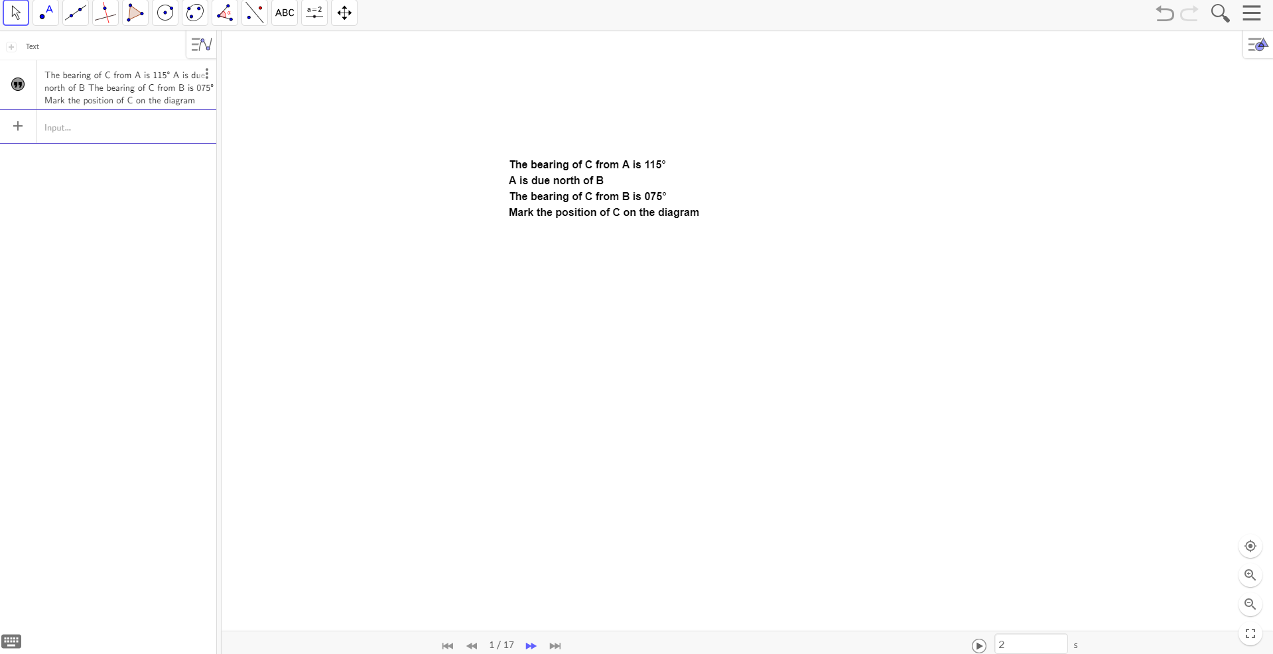  Optional: This would be a good opportunity for learners to get out and work with bearings. For this you will need a map of the school or local area and a set of compasses. Provide learners with a series of bearings that describe a route they need to follow using the map. To check progress, you may want to provide clues at certain points on the route that learners need to collect. You may need additional support for this in case learners get lost, or find it difficult to follow a route unsupported. If you are not experienced using a map and compass, and have colleagues who use maps and compasses regularly, you might want to ask them to support you with this activity. You could use this video to help you demonstrate how to use a map and a compass to get around.  https://www.youtube.com/watch?v=rZd0RfsC-9I  You could do a simpler version of this activity by using the template in this pack (Worksheet 2e: Outdoor navigation template). Using this template you can provide learners with a set of instructions to walk a series of bearings. Again, you could place an item or a clue at the middle and end of the route to check if they have followed the bearings correctly. You can support or challenge learners by the number of steps you include and / or the complexity of the steps. Learners could also design their own routes and try them out on each other. This could be used as a basis for a quite complex treasure hunt depending on the students you are working with.  Optional: if you don’t have the facility and/or support to enable learners to explore using a compass bearing in real life you could use either of these two activities as an alternative.:  Bearings Crime Scene https://www.tes.com/teaching-resource/bearings-crime-scene-6289743  You could use this interactive activity Air Traffic Control: which gives learners the opportunity to decide which aircraft are in danger of colliding from their positions and direction of travel. This is an exercise which introduces another real-life application of bearings where a lack of consistency in how they are expressed could have catastrophic consequences:  https://www.transum.org/Software/SW/Starter_of_the_day/Similar.asp?ID_Topic=6  There is a similar activity available in the Geogebra file Lesson2_Air_traffic_controller_bearings.ggb in the resources. There are also a set of cards Worksheet 2f: Air traffic control cards that can be used as a hardcopy version of this activity (more examples like that on the cards can be created using the Geogebra file above). Slides 16 and 17 are optional slides you can use to demonstrate the principle behind the GeoGebra file and/or the cards.
 | Plenary  Slide 18 introduces a simple bearings problem that relies on the basic trigonometric ratios to solve it. Allow learners time to work on the problem before using Slide 18 to draw their ideas together. This will conclude the work on bearings for some learners, but will prepare other learners for the use of trigonometry to solve bearings problems in the next lesson.

Lesson 3: Trigonometry and bearings
Resources |  | - Whiteboard  - Lesson 3: Trigonometry and bearings presentation  - Video: Bearings and trigonometry  - Worksheet 3a.
Learning objectives |  | By the end of the lesson:  - all learners should be able to draw diagrams to help solve bearings problems  - most learners should be able to use the sine and cosine rule to solve multistep bearings problems  - some learners will be able to analyse and predict potential errors in multistep bearings problems.
Timings | Activity
Starter/Introduction
Teach this lesson using Lesson 3: Trigonometry and bearings presentation.
Slide 2 Ask learners to revisit the problem they met at the end of lesson 2. Ask them:
- What is special about the triangle you drew for this problem?
- How did this help you to solve the problem?

Make sure that they appreciate it is a right-angled triangle and that the basic trigonometric ratios, Sine, Cosine and Tangent, are sufficient to solve this problem because it is based on a right-angled triangle.
 | Main lesson  Show your learners Slide 3 this introduces an example of the type of multistep problems we will be looking at in this lesson. Bearings problems that involve more than one step can be approached in the same way you would approach any problem involving non-right-angled triangles. Tell learners that is what we are going to look at in this lesson.  For this type of problem learners will need to be confident using the sine and cosine rules. Slide 4 reminds learners of the criteria for using each of these rules.  Optional: if you wish to remind learners about these rules you can use these links:  https://www.mathsisfun.com/algebra/trig-sine-law.html  https://www.mathsisfun.com/algebra/trig-cosine-law.html  The main teaching element of this lesson is the Video: bearings and trigonometry which demonstrates for learners, using an example, how to use the sine and cosine rules to solve multistep bearings problems.  Having looked at the video example, emphasise with learners how important it is to be systematic in the way that you approach this type of multistep problem, and that it can be easy to make mistakes if you are not clear in the way you present your solution, and the way you explain your workings.  Introduce Worksheet 3a: Bearings and trigonometry exam questions. Learners should work through the first 4 questions which are all past exam questions. Once they have completed the first 4 questions they can work collaboratively in small groups to mark each other’s work using the official mark scheme provided. You may want to take a little time to explain how the mark scheme works, you could mark an example as a class using a visualiser if one is available. Learners should also look at the examiner’s report, and consider whether any of the mistakes and misconceptions identified by the examiner are apparent in any of the groups examples. You may want to discuss the difference between a mistake and a misconception. You will also need to be happy that there will be a supportive atmosphere within the group when marking each other’s work.  There are more past paper questions to check your learners’ understanding of this topic. Use Test Maker to use these additional questions.  Optional: to support learners who might struggle to complete the questions on this worksheet, you could provide partially completed solutions and/or exemplars, that demonstrate some of the mistakes and misconceptions identified by examiners. Learners could mark these either instead of completing the questions themselves, or as a precursor to answering the remaining questions independently. Over time you could also collect exemplars from learners that you could use as exemplars.  Extension: learners could be asked to produce their own example questions complete with mark scheme and suggested examiners report.
Plenary
Once learners have completed the marking process for the first 4 questions on
Worksheet 3a: bearings and trigonometry exam questions ask them to reflect on any key learning points from this process. Take feedback. Learners can then complete question 5, making sure that they avoid any of the mistakes or misconceptions they have identified, and that they present their solutions in a way that will maximise marks.

Worksheets and answers

 | Worksheets | Answers
For use in Lesson 1:
1a: Angle facts | 16-17 | 30-31
For use in Lesson 2:
2a: Missing angles | 18 | 32
2b: 16-Point Compass | 19 | 33
2c: Pelmanism game of 16-point compass | 20
2d: Writing and estimating bearings | 21 | 34
2e: Outdoor navigation template | 22
2f: Air traffic control cards | 23-24 | 35-36
For use in Lesson 3:
3a: Bearings and trigonometry exam questions | 25-29 | 37-41


Worksheet 1a: Angle facts
You may want to use any or all of these angle facts to solve these problems:
- Angle sum of a triangle = 180°.
- Sum of angles at a point on a straight line = 180°
- Sum of angles at a point = 360°
- Vertically opposite angles are equal
- Pairs of corresponding angles on parallel lines are equal
- Pairs of alternate angles on parallel lines are equal
- Angles opposite the equal sides of an isosceles triangle are equal
- In a triangle with two equal angles, the sides opposite the equal angles are equal and the triangle is isosceles.
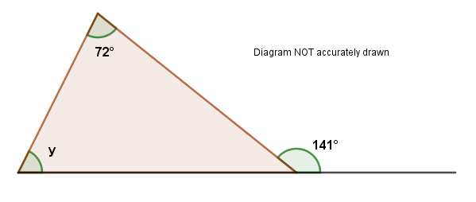
- Work out the size of the angle marked y giving your reasons for your answer.

- CalculateLKM and MNO making sure you explain what you are doing, and the angle facts you are using.
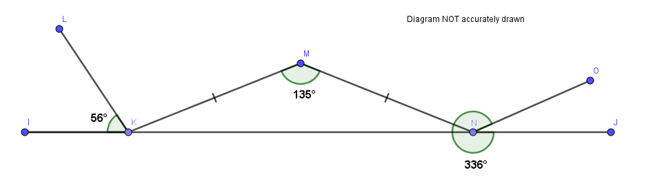

Worksheet 1a: Angle facts continued
- Find the values of x, y and z making sure you explain what you are doing in the angle facts you are using.
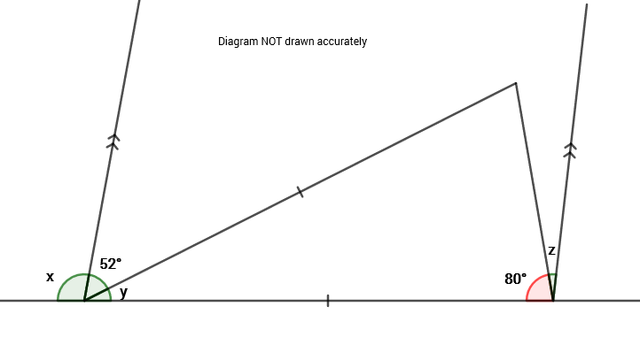

- Find the value of x in the diagram.

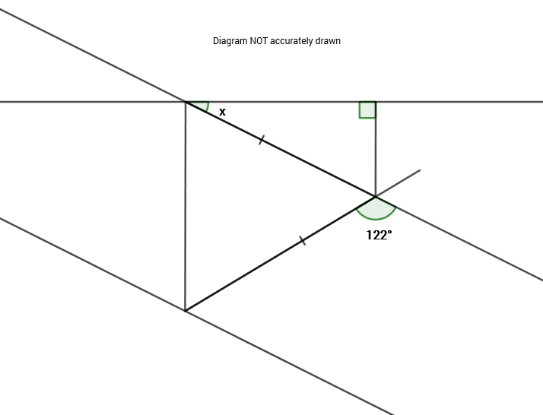

Worksheet 2a: Missing angles
Find the missing angles. Make sure you explain each step using the information on the diagram and the angle facts you met in the last lesson, and any other angle facts you might know

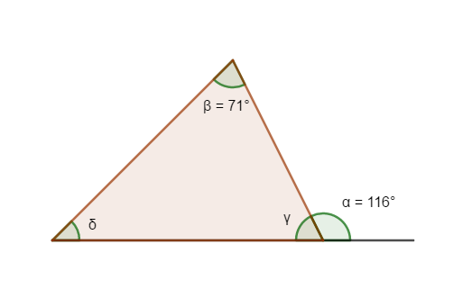

Worksheet 2b: 16 Point Compass
Use the logic introduced in the presentation to name each of the remaining points on the 16-point compass below. Then calculate the bearing for each of these points

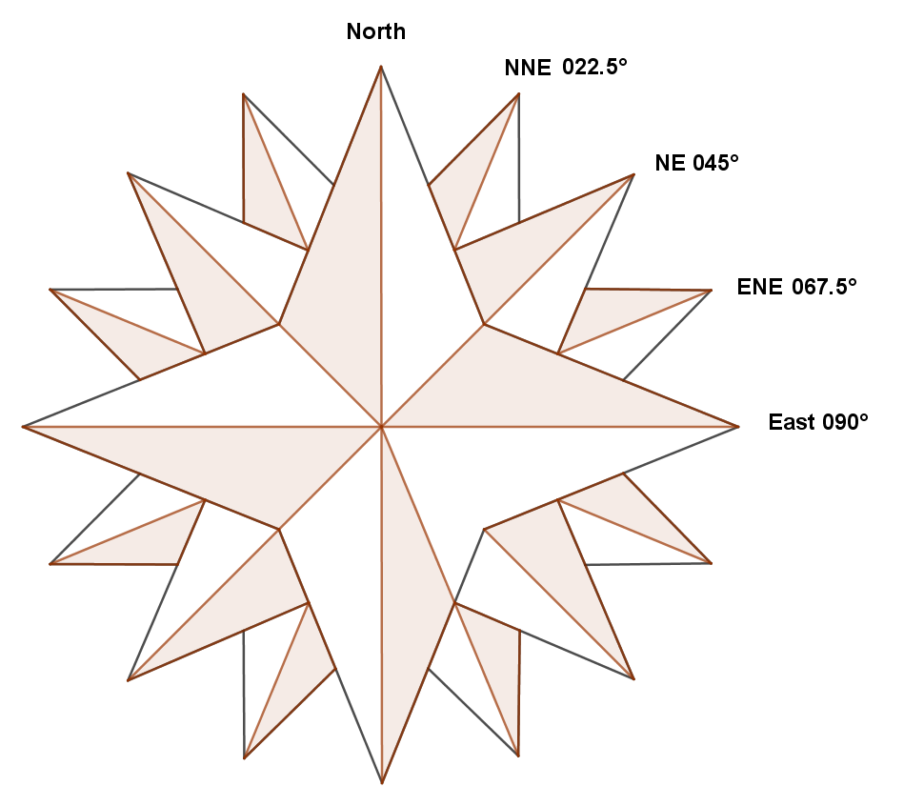

Worksheet 2c: Pelmanism game of 16-point compass
North | 000˚
North-northeast | 022.5˚
Northeast | 045˚
East-northeast | 067.5˚
East | 090˚
East-southeast | 112.5˚
Southeast | 135˚
South-southeast | 157.5˚
South | 180˚
South-southwest | 202.5˚
Southwest | 225˚
West-southwest | 247.5˚
West | 270˚
West-northwest | 292.5˚
Northwest | 315˚
North-northwest | 337.5˚
North | 360˚

Worksheet 2d: Writing and estimating bearings
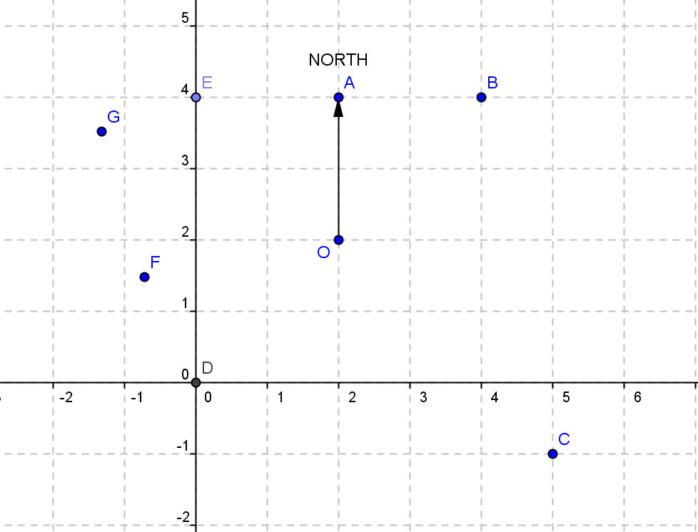
Use the diagram and the facts you already know to work out the bearings to points C, D, and E.
ALL angles should be measured clockwise from NORTH. Link each one to a point on the 16-point compass.

Worksheet 2e: Outdoor navigation template
Name of team

_____________________________________________________________

Starting location_______________________________________________________

- GO _______________ steps on a bearing of_______________________

- GO _______________ steps on a bearing of_______________________

- GO _______________ steps on a bearing of_______________________
Halfway location_______________________________________________________

- _______________ steps on a bearing of__________________________

- _______________ steps on a bearing of__________________________

- _______________ steps on a bearing of__________________________

Finishing location______________________________________________________
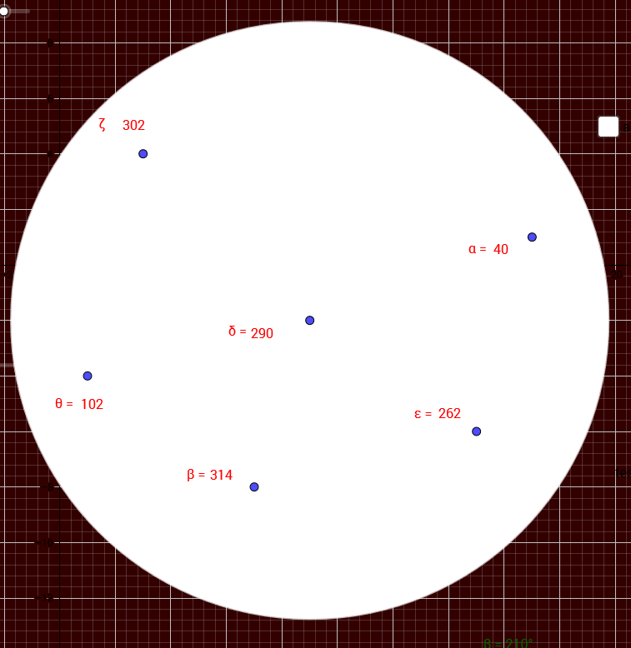
Worksheet 2f: Air traffic control cards
Case 1

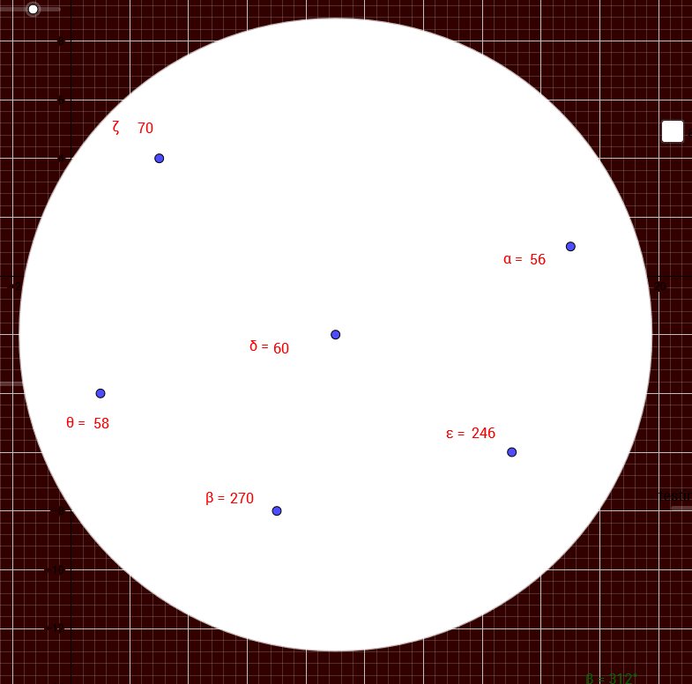
Case 2

Worksheet 2f: Air traffic control cards continued
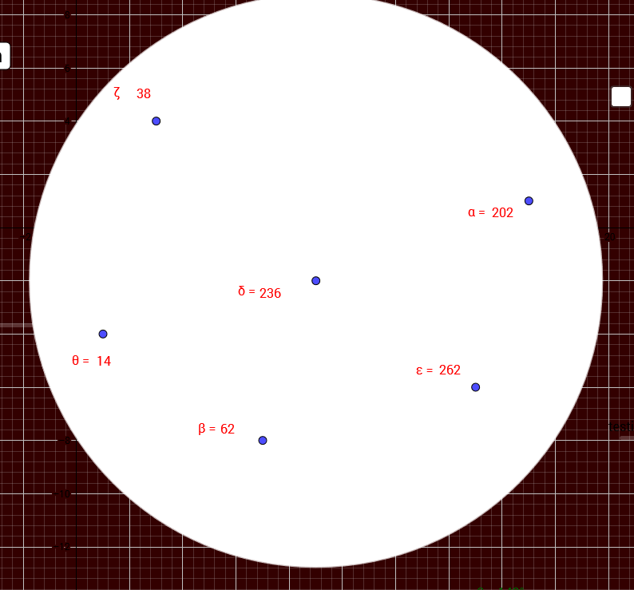
Case 3

Worksheet 3a: Bearings and trigonometry exam questions
Use the angle facts you know and trigonometry to solve these exam style questions. Make sure you explain what you are doing at each step and relate your explanations to the relevant point in the diagram whenever necessary.

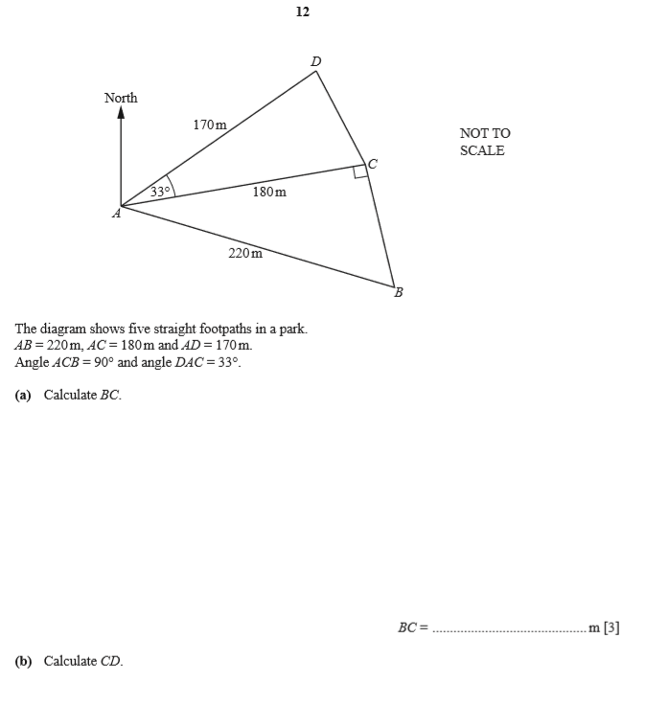

Worksheet 3a: Bearings and trigonometry exam questions

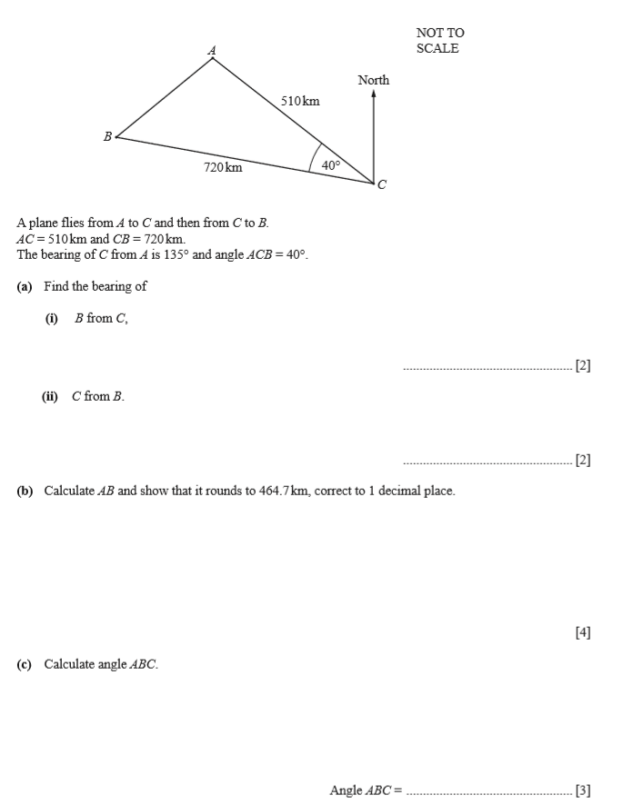

Worksheet 3a: Bearings and trigonometry exam questions

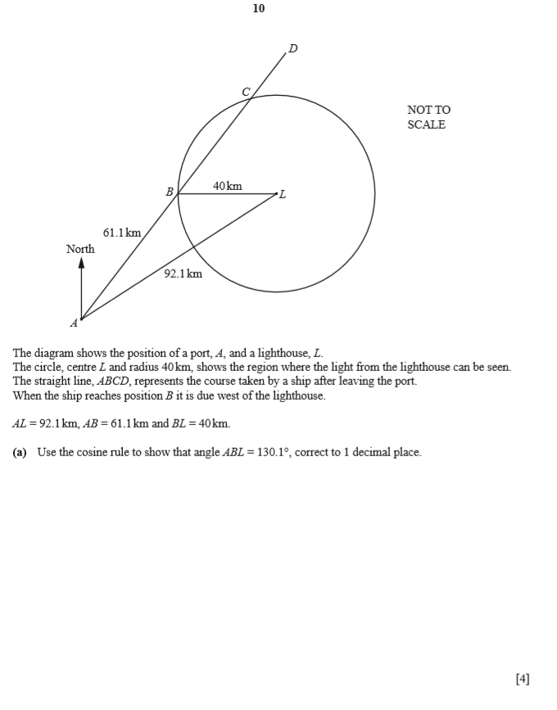

Worksheet 3a: Bearings and trigonometry exam questions
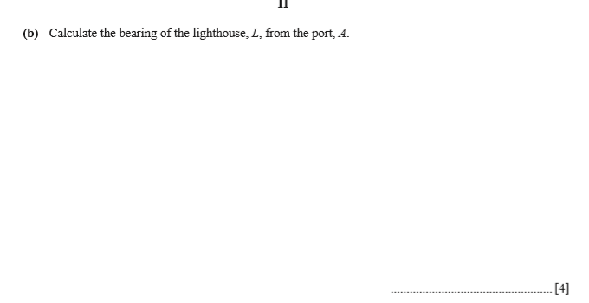
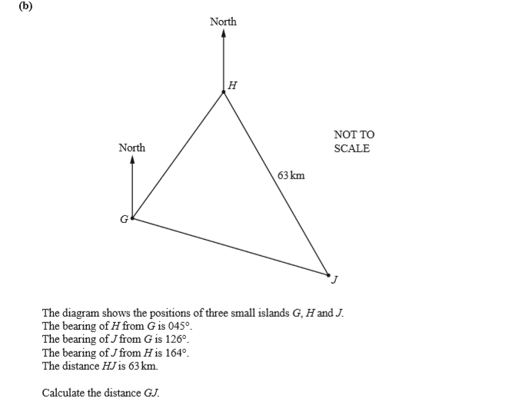

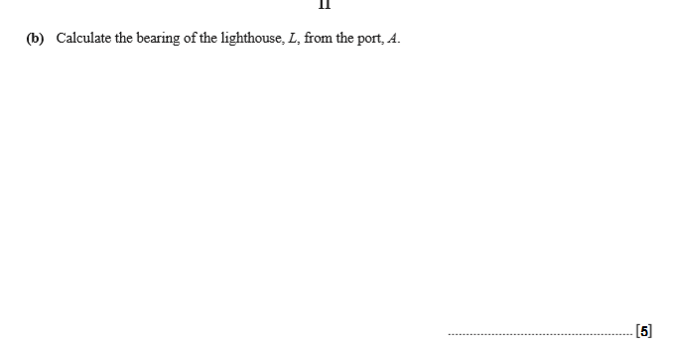
Worksheet 3a: Bearings and trigonometry exam questions

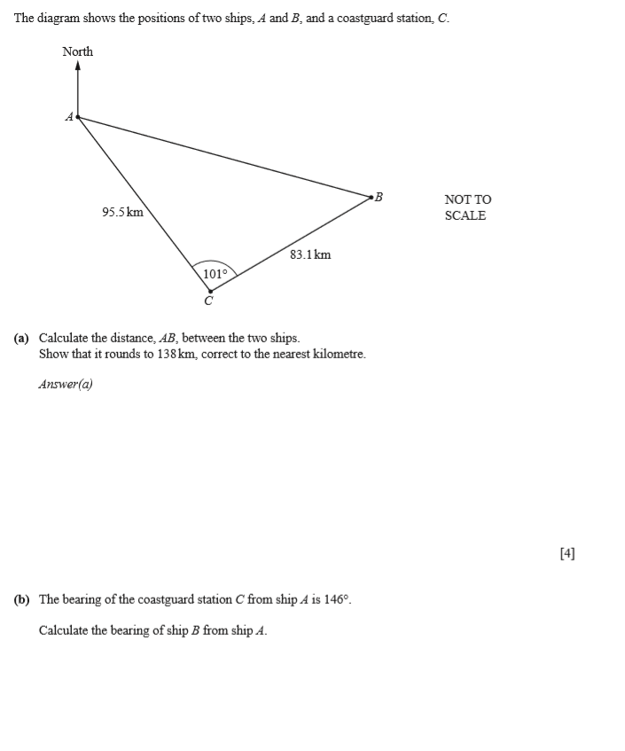

Worksheet 1a: answers
- Work out the size of the angle marked y giving your reasons for your answer
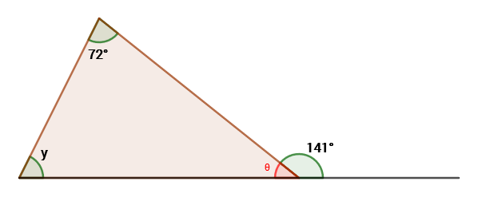
θ = 180° – 141°
Sum of angles at a point on a straight line.
θ = 39°

θ + y + 72° = 180°
Angle sum of a triangle
y = 180° – (39° + 72°)
y = 69°

- CalculateLKM and MNO making sure you explain what you are doing and the angle facts you are using.
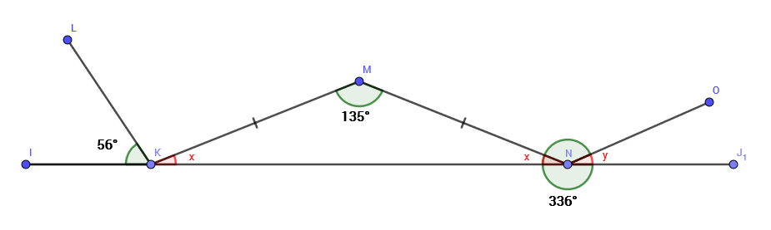
y = 360° – 336°
Sum of angles at a point = 360°
y = 24°

180° = LKM + 56° + 22°
Sum of angles at a point on a straight line = 180°
LKM = 180° – (56° + 22°)
LKM = 102°
MNO = 360° – (22° + 24° + 180°)
Sum of angles at a point & sum of angles at a point on a straight line.
MNO = 134°
Triangle KMN is an isosceles triangle so:
2x + 136° = 180° Angle sum of a triangle
x = $\frac{\text{180-136}}{\text{2}}$
x = 22°

Worksheet 1a: answers continued
- Find the values of XY and Z making sure you explain what you are doing in the angle facts you are using.
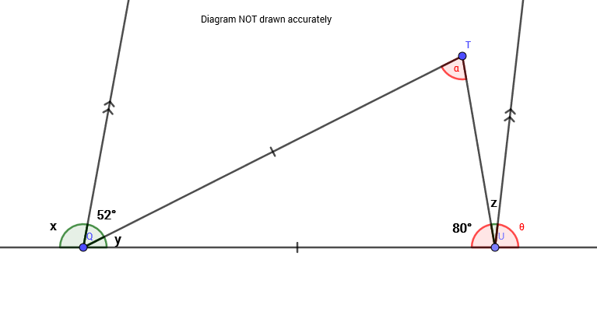
x + 52 + y = 180
Sum of angles at a point on a straight line
x = 180 – (52 + 20)
x = 108°
The triangle is an isosceles triangle so α is also equal to 80°
y + 2 × 80 = 180
Angles sum of a triangle
y = 180 – 160
y = 20°

θ = 52 + y
Corresponding angles on parallel lines.
θ = 52 + 20
θ = 72°
z = 180 – (80 + θ)
z = 180 – 152
z = 28°

- Find the value of x in the diagram.

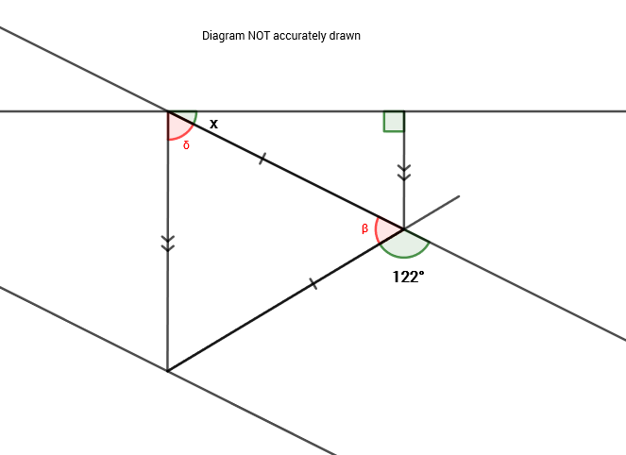
x + δ = 90° Right angle
x = 90 – 61
x = 29°

122 + β = 180
Sum of angles at a point on a straight line
β = 58°

The triangle is an isosceles triangle
2δ + β = 180
Angles sum of a triangle
δ = $\frac{\text{180-58}}{\text{2}}$
δ = 61°

Worksheet 2a: answers
3. In the diagram, we also see that:
δ + β + γ = 180° (angles sum of a triangle)
1. In the diagram we see that
α + γ = 180° (Sum of angles at a point on a straight line).
5. Therefore the missing angle are:
γ = 64°
δ = 45°
4. So δ + β + γ = 180°
Becomes:
δ + 71 + 64 = 180°
Rearranging gives:
δ = 180 – 135
δ = 45°
2. We know from the diagram that β = 71˚ and we also now know that γ = 64˚
We also know that α = 116° so rearranging this we get:
γ = 180 – 116
γ = 64°

Worksheet 2b: answers

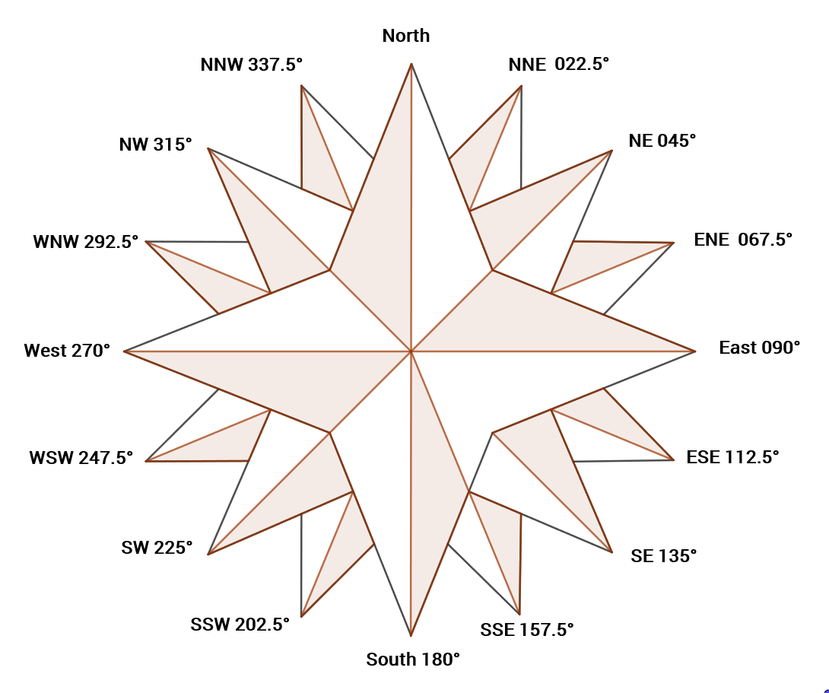

Worksheet 2d : Answers
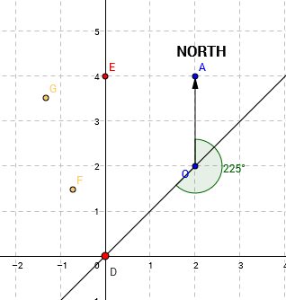
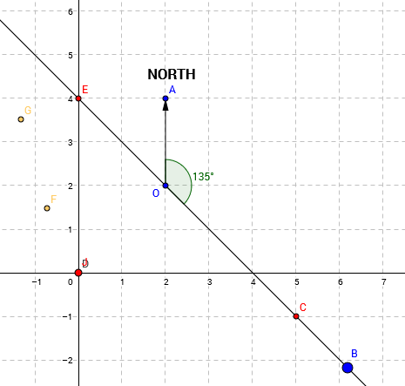

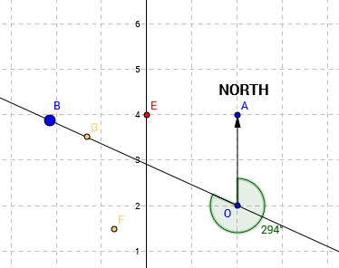
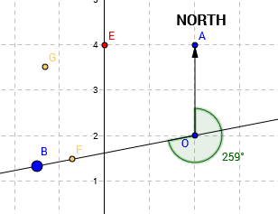

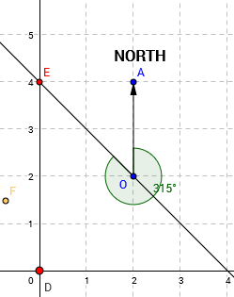

Worksheet 2f : Answers
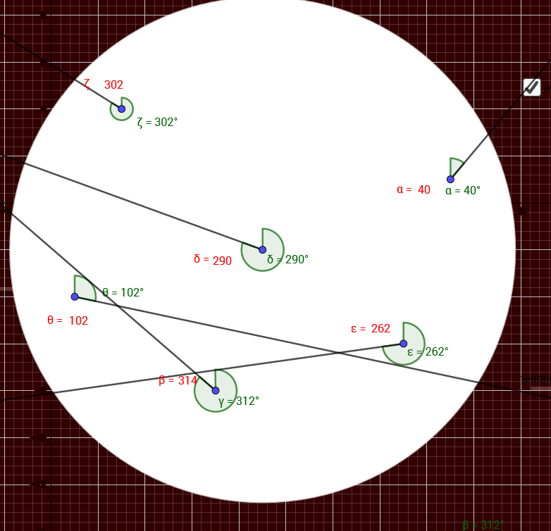
Case 1

In this case the projections from γ and θ, γ and ε and also ε and θ all cross. However, the line lengths are quite different, so they will not be at the same point at the same time.
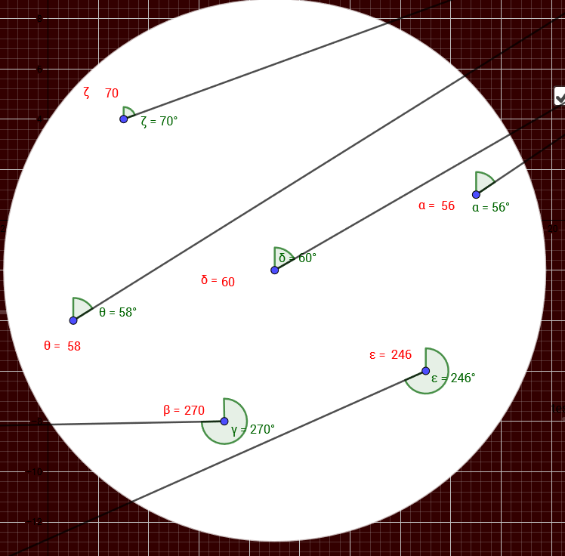
Case 2

In this case none of the lines cross so there is no chance of a collision

Worksheet 2f : Answers continued
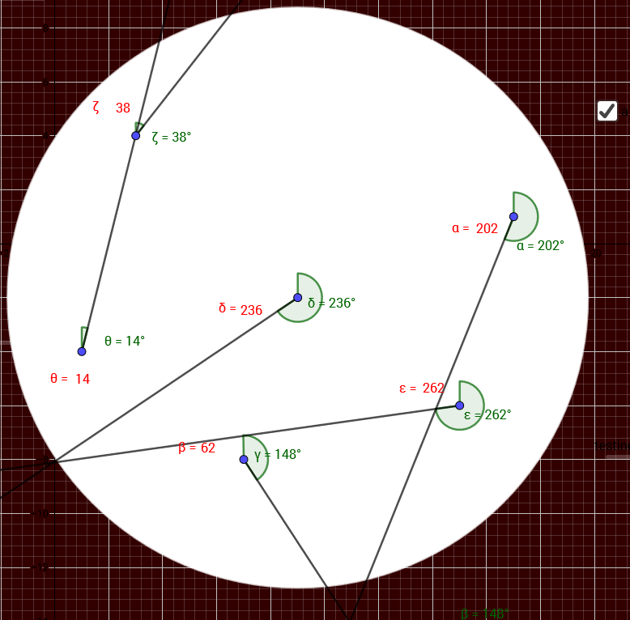
Case 3

The projections from δ and ε meet at the edge of the screen. In this case the lines are of a similar length so assuming the aircraft are travelling at similar, but not necessarily the same speed, there is a risk of them colliding and therefore action may be recommended.

Worksheet 3a: answers
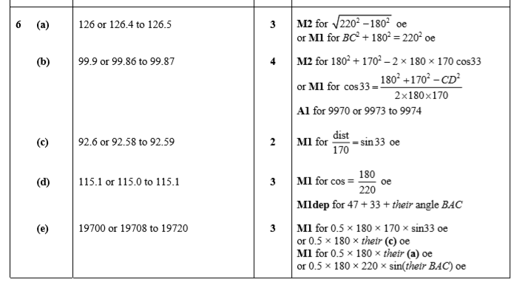
Question 1
(a) This was usually attempted correctly using Pythagoras’ theorem, although some candidates applied this incorrectly by adding the squares of the sides. Some used right-angled trigonometry to calculate either angle BAC or angle ABC and then further trigonometry to calculate BC. After a correct answer of 126.49 it was quite common to see this rounded to 126.5 and then to 127. Some candidates only wrote down their 3 figures answer; if they gave 126 this was accepted but 127 only seen lost the accuracy mark.
(b) This involved a straightforward use of the cosine rule and it was generally well done. Less able candidates often could not recall the correct formula or, having earned the method marks for correct substitution into the cosine rule, could not then process to the solution correctly. A very common processing error was to get as far as CD² = 61300 – 61200cos33 and then write
CD² = 100cos33. Other errors made included using right-angled trigonometry assuming angle ACD was 90º or using a mixture of side lengths from 170, 180 and 220.
(c) Many candidates found this part challenging as they did not understand that the shortest distance from D to AC is the perpendicular distance from D to AC. Most candidates who understood the idea of dropping the perpendicular from D to AC found this part straightforward. However candidates who had assumed angle ACD was 90º in the previous part inevitably then gave their answer for part (b) here.
(d) Many candidates answered this correctly but some were unsure which angle was required for the bearing and so made little progress. Although some candidates found angle BAC using cos BAC = 180 ÷ 220, many used the length of BC found in part (a) and used it with either sin or tan, frequently arriving at an inaccurate value as a result of using either 126 or 127, rather than a more accurate value for BC.

Worksheet 3a: answers continued
(e) There were many candidates who found the area of the two triangles correctly. There were some who used their calculated values from parts (a) and (b) in the wrong triangle and CD was quite often used as the height of ACD. The area formula A = ½absinC was sometimes applied incorrectly with C not being the included angle. A few candidates treated ABCD as a triangle and attempted to find the area using ½×220×170×sin DAB. Those who used ½×170×180sin 33+ ½x180xtheir BC were most frequently within range for the total area. However the use of rounded values from previous calculations often meant that, although the method for individual areas was correct, the final answer reached was outside the acceptable range.

Question 2
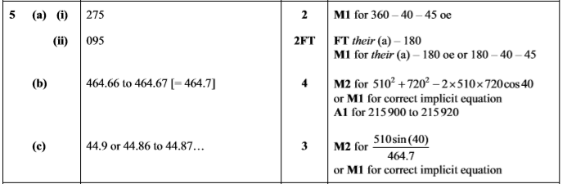
(a)(i) Some candidates seemed to be unfamiliar with bearings as many did not appreciate that the answer here should be greater than 270º. The marking of appropriate angles on the diagram was rarely seen. Many candidates stopped after 40 + 45 = 85 or 180 – 4- - 45 = 95.
(a) (ii) The correct answer of 095º was seen by only the most able candidates.
(b) Most candidates correctly applied the cosine rule, but some did not give enough accuracy in the working to justify the answer rounded to 464.7. A small number of candidates drew the perpendicular from A onto BC and used Pythagoras’ theorem in the two right-angled triangles and if enough accuracy was maintained throughout the working, their solution was correct. Some candidates used the sine rule to find angle BAC first, but did not consider the possibility that it was an obtuse angle and consequently their final answer for AB was inaccurate.
(c) Most candidates applied the sine rule correctly, but again the accuracy in the working became an issue for many as premature rounding led to answers of 44.8º or 45º.

Worksheet 3a: answers continued
Question 3
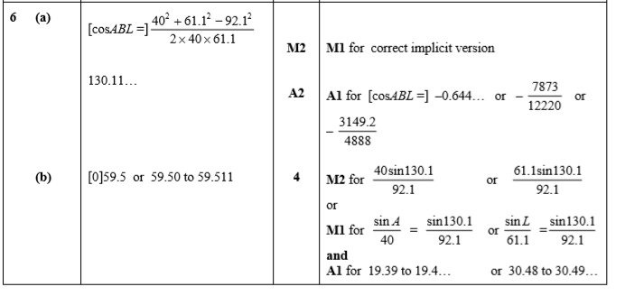
(a) Many candidates were familiar with the cosine rule and made good attempts to find the required angle. Most started with the explicit version of the cosine rule but those starting with the implicit version were more prone to errors when rearranging. A very frequent error was omitting to show the required angle to more than one decimal place after otherwise correct working. Premature approximation with values in the working often led to inaccurate answers.
(b) More able candidates were successful in this part but less able candidates found this more challenging. The cosine rule and the sine rule were widely used to find angle BLA or angle BAL. Several of those who obtained a correct value for their angle were unable to continue and find the correct bearing angle. Premature approximation with values in the working often led to inaccurate answers.
Question 4
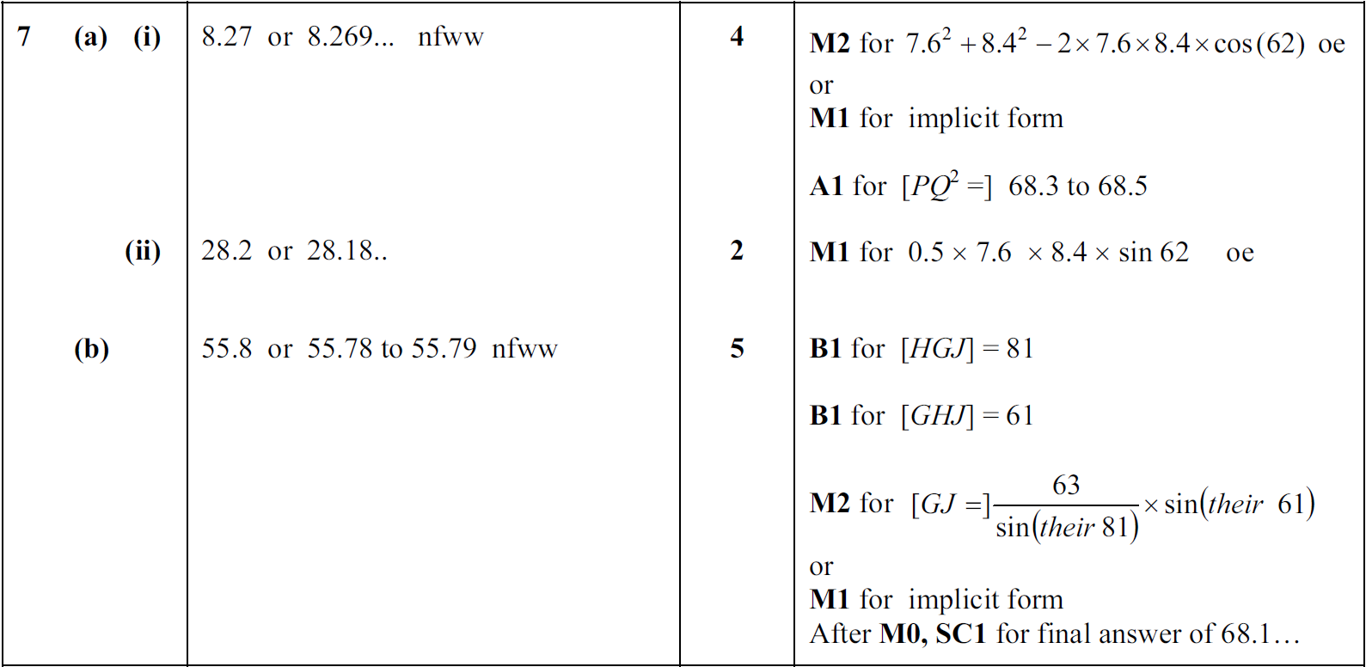
Worksheet 3a: answers continued
(a) (i) Most candidates were able to start the cosine rule correctly. Some candidates misquoted the rule, some were missing the 2, + instead of – and the use of sine instead of cosine. When the formula was correct there were two common errors. Some gave their final answer as 8.3 and did not show a more accurate value and some gave an incorrect value of PQ² after prematurely approximating the value of cos 62 to too few figures. Some of the less able candidates used right-angled trigonometry (dividing 7.6 by 2 ), the sine rule or Pythagoras’ theorem.
(ii) The area of the triangle was usually correctly calculated. A few candidates decided to calculate the perpendicular height first. Some introduced errors by unnecessarily working with inaccurate or incorrect values calculated in part (i).
(b) A lot of candidates struggled to find the angles they needed to solve the problem. Some attempted to put parallel north lines through the diagram but were unable to find the one angle they needed from this. A very common error was treating angle HGJ as 126°. Where candidates were able to find the necessary angles most realised they needed to use the sine rule and quoted it correctly with their angles. Having quoted a correct version of the sine rule some struggled to rearrange it correctly to find GJ.
Question 5
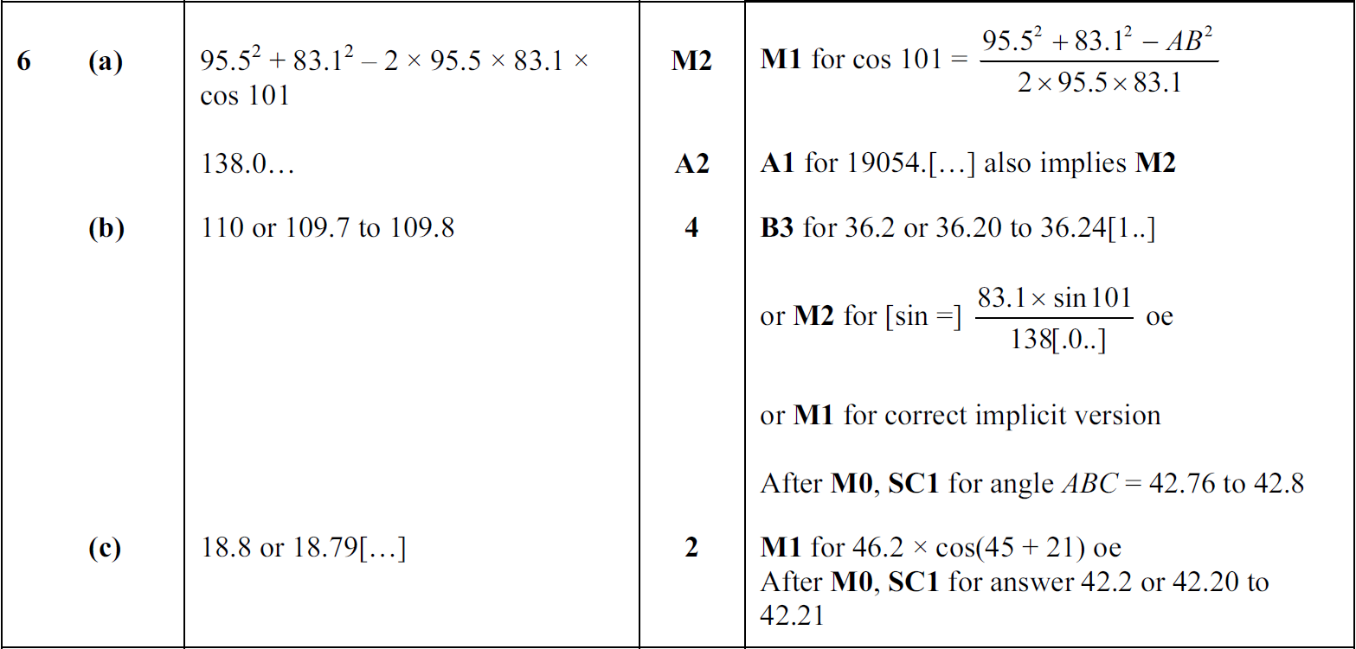
This question on using general trigonometry was answered well by many candidates who were well prepared for the use of the cosine rule and sine rule.

(a) Almost all candidates quoted the appropriate version of the cosine rule needed to find the distance AB directly, made the necessary substitutions and carried out the calculations accurately. Not all candidates showed an intermediate step and it was advisable to show at least an accurate value of AB², for example 19054. Some candidates, following the substitutions, only then gave a final answer of 138, given in the question. To earn full marks in this type of question it is essential to give an answer that is more accurate than that given in the question. So in this case an answer
such as 138.0 or 138.04 was sufficient.

Worksheet 3a: answers continued
(b) This was also answered very well with candidates applying the sine rule correctly to find
angle BAC. As in the previous part it was advisable to write down the answer to this to at least three significant figures before going on to find the bearing. Most candidates calculated the bearing correctly with just a few making an error such as adding the answer for angle BAC to 146°. Some worked out angle ABC instead of angle BAC but most realised which angle it was so were able to complete a longer correct calculation to find the bearing. Some only reached 36.2° and others subtracted from 180° instead of 146°.

(c) Candidates found this part challenging. Very few drew a line from L perpendicular to the direction in which the ship is sailing in order to give the right-angled triangle needed. One error was to draw a line from L to the end of the line giving the direction the ship is sailing and others used a triangle with an angle of 45°. Those that were able to identify the appropriate triangle sometimes calculated the distance from L rather than the distance that the ship had sailed.

Cambridge Assessment International Education
The Triangle Building, Shaftsbury Road, Cambridge, CB2 8EA, United Kingdom
t: +44 1223 553554
e: info@cambridgeinternational.org www.cambridgeinternational.org

© Cambridge University Press & Assessment 2024

