

Teaching Pack
Straight line graphs
Cambridge IGCSE™
Mathematics 0580

This Teaching Pack can also be used with the following syllabuses:
• Cambridge IGCSE™ (9–1) Mathematics 0980
• Cambridge IGCSE™ International Mathematics 0607
• Cambridge O Level Mathematics 4024

© Cambridge University Press & Assessment 2024
Cambridge Assessment International Education is part of Cambridge University Press & Assessment. Cambridge University Press & Assessment is a department of the University of Cambridge.

Cambridge University Press & Assessment retains the copyright on all its publications. Registered centres are permitted to copy material from this booklet for their own internal use. However, we cannot give permission to centres to photocopy any material that is acknowledged to a third party even for internal use within a centre.
Contents
Contents 3
Introduction 4
Skill: Straight line graphs 5
Common misconceptions: Straight line graphs 7
Lesson 1: Find the gradient of a straight line 8
Lesson 2: Interpret and obtain the equation of a straight line graph 11
Lesson 3: Determine the equation of a straight line parallel to a given line 13
Lesson 4: Find the gradient of parallel and perpendicular lines 15
Worksheets and answers 18

Icons used in this pack:
 | Lesson
 | Video
 | Assessment opportunity

Introduction
This pack will help you to develop your learners’ mathematical skills as defined by assessment objective 1 (AO1 Knowledge and understanding of mathematical techniques) in the course syllabus.

Important note
Our Teaching Packs have been written by classroom teachers to help you deliver topics and skills that can be challenging. Use these materials to supplement your teaching and engage your learners. You can also use them to help you create lesson plans for other skills.

This content is designed to give you and your learners the chance to explore mathematical skills. It is not intended as specific practice for exam papers.

This is one of a range of Teaching Packs. Each pack is based on one mathematical topic with a focus on specific mathematical techniques. The packs can be used in any order to suit your teaching sequence.

In this pack you will find the lesson plans and worksheets you will need to successfully complete the teaching of this mathematical skill.

Skill: Straight line graphs
This Teaching Pack links to the following syllabus content (see syllabus for detail):
- C3.2 Find the gradient of a straight line.
- E3.2 Find the gradient of a straight line. Calculate the gradient of a straight line from the coordinates of two points on it.
- C3.4 Interpret and obtain the equation of a straight-line graph in the form y = mx + c.
- E3.4 Interpret and obtain the equation of a straight-line graph.
- C3.5 Determine the equation of a straight line parallel to a given line.
- E3.5 Determine the equation of a straight line parallel to a given line.
- E3.6 Find the gradient of parallel and perpendicular lines.

For assessments from 2025
- C3.3 Find the gradient of a straight line.
- E3.3 Find the gradient of a straight line.
Calculate the gradient of a straight line from the coordinates of two points on it.
- C3.5 Interpret and obtain the equation of a straight-line graph in the form y = mx + c.
- E3.5 Interpret and obtain the equation of a straight line graph.
- C/E3.6 Find the gradient and equation of a straight line parallel to a given line.
- E3.7 Find the gradient and equation of a straight line perpendicular to a given line.

The pack covers the following mathematical skills, adapted from AO1: Demonstrate knowledge and understanding of mathematical techniques (see syllabus for assessment objectives):
- organising, processing and presenting information accurately in written, tabular, graphical and diagrammatic forms
- performing calculations and procedures by suitable methods, including using a calculator.

For assessments from 2025
AO1: Knowledge and understanding of mathematical techniques
- organise, process, present and understand information in written form, tables, graphs and diagrams
- performing calculations with and without a calculator.

Prior knowledge
Knowledge from the following syllabus topics is useful for the development of skills in this topic.
- C3.1/E3.1 Demonstrate familiarity with Cartesian coordinates in two dimensions.
- C2.1 ... Substitute numbers for words and letters in formulae. Rearrange simple formulae ...
- C2.11 Construct tables of values for functions of the form ax + b ... where a and b are integer constants. Draw and interpret these graphs.
- E2.11 Construct tables of values and draw graphs for functions of the form ax^{n} ... Limited to cases where n = 1 for this unit of work.
- E1.1 Identify and use ... reciprocals.

For assessments from 2025
- C/E3.1 Use and interpret Cartesian coordinates in two dimensions.
- C/E2.1 Know that letters can be used to represent generalised numbers.
Substitute numbers into expressions and formulas.
- C/E2.5 Change the subject of simple formulas.
- C2.10 Construct tables of values, and draw, recognise and interpret graphs for functions form ax + b ... where a and b are integer constants.
- E2.10 Construct tables of values and draw, recognise and interpret graphs for functions of the form ax^{n} ... Limited to cases where n = 1 for this unit of work.
- C/E1.1 Identify and use ... reciprocals.

Going forward
The knowledge and skills gained from this Teaching Pack can be used for when you teach learners about:

- C1.11 Demonstrate an understanding of ratio and proportion. Calculate average speed. Use common measures of rate
- E1.11 Demonstrate an understanding of ratio and proportion. Increase and decrease a quantity by a given ratio. Calculate average speed. Use common measures of rate.
- C2.10 Interpret and use graphs in practical situations including travel graphs and conversion graphs. Draw graphs from given data.
- E2.10 Interpret and use graphs in practical situations including travel graphs and conversion graphs. Draw graphs from given data. Apply the idea of rate of change to simple kinematics involving distance–time and speed–time graphs, acceleration and deceleration.
- E2.12 Estimate gradients of curves by drawing tangents.

For assessments from 2025
- C/E1.11 Understand and use ratio and proportion to:
  - give ratios in their simplest form
  - divide a quantity in a given ratio
  - use proportional reasoning and ratios in context
- C/E1.12 Use common measures of rate.
Apply other measures of rate.
Solve problems involving average speed.
- C2.9 Use and interpret graphs in practical situations including travel graphs and conversion graphs.
Draw graphs from given data.
- E2.9 Use and interpret graphs in practical situations including travel graphs and conversion graphs.
Draw graphs from given data.
Apply the idea of rate of change to simple kinematics involving distance–time and speed–time graphs, acceleration and deceleration.
- E2.12 Estimate gradients of curves by drawing tangents.

Before you begin

This Teaching Pack includes a Teacher Introduction video to which you should refer
before using the resources in this pack. The video is available to watch in Resource Plus within the unit relevant to this Teaching Pack.

The video introduces the resources available for teaching these topics, and explains how they can be used to successfully deliver the topics to your learners. In particular, the video highlights typical learner misconceptions and common errors this Teaching Pack will help you to overcome.

Common misconceptions: Straight line graphs
In some contexts, e.g. road signs, gradients are written as percentages or ratios (e.g. ‘1 in 5’). They do not use positive and negative symbols. Learners need to be aware how gradients are written in maths and that the convention is to use fractions or decimals for non-integer gradients.
When working with gradients, a common error is to count squares rather than finding change in y and change in x. This only gives the correct gradient if the scales on the x and y axes are the same. You can help to address this by ensuring that learners see a variety of scales.
Inconsistent substitution in the gradient formula is a common error e.g. m = (y₂−y₁)/(x₁−x₂) rather than m = (y₂−y₁)/(x₂−x₁)
Depending on the context of the graph, the gradient may be interpreted as the slope of the line. It may instead be interpreted as a rate, for example when working with conversion graphs, distance–time and speed–time graphs.
When working with straight lines, learners often fail to rearrange the equation into y = mx + c form before attempting to identify the gradient and intercept. Another common error is thinking that m is the intercept and c is the gradient.
Learners often fail to appreciate that a straight-line graph is simply a diagram representing the equation of the straight line. Consequently, learners often do not understand that x and y in the equation can represent a pair of coordinates on the graph. They may not realise that any pair of coordinates can be substituted for x and y.
When using graphing software to introduce any of these concepts, it is helpful to use the same scales on the x and y axes. This is particularly important when working with perpendicular lines, otherwise the lines will not look perpendicular. You may wish to show learners some examples using different scales on the x and y axes.

Lesson 1: Find the gradient of a straight line

Resources |  | - Whiteboard  - Lesson 1a: What is gradient? presentation  - Lesson 1b: Finding the gradient presentation  - Lesson 1c: Bingo presentation  - Lesson 1d: What went wrong? presentation  - Worksheets 1a, 1b.
Learning objectives |  | By the end of the lesson:  - all learners should be able to find the gradient of a straight line  - some learners will be able to calculate the gradient of a straight line from the coordinates of two points on it.
Timings | Activity
 | Starter/Introduction  Which is steepest? Use Worksheet 1a, a short activity where learners plot points and join them with straight lines. Then they compare the slope of their lines. Note that the final question has two lines with the same gradient but different lengths. This lesson should be non-calculator throughout.  This is a good opportunity to check familiarity with Cartesian coordinates in two dimensions. You can use targeted questioning during a short discussion to check what the learners already know about gradients.
 | Main lesson  Start by showing your learners the Lesson 1a: What is gradient? presentation.  Then move on to finding the gradient using the Lesson 1b: Finding the gradient presentation.  Work through a variety of cases:  - Basic questions with the same scale on x and y axes:  - Consider positive and negative gradients  - Where do we measure? Show learners that rise over run can be measured between any two points on the line. For convenience we choose points where it is easy to read off values  - Move on to examples where the scales on x and y are different. Emphasise the importance of reading from the scales to find rise over run, not making the common error of ‘counting squares’  - Horizontal lines  - Vertical lines. Note that a common error is to say that the gradient is ‘infinite’. Since the change in x is zero, the gradient of a vertical line is ‘undefined’.  - Gradients from two pairs of coordinates.  You may wish to give learners mini whiteboards or sheets of paper on which they can work out and write answers during this section of the lesson. They can hold these up to show you. This ensures that the learners remain involved and allows you to check their understanding.  Note that the presentation has a lot of examples. There are links to the next slide so you can choose which questions to use.  Next, use the Bingo game activity in the Lesson 1c: Gradient bingo presentation (may be used with mini whiteboards):  - Learners fill in gradients on a 3 by 3 grid  - They find gradients from simple graphs or information shown on subsequent slides  - You can assess their understanding by asking learners to write their answers on mini whiteboards or paper then hold them up  - The first person to cross out a line of three gradients (horizontally, vertically or diagonally) and call out ‘Bingo!’ is the winner.  Further practice: For more questions on finding gradients use Worksheet 1b.  Differentiation: You can ask learners who found the introduction difficult to start on the ‘bronze’ tasks. Those who are more confident can start on the ‘silver’ or ‘gold’ questions.
 | Plenary  What went wrong? Use Lesson 1d: What went wrong? presentation  If you print out the last slide as a handout, learners can stick copies of the questions into their exercise books and annotate them.  Learners review the answers to three questions. Are they correct? If not, they can identify the errors. Ask learners how they would explain to the people who made the errors that they had gone wrong.

Further resources
https://www.mathsisfun.com/gradient.html
A simple explanation of the key ideas.
http://www.resourceaholic.com/2014/06/all-about-gradient.html
Maths teacher Jo Morgan writes about introducing gradient and offers links to further resources.
http://www.bbc.co.uk/news/uk-england-38568893
Where are England's steepest streets? An article from BBC News.
https://www.google.co.uk/earth/
Google Earth (requires Google’s Chrome browser) can be used to make virtual trips to other places with steep streets. Baldwin Street, Dunedin in New Zealand is recognised as the steepest residential road in the world.
https://www.strava.com/
Sites such as Strava allow cyclists and runners to share routes, including information about elevations which can be used to find gradients.

Lesson 2: Interpret and obtain the equation of a straight line graph

Resources |  | - Whiteboard  - Lesson 2: Drawing linear graphs from equations presentation  - Worksheets 2a, 2b, 2c, 2d.
Learning objectives |  | By the end of the lesson:  - all learners should be able to interpret and obtain the equation of a straight line graph in the form y = mx + c  - some learners will be able to interpret and obtain the equation of a straight line graph.
Timings | Activity
Starter/Introduction
Learners will draw linear graphs using the equations shown in Lesson 2: Drawing linear graphs from equations presentation.
Ask learners to do this on graph paper, drawing their own axes. Most activities in this Teaching Pack provide graphs and/or axes, but learners also need to be able to draw their own. Ask them to find the gradients of their lines. This is a good opportunity for you to check recall from Lesson 1. This lesson should be non-calculator throughout.
Main lesson
Start by introducing to your learners the meaning of an equation.
Explain that an equation gives the relationship between the x and y coordinates of the points of a line. Use this idea to test whether points are on the line. You could use a graphing package such as Desmos, GeoGebra or Autograph, projecting a line on to a whiteboard or screen then plotting the points.
To explore gradient and intercept with your learners, you can use an investigative task:
- If necessary, remind learners how to find gradient.
- Define y-intercept and find it for the graphs they drew in the starter.
Either: Ask learners to investigate the link between y = mx + c and the gradient and intercept. Using Worksheet 2a, they could do this with a graphing package or the interactive model at Maths Is Fun.
Or: Give learners a card sorting task to investigate the link between y = mx + c and the gradient and intercept using Worksheet 2b. A set of cards showing graphs with equations is available in Worksheet 2c.
In both cases, learners will need to find gradients and intercepts. They will consider how these relate to the y =mx + c form of the equation.
Differentiation (for Extended): you can use the challenge task which has equations written in different forms.

Plenary
Ask learners to explain what they have discovered. You can direct the class discussion to reach a summary of key points.
Find the equation using Worksheet 2d. Give learners the sheet with pre-drawn linear graphs. Ask them to find the gradient and y-intercept for each graph and to deduce the equation. They could write it down and hand it to you as an ‘exit ticket’ as they leave the lesson. You can use the exit tickets to review your learners’ understanding before the next lesson.

Further resources
https://www.desmos.com/
Desmos provides a freely available online graphing calculator package. There is also a section where resources are shared by teachers. Desmos can be used on phones and tablets as well as computers.
https://www.geogebra.org/
GeoGebra provides a freely available graphing calculator package that can be used online or downloaded. There is also a free GeoGebra app that will run on a variety of tablets.
https://www.mathsisfun.com/equation_of_line.html
Summarises the link between an equation of the form y = mx + b and the gradient and intercept of the graph
https://www.mathsisfun.com/data/straight_line_graph.html
An interactive graph where you can change the values of m and b and explore the effect on the graph
http://donsteward.blogspot.co.uk/2016/06/find-linear-rule.html
Don Steward provides an activity with sets of points. Learners can find which points do not fit the same linear rule as the others in a set
http://donsteward.blogspot.co.uk/2014/06/muddled-rules-and-graphs.html
A selection of six linear rules and graphs that learners can match together in pairs
http://donsteward.blogspot.co.uk/2012/01/linear-equations-and-mr-venn.html
Another activity that involves sorting equations, this time into a Venn diagram

Lesson 3: Determine the equation of a straight line parallel to a given line

Resources |  | - Whiteboard  - Lesson 3: Finding equations of parallel lines presentation  - Worksheets 3a, 3b  - C/E3.5 Past paper questions
Learning objectives |  | By the end of the lesson:  - all learners should be able to find the equation of a straight line parallel to a given line
Timings | Activity
Starter/Introduction
Using Worksheet 3a, ask learners to find equations (this is a good opportunity to check recall from Lesson 2). This lesson should be non-calculator throughout.
Main lesson
Firstly, ask learners what did the starter tell them about equations of parallel lines? Why does this happen? (Parallel lines must have the same gradient.)
Start by focusing on finding equations of parallel lines using Lesson 3: Finding equations of parallel lines presentation.
Check your learners’ understanding: go through the questions that ask whether two lines are parallel. Alternatively, you could show learners the equation of a line and ask them to find the equations of one or more lines that are parallel to it. Ask them to use mini whiteboards or paper to display their answers.
Explain how to find the equation of a straight line parallel to a given line. For example to find the equation of a line parallel to y = 4x – 1 passing through (0, –3):
- Start by modelling with a diagram: draw in the parallel line (accuracy is obviously very important). Then find the equation of the line drawn.
- Use the known gradient and point to substitute values for m, x and y into the general equation for a straight line. You could use either y = mx + c or y – y₁ = m(x – x₁).
You can ask learners to go on a Treasure Hunt using Worksheet 3b
- Put learners into pairs or groups of three.
- Start each pair/group off with a different clue.
- They solve the problem to work out which clue is next.
- You could pin sheets up on the wall in a random order. If space is limited, provide each pair/group with a set of questions that they can work through.

Differentiation: hint cards are available. These contain diagrams to help Core candidates answer harder questions.

Plenary
Use past paper questions (Test Maker) to check your learners’ understanding of this topic.
Learners could check their own work but also hand it in to you as they leave. This means you can review their responses and see how well they have understood the work.
Differentiation: choice of Core or Extended questions.

Further resources
http://donsteward.blogspot.co.uk/2017/07/grid-geometry-parallels.html
This set of questions from Don Steward include examples where parallel lines can be identified from their gradients
https://www.mathsisfun.com/algebra/line-parallel-perpendicular.html
The first section of this page has a clear explanation about parallel lines.

Lesson 4: Find the gradient of parallel and perpendicular lines

Resources |  | - Whiteboard  - Worksheets 4a, 4b, 4c.  - E3.6 Past paper questions
Learning objectives |  | By the end of the lesson:  - some learners should be able to find the gradient of parallel and perpendicular lines.
Timings | Activity
Starter/Introduction
Using Worksheet 4a, give your learners sets of pre-drawn parallel and perpendicular lines. Ask learners to find gradients, intercepts and hence equations. They should look for patterns in their answers.
Core candidates are not expected to find perpendicular lines, but this activity provides good practice and consolidation of earlier work. This lesson should be non-calculator throughout.
Main lesson
Remind all learners how equations of parallel lines are related.

- You may wish to give Core candidates the card sorting task (see below) at this point.
- Show Extended candidates how perpendicular lines are related. You can describe the gradient of one line as the negative reciprocal of the other or you can demonstrate that the product of the two gradients is −1.
- Try examples
  - find the gradient of a line perpendicular to y = 3x + 1.
  - find the equation of a line that is perpendicular to the line passing through the points (1, 3) and (–2, –9).
Use the gradient of the original line to find the gradient of a perpendicular line. Then substitute the gradient into the general equation for a straight line, y = mx + c.
- It would be useful to display this using graphing software to show learners that any value for c will give a perpendicular line. To ensure that the lines look perpendicular, make sure that the scales on the x and y axes are the same.
Using Worksheet 4b, ask your learners to identify lines that are parallel, perpendicular or neither. If there is time, Extended candidates could also complete the card sorting activity to consolidate understanding of parallel lines.
OR
You could use Worksheet 4c. Ask your learners to sort cards into sets of parallel lines. There are a mixture of graphs, equations and statements such as ‘the line joining the points (2, 2) and (−1, −4)’.
Please note:
- This is ideal for paired or group work.
- Since some ‘cards’ are blank, they are probably best photocopied onto paper.
- Learners could glue sets of cards into their exercise books with each learner in a group taking one or more sets to glue in.
- The sets have unequal numbers of cards. This is to help learners think about where to put every card rather than putting them into sets where they know there is a gap.
- Some equations are not in the form y = mx + c. Encourage learners to rearrange the equations and to draw the graphs. Alternatively, you could give these cards out as an extension task.
- Some cards are blank for learners to add their own graphs/equations/statements. They could check their answers using graphing software.
OR
Any of the activities listed in the links section below (for Extended) or in the links section for Lesson 3 (for Core or Extended).
Plenary
Use past paper questions (Test Maker) to check your learners’ understanding of this topic.
Differentiation: choice of Core or mixed Core and Extended questions.

Further resources
http://www.resourceaholic.com/2014/07/linear-graphs.html
Jo Morgan considers the whole linear graphs topic, including equations of graphs and parallel and perpendicular lines. Also includes links to other resources.
https://www.tes.com/teaching-resource/parallel-and-perpendicular-lines-spiders-11391909
An activity by Andy Lutwyche where learners deduce whether two equations relate to lines that are parallel, perpendicular or neither of these.
http://map.mathshell.org/lessons.php?collection=8&unit=9220
An activity from the Mathematics Assessment Project in which learners classify equations of parallel and perpendicular lines
https://www.tes.com/teaching-resource/perpendicular-lines-worksheet-6357124
A worksheet by Jo Morgan on perpendicular lines


Worksheets and answers

 | Worksheets | Answers
For use in Lesson 1:
1a: Which is steepest? | 19-20 | 60-61
1b: Finding gradients | 21-24 | 62-63
For use in Lesson 2:
2a: Investigating linear graphs v1 | 25-26
2b: Investigating linear graphs v2 | 27-28
2c: Graph cards | 29-37
2d: Find the equations 1 | 38-39 | 64
For use in Lesson 3:
3a: Find the equations 2 | 40-41 | 65
3b: Parallel lines and equations treasure hunt | 42-51
For use in Lesson 4:
4a: Find the equations 3 | 52-53 | 66
4b: Parallel and perpendicular lines | 54-55 | 67-68
4c: Card sort | 56-59 | 69

Worksheet 1a: Which is steepest?
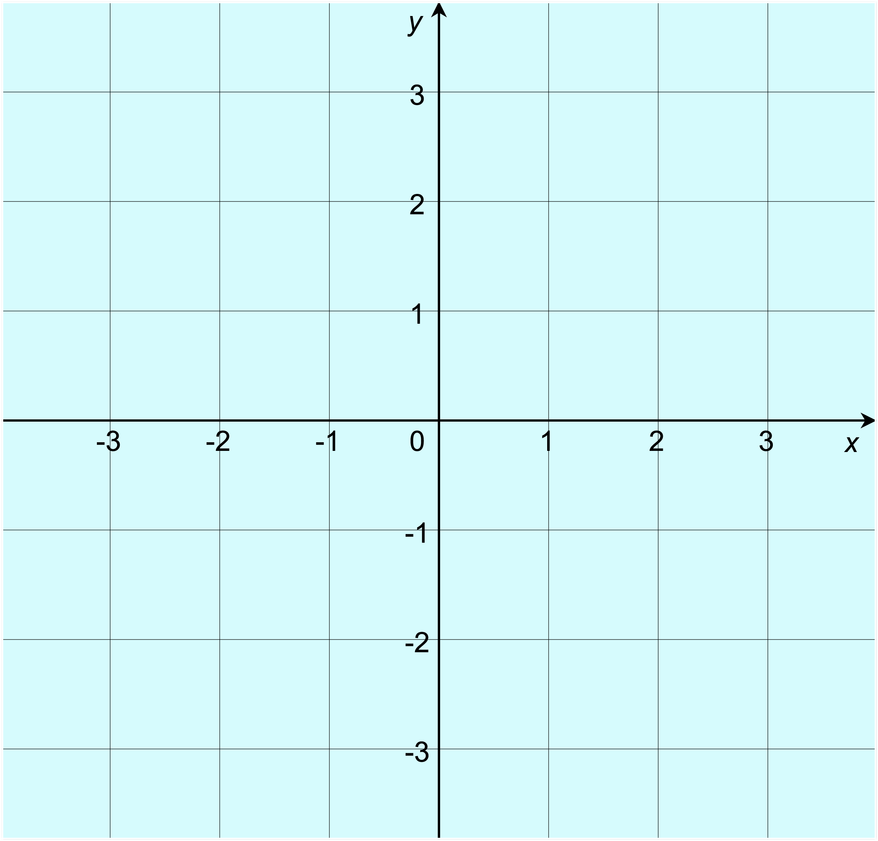

The line joining (1, 1) and (4, 4), or the line joining  (0, −4) and (3, 2)? |  | The line between the origin and (3, 3), or the line between (0, −1) and (3, 1)?

Worksheet 1a: Which is steepest? continued

The line from (−3, −1) to (2, −3), or the line from  (−2, 3) to (2, 1)? |  | The line from (−4, −1) to (1, 4), or the line from  (0, −2) to (2, 0)?

Be ready to explain how you decided.
Challenge question:
How can you use a number to describe the slope and direction of each line?

Worksheet 1b: Finding gradients

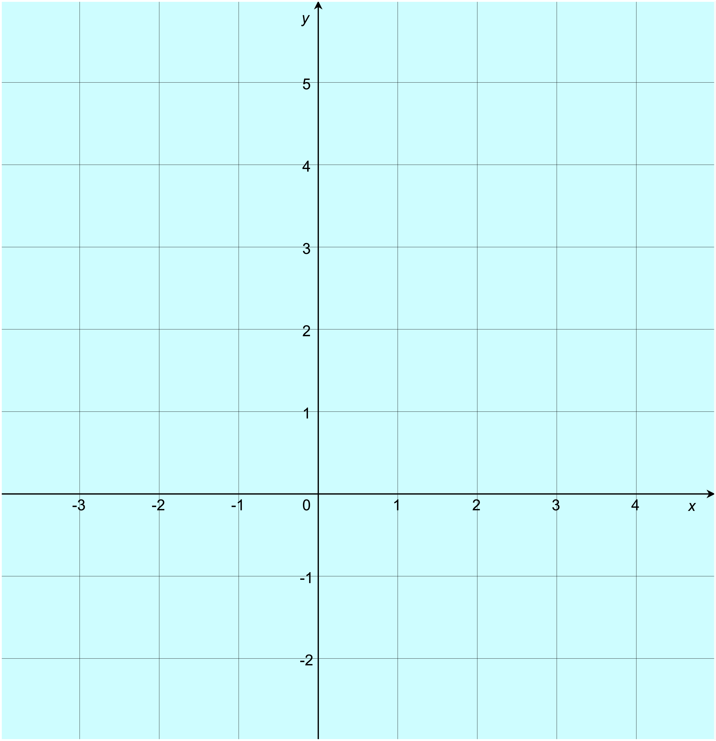
Bronze
e
d
c
b
a

Find the gradients of these lines |  | Find the gradients of these lines

Worksheet 1b: Finding gradients continued

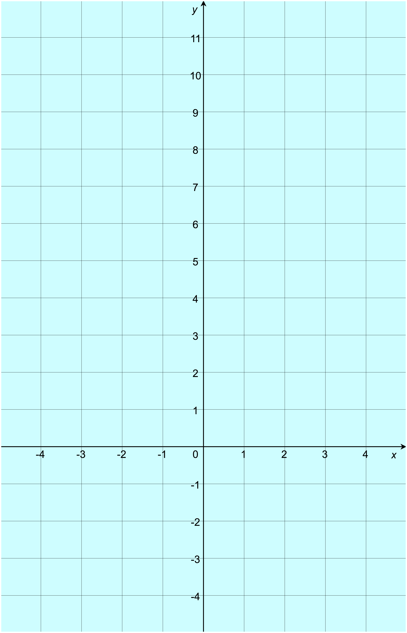
Silver
e
d
f
a
b
c

Find the gradients of these lines |  | Find the gradients of these lines

Worksheet 1b: Finding gradients continued

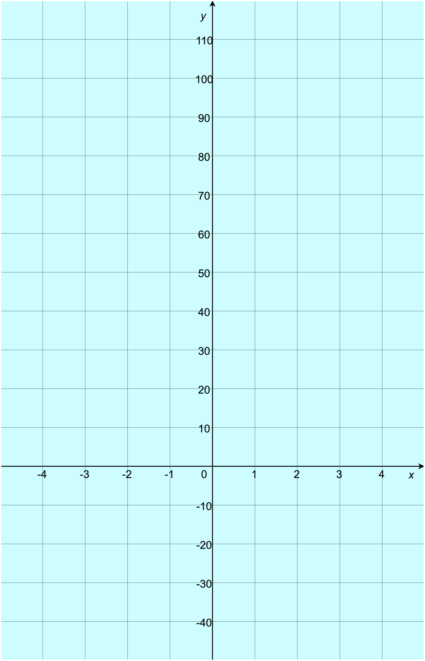
Silver continued
l
k
j
h
i
g

Find the gradients of these lines |  | Find the gradients of these lines

Worksheet 1b: Finding gradients continued
Gold
Find the gradients of the lines that join these points:
(2, 1) and (7, 6)
(−1, 2) and (3, 14)
(−3, −3) and (3, 27)
(4, −2) and (104, 0)
(2, 7) and (10, 5)
(1, 7) and (4, 1)
(−5, 4) and (5, 4)
(3, −1) and (7, 1)
(3, 1) and (3, 6)

Challenge:
Write some questions about gradients and challenge another learner to answer them

Worksheet 2a: Investigating linear graphs v1
These equations can all be used to draw linear graphs.
y = −4x − 3
y = 2x − 3
y = x
y = −3x − 2
y = −x + 1
y = 4x + 3
y = 3x + 1
y = −4x
y = 3x − 1
y = −3x
y = −2x + 3
y = 4x + 2
y = x + 2
y = −x
y = −x + 4
y = x + 4
y = 2x − 2
y = −2x − 1

Your task
Investigate the connections between the equation and the properties of the graph:
- Start by choosing some equations and using them to draw graphs. To save time, you can use graphing software to do this. You can choose equations from the list or make up some of your own. If you make up your own, make sure that all your graphs are linear.
- Find the gradient and y-intercept for each graph.
- Record your results in an organised way and look for patterns.
- Once you think you have discovered a pattern, try to make a prediction to check that your pattern is correct. For example, can you say what the gradient and y-intercept will be without looking at the graph? Check your prediction using the graph.
- Be ready to explain what you have discovered.

Worksheet 2a: Investigating linear graphs v1 continued
equation | gradient | y-intercept

Challenge:
Try drawing the graphs of x + y = 6 or 2x – y = 10
Does the pattern still work? Why? Or why not?

Worksheet 2b: Investigating linear graphs v2
These equations can all be used to draw linear graphs.
y = −4x − 3
y = 2x − 3
y = x
y = −3x − 2
y = −x + 1
y = 4x + 3
y = 3x + 1
y = −4x
y = 3x − 1
y = −3x
y = −2x + 3
y = 4x + 2
y = x + 2
y = −x
y = −x + 4
y = x + 4
y = 2x − 2
y = −2x − 1

Your task
Investigate the connections between the equation and the properties of the graph:
- Start by choosing some equations. Your teacher will give you a set of cards showing the graphs for these equations. You could also make up some equations of your own and draw the graphs yourself. If you make up your own, make sure that all your graphs are linear.
- Find the gradient and y-intercept for each graph.
- Record your results in an organised way and look for patterns.
- Once you think you have discovered a pattern, try to make a prediction to check that your pattern is correct. For example, can you say what the gradient and y-intercept will be without looking at the graph? Check your prediction with the graph.
- Be ready to explain what you have discovered.

Worksheet 2b: Investigating linear graphs v2 continued
equation | gradient | y-intercept

Challenge:
Try drawing the graphs of x + y = 6 or 2x – y = 10
Does the pattern still work? Why? Or why not?

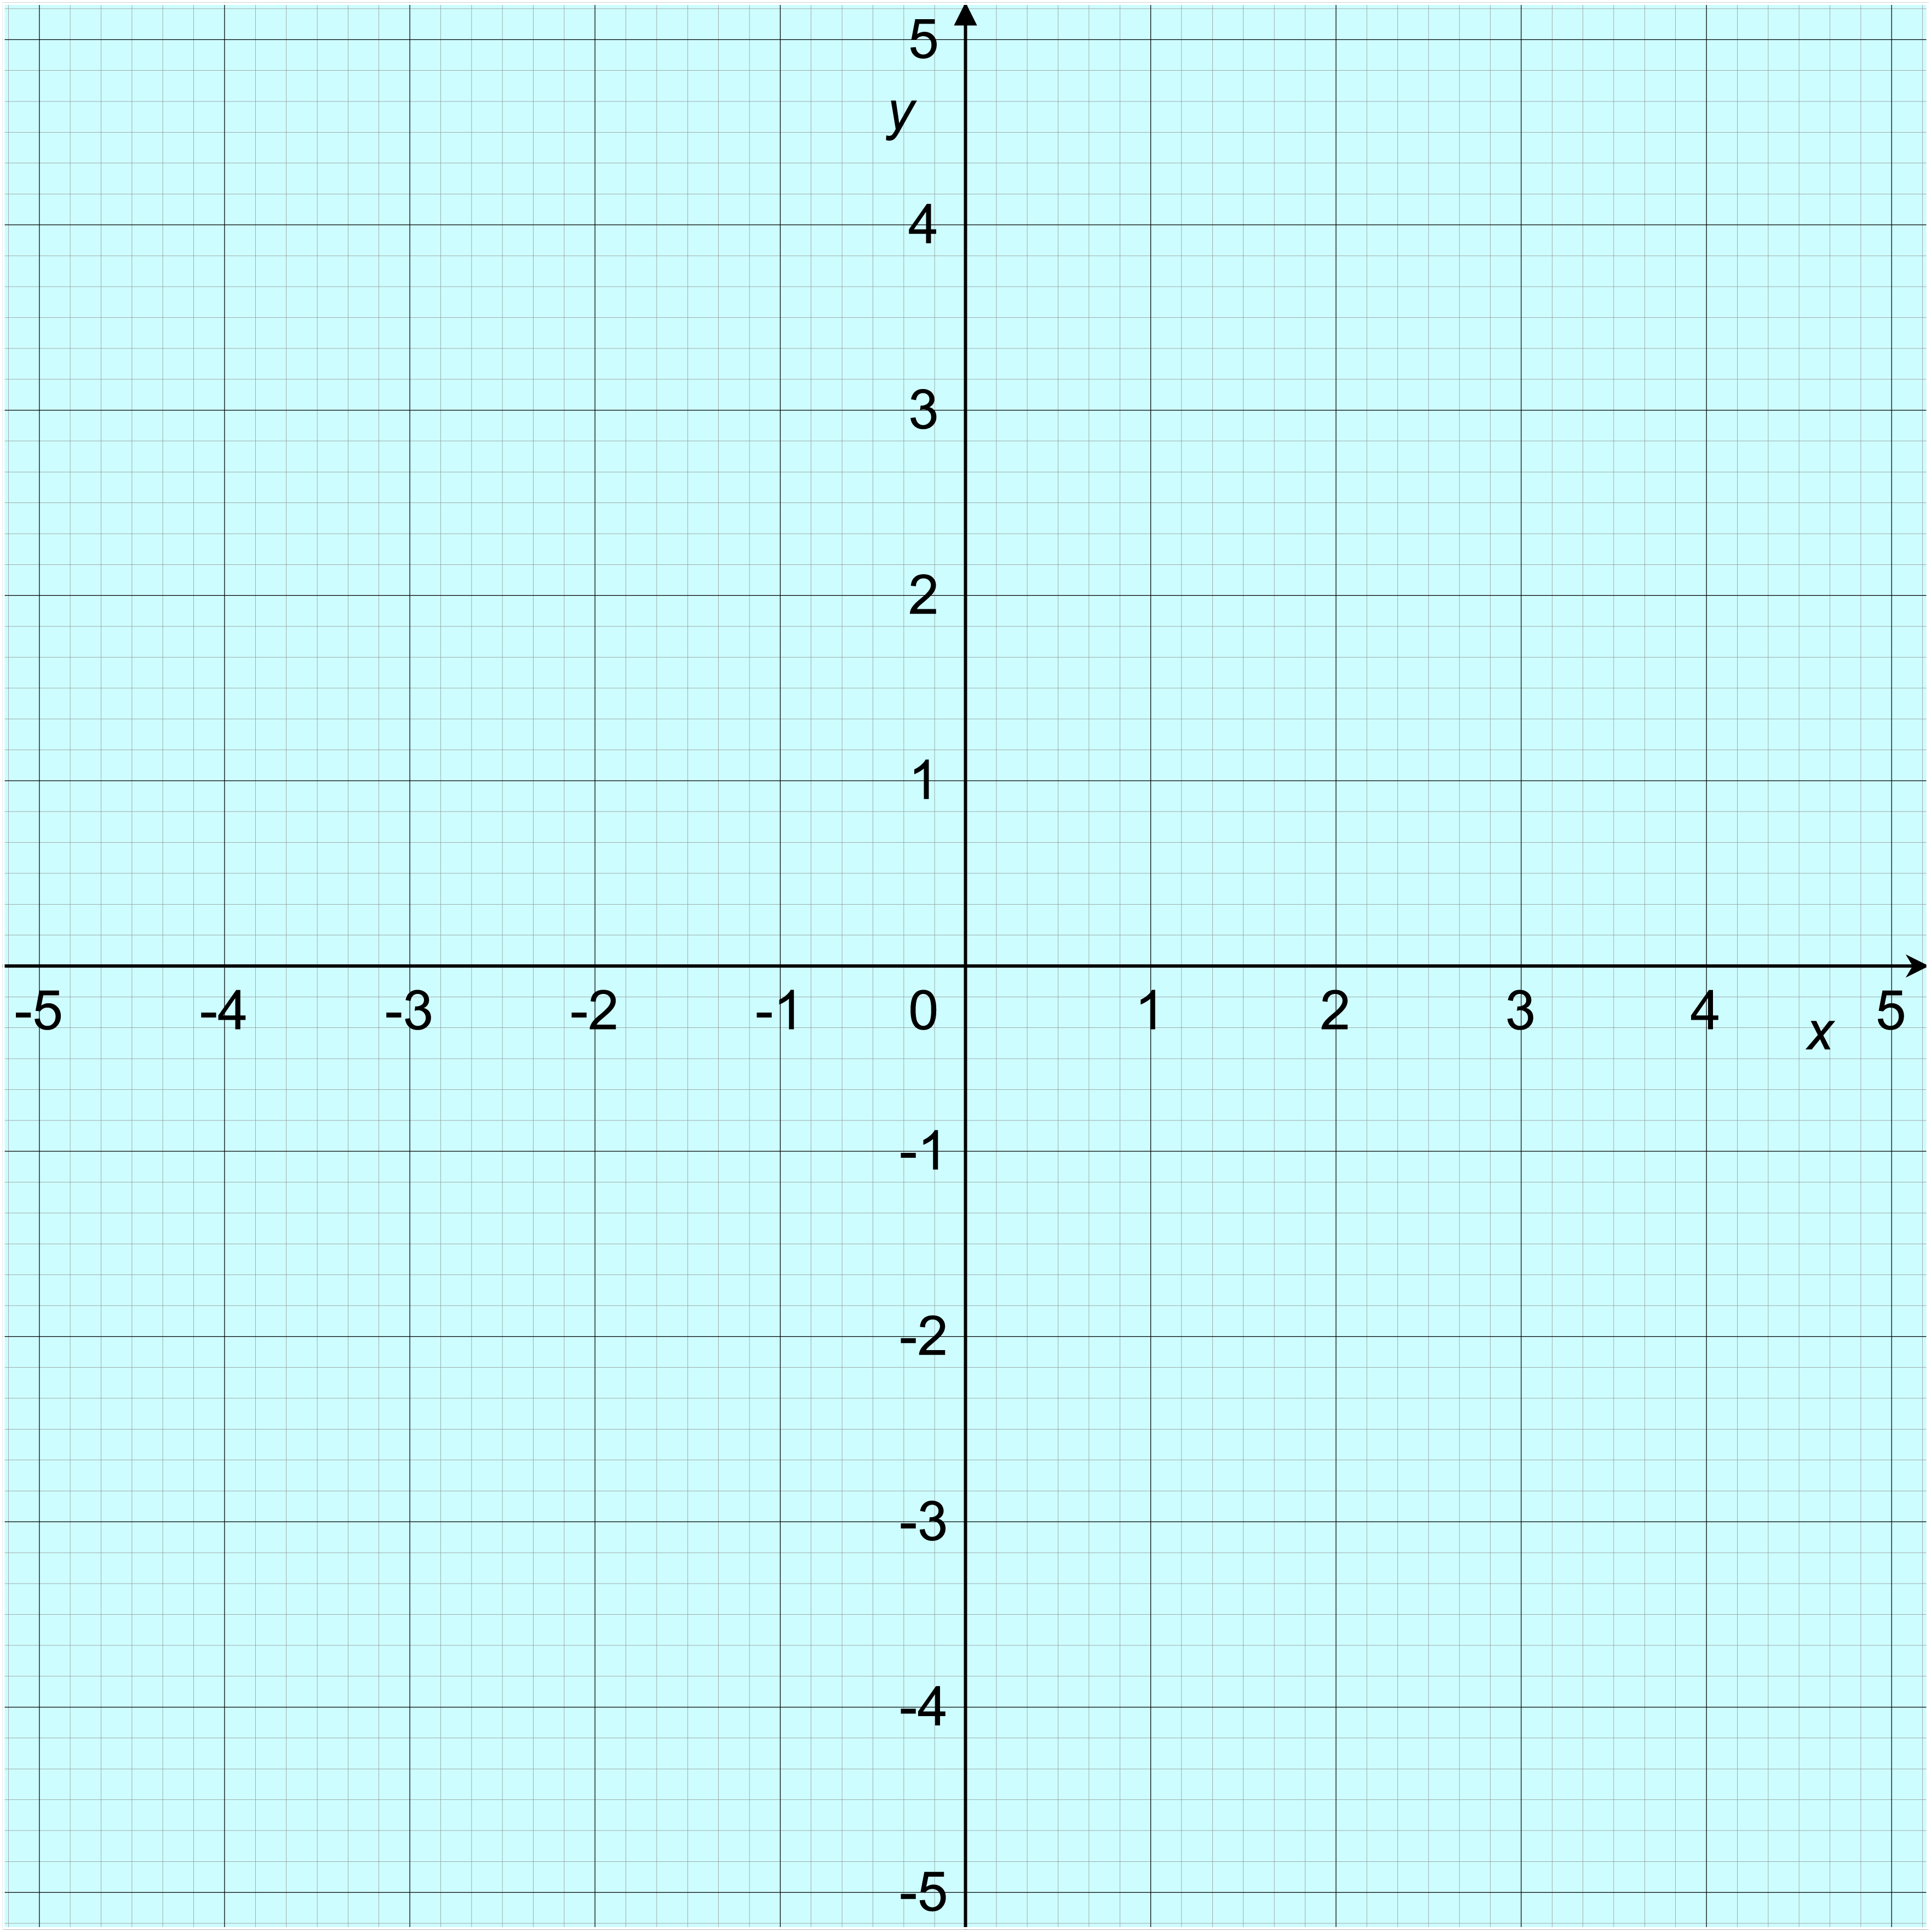
Worksheet 2c: Graph cards

y = −4x − 3 |  | y = 2x − 3
Worksheet 2c: Graph cards continued

y = x |  | y = −3x − 2
Worksheet 2c: Graph cards continued

y = 2x − 2 |  | y = −2x − 1
Worksheet 2c: Graph cards continued

y = 3x − 1 |  | y = −4x
Worksheet 2c: Graph cards continued

y = −3x |  | y = −x +1
Worksheet 2c: Graph cards continued

y = −x |  | y = 3x + 1
Worksheet 2c: Graph cards continued

y = x + 2 |  | y = 4x + 2
Worksheet 2c: Graph cards continued

y = −2x + 3 |  | y = 4x + 3
Worksheet 2c: Graph cards continued

y = −x + 4 |  | y = x + 4

Worksheet 2d: Find the equations 1
For each line on the graphs that follow, find:
- the gradient.
- the y-intercept.
- the equation of the line, giving your answer in the form y = mx + c.

 | gradient | y-intercept | equation
Line A
Line B
Line C
Line D
Line E
Line F
Line G
Line H

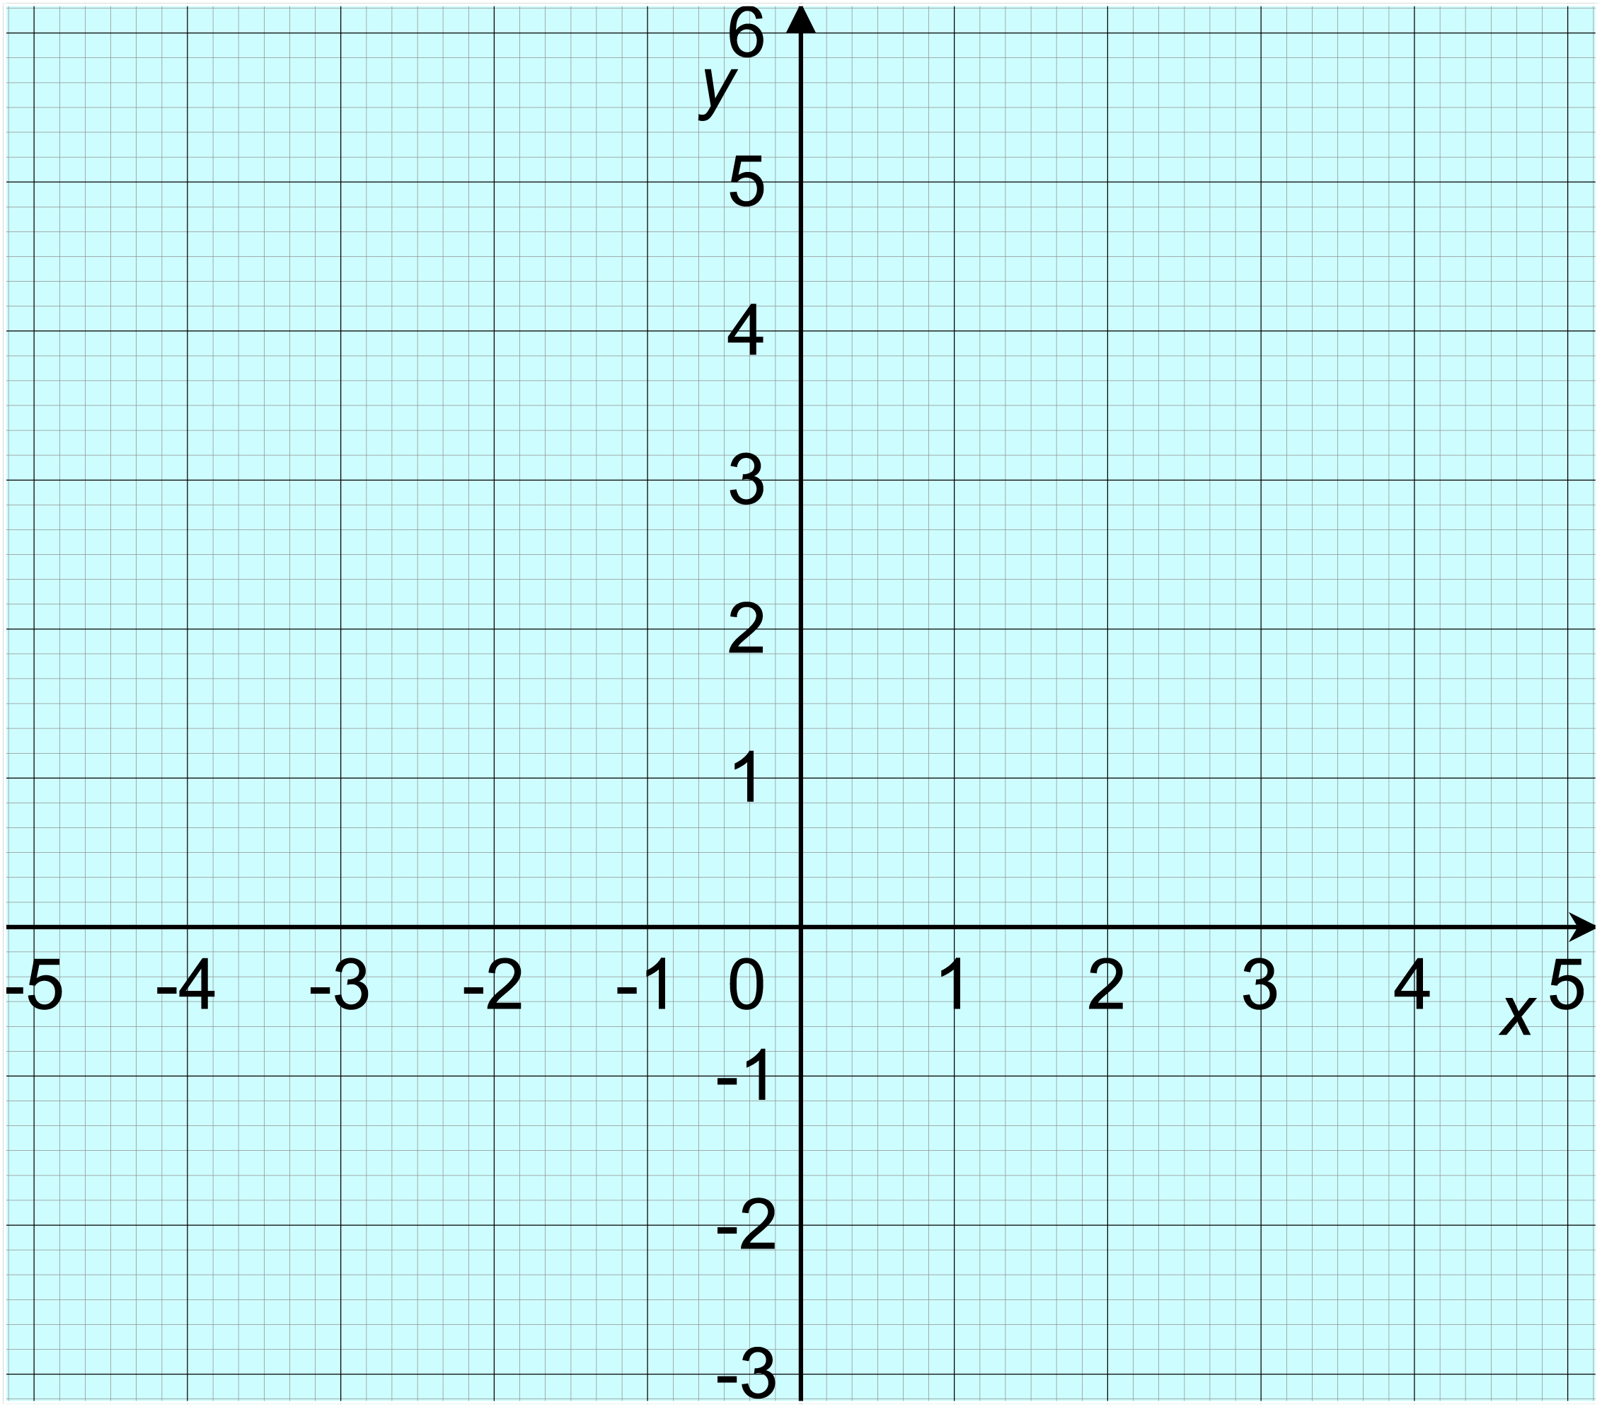
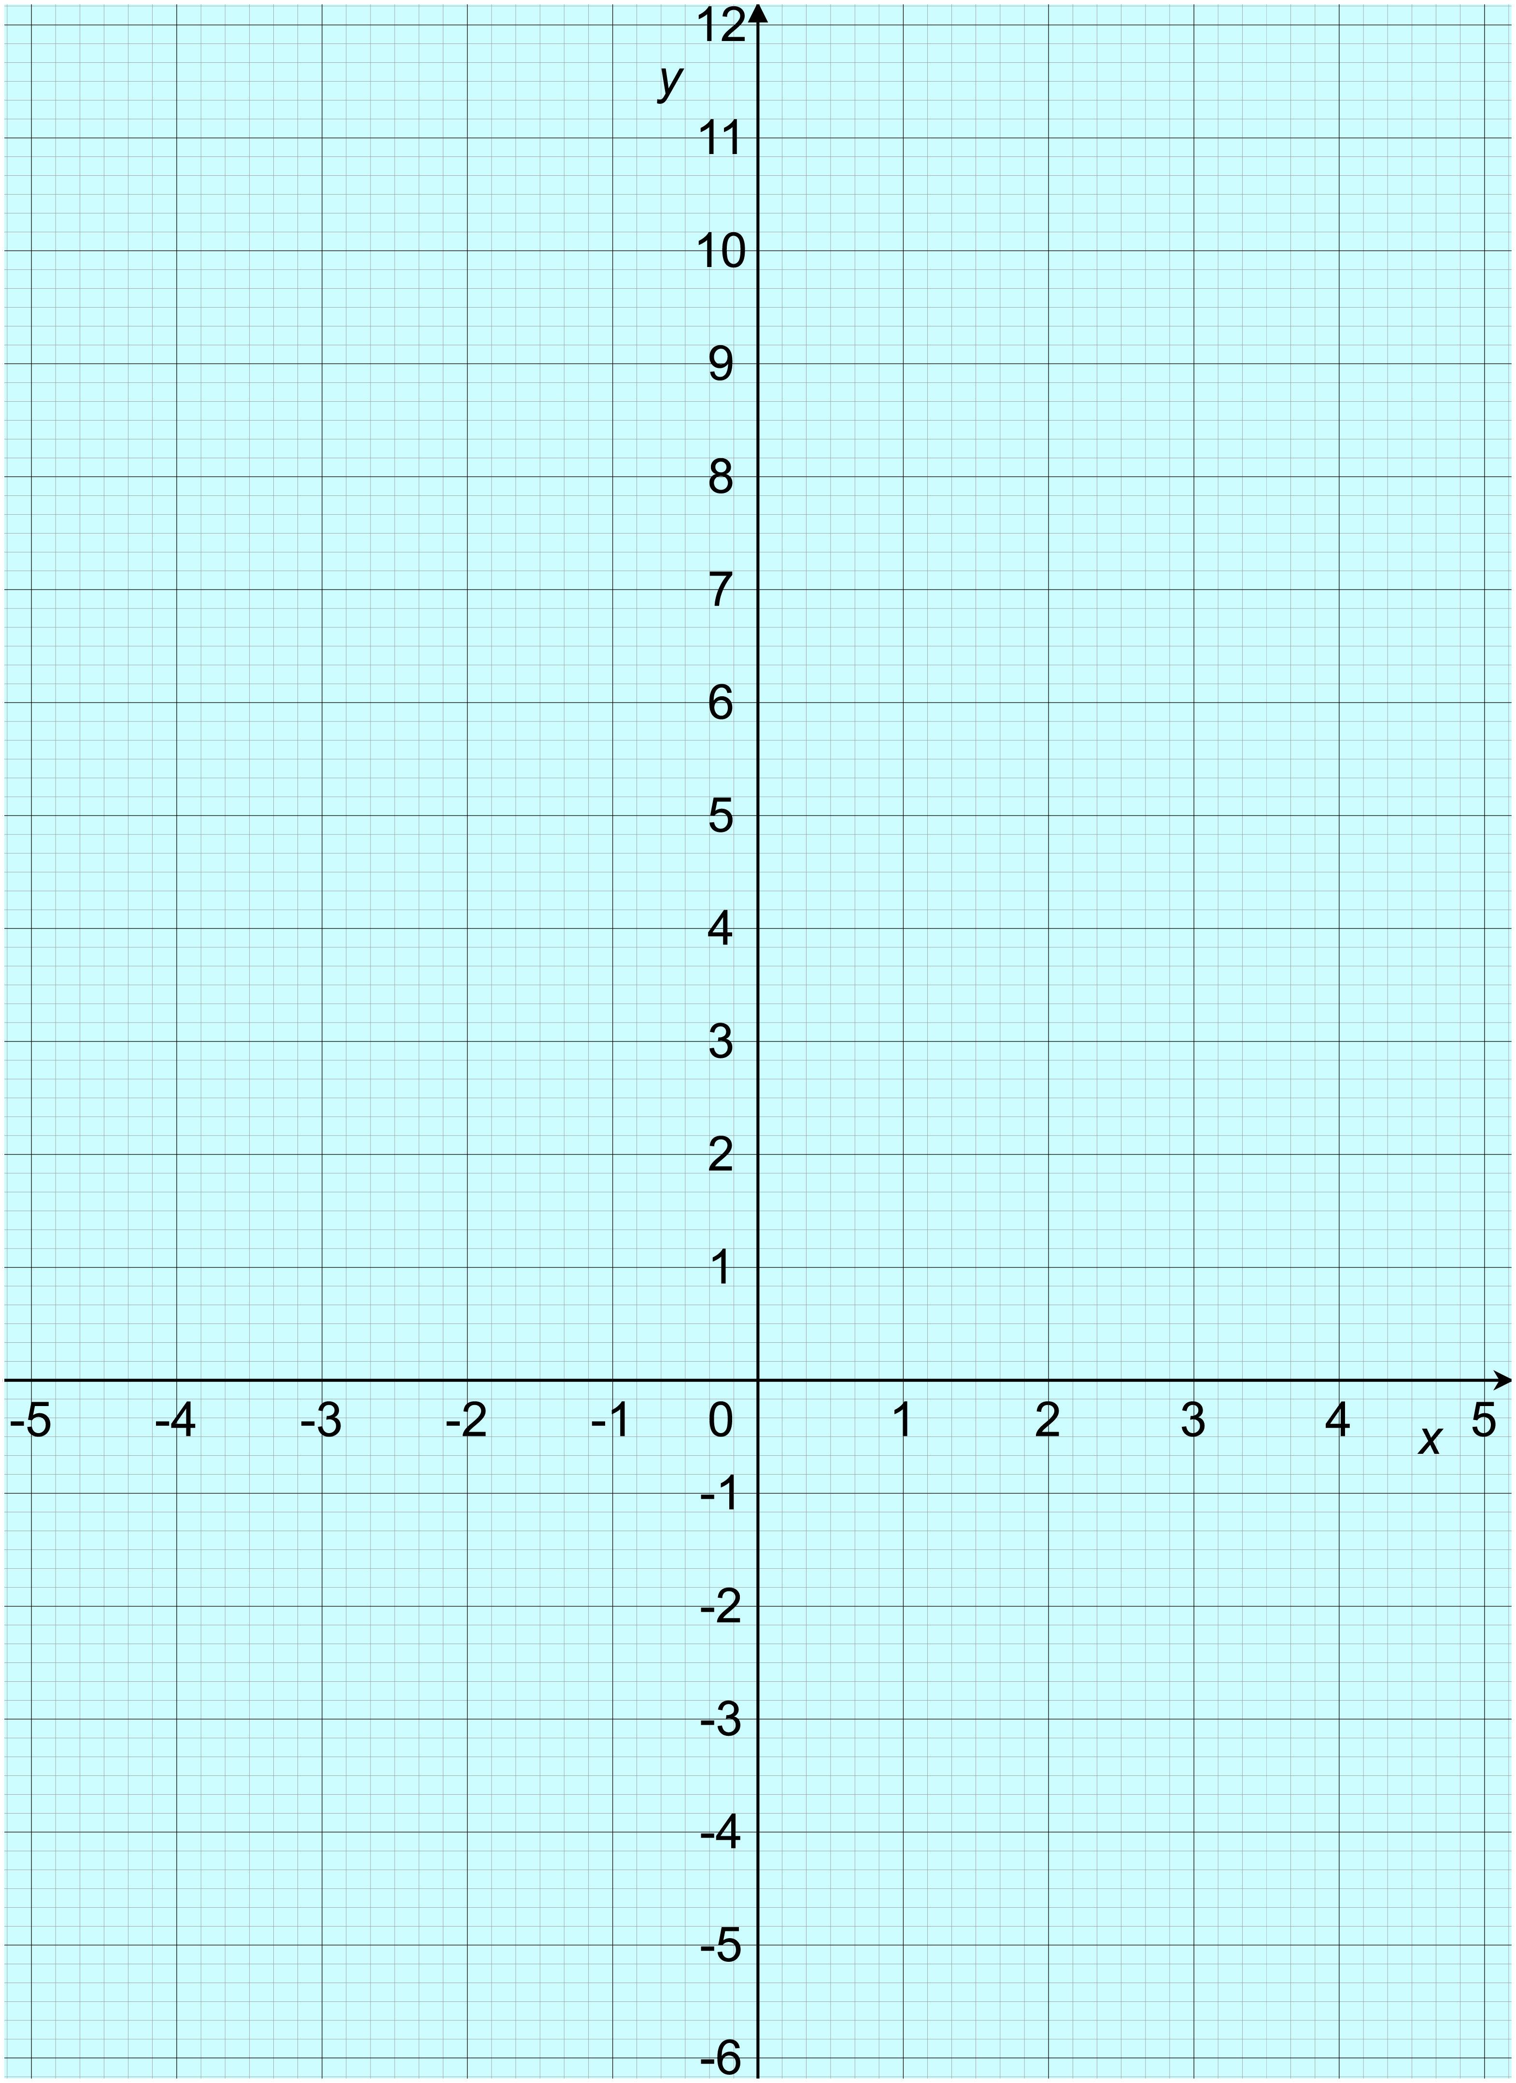
B
A
C
D
G
H
E
F
Worksheet 3a: Find the equations 2
Find the equations of all the lines in each set. Give your answers in the form y = mx + c.
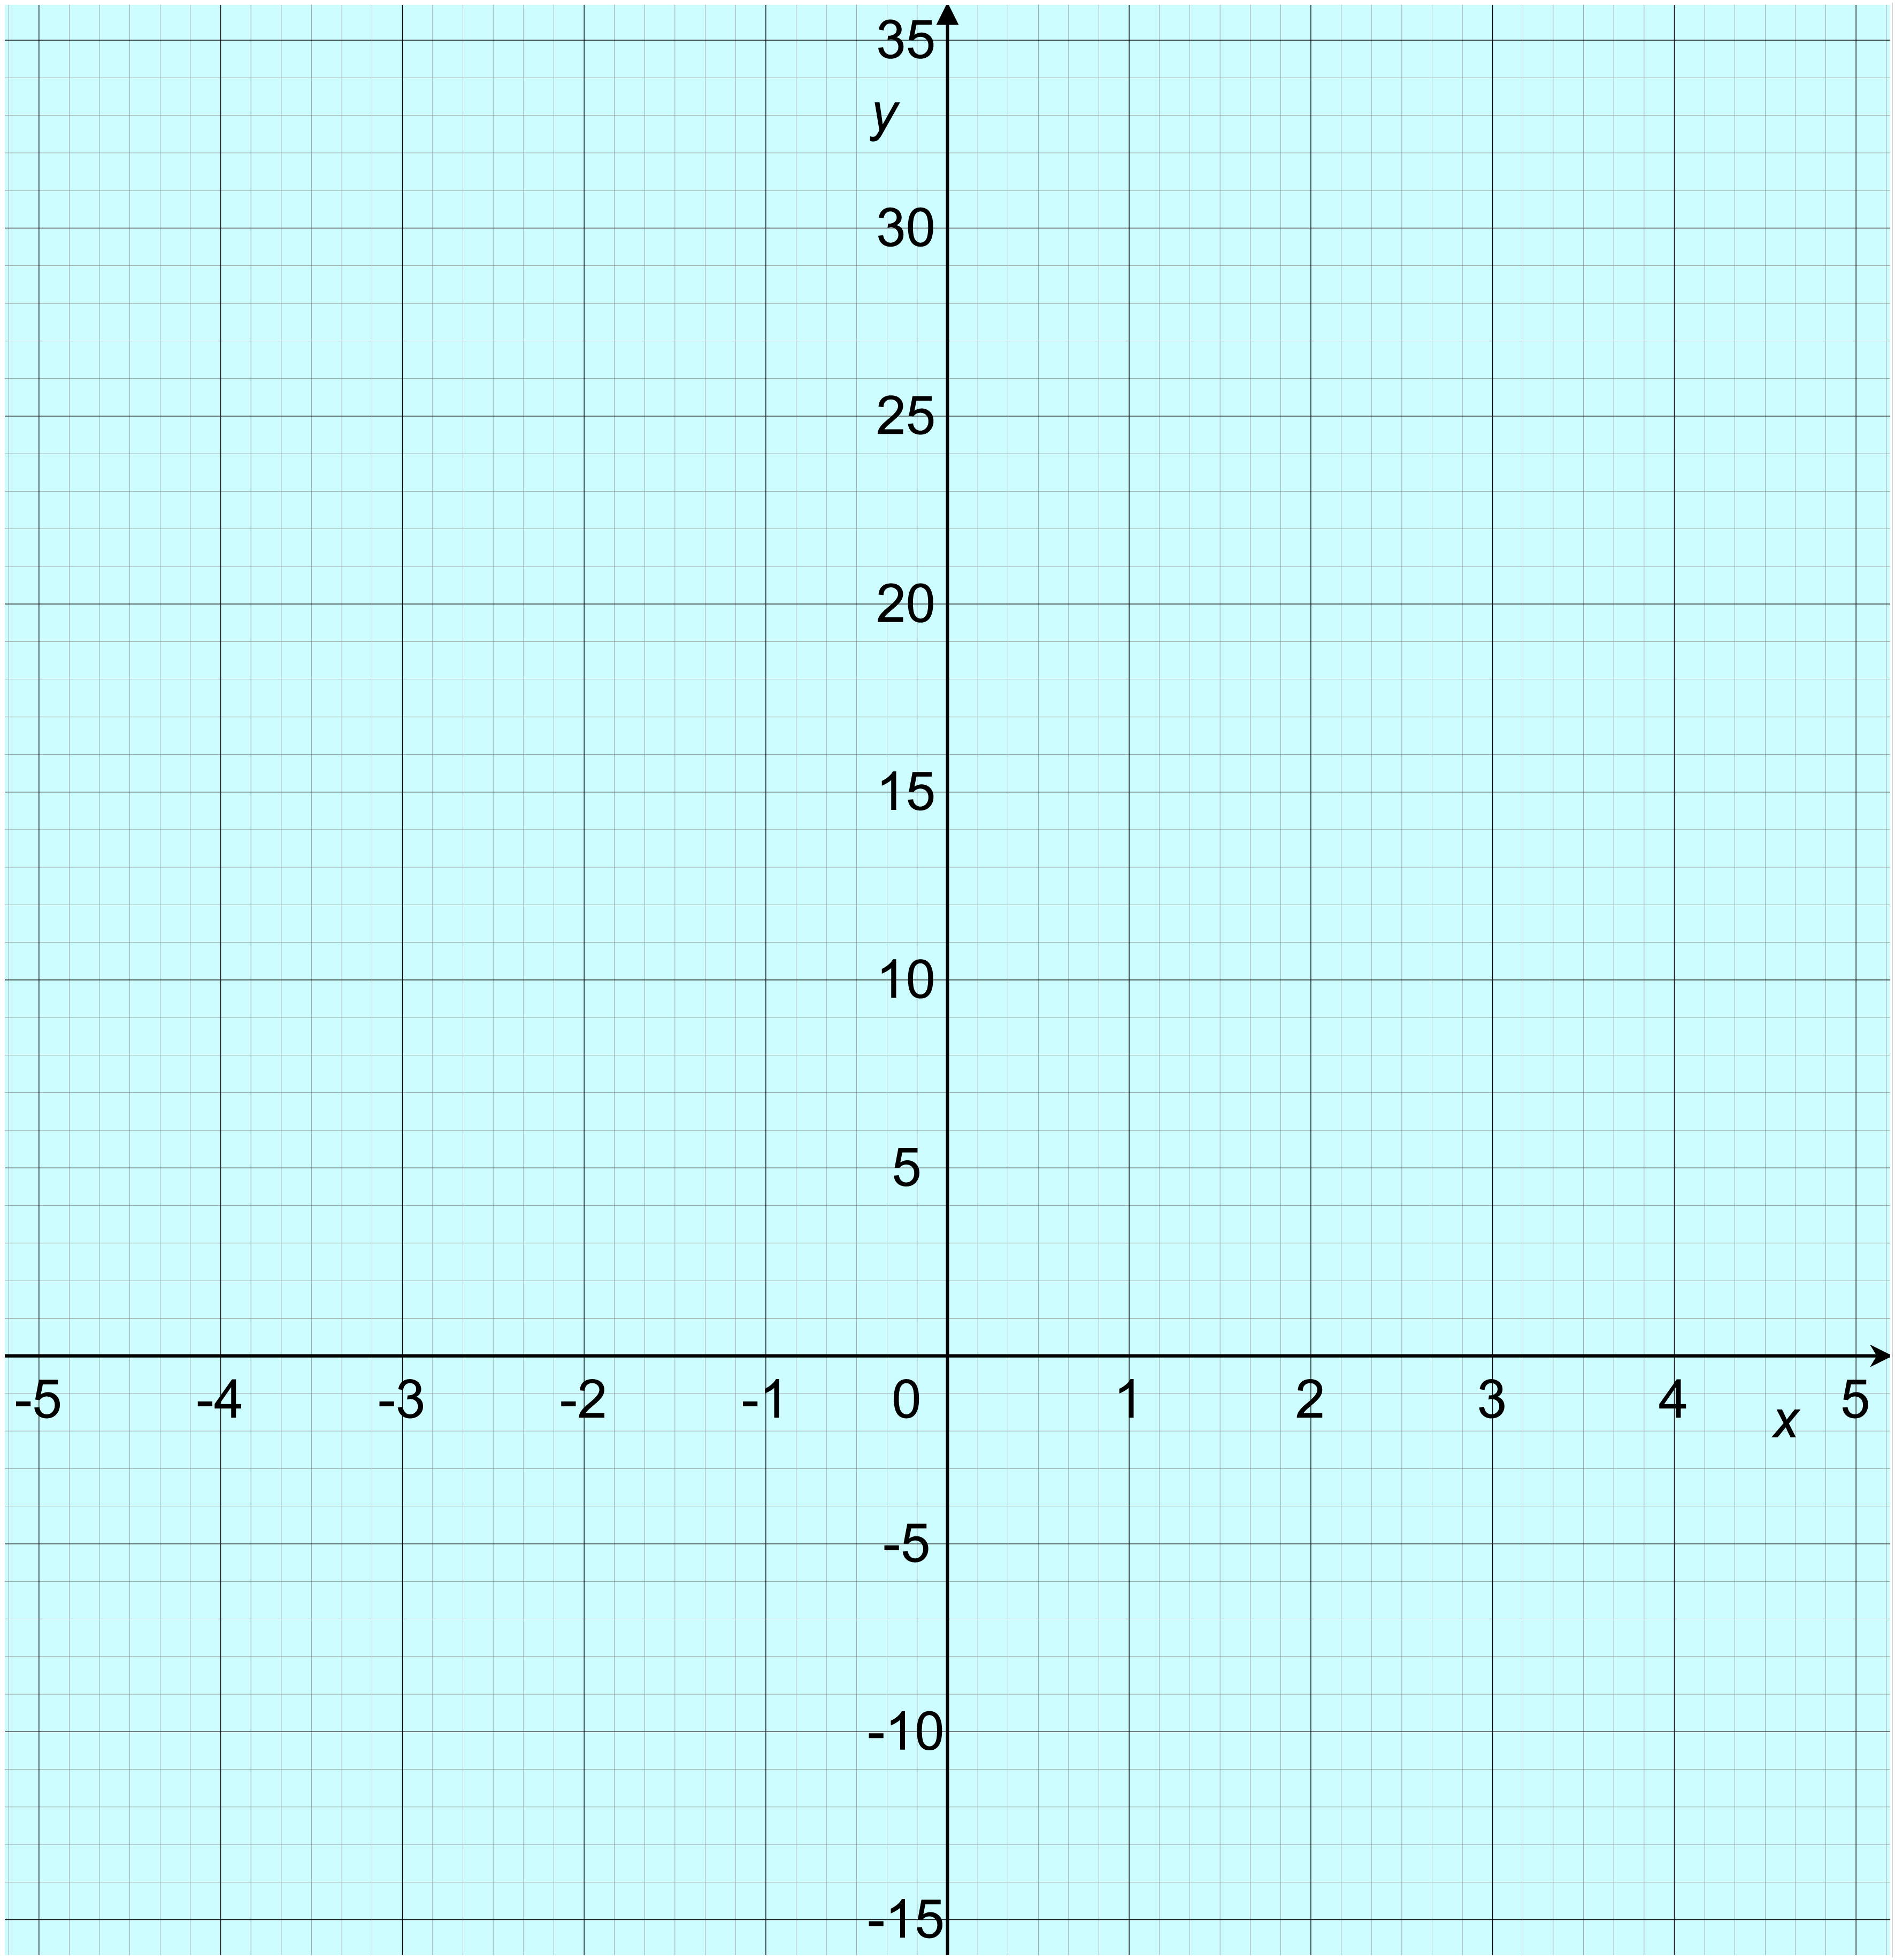
Set A: Set B (take care with the scales):
A
B

C

C

D

B

A

Worksheet 3a: Find the equations 2 continued
Set C: Axes for challenge question:
D

C

B

A
What do you notice about your answers?
Why does this happen?
Challenge:
Suggest a set of equations that will give you another set of parallel lines.
Check by drawing the lines for your equations on the blank axes above.
Worksheet 3b: Parallel lines and equations treasure hunt
Instructions:
- Print out the full set of cards, cut them into individual cards (so each one is on a sheet of A5 paper) and then stick the 15 question cards up around the classroom.
- There are also three Hint cards to help Core learners. You could either stick these up too, or give them out at the start, or just give them out later to learners who really need them.
- Learners can start on any card. The activity works best if they all choose different starting points.
- Learners solve the question on their card and record the answer.
- Then they need to hunt for the card that has this answer at the top. Some answers are very similar, so they should be careful!
- Learners solve the next question and repeat the process.
- They should end up back where they started, with the following
sequence of 15 answers:
  - y = 2x − 4
  - y = −3x − 1
  - y = 2x + 3
  - y = $\frac{1}{2}$x + 4
  - No
  - y = −2x + 4
  - y = 2x + 1
  - y = 5x − 3
  - Simon is right
  - y = $\frac{1}{2}$x − 2
  - y = 3x + 2
  - Simon is wrong
  - y = 3x − 5
  - Yes
  - y = −2x + 1

Simon is right
Line E is parallel to
y = $\frac{1}{2}$x + 4.

Line E passes through the y-axis at (0, −2).

What is the equation
of Line E?
From the last clue
Now find the clue with this answer at the top
y = 3x + 2
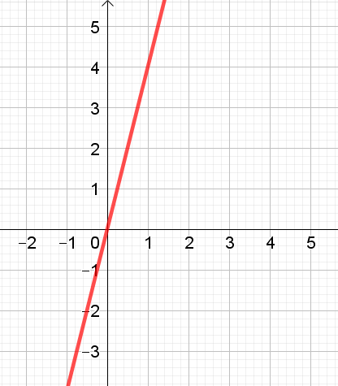
Simon says that
y = 3x + 4
is parallel to the red line.
Is Simon correct?

From the last clue
Now find the clue with this answer at the top

y = −2x + 4
What is the equation of the line that is parallel to y = 2x − 1 and that passes through (2, 5)?

Need a hint?
Ask your teacher for
Hint Card A.
From the last clue
Now find the clue with this answer at the top
y = 3x − 5
Line A is a straight line from (1, 1) to (9, 3).
Line B is a straight line from (4, −2) to (12, 0).

Is Line A parallel to Line B?

From the last clue
Now find the clue with this answer at the top

No
Here are the equations of four lines:
y = 2x − 4
y = 2x + 3
y = −2x + 4
y = 2x + 1

Which line is not parallel to the others?
From the last clue
Now find the clue with this answer at the top
y = −2x + 1
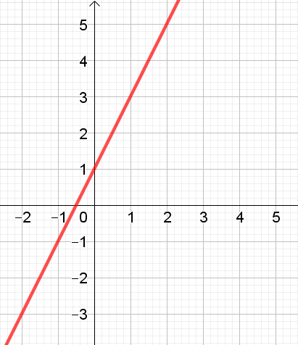
What is equation of the line that is parallel to the red line and passes through (0, −4)?
From the last clue
Now find the clue with this answer at the top

y = 2x + 1
A line is parallel to
y = 5x and intersects
the y-axis at (0, −3).

What is the equation of this line?
From the last clue
Now find the clue with this answer at the top
Yes
What is the equation of the line that is parallel to 2x + y = 3 and that passes through (1, −1)?

Need a hint?
Ask your teacher for
Hint Card C.
From the last clue
Now find the clue with this answer at the top

y = 2x + 3
Line L joins the points
(2, 1) and (6, 3).
Line M passes through the y-axis at (0, 4) and is parallel to Line L.

What is the equation of Line M?

From the last clue
Now find the clue with this answer at the top
Simon is wrong
Here are the equations of some lines:
y = 3 + 5x
y = 3x − 5
y = 5x
y = 5x − 3

Which line is not parallel to the others?

From the last clue
Now find the clue with this answer at the top

y = −3x − 1
A line is parallel to
y = 2x − 3 and intersects
the y-axis at (0, 3).

What is the equation of this line?
From the last clue
Now find the clue with this answer at the top
y = $\frac{1}{2}$x + 4
Line C is a straight line from (2, 1) to (6, 4).
Line D is a straight line from (6, 2) to (9, 6).

Is Line C parallel
to Line D?

From the last clue
Now find the clue with this answer at the top

y = 5x − 3
Simon says that
y = 3x − 4
y = 3x + 3
and y = 3x
are all parallel.
Is Simon correct?

From the last clue
Now find the clue with this answer at the top
y = $\frac{1}{2}$x − 2
Line Q meets the y-axis at (0, 2) and is parallel to y = 3x.

What is the equation of Line Q?

From the last clue
Now find the clue with this answer at the top

y = 2x − 4
What is the equation of the line that is parallel to y + 3x = 4 and that passes through (−1, 2)?

Need a hint?
Ask your teacher for
Hint Card B.
From the last clue
Now find the clue with this answer at the top
Hint Card A
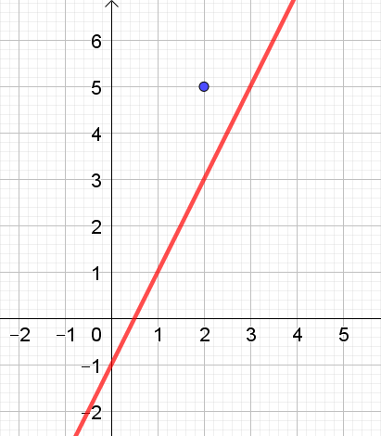

Hint Card C
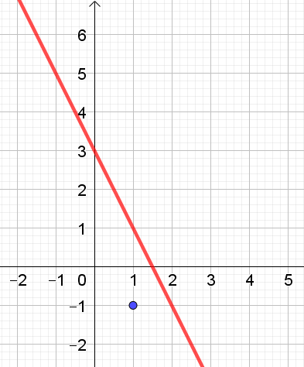
Hint Card B
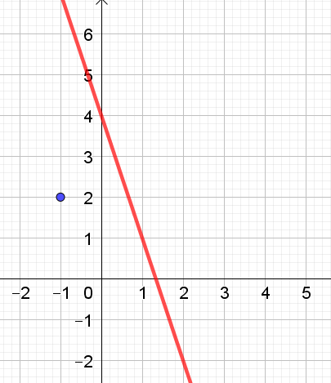

Worksheet 4a: Find the equations 3
Find the equations of all the lines in each set. Give your answers in the form y = mx + c.
Set A: Set B:
A
D
C
B
A

B

Worksheet 4a: Find the equations 3 continued
Set C: Set D:
B
A
A

B

What do you notice about the gradients of the pairs of lines in sets B, C and D?
Challenge:
Suggest a pair of equations that will give you another pair of perpendicular lines.

Worksheet 4b: Parallel and perpendicular lines
Bronze:
From the equations listed below, find
- Two lines that are parallel to y = 2x – 3
- Two lines that are perpendicular to y = – x
y = −x + 4
y = 2x + 2

y = x
y = x − 2
y = −x − 1
y = −2x − 1
y = 2x
y = 2 − x

y = −2x + 3
Silver:
- Sort these into pairs of lines that are parallel:
y = −3x + 4
y = 4x − 3
y = −4x + 3
y = 4x − 4
y = 4 − 4x

y = −3x + 3

- Sort these into pairs of lines that are perpendicular:
y = −2x + 2
y = −$\frac{1}{2}$x − 2
y = −$\frac{1}{4}$x − 1
y = x + 1
y = 3
y = −4x + 1
y = $\frac{1}{4}$x − 1
y = 2x + 2
y = $\frac{1}{2}$x + 2
x = 3
y = 4x + 1
y = −x

- Complete the table to show whether each pair of lines is parallel, perpendicular or neither of these:
line A | line B | parallel, perpendicular  or neither?
y = −7x + 2 | y = 7x + 2
y = −4x − 3 | y = $\frac{1}{4}$ x + 2
y = $\frac{1}{2}$ x − 2 | y = $\frac{1}{2}$ x + $\frac{1}{2}$
y = $\frac{3}{4}$ x + 3 | y = $\frac{1}{4}$ x + 4
y = −$\frac{1}{8}$x + 1 | y = 8x
Worksheet 4b: Parallel and perpendicular lines continued
Gold:
- Complete the table to show whether each pair of lines is parallel, perpendicular or neither of these:
line A | line B | parallel, perpendicular  or neither?
y = 2 − 2x | 2x + y = − 2
x + y = 10 | y = −x
8y − 5x = 8 | y = $\frac{5}{8}$ x + 3
$\frac{3}{8}$x + 2 = y | 3x + 8y = 2
7y + 8x = 0 | $\frac{7}{8}$x + 2 = y

- Find the equation of the line that is parallel to y = 2x + 4 and passes through (2, 1).

- Find the equation of the line that is perpendicular to y = −x + 3 and passes through (−5, 2).

- Find the equation of the line that is parallel to y = $\frac{1}{2}$ x + 1 and passes through (4, −1).

- Find the equation of the line that is perpendicular to y = $\frac{2}{3}$ x + 2 and passes through (3, 4)

- Find the equation of the line that is perpendicular to x + 2y = 12 and passes through (3, 2)

Challenge:
Write your own question about parallel or perpendicular lines
and challenge another learner to answer it.

Worksheet 4c: Card sort
Instructions:
- Cut out the cards and sort them so that each set of cards contains lines that are all parallel to each other.
- The sets do not all have the same number of cards.
- Some cards are blank for you to fill in.
Learners could check their own cards with equations or lines joining two points by drawing them. They could do this using graphing software. Alternatively, they could swap their answers with another pair or group and check whether they agree.

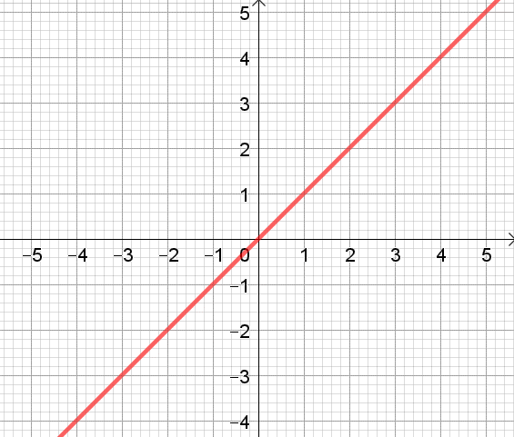  Graph A | 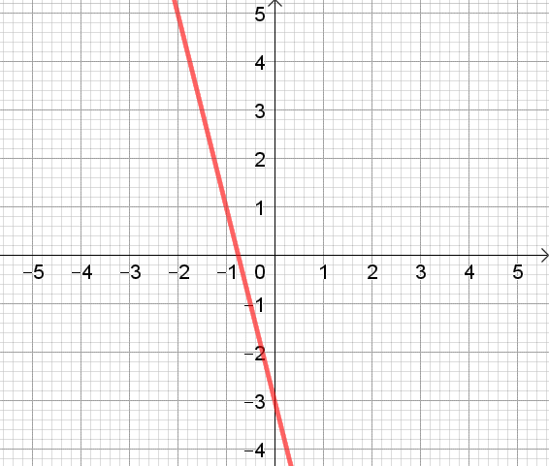  Graph B | 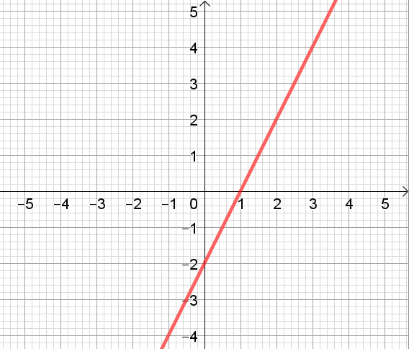  Graph C
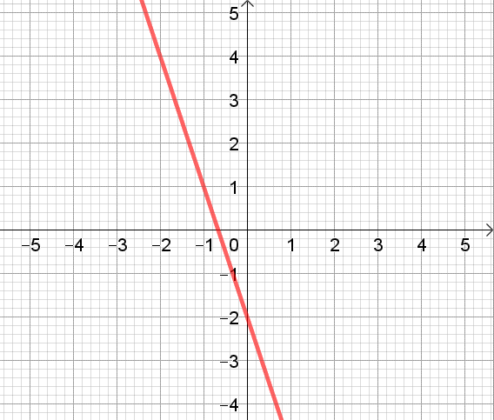  Graph D | 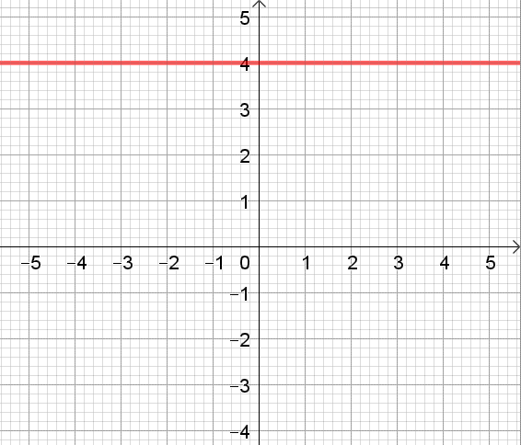  Graph E | 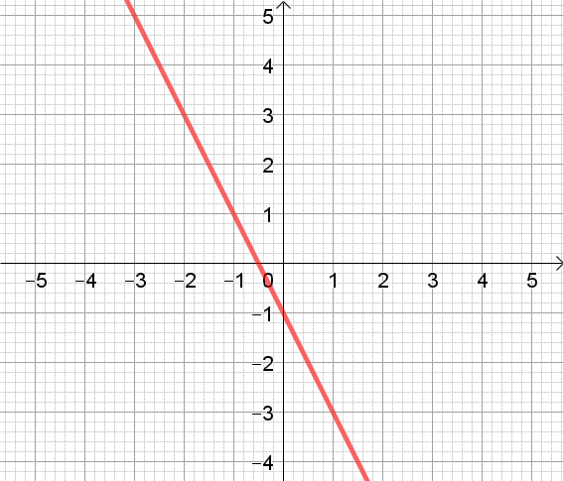  Graph F
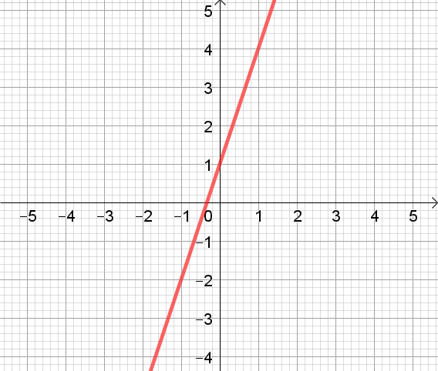  Graph G | 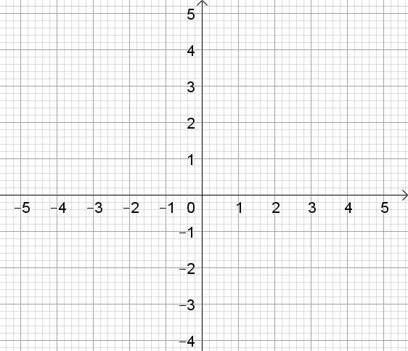  Graph H | Graph I
y = 5x − 2 | y = 2x − 5 | y = −2x − 5
y = 3x + 7 | y = −4x + 2 | y = x + 6
y = −3x | y = x + 7 | y = 2x
y = 5x + 4 | y = −x | y = 3x − 1
y + 1 = 2x | y + 3x = 4 | 6 = 3x − y
y + x = 2 | y – 2x = 4 | y = −2x + 3
………………… | ………………… | …………………
The line joining the points  (−4, −2) and (2, −2) | The line joining the points  (−1, 4) and (3, 0) | The line joining the points  (2, 2) and (−1, −4)
The line joining the origin  and the point (2, −4) | The line joining the points  (…., ….) and (…., ….) | The line joining the points  (…., ….) and (…., ….)

Worksheet 1a: Answers

The line joining (1, 1) and (4, 4) or the line joining  (0, −4) and (3, 2)? |  | The line between the origin and (3, 3) or the line between (0, −1) and (3, 1)?

No difference

The line from (−3, −1) to (2, −3) or the line from  (−2, 3) to (2, 1)? |  | The line from (−4, −1) to (1, 4) or the line from  (0, −2) to (2, 0)?

Worksheet 1b: Answers
Bronze
- 1
- 2
- 3
- −2
- 0

Silver
- 3
- −2
- −1
- -$\frac{2}{3}$
- 2
- $–\frac{1}{2}$
- $\frac{1}{2}$
- $\frac{2}{3}$
- $–\frac{1}{3}$
- 50
- −20
- undefined

Gold
(2, 1) and (7, 6)
Answer: 1
(−1, 2) and (3, 14)
Answer: 3
(−3, −3) and (3, 27)
Answer: 5
(4, −2) and (104, 0)
Answer: $\frac{1}{50}$
(2, 7) and (10, 5)
Answer: −$\frac{1}{4}$
(1, 7) and (4, 1)
Answer: −2
(−5, 4) and (5, 4)
Answer: 0
(3, −1) and (7, 1)
Answer: $\frac{1}{2}$
(3, 1) and (3, 6)
Answer: undefined

Worksheet 2d: Answers
 | gradient | y-intercept | equation
Line A | − 1 | − 2 | y = −x − 2
Line B | − 2 | 0 | y = −2x
Line C | 1 | 3 | y = x + 3
Line D | $$\frac{1}{2}$$ | 0 | y =$\frac{1}{2}$ x
Line E | 1 | 4 | y = x + 4
Line F | − 2 | −4 | y = −2x – 4
Line G | − 3 | 1 | y = −3x + 1
Line H | $$\frac{1}{2}$$ | −4 | y = $\frac{1}{2}$ x − 4

Worksheet 3a: Answers
Set A
A: y = 2x + 4
B y = 2x + 1
C: y = 2x
D: y = 2x − 2

Set B
A: y = 10x + 20
B: y = 10x + 5
C: y = 10x – 10

Set C
A: y = −1x – 1 = −x − 1
B: y = −1x + 1 = −x + 1
C: y = −1x + 3 = −x + 3
D: y = −1x + 5 = −x + 5

Worksheet 4a: Answers
Set A
A: y = 3x + 5
B: y = 3x + 3
C: y = 3x
D: y = 3x – 4

Set B
A: y = −3x
B: y = $\frac{1}{3}$ x

Set C
A: y = x + 2
B: y = −x + 2

Set D
A: y = 4x + 6
B: y = −$\frac{1}{4}$ x + 1
Worksheet 4b: Answers
Bronze
- y = 2x + 2, y = 2x
- y = x, y = x −2

Silver
- y = −3x + 4 and y = −3x + 3;
y = 4x − 3 and y = 4x − 4;
y = −4x + 3 and y = 4 − 4x;

- y = 3 and x = 3;
y = x + 1 and y = −x;
y = 2x + 2 and y = −$\frac{1}{2}$x − 2;
y = −2x + 2 and y = $\frac{1}{2}$x + 2;
y = 4x + 1 and y = −$\frac{1}{4}$ x − 1;
y = −4x + 1 and y = $\frac{1}{4}$ x – 1

line A | line B | parallel, perpendicular  or neither?
y = −7x + 2 | y = 7x + 2 | neither
y = −4x − 3 | y = $\frac{1}{4}$ x + 2 | perpendicular
y = $\frac{1}{2}$ x − 2 | y = $\frac{1}{2}$ x + $\frac{1}{2}$ | parallel
y = $\frac{3}{4}$ x + 3 | y = $\frac{1}{4}$ x + 4 | neither
y = −$\frac{1}{8}$x + 1 | y = 8x | perpendicular

Gold

line A | line B | parallel, perpendicular  or neither?
y = 2 − 2x | 2x + y = − 2 | parallel
x + y = 10 | y = −x | perpendicular
8y − 5x = 8 | y = $\frac{5}{8}$ x + 3 | parallel
$\frac{3}{8}$ x + 2 = y | 3x + 8y = 2 | neither
7y + 8x = 0 | $\frac{7}{8}$ x + 2 = y | perpendicular

- y = 2x − 3 (or equivalent equation)
- y = x + 7 (or equivalent equation)
- y = $\frac{1}{2}$ x − 3 (or equivalent equation)
- y = −1.5x + 8.5 (or equivalent equation)
- y = 2x − 4 (or equivalent equation)

Worksheet 4c: Answers
Set A: graph A (y = x); equations y = x + 6, y = x + 7
Set B: graph B (y = −4x − 3); equation y = −4x + 2
Set C: graph C (y = 2x − 2); equations y = 2x, y = 2x − 5, y + 1 = 2x, y – 2x = 4; line joining (2, 2) and (−1, −4)
Set D: graph D (y = −3x − 2); equations y = −3x, y + 3x = 4
Set E: graph E (y = 4), equations; line joining (−4, −2) and (2, −2)
Set F: graph F (y = −2x − 1), equations y = −2x − 5, y = −2x + 3; line joining the origin and the point (2, −4)
Set G: graph G (y = 3x + 1); equations y = 3x − 1, y = 3x + 7, 6 = 3x − y
Sets H and I:
- One set with own graph with gradient −1; equations y = −x, y + x = 2; line joining (−1, 4) and (3, 0)
- One set with own graph with gradient 5; equations y = 5x − 2, y = 5x + 4

Cambridge Assessment International Education
The Triangle Building, Shaftsbury Road, Cambridge, CB2 8EA, United Kingdom
t: +44 1223 553554
e: info@cambridgeinternational.org www.cambridgeinternational.org

© Cambridge University Press & Assessment 2024

