

Teaching Pack
Differentiation
Cambridge IGCSETM
Mathematics 0580

This Teaching Pack can also be used with the following syllabuses:
• Cambridge IGCSE™ (9–1) Mathematics 0980
• Cambridge IGCSE™ International Mathematics 0607

© Cambridge University Press & Assessment 2022
Cambridge Assessment International Education is part of Cambridge University Press & Assessment. Cambridge University Press & Assessment is a department of the University of Cambridge.

Cambridge University Press & Assessment retains the copyright on all its publications. Registered centres are permitted to copy material from this booklet for their own internal use. However, we cannot give permission to centres to photocopy any material that is acknowledged to a third party even for internal use within a centre.
Contents
Introduction 4
Skill: Differentiation 5
Common misconceptions: Differentiation 7
Lesson 1: Introduction to Calculus 8
Lesson 2: Using differentiation to find the gradient of a curve 10
Lesson 3: Classifying Turning Points 12
Lesson 4: Exam Practise and Second Derivatives 13
Worksheets and answers 15

Icons used in this pack:
 | Lesson
 | Video
 | Assessment opportunity

Introduction
This pack will help you to develop your learners’ mathematical skills as defined by assessment objective 1 (AO1 Knowledge and understanding of mathematical techniques) in the course syllabus.

Important note
Our Teaching Packs have been written by classroom teachers to help you deliver topics and skills that can be challenging. Use these materials to supplement your teaching and engage your learners. You can also use them to help you create lesson plans for other skills.

This content is designed to give you and your learners the chance to explore mathematical skills. It is not intended as specific practice for exam papers.

This is one of a range of Teaching Packs. Each pack is based on one mathematical topic with a focus on specific mathematical techniques. The packs can be used in any order to suit your teaching sequence.

In this pack you will find the lesson plans and worksheets for learners you will need to successfully complete the teaching of this mathematical skill.

Skill: Differentiation
This Teaching Pack links to the following syllabus content (see syllabus for detail):
- E2.12 Estimate gradients of curves by drawing tangents
- E2.13 Understand the idea of a derived function.
- Use the derivative of functions in the form y = axn, and simple sums of not more than three of these.
- Apply differentiation to gradients and turning points (stationary points).
- Discriminate between maxima and minima by any method.

For assessments from 2025
E2.12
- Estimate gradients of curves by drawing tangents.
- Use the derivatives of functions of the form ax^{n}, where a is a rational constant and n is a positive integer or zero, and simple sums of not more than three of these.
- Apply differentiation to gradients and stationary points (turning points).
- Discriminate between maxima and minima by any method.

The pack covers the following mathematical skills, adapted from AO1: Demonstrate knowledge and understanding of mathematical techniques (see syllabus for assessment objectives):
- organising, processing and presenting information accurately in written, tabular, graphical and diagrammatic forms
- using and interpreting mathematical notation correctly
- performing calculations and procedures by suitable methods, including using a calculator
- using geometrical instruments to measure and to draw to an acceptable degree of accuracy

For assessments from 2025
AO1: Knowledge and understanding of mathematical techniques
- organise, process present and understand information in written form, tables, graphs and diagrams
- understand and use mathematical notation
- performing calculations with and without a calculator
- measure and draw using geometrical instruments to an appropriate degree of accuracy

The pack covers the following mathematical skills, adapted from AO2: Reason, interpret and communicate mathematically when solving problems (see syllabus for assessment objectives):

- presenting arguments and chains of reasoning in a logical and structured way
- applying combinations of mathematical skills and techniques using connections between different areas of mathematics in problem solving
- interpreting results in the context of a given problem and evaluating the methods used and solutions obtained

For assessments from 2025
AO2: Analyse, interpret and communicate mathematically
- analyse a problem and identify a suitable strategy to solve it, including using a combination of process when appropriate
- make logical inferences and draw conclusions from mathematical data or results
- communicate methods and results in a clear and logical form

Prior knowledge
Knowledge from the following syllabus topics is useful for this unit.
- E1.8 Use the four rules for calculations with whole numbers, decimals and fractions including mixed numbers and improper fractions), including correct ordering of operations and use of brackets.
- E2.1 Substitute numbers for words or letters into complicated formulae.
- E2.2 Manipulate directed numbers.
Use brackets and extract common factors.
- E2.5 Derive and solve quadratic equations by factorisation.
- E2.11 Construct tables of values and draw graphs for functions of the form ax^{n} and simple sums of these functions.
Recognise, sketch and interpret graphs of linear, quadratic, cubic functions
- E2.12 Estimate gradients of curves by drawing tangents.
- E3.2 Find the gradient of a straight line.
Calculate the gradient of a straight line from coordinates of two points on it.

For assessments from 2025
- E1.6 Use the four operations for calculations with integers, fractions and decimals and fractions, including correct ordering of operations and use of brackets.
- E2.1 Know that letters can be used to represent generalised numbers.
Substitute numbers into expressions and formulas.
- E2.2 Expand products of algebraic expressions.
Factorise by extracting common factors.
- E2.5 Construct expressions, equations and formulas.
Solve quadratic equations by factorisation, completing the square and by use of the quadratic formula.
- E2.10 Construct tables of values and draw, recognise and interpret graphs for functions of the following form:
● ax^{n} (includes sums of no more than three of these)
● ab^{x} + c
where n = −2, −1, −½, 0, 1, 2, 3; a and c are rational numbers and b is a positive integer.
- E2.12 Estimate gradients of curves by drawing tangents.
- E3.3 Find the gradient of a straight line.
Calculate the gradient of a straight line from the coordinates of two points on it.

Before you begin
This Teaching Pack includes a Teacher Introduction video to which you should refer before
using the resources in this pack. The video is available to watch in Resource Plus within the topic section relevant to this Teaching Pack.

The video introduces the resources available for teaching this topic, and explains how they can be used to successfully deliver the topic to your students. In particular, the video highlights typical student misconceptions and common errors this Teaching Pack will help you to overcome.

Common misconceptions: Differentiation
Learners often…

Pre Learning:
Struggle to find gradients of lines when the scales differ along each axes.

Main Topic:
Confuse the gradient function and the original function, for example when finding the y coordinate of a stationary point.

When using a second derivative to classify a turning point intuitively mistaking that a positive value of $\frac{{\text{d}}^{\text{2}}\text{y}}{\text{d}{\text{x}}^{\text{2}}}$ indicates a maximum value when in fact it represents a minimum value. Vice-versa for a minimum value.
Lesson 1: Introduction to Calculus

Resources |  | - Whiteboard  - Video: Overview of Calculus  - Lesson 1 Introduction to differentiation presentation  - Worksheets 1a, 1b, 1c, 1d, 1e.
Learning objectives |  | By the end of the lesson:  - all learners should be able to recognise graphs of quadratic and cubic functions  - all learners should be able to find the gradient of a line  - all learners should be able to use a tangent to find the gradient of a curve at a point  - some learners will be able to find the gradient function of a curve by using ICT or by investigating the gradient of tangents at various points and comparing them to the x coordinate
Timings | Activity
 | Starter/Introduction  Teach this lesson using Lesson 1 Introduction to differentiation presentation.  Watch the video “Overview of Calculus” (slide 3).  From 0.00 to 2.17 the video introduces the concepts of integration and differentiation together with some examples of applications.  The section from 2.17 to 8.04 explains the prior learning that will be required for study of the topic and could also be played. This section of the video could be shown later in the lesson
    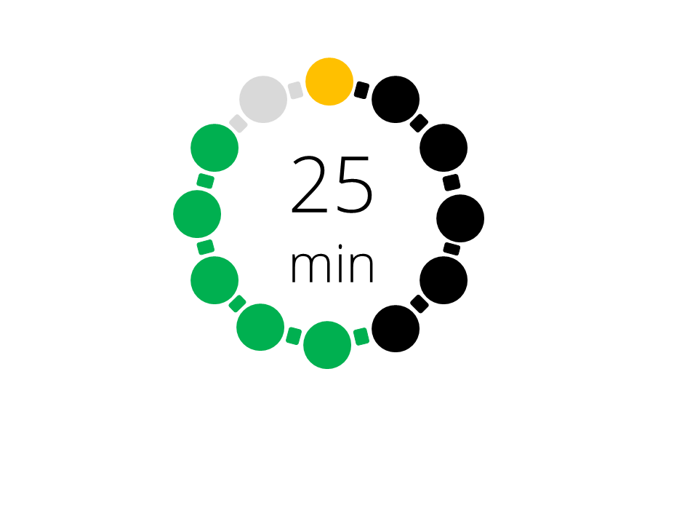 | Main lesson Part 1 – Recap finding the gradient/equation of a line  Show your learners Slide 4 from Lesson 1 Introduction to differentiation presentation. Ask learners to find the gradients of the lines shown. As an extension learners could also revise their knowledge of straight line graphs to write down the actual equations of the lines.  Ensure that students know how to find the gradient of a line.  Main lesson Part 2 – Using tangents to estimate the gradient of a curve  Show your learners Slide 5 from Lesson 1 Introduction to differentiation presentation. A copy of Slide 5 (Worksheet 1a Slide 5) is provided for learners for this lesson.  Ask learners about the issues surrounding finding the gradient of a curve, ensuring that they understand that a curve is a curve because the gradient changes smoothly and is not constant.  Ask learners how they might use the graph to estimate the gradient of the line. Use Slide 5 to model the process of using a tangent to estimate the curve.  Main lesson Part 3 – Investigating the gradient function using tangents  There is some flexibility in the lesson approach here depending on the ability of the class and the choice of learning style. There are three activities one of which could be used as a homework/assessment opportunity  Activity 1: More practise on finding tangents where the scales are different on each axes – this is often something learners struggle with and would be a good precursor to activity 2:  Show slide 6 and ask pupils to estimate the gradient of the curve at the three points indicated (displayed on slides 6-8). Use Worksheet 1b Slide 8, so that your learners can draw the tangents and estimate the gradients. Take care with the scale.  Activity 2: Practising using tangents to find the gradients of a curve with a view to discovering part of the rule y = ax^{n} differentiates to $\frac{\text{d}\text{y}}{\text{d}\text{x}}\text{=}{\text{nax}}^{\text{n}\text{-1}}$ by investigation.  Option 1: Use Worksheet 1c Gradient Function Investigation (paper based) to practise finding the gradient of a curve using tangents. This activity is designed to get the learners to hypothesise that the gradient function for y = x² is 2x. The extra questions can easily be extended to develop the investigation further.  Option 2: Use Worksheet 1d Gradient Function Investigation (IT based) to practise finding the gradient of a curve using tangents and to investigate more accurately the relationship between a function and its gradient function. Learners should quickly spot that the relationship for y = x² is 2x and are then encouraged to look for the relationship between y = ax² + bx + c and the gradient function 2ax + b. This can easily be extended to look at cubic equations.  Activity 3: Use the Worksheet 1e Prior Learning to practise the more basic skills covered in the lesson: substitution, graph recognition, graph drawing, finding gradients of tangents and lines. This is probably best used as a homework/assessment. Note that Q.C2 contains a function containing more than three terms. The syllabus only requires three)
 | Plenary  Quiz to check for understanding using slides 9-15 from Lesson 1 Introduction to differentiation presentation.

Lesson 2: Using differentiation to find the gradient of a curve

Resources |  | - Whiteboard  - Video: Introduction to Calculus  - Lesson 2 Differentiation and gradients presentation  - Worksheet 2a, 2b, 2c.
Learning objectives |  | By the end of the lesson:  - all learners should be able to differentiate a polynomial up to degree 3 and use the derivative to find the gradient of a curve for a specific x-value  - most will be able to use differentiation to find the coordinates of a point on a curve with a specific gradient  - some will begin to understand how we can use differentiation to find local maxima and minima points
Timings | Activity
Starter/Introduction
Teach this lesson using Lesson 2 Differentiation and gradients presentation

Show slide 3. Ask learners to complete the activity (answers on slide 4).

A competitive challenge is to look for the arrangement of x values that would give the highest score. Answers on slide 4.
     | Main lesson Part 1 – Learning how to differentiate a polynomial using the  correct notation  Show your learners the Video: Introduction to Calculus (Slide 5) from 0.00 to 4.05. This explains how to differentiate a function.  Optional: Slides 6-8 cover the same content, linking back to the work from lesson 1, but if using the slides, ensure that the correct language is used and focus on the correct notation.  Give your learners Worksheet 2a: Differentiating polynomials to complete, which provides an assessment opportunity on differentiating polynomials using the correct notation.  Extension: To consider how to reverse the process. A learning opportunity to demonstrate that polynomials with the same shape, but different vertical positions, will have the same gradient function.  Main lesson Part 2 – Using differentiation to find the gradient of a curve at a  point  Show your learners the Video: Introduction to Calculus from 4.00 to 6.45. This explains how to use differentiation to find the gradient of a curve at a point.  Use slides 9-10 to assess learners understanding of the video, or as an alternative to the video to demonstrate how to use differentiation to solve problems relating to the gradient of a curve.  Handout Worksheet 2b Differentiation to find gradients of curves to your learners to complete. It provides an assessment opportunity using differentiation to find gradients of curves and other related problems that link into the next lesson on locating stationary points. Note that Q.5 contains a function of more than three terms. The syllabus only requires three.
 | Plenary  Slides 11-32. Bingo game to reinforce the process of differentiating a polynomial expression and using it to find a gradient. Instructions to follow are on slide 11, and the remaining slides contain the problems for learners to solve and mark off on their 3x3 grids.  Worksheet 2c Card Sort – match the functions to their derived functions (you will need to cut out sets of the cards and give them to your learners). This activity could alternatively be used as homework. Note that there are 4 cards that include more than three functions, but these are good opportunities for extension of your learners. Note that Cards 9, 11, F and G fall outside the syllabus requirements in E2.12 point 2.

Lesson 3: Classifying Turning Points

Resources |  | - Whiteboard  - Video: Introduction to Calculus  - Lesson 3 Classifying turning points presentation  - Worksheet 3a
Learning objectives |  | By the end of the lesson:  - all learners should be able to understand what turning points/stationary points are  - most learners should be able to use differentiation to find and classify turning points
Timings | Activity
 | Starter/Introduction  Teach this lesson using Lesson 3 Classifying turning points presentation.  Show slide 3 and ask learners to answer the questions, to recap the knowledge learned in the previous lesson. Answers are provided on the slide.
   | Main lesson Part 1 – Learning about stationary points and classifying them  Show your learners the Video: Introduction to Calculus (Slide 4) from 6.45 until 10.39.  Get learners to do some of the examples on slides 3 to 13 to check their understanding of the video.  Activity:  Use Worksheet 3a Locating and classifying turning points with your learners. They can check their answers by plotting the graph of the function using Geogebra, Desmos or Autograph. Note Q.4 falls outside the syllabus requirements in E2.12.2.  Extension: Ask students to research the use of the second derivative to classify turning points. They can compare and contrast this method to the method of checking the signs on either side of the turning point.
 | Plenary  Watch the Video: Introduction to Calculus from 10.25 to 11.22 (end). This introduces the concept of stationary points which are not turning points and provides a brief summary of how to classify these points.  Extension: Work through slides 11 to 12 with the students to cover the same content as the video using interactive teaching and worked examples. Start by asking the learners if it possible for the gradient of a curve to be zero at a point and for the point not to be a turning point? Use the example of finding the turning points for y = x³ on slide to show the existence of points of inflection.

Lesson 4: Exam Practise and Second Derivatives

Resources |  | - Whiteboard and mini-whiteboards for the starter  - Video Example Question Calculus  - Lesson 4 Exam Practise and Second Derivative presentation  - Worksheets 4a
Learning objectives |  | By the end of the lesson:  - all learners should be able to apply differentiation to turning points in the context of an examination question  - all learners should be able to discriminate between maxima and minima by any method in the context of an examination question  - some learners will be able to use the second derivative to classify turning points
Timings | Activity
Starter/Introduction
Teach this lesson using Lesson 4 Exam Practise and Second Derivatives presentation.
Hand out mini-whiteboards and show slides 3 to 6 in turn. The learners should take about 1 minute to work out the answers to the questions on their whiteboard and show the results when instructed by the teacher. The activity provides for an assessment opportunity as well as a chance to recap key knowledge covered in lessons 1 to 3.
       | Main lesson Part 1 – Exam Style Question Walkthrough  Ensure that learners have a copy of the question Worksheet 4a Exam-style question so that they have a copy of the exam question to work through. The question and the answer are on Slide 7.  Show your learners the Video: Example Calculus Question (Slide 8) from 0.00 to 1.06. Pause at this point to enable the learners to consider the steps required to answer part (a) of the question.  If learners are able to identify the steps then they should attempt this part of the question. If learners are not able to identify the steps then they should review their notes and discuss in pairs how this part of the question should be approached.  Show your learners the Video: Example Calculus Question from 1.06 to 4.12 and get them to mark their work.  Pause the video at this point and ask the learners to consider the steps required to answer part (b) of the question. Start by asking the learners to consider whether they expect each point to be a maximum or minimum point. They can use their knowledge of the shape of cubic graphs to identify whether each point would be expected to be a maximum or a minimum point.  Ask the learners to consider how to approach this part of the question (there are two possible methods which are considered in the video – the first is considering the sign of the gradient on either side of the turning point, the second is using the second derivative).  Extension: As an extension, for more able students, you might like to ask them to use both methods.  Learners should then attempt this part of the question. Learners who are struggling should review their notes and discuss in pairs how this part of the question should be approached.  Show your learners the Video: Example Calculus Question from 4.12 to 8.40 (end). The section from 4.12 to 4.50 covers the shape of the graph and whether each point would be expected to be a maximum or minimum. The section from 4.50 to 6.49 covers determining whether each point is a maximum or minimum by considering the gradient on either side of the turning point. The section from 6.49 to 8.40 (end) covers determining whether each point is a maximum or minimum by considering the second derivative.  You may wish to show the sections separately depending upon the confidence of the learners. It may also be that you do not wish to show both methods.  Ask learners to produce a summary of the steps taken to determine the type of turning point.  Main lesson Part 2 – Exam Style Question Practise  Slides 9 and 10. Ask the learners to practise more exam style questions.  Extension: Learners can use this as an opportunity to practise using the second derivative to classify stationary points.
Plenary
Slide 11. Ask the learners to write a 5 point summary outlining the key messages and facts they have learned about in this unit on differentiation.

Worksheets and answers

 | Worksheets | Answers
For use in Lesson 1:
1a: Slide 5 | 16 | N/A
1b: Slide 7 | 17 | N/A
1c: Gradient Function Investigation (paper based) | 18-21 | N/A
1d: Gradient Function Investigation (IT based) | 22-27 | N/A
1e: Prior Learning Worksheet (Homework) | 28-33 | 44-45
For use in Lesson 2:
2a: Differentiating polynomials | 34 | 46
2b: Differentiation to find gradients of curves | 35-37 | 47-48
2c: Card Sort | 38-39 | 49
For use in Lesson 3:
3a: Locating and classifying turning points | 40-42 | 50-52
For use in Lesson 4:
4a: Exam-style question | 43 | N/A

Worksheet 1a: Slide 5
The graph shown is y = x³ – 2x² + 1

What can you say about the gradient of the graph?

How can we estimate the gradient of the graph at the coordinate (2,1)?

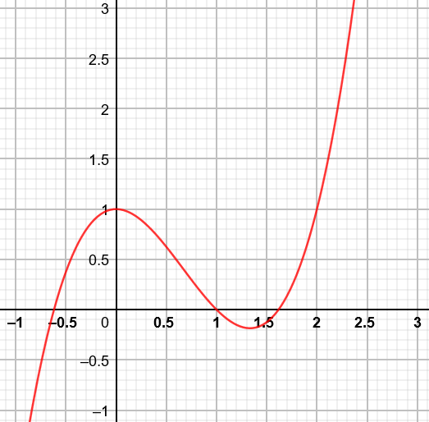

Worksheet 1b: Slide 8
This is a section of the graph y = x³ + x² – 6 plotted between x = -4 and x = 3. Use tangents to estimate the gradient of the curve at the points labelled B, C and D.
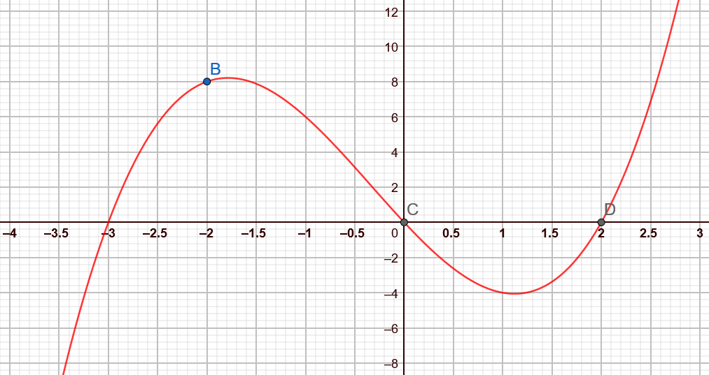

Worksheet 1c: Gradient Function Investigation (paper based)
Investigation to find the gradient function of y = x² by drawing tangents
Use the graph on the next page to estimate the gradient of the curve y = x² at each of the x-values given in the table:
x-coordinate | -4 | -3 | -2 | -1 | 0 | 1 | 2 | 3 | 4
Gradient of the curve

a) There is a simple relationship between the gradient of the curve and the x-coordinate value. Use your table
of results to suggest what this relationship might be.

b) If we repeated this task for the graphs of
i) y = x² + 1
ii) y = x² – 3
iii) y = -x²
iv) y = 2x²
v) y = x² + x
How would the relationship that you suggested in part (a) change? (The graphs of y = 2x² and y = x² + x are printed for you to test your ideas)

Worksheet 1c: Gradient Function Investigation (paper based) continued
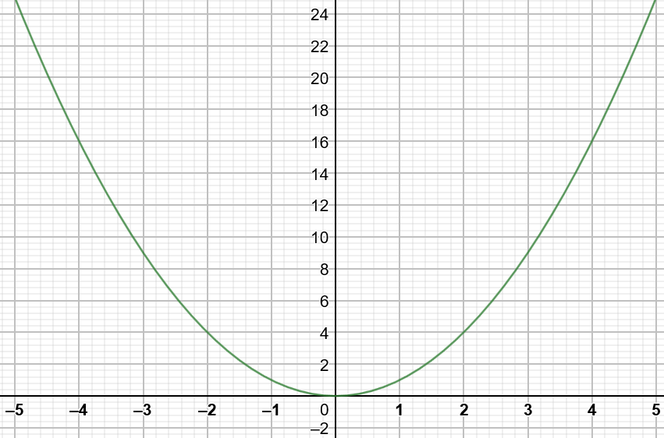
y = x²
Worksheet 1c: Gradient Function Investigation (paper based) continued
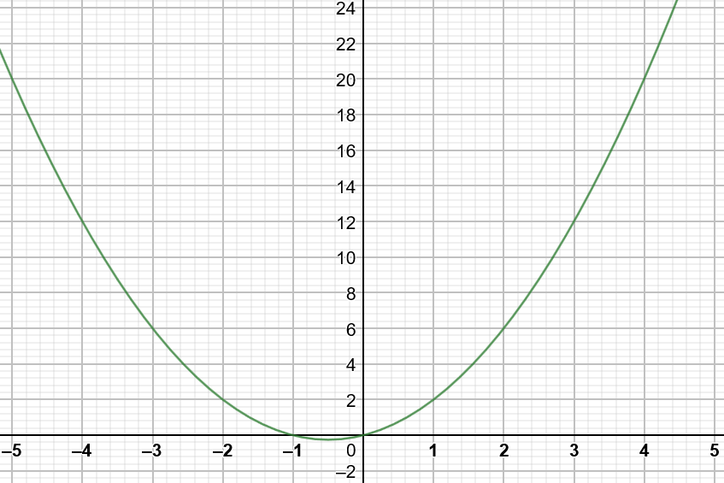
y = x² + x

Worksheet 1c: Gradient Function Investigation (paper based) continued
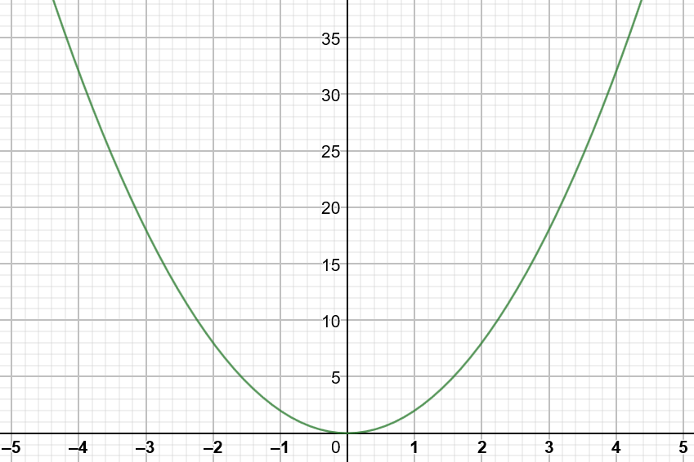
y = 2x²
Worksheet 1d: Gradient Function Investigation (IT based)
Investigation to find the gradient function of y = x² by drawing tangents using GeoGebra*
* or use an alternative graphing package such as DESMOS or Autograph
You can download GeoGebra for free here https://www.geogebra.org/download and install it. However, GeoGebra will run on any modern browser without needing to be installed. To do this:
- Navigate to the GeoGebra home page https://www.geogebra.org/
- Choose and click on the appropriate app (GeoGebra Classic) to open it
- Open the top right main menu and click on ‘Open’
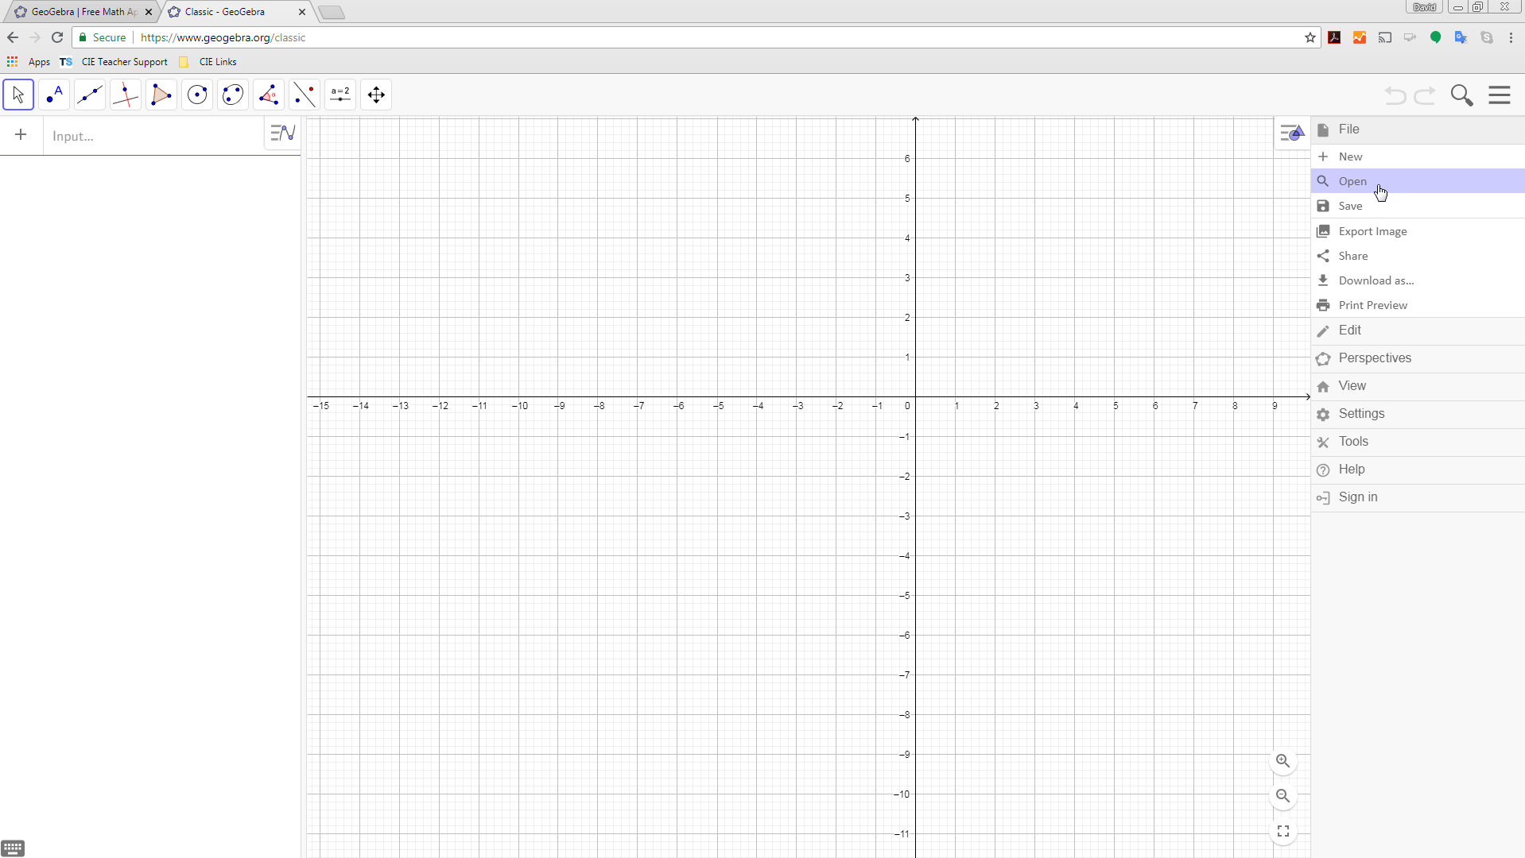
Worksheet 1d: Gradient Function Investigation (IT based) continued
- Select the folder button to choose a file, and navigate to the GeoGebra file you want to open
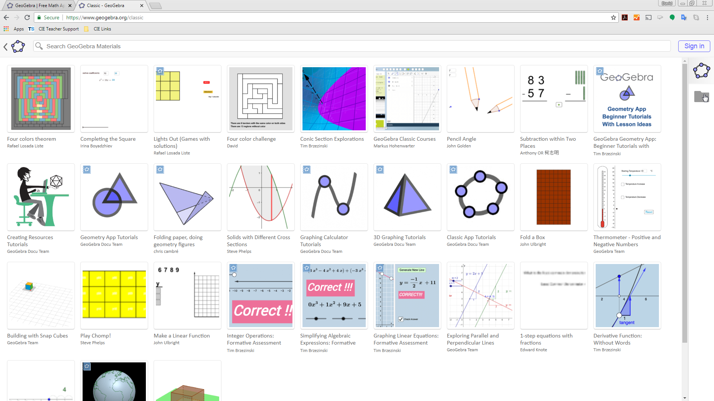

Worksheet 1d: Gradient Function Investigation (IT based) continued
Load the file: Investigating the gradient function using geogebra.ggb

Once loaded the file allows you to find the gradient of a tangent to a curve of your choice at any point on the curve.
The default file shows:
- The graph of y = x²
- A tangent drawn at the point (2,4)
- The gradient of the tangent = 4

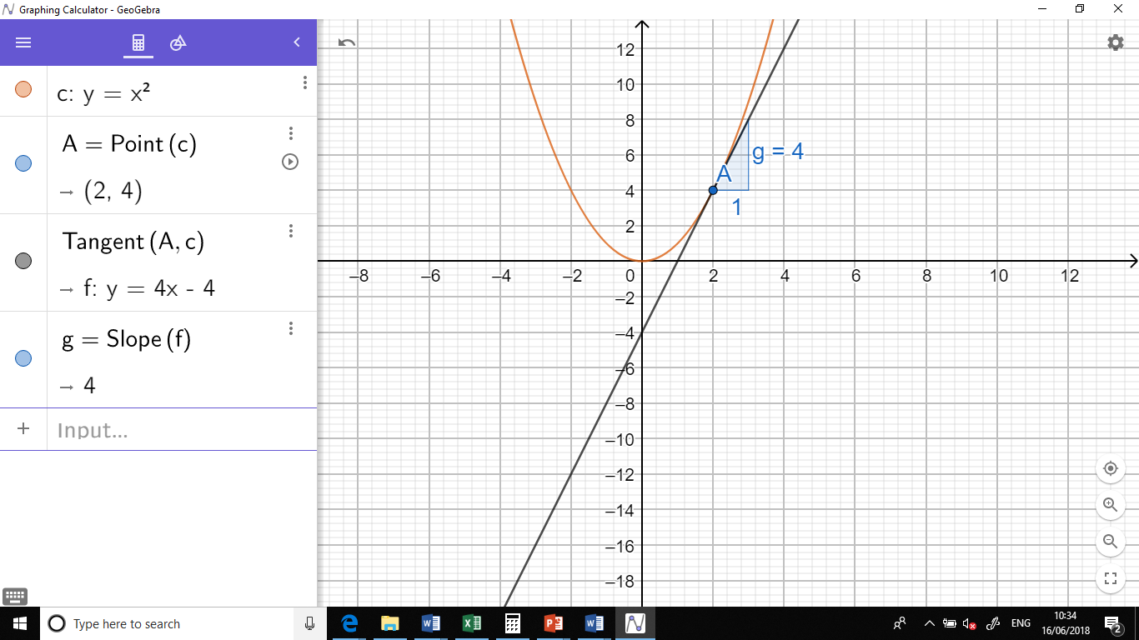

Worksheet 1d: Gradient Function Investigation (IT based) continued
You can change the graph by editing the equation here.

The gradient of the tangent is the value of g, shown next to the triangle used to calculate the gradient here.
You can move the tangent to a new position on the curve by dragging the point A on the graph here.

Worksheet 1d: Gradient Function Investigation (IT based) continued
x-coordinate | -4 | -3 | -2 | -1 | 0 | 1 | 2 | 3 | 4
Gradient of the curve
Use the graph to estimate the gradient of the curve y = x² at each of the x-values given in the table:

a) There is a simple relationship between the gradient of the curve and the x-coordinate value. Use your table
of results to suggest what this relationship might be.

b) If we repeated this task for the graphs of
i) y = x² + 1
ii) y = x² – 3
iii) y = -x²
iv) y = 2x²
v) y = x² + x

Worksheet 1d: Gradient Function Investigation (IT based) continued
How would the relationship that you suggested in part (a) change?

Draw each of these graphs in turn to verify your results.
c) Can you find a relationship between the graph of y = ax² + bx + c and its gradient function?

Worksheet 1e: Prior Learning Worksheet
A) Recognising Types of graphs
Match each graph to its equation:
1) y = x² – 2x 2) y = 2x – x² 3) y = 2x + 1
4) y = 1 – 2x 5) y = 2x – x³ 6) y = x³ – 2x
A B
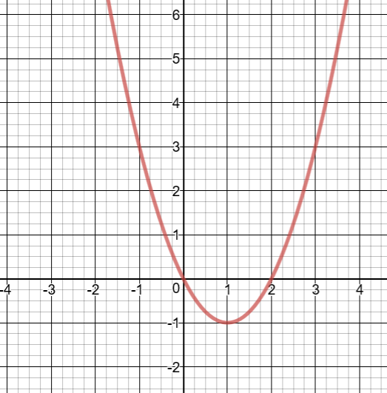
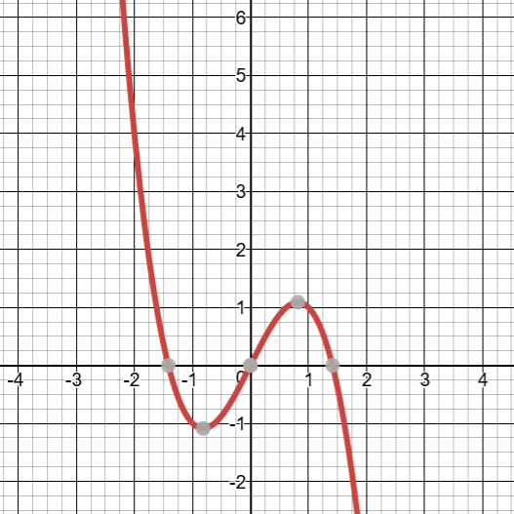

C D
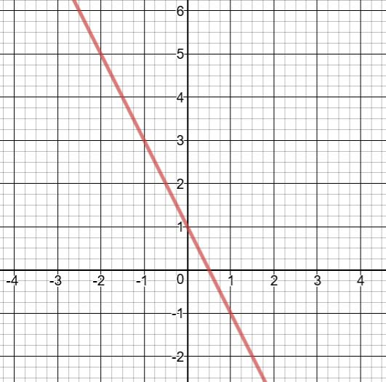
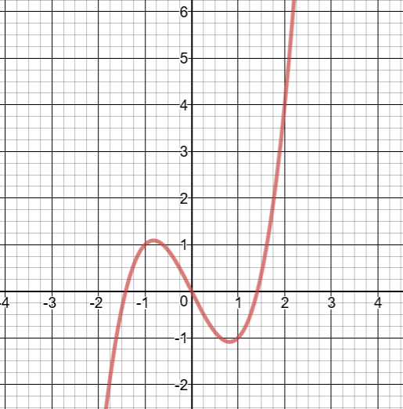

E F
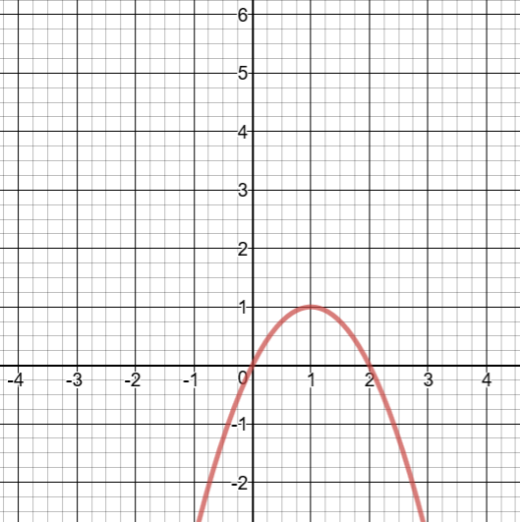
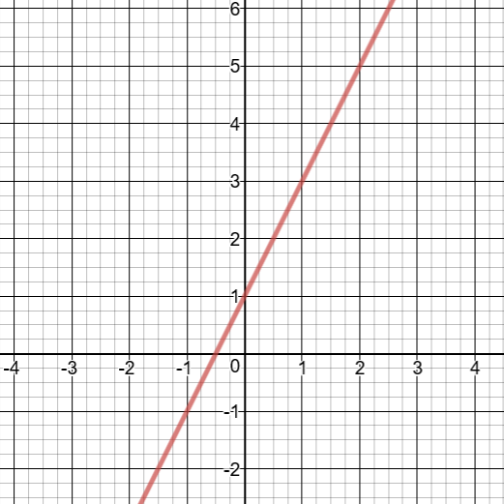

Worksheet 1e: Prior Learning Worksheet continued
B) Finding gradients of lines
1) 2)
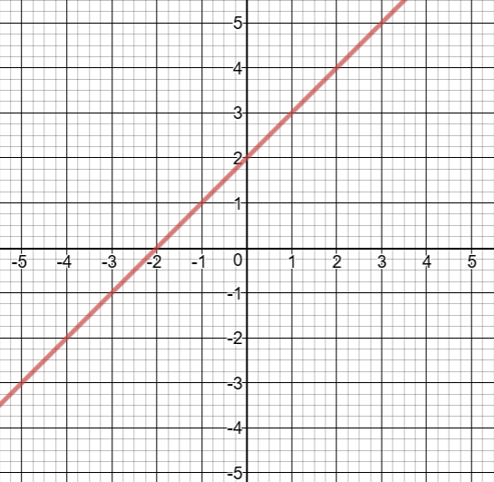
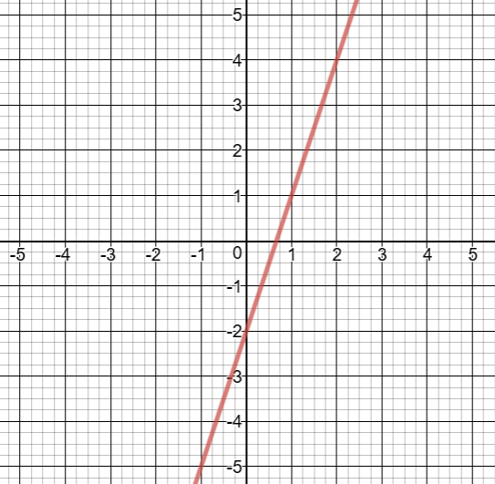

3) 4)
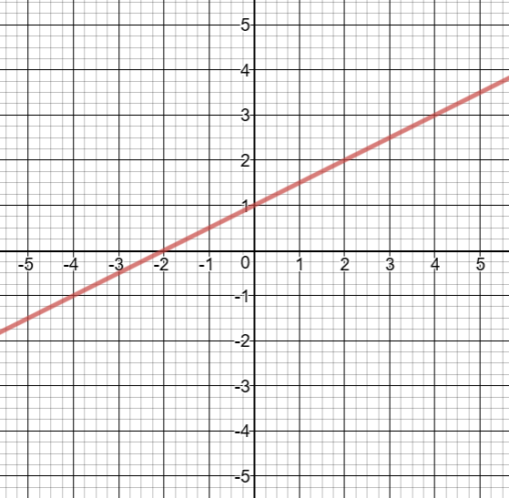
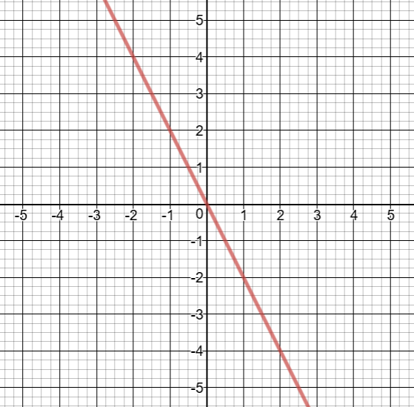

5) 6)
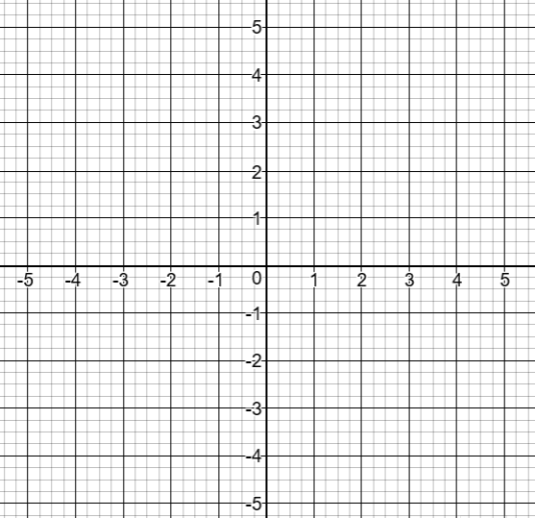
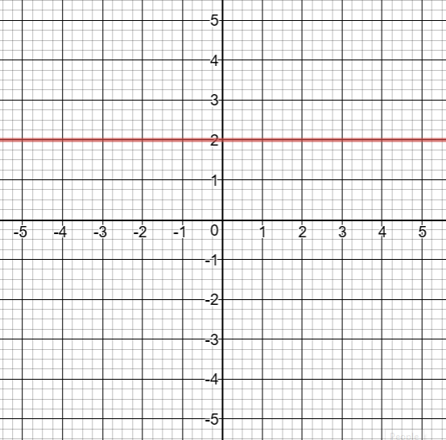

Worksheet 1e: Prior Learning Worksheet continued
C) Drawing tangents and estimating gradients of curves
1. Look at the graph below:

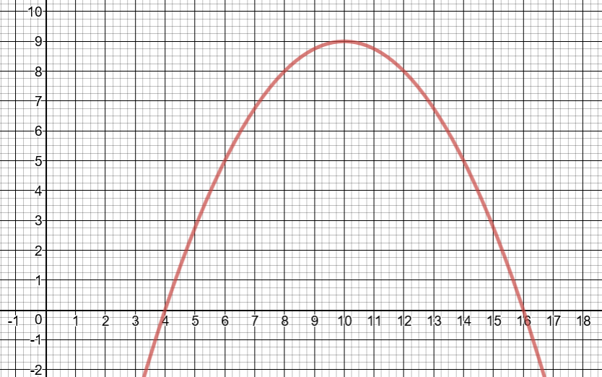
a) Use a tangent to the curve at the point when x = 8 to make an estimate of the gradient of the
curve at this point.
b) Use a tangent to the curve at the point when x = 14 to make an estimate of the gradient of the
curve at this point.

Worksheet 1e: Prior Learning Worksheet continued
2. The graph below shows the function y = 0.25x³–x²–x+4

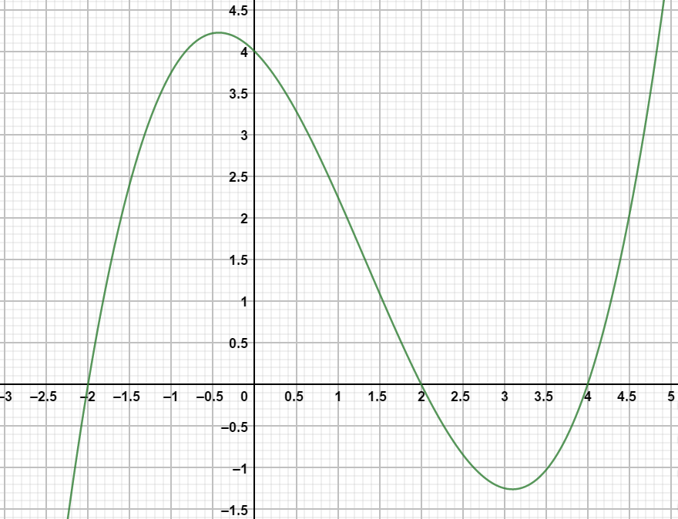

Use tangents to estimate the gradient of the curve for the following x values:

a) x = -2

b) x = 0

c) x = 2

d) x = 4

Worksheet 1e: Prior Learning Worksheet continued
D) Substituting Values into functions/Drawing graphs
1) Let y = x² – 2x – 3
Complete the table of values below for values of x from -1 to 4.
x | -1 | 0 | 1 | 2 | 3 | 4
y

Use the table of values to plot the graph of y = x² – 2x – 3 for x values between -1 and 4 on the
axes below:
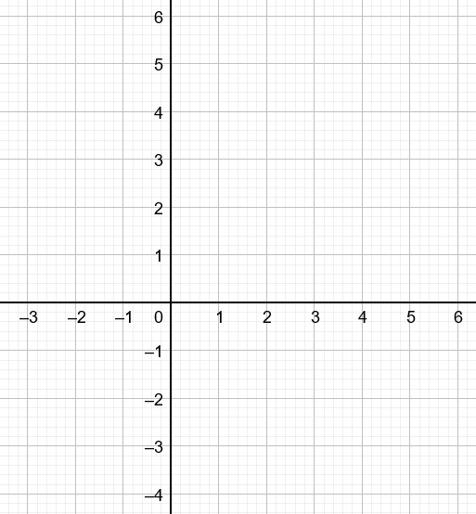

Worksheet 1e: Prior Learning Worksheet continued
2) Let y = x³ – 4x² + 5
Complete the table of values below for values of x from -1 to 4.
x | -1 | 0 | 1 | 2 | 3 | 4
y

Use the table of values to plot the graph of y = x³ – 4x² + 5 for x values between -1 and 4 on the axes below:

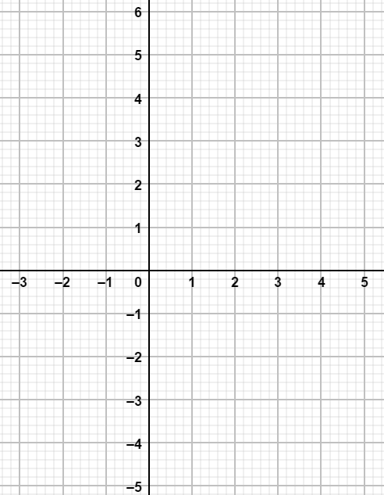

Worksheet 2a: Differentiating polynomials
Copy and complete this table, the first line has been completed for you:
Function | Derivative
y = 2x³ | $$\frac{\text{d}\text{y}}{\text{d}\text{x}} \text{=} \text{6}{\text{x}}^{\text{2}}$$
y = 3x – 2
y = 7
y = 3x² + 2x – 4
y = 5x³ + 2x² – 3x
y = 4 – 3x³
y = 2x + 1
y = 5x
y = 1 – ½x
y = 5x² – 2x + 1
 | $$\frac{\text{d}\text{y}}{\text{d}\text{x}} \text{=} \text{3}$$
 | $$\frac{\text{d}\text{y}}{\text{d}\text{x}} \text{=} \text{4}\text{x} \text{–} \text{2}$$

Worksheet 2b: Differentiation to find gradients of curves
1. Find the gradient of the curve y = 3x² – 5x + 1 at the point (4, 29).

2. Find the gradient of the curve y = 2x³ – x² + 3x at the point (-2, -26).

3. Find the coordinate where the curve y = x² – 3x + 1 has a gradient of 7.

4. Find the coordinate where the curve y = 3x² + 4x – 1 has a gradient of -2.

5. Find the coordinates where the graph of y = x³ – 7x² +15x + 1 has a gradient of 20.

6.
a. Find the gradient of the curve y = 2x³ – 54x + 7 when x = 3.

b. What does this tell you about the graph at this point?

Worksheet 2b: Differentiation to find gradients of curves continued
c. What other ‘x’ coordinate has the same property?

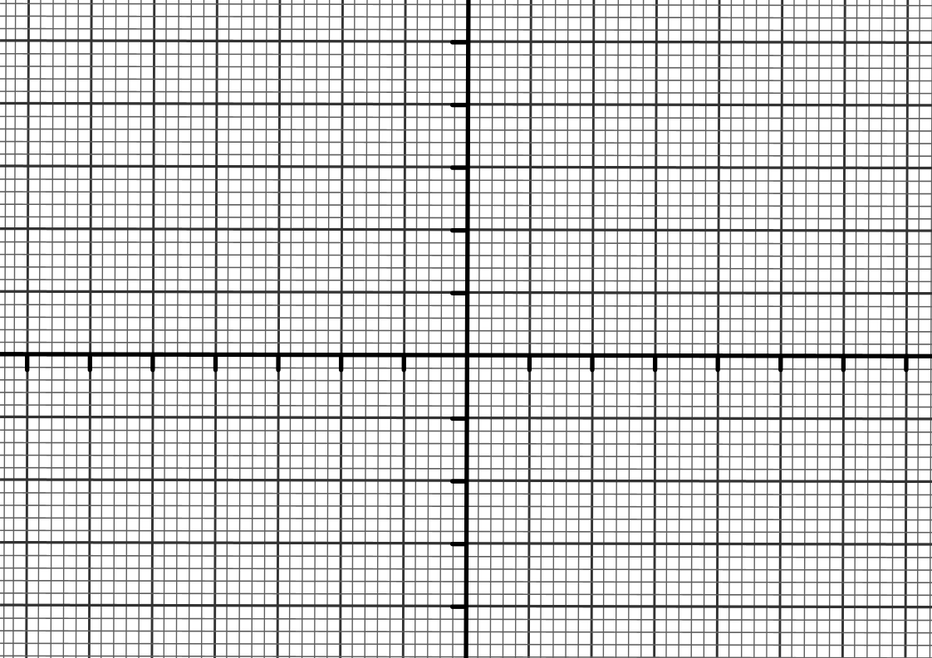
d. Can you use this to sketch the graph of y?

Worksheet 2b: Differentiation to find gradients of curves continued
7. Consider the graph y = 3x² – x³.
a. What are the x values where the graph has a gradient of zero?

b. Use this information to sketch the graph.
Worksheet 2c: Card Sort

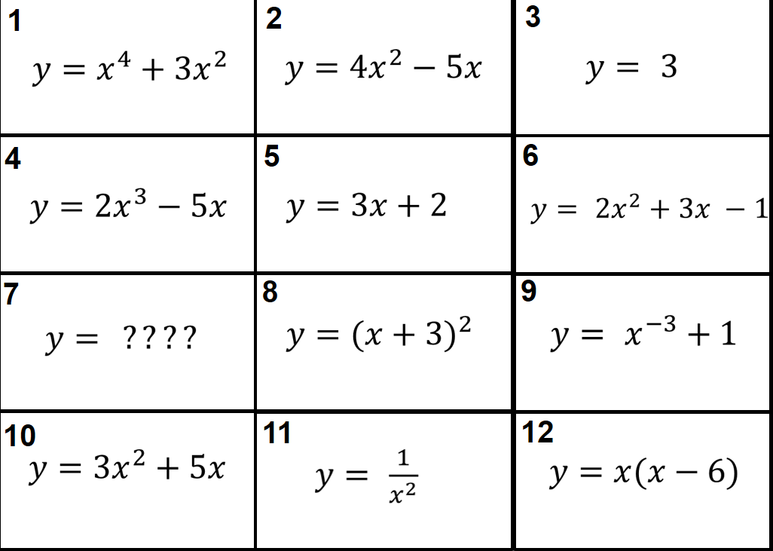
y = 6x + 7

Worksheet 2c: Card Sort continued

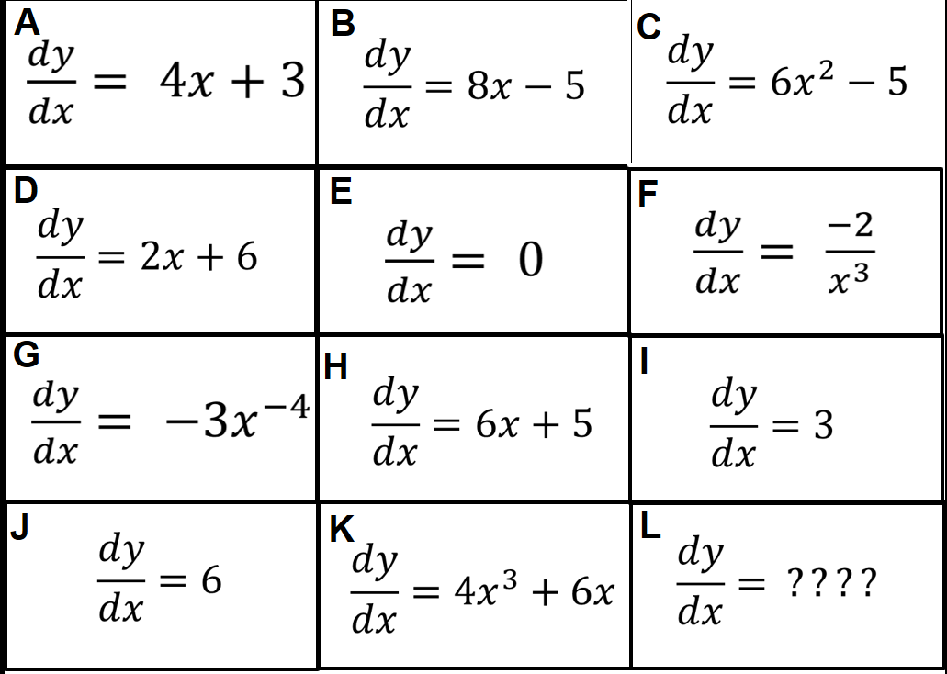
2x – 6

Worksheet 3a: Locating and classifying turning points
1) Let y = 2x² + 6x – 3.
Find and classify the turning points, hence sketch the graph.

2) Let y = 8x – 2x².
Find and classify the turning points, hence sketch the graph.

Worksheet 3a: Locating and classifying turning points contd
3) Let y = x³ – 12x.
Find and classify the turning points, hence sketch the graph.
4) Let y = x³ – 4x² – 3x + 1.
Find and classify the turning points, hence sketch the graph.

Worksheet 3a: Locating and classifying turning points contd
5) A ball is thrown from the ground at an angle of 30 degrees to the horizontal. The height, h, of a ball is related to the time that the ball is in flight, t, by the equation:

h = 2 + 12t – t²

What is the maximum height obtained by the ball?

Plot the graph to verify this result.

Worksheet 4a: Exam-style question
A curve has equation y = x³ – 6x² + 16.

(a) Find the coordinates of the two turning points.

(b) Determine whether each of the turning points is either a maximum or a minimum. Give reasons for your answers.

Worksheet 1e: Answers
Answers:
A) 1 and B 2 and F 3 and E 4 and D 5 and A 6 and C
B) 1) 3 2) 1 3) -2 4) ½ 5) 0 6) -1
C) 1) a) gradient = 1 (tangent is y = x)
b) gradient = -2 (tangent is y = -2x + 33)

2) a) gradient = 6 (tangent is y = 6x + 12)
b) gradient = -1 (tangent is y = -x + 4)
c) gradient = -2 (tangent is y = -2x + 4)
d) gradient = 3 (tangent is y = 3x – 12)

D) 1)
x | -1 | 0 | 1 | 2 | 3 | 4
y | 0 | -3 | -4 | -3 | 0 | 5
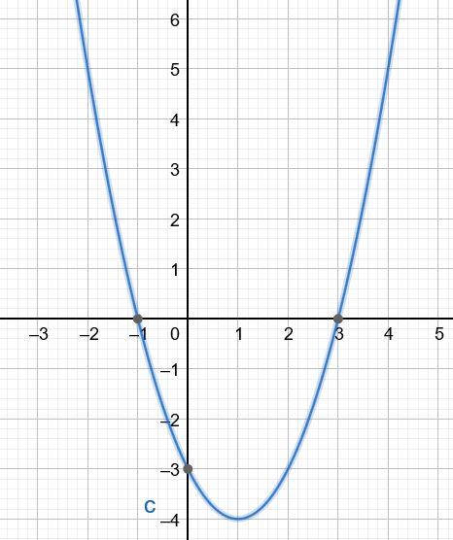
Worksheet 1e: Answers continued
2)
x | -1 | 0 | 1 | 2 | 3 | 4
y | 0 | 5 | 2 | -3 | -4 | 5

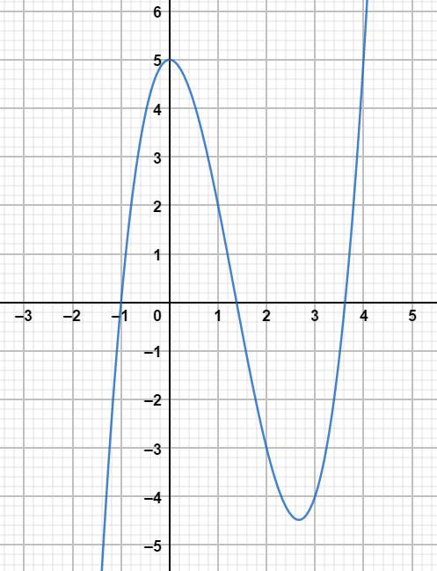

Worksheet 2a: Answers
Function | Derivative
y = 2x³ | $$\frac{\text{d}\text{y}}{\text{d}\text{x}} \text{=} \text{6}{\text{x}}^{\text{2}}$$
y = 3x – 2 | $$\frac{\text{d}\text{y}}{\text{d}\text{x}} \text{=} \text{3}$$
y = 7 | $$\frac{\text{d}\text{y}}{\text{d}\text{x}} \text{=} \text{0}$$
y = 3x² + 2x – 4 | $$\frac{\text{d}\text{y}}{\text{d}\text{x}} \text{=} \text{6}\text{x}\text{+2}$$
y = 5x³ + 2x² – 3x | $$\frac{\text{d}\text{y}}{\text{d}\text{x}}\text{ = 15}{\text{x}}^{\text{2}} \text{+} \text{4}\text{x} \text{–} \text{3}$$
y = 4 – 3x³ | $$\frac{\text{d}\text{y}}{\text{d}\text{x}}\text{ = } \text{– 9}{\text{x}}^{\text{2}}$$
y = 2x + 1 | $$\frac{\text{d}\text{y}}{\text{d}\text{x}} \text{=} \text{2}$$
y = 5x | $$\frac{\text{d}\text{y}}{\text{d}\text{x}} \text{=} \text{5}$$
y = 1 – ½x | $$\frac{\text{d}\text{y}}{\text{d}\text{x}}\text{ = –}\frac{\text{1}}{\text{2}}$$
y = 5x² – 2x + 1 | $$\frac{\text{d}\text{y}}{\text{d}\text{x}}\text{ = 10}{\text{x}}^{} \text{– 2}$$
y = 3x ± something | $$\frac{\text{d}\text{y}}{\text{d}\text{x}} \text{=} \text{3}$$
y = 2x² – 2x ± something | $$\frac{\text{d}\text{y}}{\text{d}\text{x}} \text{=} \text{4}\text{x} \text{–} \text{2}$$

Worksheet 2b: Answers
1. $\frac{\text{d}\text{y}}{\text{d}\text{x}} \text{=} \text{6}\text{x} \text{–} \text{5}$ when x = 4 $\frac{\text{d}\text{y}}{\text{d}\text{x}} \text{=} \text{19}$ so gradient is 19
2. $\frac{\text{d}\text{y}}{\text{d}\text{x}}\text{ = 6}{\text{x}}^{\text{2}} \text{– 2}\text{x}\text{ + 3}$ when x = -2 $\frac{\text{d}\text{y}}{\text{d}\text{x}} \text{=} \text{31}$ so gradient is 31
3. $\frac{\text{d}\text{y}}{\text{d}\text{x}} \text{=} \text{2}\text{x} \text{–} \text{3}$ Solving 2x – 3 = 7 x = 5, y = 11 so (5, 11)
4. $\frac{\text{d}\text{y}}{\text{d}\text{x}} \text{=} \text{6}\text{x} \text{+ 4}$ Solving 6x + 4 = -2 x = -1, y = -2 so (-1, -2)
5. $\frac{\text{d}\text{y}}{\text{d}\text{x}}\text{ = 6}x^{2} \text{– 14}\text{x}\text{ + 15}$ Solving 3x² – 14x + 15 = 20
Solving 3x² – 14x – 5 = 0
(3x + 1)(x – 5) = 0
x = $\text{-}\frac{\text{1}}{\text{3}}$ and x = 5
Coordinates ($\text{-}\frac{\text{1}}{\text{3}}$, -4$\frac{\text{22}}{\text{27}}$) and (5, 26)
6.
a. $\frac{\text{d}\text{y}}{\text{d}\text{x}}\text{ = 6}{\text{x}}^{\text{2}}\text{ – 54}$ when x = 3 $\frac{\text{d}\text{y}}{\text{d}\text{x}} \text{=} \text{0}$ so gradient is 0
b. The gradient is horizontal, graph must have a local maxima or local minima
c. 6x² – 54 = 0 solving x = -3 as well as 3
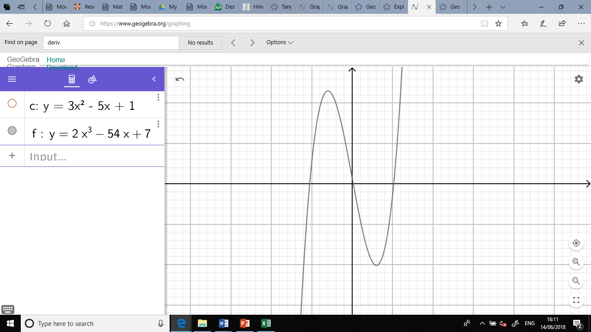

Worksheet 2b: Answers continued
7. $\frac{\text{d}\text{y}}{\text{d}\text{x}}\text{ = 6}\text{x}\text{ – 3}{\text{x}}^{\text{2}}$ when $\frac{\text{d}\text{y}}{\text{d}\text{x}}\text{ = 0}$ 0 = 6x – 3x²
0 = 3x(2 – x)
X = 0 or 2
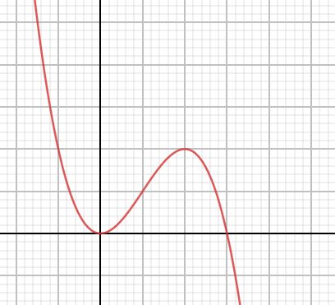

Worksheet 2c: Answers
Answers to the Card Sort match-up:
1 and K
2 and B
3 and E
4 and C
5 and I
6 and A
7 and J
8 and D
9 and G
10 and H
11 and F
12 and L

Worksheet 3a: Answers
1) Turning point is a minimum at (-1.5, -7.5)

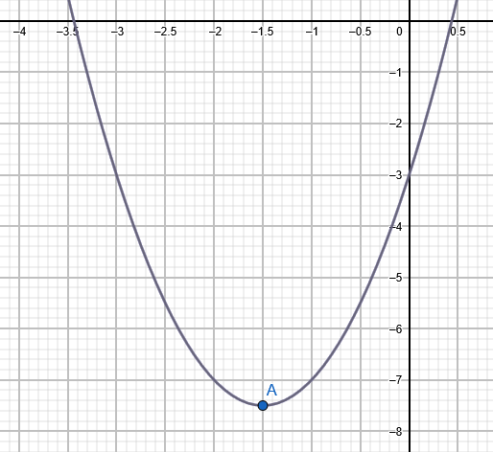

2) Maximum point at (2, 8)

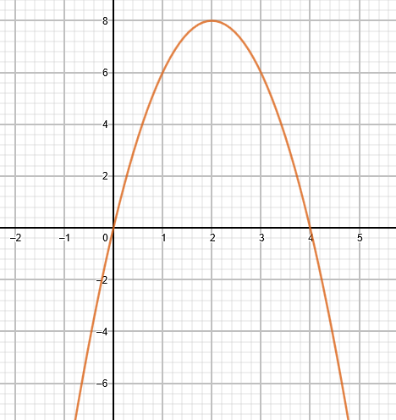

Worksheet 3a: Answers continued
3) Maximum point at (-2, 16) Minimum point at (2, -16)

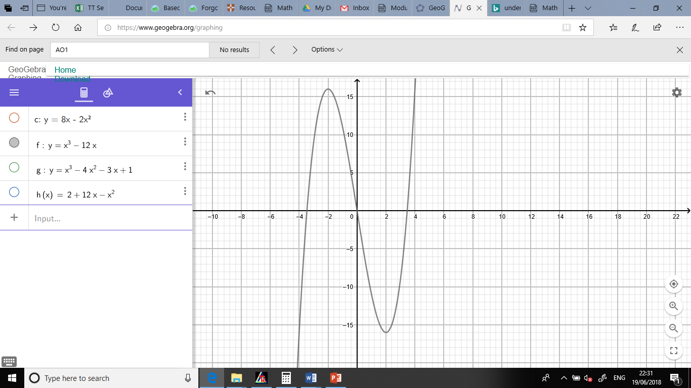

4) Maximum point at (-0.333, 1.52) Minimum point at (3, -17)

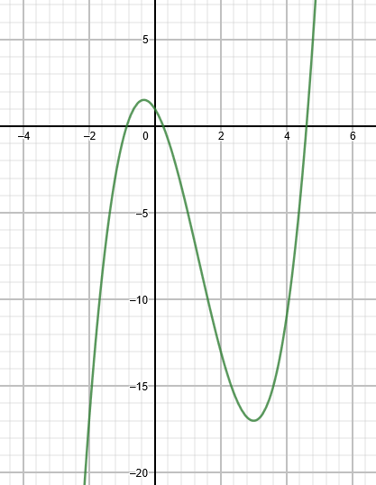

Worksheet 3a: Answers continued
5) Maximum height 38m when t = 6s

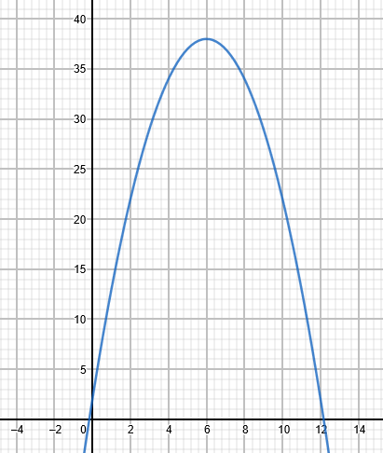

Cambridge Assessment International Education
The Triangle Building, Shaftsbury Road, Cambridge, CB2 8EA, United Kingdom
t: +44 1223 553554
e: info@cambridgeinternational.org www.cambridgeinternational.org

© Cambridge University Press & Assessment 2022

