

Teaching Pack
Scale drawing
Cambridge IGCSE™
Mathematics 0580

This Teaching Pack can also be used with the following syllabuses:
• Cambridge IGCSE™ (9–1) Mathematics 0980
• Cambridge IGCSE™ International Mathematics 0607
• Cambridge O Level Mathematics 4024

© Cambridge University Press & Assessment 2024
Cambridge Assessment International Education is part of Cambridge University Press & Assessment. Cambridge University Press & Assessment is a department of the University of Cambridge.

Cambridge University Press & Assessment retains the copyright on all its publications. Registered centres are permitted to copy material from this booklet for their own internal use. However, we cannot give permission to centres to photocopy any material that is acknowledged to a third party even for internal use within a centre..
Contents
Contents 3
Introduction 5
Skill: Scale drawing 6
Common misconceptions: Scale drawing 8
Lesson 1: Similar shapes and scale factors 9
Lesson 2: Maps 11
Lesson 3: Other real-life examples of scale drawings 13
Lesson 4: Extended scale and area (Extended only) 16
Links to websites: Scale drawing 17
Worksheets and answers 18
Worksheet 1a: Similar shapes and scale factors 19
Worksheet 1a: Similar shapes and scale factors continued 20
Worksheet 1a: Similar shapes and scale factors continued 21
Worksheet 1b: Proportional reasoning template 22
Worksheet 2a: Scale drawings and maps 23
Worksheet 2a: Scale drawings and maps continued 24
Worksheet 2a: Scale drawings and maps continued 25
Worksheet 2a: Scale drawings and maps continued 26
Worksheet 2b: Multiple choice quiz 27
Worksheet 2b: Multiple choice quiz 28
Worksheet 3a: Doing the mathematics 29
Worksheet 3a: Doing the mathematics continued 30
Worksheet 3b: Drawing a floor plan to scale 31
Worksheet 3c: Designing a racing track 32
Worksheet 3d: Designing a racing track hints 33
Worksheet 1a: Answers 34
Worksheet 1a: Answers continued 35
Worksheet 1a: Answers continued 36
Worksheet 1a: Answers continued 37
Worksheet 1a: Answers continued 38
Worksheet 2a: Answers 39
Worksheet 2a: Answers continued 40
Worksheet 2b: Answers 41
Worksheet 2b: Answers continued 42
Worksheet 2b: Answers continued 43
Worksheet 3a: Answers 44
Worksheet 3a: Answers continued 45
Worksheet 3a: Answers continued 46
Worksheet 3a: Answers continued 47

Icons used in this pack:
 | Lesson
 | Video
 | Assessment opportunity

Introduction
This pack will help you to develop your learners’ mathematical skills as defined by assessment objective 1 (AO1 Knowledge and understanding of mathematical techniques) in the course syllabus.

Important note
Our Teaching Packs have been written by classroom teachers to help you deliver topics and skills that can be challenging. Use these materials to supplement your teaching and engage your learners. You can also use them to help you create lesson plans for other skills.

This content is designed to give you and your learners the chance to explore mathematical skills. It is not intended as specific practice for exam papers.

This is one of a range of Teaching Packs. Each pack is based on one mathematical topic with a focus on specific mathematical techniques. The packs can be used in any order to suit your teaching sequence.

In this pack you will find the lesson plans and worksheets for learners you will need to successfully complete the teaching of this mathematical skill.

Skill: Scale drawing
This Teaching Pack links to the following syllabus content (see syllabus for detail):
- C4.3 Read and make scale drawings
- E4.3 Read and make scale drawings

For assessments from 2025
- C/E4.3 Draw and interpret scale drawings

The pack covers the following mathematical skills, adapted from AO1: Demonstrate knowledge and understanding of mathematical techniques (see syllabus for assessment objectives):
- organising, processing and presenting information accurately in written, tabular, graphical and diagrammatic forms
- using geometrical instruments to measure and to draw to an acceptable degree of accuracy
- recognising and using spatial relationships in two and three dimensions.

For assessments from 2025
AO1: Knowledge and understanding of mathematical techniques
- understand and use mathematical notation and terminology
- perform calculations with and without a calculator

Prior knowledge
Knowledge from the following syllabus topics is useful for this experiment.
- C5.1 Use current units of mass, length, area, volume and capacity in practical situations and express quantities in terms of larger or smaller units.
- E5.1 Use current units of mass, length, area, volume and capacity in practical situations and express quantities in terms of larger or smaller units.

For assessments from 2025
- C/E5.1 Use metric units of mass, length, area volume and capacity in practical situations and convert quantities into larger or smaller units.

Going forward
The knowledge and skills gained from this Teaching Pack can be used for when you teach learners about scale factors and bearings.
- C7.2 Construct given translations and enlargements of simple plane figures. Recognise and describe reflections, rotations, translations and enlargements.
- E7.2 Construct given translations and enlargements of simple plane figures. Recognise and describe reflections, rotations, translations and enlargements

For assessments from 2025
- C/E4.3 Use and interpret three-figure bearings.
- C/E4.4 Calculate lengths of similar shapes
E4.4 Use the relationships between lengths and areas of similar shapes and lengths, surface area and volumes of similar solids.
Solve problems and give simple explanations involving similarity.
- C/E7.1 Recognise, describe and draw the following transformations:
1 reflection of a shape in a straight line.
2 rotation of a shape from a given centre through multiples of 90°.
3 enlargement of a shape from a given centre by a given scale factor.
4 translation of a shape by a given vector $\left({x \atop y}\right)$.

Before you begin
This Teaching Pack includes a Teacher Introduction video to which you should refer before
using the resources in this pack. The video is available to watch in Resource Plus within the topic section relevant to this Teaching Pack.

The video introduces the resources available for teaching this topic, and explains how they can be used to successfully deliver the topic to your learners. In particular, the video highlights typical learner misconceptions and common errors this Teaching Pack will help you to overcome.

Common misconceptions: Scale drawing
Scale drawing is an aspect of proportional reasoning, and it is important to establish that the scale of a scale drawing is a ratio that compares length measurements in the drawing of an object to corresponding actual length measurements. For example, the number of kilometres on the ground, to centimetres on the map.

The terms 'large scale' and 'small scale' are used to describe different scales. However, they can be confusing. Learners need to understand that large scale maps for example, have low numbers in the scale, such as 1: 1250. The features are shown are large, and therefore you can show a lot more detail. Small-scale maps have a high number in the scale, such as 1: 250000. Individual features shown are small and you can therefore see less detail, but a much wider view.

Learners often struggle to decide whether they need to multiply or divide when converting between different units, such as kilometres and centimetres or millimetres and metres. Encourage learners to make sense of the answers to these questions themselves, by asking questions such as “would you expect more or less centimetres than metres? And does this mean you need to divide or multiply?”

Lesson 1: Similar shapes and scale factors

- Whiteboard
- Lesson 1 Similar shapes and scale factors presentation
- Worksheet 1a, 1b.
Learning objectives |  | By the end of the lesson:  - all learners should know what it means when two shapes are similar.  - all learners should be able to find a missing length when two shapes are similar.
Timings | Activity
 | Starter/Introduction  Teach this lesson using Lesson 1 Similar shapes and scale factors presentation.  The unit begins with this lesson which reminds learners about similar shapes in mathematics. You will develop the link between this and scale drawings in subsequent lessons.  Slide 3 starts with a simple example of how we can find missing dimensions in similar shapes by calculating the scale factor. Ask your learners to work through it with you on screen. They should have met similar shapes in other units for example unit 5.1 on conversions.
 | Main lesson  Slide 4 Uses the example from the starter to remind learners of the representation used in the conversions unit for proportional reasoning problems.  If you haven’t taught the unit 5.1 on conversions you may need to go through this more slowly and in greater detail.  If learners struggle accepting the final step on the slide encourage them to check it on a calculator by dividing 2 by 2, and then multiplying by 3.  They could also try some other examples to consolidate their understanding. Tell learners that scale drawing is a type of conversion.  Give learners Worksheet 1a Similar shapes and scale factors to complete. It contains some questions to answer.  Worksheet 1b Proportional reasoning template can be used as a template to support learners when working on this worksheet 1a.  You could use this link to further reinforce the link between ratio and scale drawings, before moving to the next lesson:  https://www.mathsisfun.com/numbers/ratio.html
 | Plenary  Slide 5 asks whether scaling from 1:5 is the same as scaling from 5:1? Explain your answer.  As this is a recap before starting the main part of the unit, there is no specific assessment activity for this lesson. However, you should be sure learners are comfortable with the material in this lesson before moving on.

Lesson 2: Maps

Resources |  | - Whiteboard  - Lesson 2 Maps presentation  - Lesson 2 Why do we need scale drawings video  - Worksheets 2a, 2b.
Learning objectives |  | By the end of the lesson:  - all learners should be able to use scale factors to produce a scale drawing  - all learners should be able to use scales on a map  - all learners should be able to make links to proportion and conversions, when working out distances on a map.
Timings | Activity
Starter/Introduction
Teach this lesson using Lesson 2 Maps presentation.
Using slide 3, ask learners if they can think of examples where large items are reduced to a small scale, or small items are expanded to a larger scale?” (Possible answers include maps, murals, diagrams in textbooks).
Introduce Lesson 2 Why do we need scale drawings video to your learners.
Main lesson
Slide 4 introduces maps as a form of scale drawing and asks learners how they would describe what a map is?
A map is a two dimensional scale drawing of what we could think of as an aerial view of the earth around us. Maps are a universal way of conveying information, easily understood by most people, regardless of language or culture. Incorporated in a map is the understanding that it is a "snapshot" of information about the constantly changing world about us.
Slides 5 runs through some history around maps and map drawing.
Homework: could be to find out more about the history of maps

Differentiation: An extension to this homework could include the concept of different map projections. Learners could be asked to sketch some routes around school.

Slide 6 asks learners to consider whether maps are exact representations of the actual world? A map can display only a few selected features, which are portrayed usually in a very symbolic way to some standardised classification scheme. When thinking about the purpose of your map an important consideration is the scale of your map. How to work with the scale of the map is the focus for the rest of this lesson.

Slides 7 and 8 demonstrate how to use the scale on a map with a couple of simple examples. When thinking about the purpose of your map an important consideration is the scale of your map. Maps are made at different scales for different purposes. The 1:25000 scale map is very useful for walking, but if you use it in a car you will quickly drive off the edge! On the other hand, maps at 1:250000 scale (note the extra zero) show lots more area, but in far less detail. The terms 'large scale' and 'small scale' are used to describe different scales. However, they can be confusing:
Large scale maps have low number is the scale, such as 1: 1250. The features shown are large Small-scale maps have a high number in the scale, such as 1: 250000. Individual features shown are small
High number = small scale. Small number = large scale.
Tell learners that they are now going to practice using scales and introduce Worksheet 2a Scale drawings and maps.
Differentiation: An extension activity could be https://nrich.maths.org/5634 Scale for the solar system.

Plenary
Ask students to write a post card to convince a friend ‘Why we need scale drawings?’ This will consolidate what they have done in this lesson and also prepare them for more work on scale drawings in different contexts in the next lesson.
Give learners Worksheet 2b Multiple choice quiz as the final activity this lesson.

Lesson 3: Other real-life examples of scale drawings

Resources |  | - Whiteboard  - Lesson 3 Other real life examples of scale drawings presentation  - Worksheets 3a, 3b, 3c, 3d.
Learning objectives |  | By the end of the lesson:  - all learners should be able to understand scale drawings in different contexts  - all learners should be able to decide on the best scale for any particular scale drawing  - all learners should be able to use mathematics to draw scale drawings  - some learners should be able to convert between representational scales.
Timings | Activity
Starter/Introduction
Teach this lesson using Lesson 3 Other real life examples of scale drawings presentation.
Introduce slide 3 to your learners and discuss the various questions that appear:
- Can you think of as many people as possible who might use scale drawings as part of their work?
- What does it mean when we say a drawing is “To scale”?
- Why don’t we draw at a ratio of 1:1?
'To scale’ simply means that every element in a drawing is in the same proportion in relation to the real object. In other words, the ratio between the drawing and the real object is constant. The choice of scale is based on the practicality of making the drawing fit on the page. The reason we don’t often draw at 1:1, is simply because the real drawing would often be too big, take too long to draw, and take up too many pieces of paper.
Main lesson
Introduce learners to Lesson 3 Doing the mathematics video.
Differentiation – Extension Converting between representational scales.
Using slide 4, introduce the video for this extension material Lesson 3 Converting between representational scales video. Assuming rectangle A is the original object ask students for the scale factor for each of the other rectangles. Then animate. Ask students if there is anything surprising in the scales. They should be able to tell that all the rectangles are similar but not congruent. The ratio of the width to the length is the same for each rectangle. They might note the ratio with a bigger number to the right gives a smaller version of the original.

Then follow up with learners by giving them Worksheet 3a Doing the mathematics to complete. Note that questions 3 and 4 are for learners taking the extended syllabus. Some learners might also want to refer to Worksheet 1b Proportional reasoning template to answer some of the questions.

Slide 5 Asks learners to think about how we can estimate scale in real life. Learners should work on a set of real life activities to help them practice the skills they have learnt in this unit.

Differentiation: learners do not need to do all the activities, and you can choose the activities to suit levels of ability. There is also guidance on differentiation within the activities.

Introduce the activity on slide 6 - Drawing a floor plan to scale to your learners.
This first activity will put what has been learnt into practice, by drawing a floor plan to size. Drawing a floor plan to scale is a critical part of the design process for an architect and can also be very helpful for visualising things like furniture layout. To draw a floor plan to scale learners need to plan carefully, and it is useful to have a set of steps they can follow. Slide 6 and 7 establishes a set of guidelines that learners can use when drawing a floor plan to scale. Start by asking pairs of learners to write a set of steps that they would need to go through to draw a floor plan to scale. Take feedback, then animate this slide and discuss each step.

Worksheet 3b Drawing a floor plan to scale (activity 1), is a copy of the steps on slide 6 and 7, and if appropriate, learners can have a copy of this to refer to whilst drawing their own floorplan.

Differentiation: Learners can either choose their own space to draw, or you can decide for them. If you think learners might struggle with this, you can provide them with the measurements of an imaginary space that would be easier to scale. You could also provide them with a partially completed scale drawing to complete.

Slide 8 introduces three additional activities that you can use with your learners:

Activity 2 concerns scale drawings of items pictured in magazines, and considers making an item either larger or smaller. Distribute magazines, newspapers, and/or photocopied images and challenge learners to select an image and create a scale drawing of it, making it either larger or smaller.

Differentiation: Support learners who need help working out the ratio between the original and their own scale drawing, so they can decide on the scale for their own scale drawing. You may also want to choose examples for learners if you want to support or challenge them. Using a grid may be useful for learners who struggle or to challenge learners with more complicated images. Learners may work as individuals or in pairs or groups and grouping can be used to support or challenge learners.

Activity 3 uses Worksheet 3c Designing a racing track. This activity starts by looking at a circular race track. This is unusual, and learners may remark on this. This could lead nicely into the second part of this problem, and you may want to comment that this initial model makes the mathematics easier to start with. The next part of the problem extends this to more typical race tracks of an oval shape.

Differentiation: there are a couple of hints that you can print off and used to support this activity using Worksheet 3d Designing a racing track hints. You could also work with small groups on the activity as part of a guided group work activity. You can also use pupil grouping to support or challenge learners.

Activity 4 uses development of a car park as the case study. For this activity either identify a space locally, or provide the dimensions and a rough sketch of a potential parking lot. Tell learners that the current problem is there are no parking spaces marked out, so it is a ‘free for all’ - the space is being used inefficiently and not everyone can get their cars parked. Tell them the local council is going to have the surface tarmacked, and that they will be marking in parking spaces. But where should the spaces be placed to make best use of the area? Learners need to explore this question and provide a scale drawing of their suggested solution.

Differentiation: You can provide differentiation for this activity by the amount of scaffolding and support you provide. For example, you could provide a partly completed sketch. You could also work with learners to decide how much space to leave for each car, including getting in and out, or challenge them to think about this independently.

Plenary
To recreate a real-world environment, such as a football field and stadium with players and fans, video game designers and artists have to know how to create images “to scale” using accurate relative sizes and proportions. Ask students what is wrong with the image on slide 9?
A giant football player on a tiny football field would not look realistic or allow accurate game play (nor would a tiny football player on a giant field), so scale is important.
Assessment opportunity: the activities above are a good opportunity for formative assessment, and you should circulate amongst groups and individuals to see how they are responding to the activities, and whether they are applying what they have learnt independently, confidently and fluently in these different contexts.

Lesson 4: Extended scale and area (Extended only)

Resources |  | - Whiteboard  - Lesson 4 Extended scale and area presentation
Learning objectives |  | By the end of the lesson:  - Some learners should be able to consider the impact on the area of a shape when making a scale drawing.
Timings | Activity
Starter/Introduction
Teach this lesson using Lesson 4 Extended scale and area presentation.
This is an extension lesson. Slides 3 – 5 guide learners through an investigative approach to consider the impact on area when making scale drawings. Calculators don’t need to be used.
Main lesson
Slide 6 works through an example problem. If necessary before tackling the problem, consolidate learner understanding from slides 3 – 5, that the scale factor for area is the scale factor for length squared. When they complete the question ask learners if their answer makes sense? They should be able to see from the diagram that the answer makes sense. Non-calculator examples to be used here too.

Differentiation: You can challenge learners to consider this algebraically by using the formula for area ½ (base × height). If we multiply the length by a scale factor of 2, we get ½ (2 × base × 2 × height) = 4 (base × height) = 2² (base × height). This is 2² × the area of the original triangle. So the alternative way to approach this problem is to use what learners discovered at the start of this lesson, which is that when the side is multiplied by d the area is multiplied by d².

Plenary
Learners can now have a go at this extension activity (slide 7) on ‘The rescaled map’ – https://nrich.maths.org/4958. You could find additional data to use with the activity at https://www.gapminder.org/data/.
Assessment opportunity: the activity above will provide an opportunity for formative assessment and you should circulate amongst groups and individuals to see how they are responding to the activities and whether they are applying what they have learnt independently, confidently and fluently in these different contexts.

Links to websites: Scale drawing
https://www.mathsisfun.com/numbers/ratio.html
https://nrich.maths.org/5634
https://www.mathsisfun.com/geometry/circle.html
https://nrich.maths.org/4958
https://nrich.maths.org/4958
https://www.gapminder.org/data/

Worksheets and answers

 | Worksheets | Answers
For use in Lesson 1:
1a: Similar shapes and scale factors | 18-20 | 33-37
1b: The proportional reasoning template | 21 | 38
For use in Lesson 2:
2a: Scale drawings and maps | 22-25 | 39-40
2b: Multiple choice quiz | 26-27 | 41-43
For use in Lesson 3:
3a: Doing the mathematics | 28-29 | 44-46
3b: Drawing a floor plan to scale | 30
3c: Designing a racing track | 31
3d: Designing a racing track hints | 32

Worksheet 1a: Similar shapes and scale factors

Values to scale | Scale factor | Scale factor
5  28  260  0.8  11.6 | $$\frac{\text{3}}{\text{8}}$$ | 0.4
5  28  260  0.8  11.6 | $$\frac{\text{5}}{\text{3}}$$ | 1.6
5  28  260  0.8  11.6 | $$\frac{\text{4}}{\text{5}}$$ | 1.9
5  28  260  0.8  11.6 | $$\frac{\text{9}}{\text{4}}$$ | 0.6
5  28  260  0.8  11.6 | $$\frac{\text{7}}{\text{6}}$$ | 0.53
5  28  260  0.8  11.6 | $$\frac{\text{3}}{\text{12}}$$ | 0.08
5  28  260  0.8  11.6 | $$\frac{\text{10}}{\text{5}}$$ | 9.6
Scale factors can be expressed as decimals as well as percentages. Answer these questions by referring to the table above.

  - What would be the effect of using a scale factor of $\frac{\text{4}}{\text{5}}$ on the value of 28
  - What would be the effect of using a scale factor of 0.53 on the value of 260.
  - Which scale factor would give a result which is about half the original. Choose one fraction and one decimal.
  - If you take a starting value of five, how big will the resulting value be when you use the scale factor of $\frac{\text{3}}{\text{8}}$?
  - Which scale factor would make 11.6 approximately 116?
Worksheet 1a: Similar shapes and scale factors continued

  - Which scale factor would result in 0 .8 becoming 1.6?
  - If you wanted to work out, in your head, the approximate effect of scaling by a factor of $\frac{\text{3}}{\text{12}}$, what might be the easiest way of doing this?

  - The ratio of p:q is 4:5 what is the scale factor as a fraction?
  - What is the ratio of q:p as a fraction?

- In this example we are told that the shapes are similar, and the perimeter of Shape B is
7.65 cm. Work out the missing dimensions.
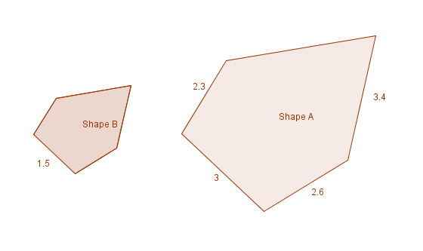

Worksheet 1a: Similar shapes and scale factors continued
- Look at these images:

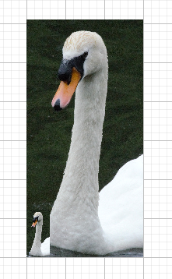

  - What is the scale factor from the large image to the smaller one?
  - What is the scale factor between the small image and the larger one?
3
EXTENSION. Is there a relationship between part a and part b? If so, do you think this is always going to be the case?

Worksheet 1b: Proportional reasoning template

Worksheet 2a: Scale drawings and maps
- The scale of a map shows how much you would have to enlarge your map to get the actual size of the piece of land you are looking at. For example, a common scale for a UK map is 1:25000, which means that every 1cm on the map represents 25000cm on the ground. Using this scale answer these questions.
  - 50 cm on the map is equivalent to _________cm on the ground?
  - 75cm on the map is equivalent to __________km on the ground?
  - 25km on the ground is equivalent to __________cm on the map?
  - 15cm on the map is equivalent to __________m on the ground?
- Look at the shape. If you are told this shape represents the boundaries of the field on a scale of 1 :25000. The main grid lines are 1cm apart. Answer the following questions.
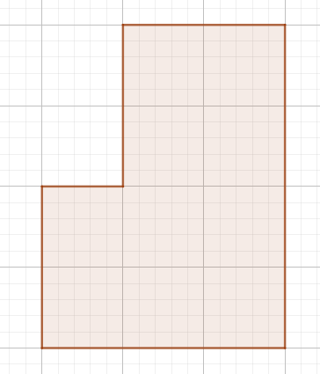

  - What is the maximum width of the field on the ground in metres?
  - What is the minimum length of the field on the ground in metres?

Worksheet 2a: Scale drawings and maps continued
  - If the scale is changed to 1:50000 would the shape look bigger or smaller than on a scale of 1:25000? Make sure you explain your answer.
Then draw the shape on this grid:

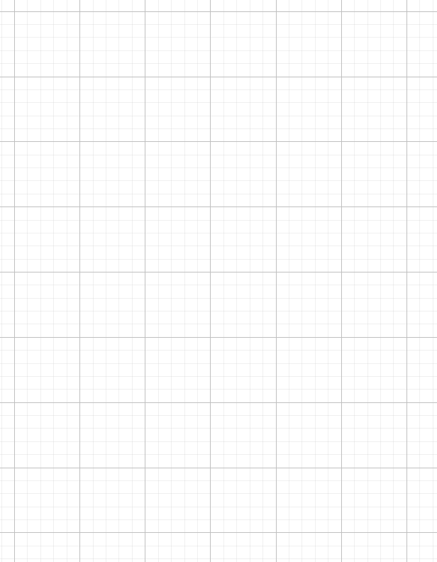

Worksheet 2a: Scale drawings and maps continued
- Maps are made at different scales for different purposes. The 1:25000 scale map is very useful for walking, but if you use it in a car you will quickly drive of the edge! On the other hand, maps at 1:250 000 scale (note the extra zero) show lots more area, but in far less detail. To demonstrate this try reproducing this map on the grid below:
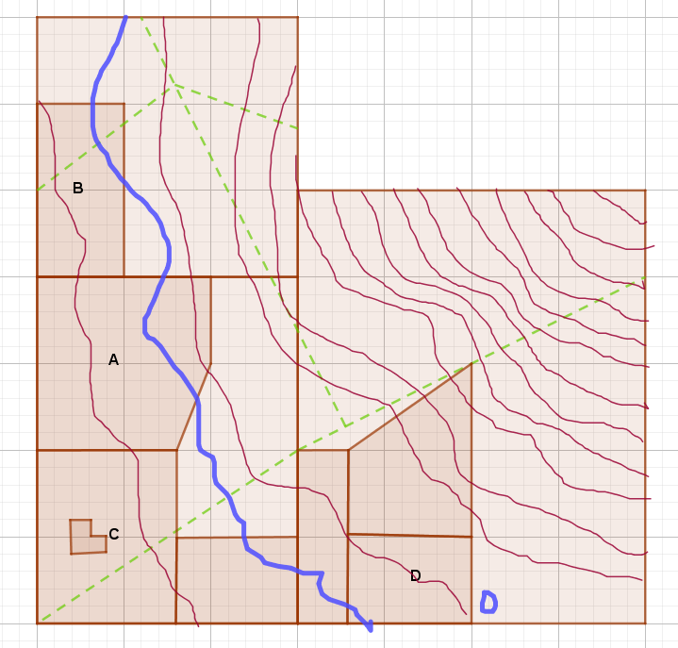
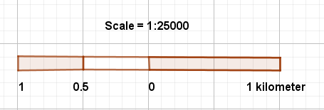
re

Worksheet 2a: Scale drawings and maps continued
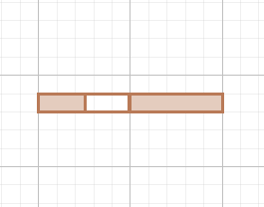
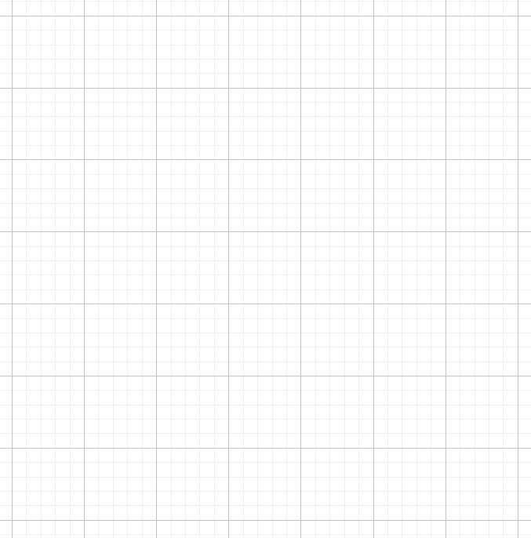
Scale = 1:50000
1 kilometre
1
0.5
0

Worksheet 2b: Multiple choice quiz
This quiz checks you understand the purpose and how to use maps as scale drawings. It is an interactive multiple-choice assessment and the questions are designed to highlight any misconceptions or misunderstandings. Please choose the answer you think is correct and explain why you think it is correct.

1. By now you should realise that everything on a map is drawn to scale. But why do we use a different scale when drawing maps from reality on the ground?

a. To make things easier to read
b. To show things smaller than they appear in real life so you can fit them on one piece of paper.
c. To show you interesting places to visit.
d. To help you work out which direction you need to travel in.

2. What scale should you choose if you want to show a lot of detail?
a. 1 : 25000
b. 1 : 50000

c. 1 : 1250

d. 1 : 250000

3. You want to plan a 7km walk. Using a map with a scale of 1:25000, how far will your route be on the map?

a. 7cm

b. 0.00028cm

c. 28cm

d.0.28cm

4. The scale of your map is 1: 50000. There is a distance of 8 cm between two villages on the map. How far will this be in kilometres on the ground?

a. 4

b. 4000000

c. 4000

d. 6.25

Worksheet 2b: Multiple choice quiz
5. On a 1: 250000 scale map you could quite easily:
a. Work out the distance between two towns
b. Plan a long walk in the country
c. Study detailed drawings of your house
d. Find the best route from one village to another

Worksheet 3a: Doing the mathematics
- Converting between reality and your representation:
  - How long will a 2.5m wall be drawn on a scale drawing with a scale of 1:200.
  - A wall is 1.75 cm on a scale of 1: 500. How long is the wall in reality?
- This is a scale drawing of a bedroom.
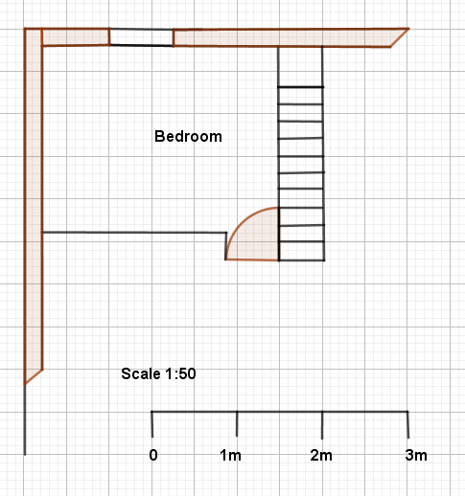
  - Label these features on the diagram. Window, stairs, door.
  - A typical double bed is approximately 240cm by 190 cm. Draw this to scale on the diagram

Worksheet 3a: Doing the mathematics continued
  - Once you have drawn the bed on the diagram what would you have to say about the room?

- Converting between representational scales:
  - What is the scale factor from a 1:50 to a 1:100 scale drawing?

  - What is the scale factor from a 1:500 to a 1:200 scale drawing?
HINT: you might want to use copies of the proportional reasoning template. If you need more copies you can always sketch them yourself.

- The width of a house is drawn as 17cm on a 1:500 scale drawing. How wide should the house be drawn on a scale drawing where the scale is 1: 400?

Worksheet 3b: Drawing a floor plan to scale
Drawing a floor plan to scale is a critical part of the design process for architects and also can be very helpful for visualising things like furniture layout. To draw a floor plan to scale you need to plan carefully and it is useful to have a set of steps you can follow.
- If you are making a floor plan of an actual physical space, not something you are designing or imagining, measure the length of the longest wall.
- Decide on a scale that will allow you to draw this wall on the piece of paper you are using.
- Measure the length of the other walls and convert these measurements to your scale.
- Make sure you place your drawing on the piece of paper, so you can fit in all the external walls you need.
- Then measure and convert to scale all the internal walls, windows, and doors on your floor plan. Draw each window as double lines and each door as a line with an arc that shows the actual swing path of the door. This is useful when trying to place furniture on your scale drawing.
- Measure the length and widths of all built-in fixtures such as internal walls and cupboards, convert them to the scale you are using, and add them to your plan.
- If you want you can add movable furniture to the floor plan.

Worksheet 3c: Designing a racing track
One of the criteria for designing a space for competitive sports events is to make sure that individual competitors are not advantaged or disadvantaged, and that one sports site compares accurately with another. You are going to look at what this means in the case of a running track.

Construct a scale drawing of a circular running track. The track needs to be for 4 runners for a 100m race. You will need to decide on a suitable scale.
If the runners all start in the same place will the race be fair? If not think about how you could make it fair and show the results on your scale drawing.
Think about the racing tracks you’ve seen, are they generally circular or are they usually a slightly different shape? You could explore the internet for ideas.
Now design and construct another scale drawing of a different type of track. This track is to be used for 100 metre, 200 metre and 400 metre races. All these races are run in lanes and all finish at the same place. How can you make sure this new racetrack is fair for all these different races? Show your results on your scale drawing and make sure you show any calculations you have done as well.

Worksheet 3d: Designing a racing track hints
Hint 1: You will need to use the formula for the circumference of a circle. Here is a link if you need reminding what this is. https://www.mathsisfun.com/geometry/circle.html

Hint 2: You might like to think about races you’ve seen on television for example. This picture may also give you a clue to how to make the race fair.



Worksheet 1a: Answers

Values to scale | Scale factor | Scale factor
5  28  260  0.8  11.6 | $$\frac{\text{3}}{\text{8}}$$ | 0.4
5  28  260  0.8  11.6 | $$\frac{\text{5}}{\text{3}}$$ | 1.6
5  28  260  0.8  11.6 | $$\frac{\text{4}}{\text{5}}$$ | 1.9
5  28  260  0.8  11.6 | $$\frac{\text{9}}{\text{4}}$$ | 0.6
5  28  260  0.8  11.6 | $$\frac{\text{7}}{\text{6}}$$ | 0.53
5  28  260  0.8  11.6 | $$\frac{\text{3}}{\text{12}}$$ | 0.08
5  28  260  0.8  11.6 | $$\frac{\text{10}}{\text{5}}$$ | 9.6

Scale factors can be expressed as decimals as well as percentages. Answer these questions by referring to the table above.

  - What would be the effect of using a scale factor of $\frac{4}{5}$ on the value of 28
Divide by 5 and then multiply by 4
28
22.4
×$\frac{4}{5}$

  - What would be the effect of using a scale factor of 0.53 on the value of 260.

260
137.8
× 0.53

NOTE: Does this make sense? Yes, it does. 0.53 is approximately one half and half of 260 and 130, so the answer does make sense. Whenever possible check the “sense “of your answers

  - Which scale factor would give a result which is about half the original. Choose one fraction and one decimal.
$\frac{3}{8}$ is the faction that is closest to a scale factor of one half as it is only one eighth below a half.
The decimals that are closest to a scale factor of one half are 0 .6 and 0 .53. The closest is 0.53 as it is only 0.07, or seven hundredths, away from a half whilst 0.6 is 0.1, or one tenth away from a half.
Worksheet 1a: Answers continued
  - If you take a starting value of five how big will the resulting value be when you use the scale factor of $\frac{3}{8}$?
Divide by 8 and then multiply by 3
5
1.875
×$\frac{3}{8}$

NOTE: Again does this make sense? Yes, it does. $\frac{3}{8}$ is closer to a half that it is to 0 or 1 and one half of 5 is 2.5,so the answer does make sense.

  - Which scale factor would make 11.6 approximately 116?
116 is 10 times bigger than 11.6 and 9.6 is the scale factor closest to 10.
  - Which scale factor would result in 0 .8 becoming 1.6?
  - is twice 0. 8 and the scale factor $\frac{10}{5}$ is equivalent to a scale factor of two
  - If you wanted to work out in your head the approximate effect of scaling by a factor of $\frac{3}{12}$ what might be the easiest way of doing this?
Two of the fractional scale factors that are easy to work out mentally are one quarter and one half. $\frac{3}{12}$ is closer to ¼ so you could approximate the effect of scaling by a factor of $\frac{3}{12}$ by scaling by a factor of quarter or in other words dividing by four.

  - The ratio of p:q is 4:5 what is the scale factor as a fraction?
Divide by 4 and then multiply by 5
4
5
×$\frac{5}{4}$
  - What is the ratio of q:p as a fraction?
NOTE: Again, does this make sense? Yes, it does. $\frac{5}{4}$ is greater than 1 so the scale factor will make you value bigger and $\frac{4}{5}$ is less than 1, so the scale factor will make your value smaller
×$\frac{4}{5}$

Divide by 5 and then multiply by 4
4
5
Worksheet 1a: Answers continued
- In this example we are told that the shapes are similar, and the perimeter of Shape B is 7.65 cm. Work out the missing dimensions.
1.15
1.3
1.7
2
4

When you are told the shapes are similar
1.3
you know all the angles are the same and
that the ratio of the sides is the same.
This allow you to work out the scale factor
using the one pair of sides you are given.
You can see that the ratio of Shape A to
Shape B is 3 : 1.5.
So you know the scale factor from
shape A to B is ½
You also therefore know that the scale
factor from shape B to A is 2.
You can use this to find most of the missing
dimensions:
2.3 ÷ 2 = 1.15
3.4 ÷ 2 = 1.7
2.6 ÷ 2 = 1.3
We are also told the perimeter of Shape B is 7.65 which allows us to calculate the final missing side for Shape B.
7. 65 – (1.15 + 1.7 + 1.3 + 1.5)
= 7.65 – 5.65 = 2
the final missing side on shape A will be twice this so it will be 4.

Worksheet 1a: Answers continued
- Look at these images:
  - What is the scale factor from the large image to the smaller one?
We can use either the width or the height of the images.
In this case we are going to use the width. The width of the larger image is 15 units, the width of the smaller image is three units.
Using the visual representation we used at the start of the session
(slide 6).
Divide by 15 and then multiply by 3
15
3

× $\frac{3}{15}$ = × $\frac{1}{5}$
The scale factor from the large image to the smaller image is one fifth. Or in other words the small images one fifth the size of the larger image.
  - What is the scale factor between the small image and the larger one?
3
To work at the scale factor from the smaller image to the larger image we just reverse the process.
3
Divide by 3 and then multiply by 15
15

× $\frac{15}{3}$ = × 5
The scale factor from the small image to the larger image is 5. Or in other words the small images one fifth the size of the larger image.

Worksheet 1a: Answers continued
EXTENSION. Is there a relationship between part a and part b? If so, do you think this is always going to be the case?
The answer to part a is one over the answer to part b and vice versa. In other words, the two answers are the reciprocal of each other. Yes, this rule will always apply when working out scale factors in this way.

Worksheet 2a: Answers
1.
a. 50 × 25000 = 1250000 cm
b. 75 × 25000 = 1875000cm on the ground.
1875000 ÷ 100000 = 18.75km on the ground
c. 25 ÷ 25000 = 0.001 km on the map?
1km is equal to 100000 cm. So 25km on the map is equivalent to
0.001 × 100000 = 100cm on the map.

d. 15cm on the map is equivalent to
15 × 25000 = 375000 cm on the ground.
1cm is 1 hundredth of a meter.
375000 ÷ 100 = 3750
So 15cm on the map is equivalent 3750m on the ground

2.
a. The maximum width on the map is 3 large squares.
3 x 25000 = 75000cm on the ground.
1 cm is $\frac{\text{1}}{\text{100}}$ of a meter.
75000 ÷ 100 = 750m
The maximum width of the field on the ground is 750m.

b. The minimum length on the map is 2 large squares.
2 x 25000 = 50000cm on the ground.
50000 ÷ 100 = 500m
The minimum length of the field on the ground is 500m.

c. In this case each square on the map would be equivalent to 50000 cm on the ground.
Using our calculations for part a and part b. The maximum width of the field would be one and a half squares and the minimum length of the field would be one square.
The new map of the field on a scale of 1 : 50000 will be smaller than the map the same field on a scale of 1 : 25000

Worksheet 2a: Answers continued
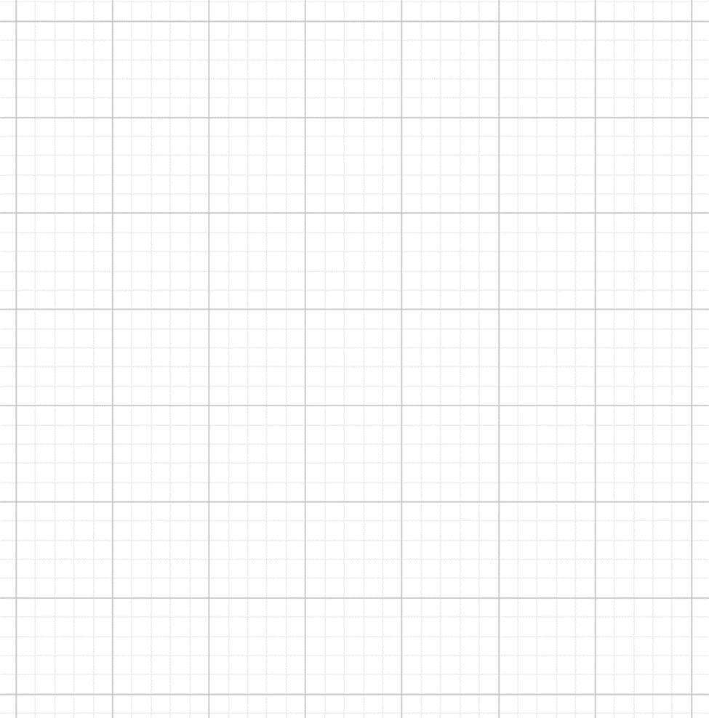
Scale = 1:50000
1 kilometre
1
0.5
0

Worksheet 2b: Answers
This quiz checks you understand the purpose and how to use maps as scale drawings. It is an interactive multiple-choice assessment and the questions are designed to highlight any misconceptions or misunderstandings. Please choose the answer you think is correct and explain why you think it is correct.

1. By now you should realise that everything on a map is drawn to scale. But why do we use a different scale when drawing maps from reality on the ground?

a. To make things easier to read
This is not the case, every time we use a scale drawing to draw a map we lose a little bit of detail. The amount of detail depends on the scale we are using.
b. To show things smaller than they appear in real life so you can fit them on one piece of paper.
c. To show you interesting places to visit.

This is one of the purposes of a map, but the scale of the map does not tell us this.
d. To help you work out which direction you need to travel in.

Again, this is one of the purposes of a map, but the scale of the map does not tell us this.

2. What scale should you choose if you want to show a lot of detail?
a. 1 : 25000

The terms 'large scale' and 'small scale' are used to describe different scales. However, they can be confusing. Large scale maps have low numbers is the scale, such as 1: 1250. The features shown are large and therefore you can show a lot more detail. Small-scale maps have a high number in the scale, such as 1: 250000. Individual features shown are small and you can therefore see less detail.
b. 1 : 50000

The terms 'large scale' and 'small scale' are used to describe different scales. However, they can be confusing. Large scale maps have low numbers is the scale, such as 1: 1250. The features shown are large and therefore you can show a lot more detail. Small-scale maps have a high number in the scale, such as 1: 250000. Individual features shown are small and you can therefore see less detail.

c. 1 : 1250

d. 1 : 250000

The terms 'large scale' and 'small scale' are used to describe different scales. However, they can be confusing. Large scale maps have low numbers is the scale, such as 1: 1250. The features shown are large and therefore you can show a lot more detail. Small-scale maps have a high number in the scale, such as 1: 250000. Individual features shown are small and you can therefore see less detail.

Worksheet 2b: Answers continued
3. You want to plan a 7km walk. Using a map with a scale of 1:25000, how far will your route be on the map?

a. 7cm

This would be correct for a scale of 1:100000

b. 0.00028cm

Don’t forget you have to convert your answer in kilometres to centimetres on the map. This would be the answer in km on the map.

c. 28cm

d.0.28cm

Don’t forget the scale factor from kilometres to centimetres is multiply by 100000.

4. The scale of your map is 1: 50000. There is a distance of 8 cm between two villages on the map. How far will this be in kilometres on the ground?

a. 4

b. 4000000

Don’t forget the question asks you for the answer in kilometres. This would be the correct answer in centimetres.

c. 4000

Don’t forget the scale factor from centimetres to kilometres is divide by 100000.

d. 6.25

Remember 8 cm on the map is 50000 × 8 on the ground not 500000 ÷ 8 .

5. On a 1: 250000 scale map you could quite easily:
a. Work out the distance between two towns
b. Plan a long walk in the country
The terms 'large scale' and 'small scale' are used to describe different scales. However, they can be confusing. Large scale maps have low numbers is the scale, such as 1: 1250. Small-scale maps have a high number in the scale, such as 1: 250000. Small scale maps with a high number in the scale such ass 1:250000 can represent greater distance on the ground but in less detail. Because you cover less distance when you are walking a 1:25000 map would be better for this purpose as it would show more detail without taking up too many pieces of paper.

Worksheet 2b: Answers continued
c. Study detailed drawings of your house
A map would only show your house as a block it would not include any detail.
d. Find the best route from one village to another
The terms 'large scale' and 'small scale' are used to describe different scales. However, they can be confusing. Large scale maps have low numbers is the scale, such as 1: 1250. Small-scale maps have a high number in the scale, such as 1: 250000. Small scale maps with a high number in the scale such ass 1:250000 can represent greater distance on the ground but in less detail. A 1:25000 map would be better for this purpose as it would show more detail without taking up too many pieces of paper.

Worksheet 3a: Answers
- Converting between reality and your representation:
  - How long will a 2.5m wall be drawn on a scale drawing with a scale of 1:200.
First convert metres to centimetres. 2.5 × 100 = 250 cm
The wall will be $\frac{\text{5}}{\text{4}}$ or 1.25cm on a 1:200 scale drawing
  - A wall is 1.75 cm long on a scale of 1: 500. How long is the wall in reality?
The wall is 875cm long in reality.

- This is a scale drawing of a bedroom.
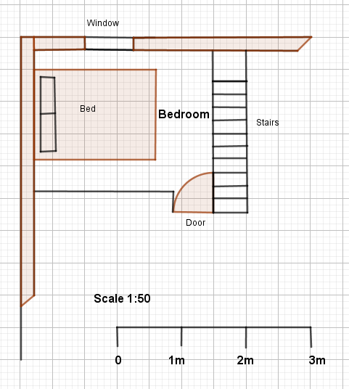
  - Label these features on the diagram. Window, stairs, door.
  - A typical double bed is approximately 240cm by 190 cm. Draw this to scale on the diagram

Worksheet 3a: Answers continued
  - Once you have drawn the bed on the diagram what would you have to say about the room?
The bed takes up a lot of the room and there would not be much space left to move around it. Maybe this should be a single bedroom.
- . a. You can work out the scale factor between a scale drawing of 1:50 and a scale drawing of 1:100.
1
50

1
100

On a scale drawing of 1:50 one unit represents 50units on the ground. The same unit on a scale drawing of 1: 100 represent 100 units on the ground. On a scale drawing of 1:100 you will need $\frac{\text{50}}{\text{100}}$ = $\frac{\text{1}}{\text{2}}$ units to represent the same object on the scale drawing.
b. You can work out the scale factor between a scale drawing of 1:500 and a scale drawing of 1:200.
1
500

1
200

On a scale drawing of 1:500 one unit represents 500 units on the ground. The same unit on a scale drawing of 1: 200 represent 200 units on the ground. On a scale drawing of 1:200 you will need $\frac{\text{500}}{\text{200}}$ = $\frac{\text{5}}{\text{2}}$ units to represent the same object on the scale drawing

Worksheet 3a: Answers continued

- The width of a house is drawn as 17cm on a 1:500 scale drawing. How wide should the house be drawn on a scale drawing where the scale if 1: 400?
There are two ways of answering this question:
Method 1 First find out the width of the house in reality using the original scale.
1
500

17
500 ×17 = 8500

×17

On the ground the house is 8500 cm or 8.5 m wide.
You can now work out how wide this should it be drawn on a scale drawing where the scale if 1: 400.
1
400

$$\frac{\text{85}}{\text{4}}$$
8500

$$\frac{\text{8500}}{\text{400}}\text{=}\frac{\text{85}}{\text{4}}$$

The house should be 21.25cm on a scale of 1 to 400.

Worksheet 3a: Answers continued
Method 2. Alternatively, you can work out the scale factor between a scale drawing of 1:500 and a scale drawing of 1:400.
1
500

1
400

On a scale drawing of 1:500 one unit represents 500 units on the ground. The same unit on a scale drawing of 1: 400 represent 400 units on the ground. On a scale drawing of 1:400 you will need $\frac{\text{500}}{\text{400}}$ = $\frac{\text{5}}{\text{4}}$ units to represent the same object on the scale drawing. To get the whole house you will need:
17 × $\frac{\text{5}}{\text{4}}$ = 21.25cm As in Method 1.

Cambridge Assessment International Education
The Triangle Building, Shaftsbury Road, Cambridge, CB2 8EA, United Kingdom
t: +44 1223 553554
e: info@cambridgeinternational.org www.cambridgeinternational.org

© Cambridge University Press & Assessment 2024

