

Teaching Pack
Accuracy and bounds
Cambridge IGCSE™
Mathematics 0580

This Teaching Pack can also be used with the following syllabuses:
• Cambridge IGCSE™ (9–1) Mathematics 0980
• Cambridge IGCSE™ International Mathematics 0607
• Cambridge O Level Mathematics 4024

© Cambridge University Press & Assessment 2022
Cambridge Assessment International Education is part of Cambridge University Press & Assessment. Cambridge University Press & Assessment is a department of the University of Cambridge.

Cambridge University Press & Assessment retains the copyright on all its publications. Registered centres are permitted to copy material from this booklet for their own internal use. However, we cannot give permission to centres to photocopy any material that is acknowledged to a third party even for internal use within a centre.
Contents
Introduction 4
Skill: Accuracy and bounds 5
Common misconceptions: Accuracy and bounds 7
Lesson 1: Accuracy and bounds to the nearest 10, 100 or 1000 8
Lesson 2: Accuracy and bounds to 3 decimal places 10
Lesson 3: Accuracy and bounds to significant figures 12
Lesson 4: Substituting bounds into formulae (extended) 13
Links to websites: Accuracy and bounds 14
Worksheets and answers 15

Icons used in this pack:
 | Lesson
 | Video
 | Assessment opportunity

Introduction
This pack will help you to develop your learners’ mathematical skills as defined by assessment objective 1 (AO1 Knowledge and understanding of mathematical techniques) in the course syllabus.

Important note
Our Teaching Packs have been written by classroom teachers to help you deliver topics and skills that can be challenging. Use these materials to supplement your teaching and engage your learners. You can also use them to help you create lesson plans for other skills.

This content is designed to give you and your learners the chance to explore mathematical skills. It is not intended as specific practice for exam papers.

This is one of a range of Teaching Packs. Each pack is based on one mathematical topic with a focus on specific mathematical techniques. The packs can be used in any order to suit your teaching sequence.

In this pack you will find the lesson plans and worksheets you will need to successfully complete the teaching of this mathematical skill.

Skill: Accuracy and bounds
This Teaching Pack links to the following syllabus content (see syllabus for detail):
- C1.10 Give appropriate upper and lower bounds for data given to a specified accuracy.
- E1.10 Give appropriate upper and lower bounds for data given to a specified accuracy. Obtain appropriate upper and lower bounds to solutions of simple problems given data to a specified accuracy.

For assessments from 2025
- C/E1.10 Give upper and lower bounds for data rounded to a specified accuracy.
- E1.10 Find upper and lower bonds of the results of calculations which have used data rounded to a specified accuracy.

The pack covers the following mathematical skills, adapted from AO1: Demonstrate knowledge and understanding of mathematical techniques (see syllabus for assessment objectives):
- estimating, approximating and working to degrees of accuracy appropriate to the context and converting between equivalent numerical forms

For assessments from 2025
AO1: Knowledge and understanding of mathematical techniques
- estimate, approximate and work to degrees of accuracy appropriate to the context and convert between equivalent number forms.

Prior knowledge
Knowledge from the following syllabus topics is useful for development of skills in this topic.
- C1.9 Make estimates of numbers, quantities and lengths, give approximations to specified numbers of significant figures and decimal places and round off answers to reasonable accuracy in the context of a given problem.
- E1.9 Make estimates of numbers, quantities and lengths, give approximations to specified numbers of significant figures and decimal places and round off answers to reasonable accuracy in the context of a given problem.
- C1.6 Order quantities by magnitude and demonstrate familiarity with the symbols =, ≠, >, <, ⩾, ⩽.
- E1.6 Order quantities by magnitude and demonstrate familiarity with the symbols =, ≠, >, <, ⩾, ⩽.

For assessments from 2025
- C/E1.9 Round values to a specified degree of accuracy.
Make estimates for calculations involving numbers, quantities and measurements.
Round answers to a reasonable degree of accuracy in the context of a given problem.
- C/E1.5 Order quantities by magnitude and demonstrate familiarity with the symbols =, ≠, >, <, ⩾, ⩽.

Going forward
The knowledge and skills gained from this Teaching Pack can be used for when you teach learners about Mensuration.
- C5.1 Use current units of mass, length, area, volume and capacity in practical situations and express quantities in terms of larger or smaller units.
- E5.1 Use current units of mass, length, area, volume and capacity in practical situations and express quantities in terms of larger or smaller units.

For assessments from 2025
- C/E5.1 Use metric units of mass, length, area, volume and capacity in practical situations and convert quantities into larger or smaller units.

Before you begin
This Teaching Pack includes a Teacher Introduction video to which you should refer before
using the resources in this pack. The video is available to watch in Resource Plus within the topic section relevant to this Teaching Pack.

The video introduces the resources available for teaching this topic, and explains how they can be used to successfully deliver the topic to your learners. In particular, the video highlights typical learner misconceptions and common errors this Teaching Pack will help you to overcome.

Common misconceptions: Accuracy and bounds
There is often confusion about the upper bound, e.g. 1.49 compared with 1.5.

Learners often believe that, to find the bounds for a calculation, they should work out the answer using their rounded values and then find bounds for their answer. To help address this, give them contextual examples to investigate, e.g. area of a rectangle.

Learners may believe that, to find the lower bound for a calculation, they should substitute the lower bounds of each variable. You can correct this by helping them to experiment with substituting lower bounds. You could include examples such as a – b and a/b and help them to investigate systematically, as in Lesson 4. For instance, ask them to check what happens when they use:

- lower bound a, lower bound b,
- lower bound a, upper bound b,
- upper bound a, lower bound b,
- upper bound a, upper bound b?

Lesson 1: Accuracy and bounds to the nearest 10, 100 or 1000

Resources |  | - Whiteboard  - Lesson 1 presentation  - Worksheets 1a, 1b, 1c
Learning objectives |  | By the end of the lesson:  - all learners should be able to round numbers to a specified accuracy of 10, 100 or 1000  - most learners should be able to recognise both the upper and lower bounds for a variety of numbers  - some learners will be able to recognise both the upper and lower bounds for a variety of numbers in context
Timings | Activity
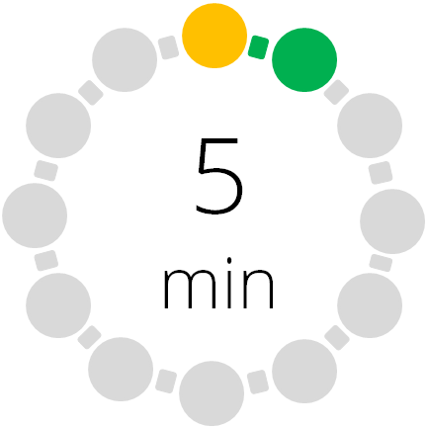 | Starter/Introduction  Use Lesson 1 presentation for teaching this topic.  You could start with a reminder on the use of inequality notation. Use the activity in the presentation (slide 3) or give your learners Worksheet 1a. Ask your learners to explain in words what each of the inequality notation symbols means.  A reminder on rounding to a specified accuracy is on slide 4 in the presentation.
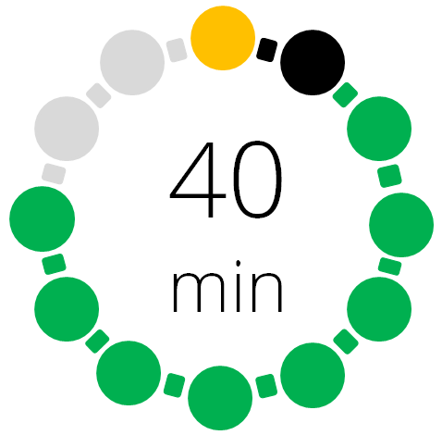 | Main lesson  Show your learners slide 5 with the newspaper headline. Ask them to say what the upper and lower bounds are to the nearest 1000. What numbers would they put in the gaps in this inequality?  ___ ≤ number of people < ___  Optional: Slide 6 shows the same example but using a number line. You can use this to help learners who prefer a visual representation of the problem.  Ask your learners to consider the same example again, but this time rounding to the nearest 100 (slides 7 and 8). What does this change in accuracy imply?  Differentiation: Collect some more examples of upper and lower bounds from local papers or websites. Show them to learners and ask them to discuss what they notice.  The remaining presentation slides provide further examples of bounds to differing accuracies. Your learners could use these for practice.  Now give your learners Worksheet 1b, which provides some values for rounding. Some values are given in context while others are not. Learners should complete the worksheet by giving the upper and lower bounds to the nearest 10, 100 or 1000 as shown.  This should prepare them for the plenary that follows.
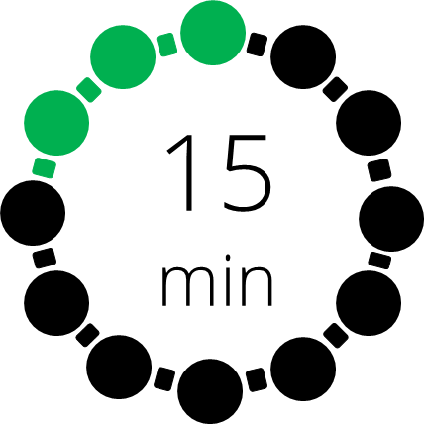 | Plenary  You can play this game with the whole class or divide them into groups. Give each learner one card from the set of ‘follow me’ cards on Worksheet 1c. The learner with the End/Start card asks their question first. The learner with the correct answer replies “I have ………….” and then asks their question. This continues until the last learner with the End/Start card answers the final question.  Swap the cards around so each learner has a different card and play again (starting from the opposite end of the card pack).  Play against the clock. Record the times and see if the class can beat their previous best.  (Hint: print two copies so that you can keep one as a reference sheet.)

Lesson 2: Accuracy and bounds to 3 decimal places

Resources |  | - Whiteboard  - Lesson 2 presentation  - Worksheets 2a, 2b, 2c, 2d
Learning objectives |  | By the end of the lesson:  - all learners should be able to round numbers to a specified accuracy. This could be to a whole number or to one, two or three decimal places  - most learners should be able to recognise both the upper and lower bounds for a variety of numbers  - some learners will be able to recognise both the upper and lower bounds for a variety of numbers in context.
Timings | Activity
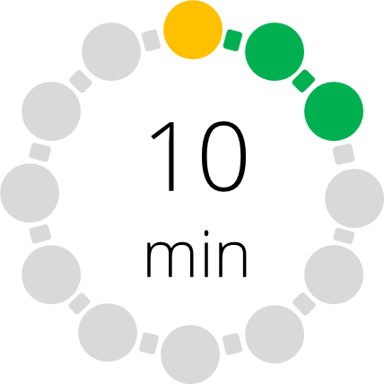 | Starter/Introduction  You could begin by working through slides 2 to 11 of the Lesson 2 presentation. This will remind your learners how to find upper and lower bounds for numbers rounded to the nearest 10, 100 or 1000. Ask them to explain how they have found their answers and address any misconceptions that you notice.
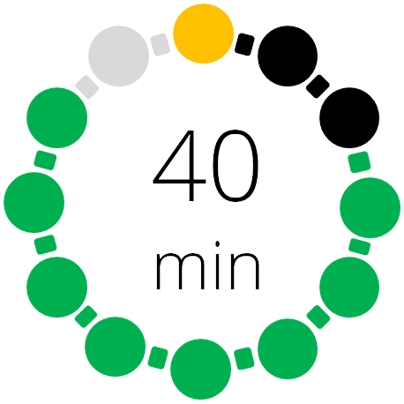 | Main lesson  With your learners, work through slides 12 to 22 in the Lesson 2 presentation. Use these slides to introduce bounds for numbers given to the nearest whole number. Inequality notation is included here but you could just ask learners to state the lower and upper bounds without using inequality notation.  Slides 13 and 14 provide number lines which you can use to help explain the bounds for the length and the width. You may not need these for more confident learners. Later slides provide further examples for your learners to work on.  Differentiation: you could focus on bounds for numbers to the nearest whole number. As an alternative, you could look at both rounding to whole numbers and to a given number of decimal places in one step.  Now give your learners Worksheet 2a, which shows a number of values rounded to the nearest whole. Some numbers are given in context while others are not.  Now give your learners Worksheet 2b which shows a number of values rounded to 1, 2 or 3 decimal places.  Complete this section of the lesson with your learners by running a Rolling Dice activity as described on slide 23. Ideally you would use a 10-sided die. Learners obtain a single-digit number (one roll), two-digit number (two rolls) and then write down the appropriate inequality. You could also use this to generate numbers with 1 decimal place.  Differentiation: the activity can be adjusted to generate different types of numbers as required, e.g. one-digit, two-digit, one decimal place.
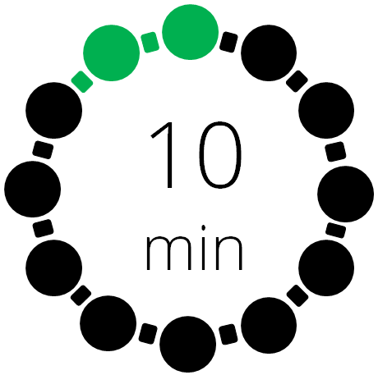 | Plenary  Give your learners Worksheet 2c, a card sort activity. Pairs of learners can match the numbers and the inequalities for different bounds.  Differentiation: more confident learners can use Worksheet 2d and complete it individually. Then they could swap sheets with another learner to mark each other’s work.

Lesson 3: Accuracy and bounds to significant figures

Resources |  | - Whiteboard  - Lesson 3 presentation  - Worksheets 3a, 3b, 3c, 3d, 3e, 3f
Learning objectives |  | By the end of the lesson:  - all learners should be able to round numbers to a specified accuracy of a whole number, or to one, two or three decimal places
Timings | Activity
Starter/Introduction
Begin by revisiting upper and lower bounds for numbers rounded to the nearest whole number or to a given number of decimal places.

Ask learners to sort cards into sets using the cards provided on Worksheet 3a (rounding to whole numbers) and/or Worksheet 3b (rounding to significant figures). This can be done in groups, or individually if you have enough sets of cards. You could time the activity to introduce some competition.

Differentiation: two possible levels of rounding allow for differentiation.
Main lesson
Start by working through slide 2 of the Lesson 3 presentation with your learners. This will remind them about rounding to significant figures.

Next introduce Worksheet 3c and ask your learners to work through the problems on rounding to significant figures.

Differentiation: optional activity using Worksheet 3d on rounding to significant figures.

Follow with an activity for your learners using slide 3 to 28. Give them a number rounded to 1 significant figure. Ask them to hold up mini whiteboards, or paper, to show the upper and lower bounds. Repeat for 2 significant figure numbers and 3 significant figure numbers.
 | Plenary  Complete the lesson using Worksheet 3e. Learners should create sets of 3 cards consisting of a number, its lower bound and upper bound. All numbers are rounded to 1 significant figure.  Differentiation: you can adapt the card sort for just one significant figure examples. Alternatively, you could use Worksheet 3f which is another card sort activity where learners find sets of 4 cards: a number, its accuracy, lower and upper bounds.

Lesson 4: Substituting bounds into formulae (extended)

Resources |  | - Whiteboard  - Lesson 4 presentation  - Worksheets 4a, 4b, 4c
Learning objectives |  | By the end of the lesson:  - some learners will be able to substitute bounds into formulae.
Timings | Activity
Starter/Introduction
Start by giving learners Worksheet 4a which is a card sort activity. This contains questions on bounds for numbers rounded to different accuracies.
OR
Give learners Worksheet 4b which is a matching activity. The cards contain formulae, numbers to substitute into the formulae and answers.
Main lesson
Lesson 4 presentation provides examples for substituting bounds into formulae. With your learners, work through slides 2 to 5 initially. These calculations involve addition, subtraction, multiplication and division. In each case, learners need to find the lower and upper bounds for the answer to the calculation.
OR
Using slide 6, ask learners to carry out the investigation. They are given two numbers, a and b, to a specified accuracy. Using the upper and lower bounds for a and b, learners need to find the smallest value for each of a + b, a $–$ b, ab and a/b. Then they use the bounds for a and b to see what are the largest values they can make for each of those expressions.

What do they notice? Can they write down a set of rules for how to calculate the upper and lower bound for these calculations: addition, subtraction, multiplication and division?

Give learners Worksheet 4c to complete. This is a differentiated worksheet asking for upper and lower bounds in a range of calculations.
Plenary
Use examples from your classroom or school context to present a problem that requires learners to use bounds within a calculation. Slide 7 shows an example: the school car park. Encourage learners to challenge all aspects of the plan, e.g. the layout of car parking spaces, the accuracy of the measurements and even the choice of materials.

Links to websites: Accuracy and bounds
The following websites provide further opportunities to create activities for this topic:

https://www.bbc.co.uk/bitesize/guides/zg634qt/revision/1
Revision of rounding to different accuracies and introduction to bounds

www.transum.org/Maths/Exercise/Bounds.asp?Level=1
Five levels of questions on bounds using inequality notation

Worksheets and answers

 | Worksheets | Answers
For use in Lesson 1:
1a: Inequality notation | 16 | 57
1b: Rounding numbers | 17 | 58
1c: Follow me cards | 19 | 59
For use in Lesson 2:
2a: Bounds for numbers to the nearest whole number | 22
2b: Bounds for numbers to 1, 2 or 3 decimal places | 28
2c: Card sort rounding to significant figures | 33 | 61
2d: Rounding to significant figures optional task | 35 | 62
For use in Lesson 3:
3a: Card sort – whole numbers | 36
3b: Card sort – decimal places | 38
3c: Rounding to significant figures | 40 | 63
3d: Rounding to significant figures optional task | 44 | 66
3e: Card sort | 46
3f: Card sort alternative | 48
For use in Lesson 4:
4a: Card sort | 50
4b: Matching activity | 52
4c: Lower and upper bounds for calculations | 54 | 67

Worksheet 1a: Inequality notation
The notation used to show mathematical inequalities are listed below. Describe the meaning of each symbol using words. One has been completed for you.
= Equals

≠

>

<

⩾

⩽

Worksheet 1b: Rounding numbers to 10, 100 or 1000

Give the upper and lower bounds for each of the following values to the specified accuracy.

- Approximately 30% of learners got A* this year (rounded to the nearest 10)
Lower bound: Upper bound:

- 700 (rounded to the nearest 100)
Lower bound: Upper bound:

- About 36 000 people have been evacuated since Tuesday (rounded to the nearest 1000)
Lower bound: Upper bound:

- 500 (rounded to the nearest 10)
Lower bound: Upper bound:

- Roughly 60 cattle escaped from the farm during the storm (rounded to the nearest 10)
Lower bound: Upper bound:

- 6800 (rounded to the nearest 100)
Lower bound: Upper bound:

- 3000 (rounded to the nearest 1000)
Lower bound: Upper bound:

- The engine revolves at about 7200 r.p.m when at full power (rounded to the nearest 10)
Lower bound: Upper bound:

Worksheet 1b: Rounding numbers to 10, 100 or 1000 continued
- They have earned about $156 000 since leaving university (rounded to the nearest 1000)
Lower bound: Upper bound:

- $1 000 000 (rounded to the nearest 100)
Lower bound: Upper bound:

- Observers claim they saw this happen approximately 100 times (rounded to the nearest 100)
Lower bound: Upper bound:

- 10 (rounded to the nearest 10)
Lower bound: Upper bound:

- This year we are sending around 71 000 learners to university for the first time (rounded to the nearest 1000)
Lower bound: Upper bound:

- 390 (to the nearest 10)
Lower bound: Upper bound:

- At about 3500 kilometres, this year’s Tour de France cycle race is one of the longest there has been (to the nearest 1000)
Lower bound: Upper bound:

Worksheet 1c: Follow me cards

Cut out the cards to create a pack for each group of learners.

The learner with the Start/End card (any one) asks their question first. The learner with the correct answer replies “I have ………….” and then asks their question. This continues until the last learner with the End/Start card (corresponding to the Start/End card) answers the final question.

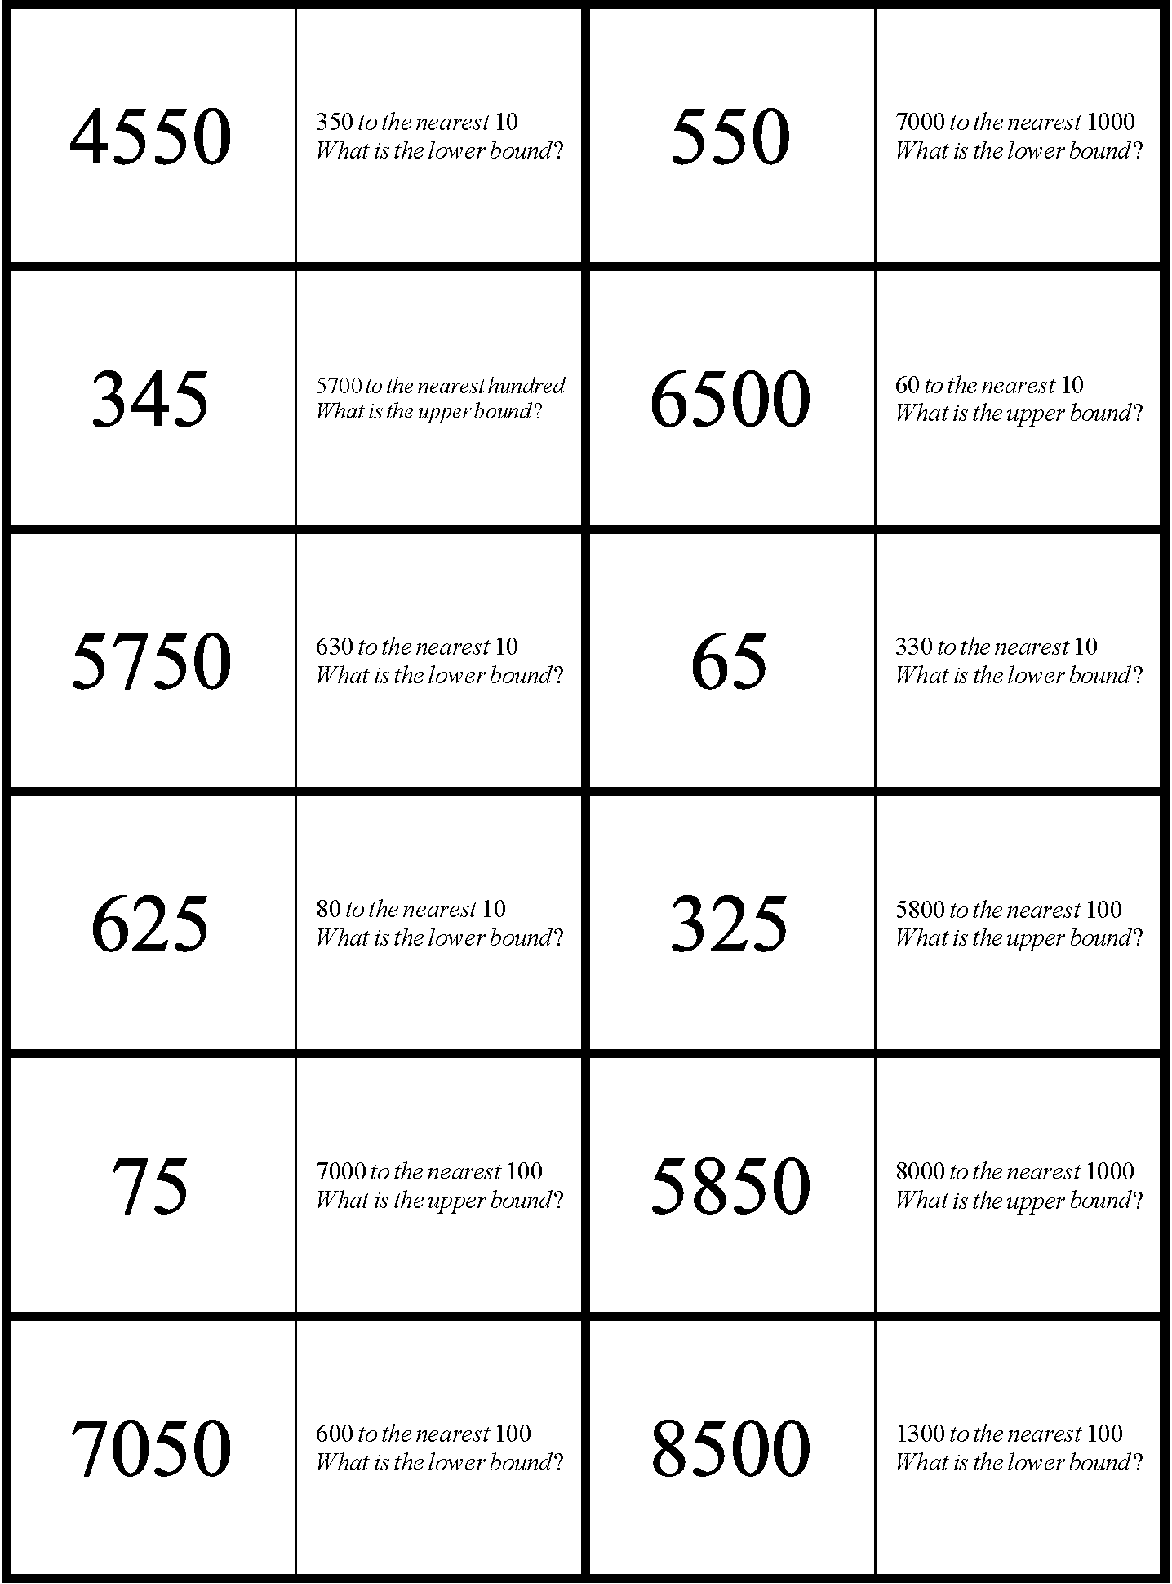

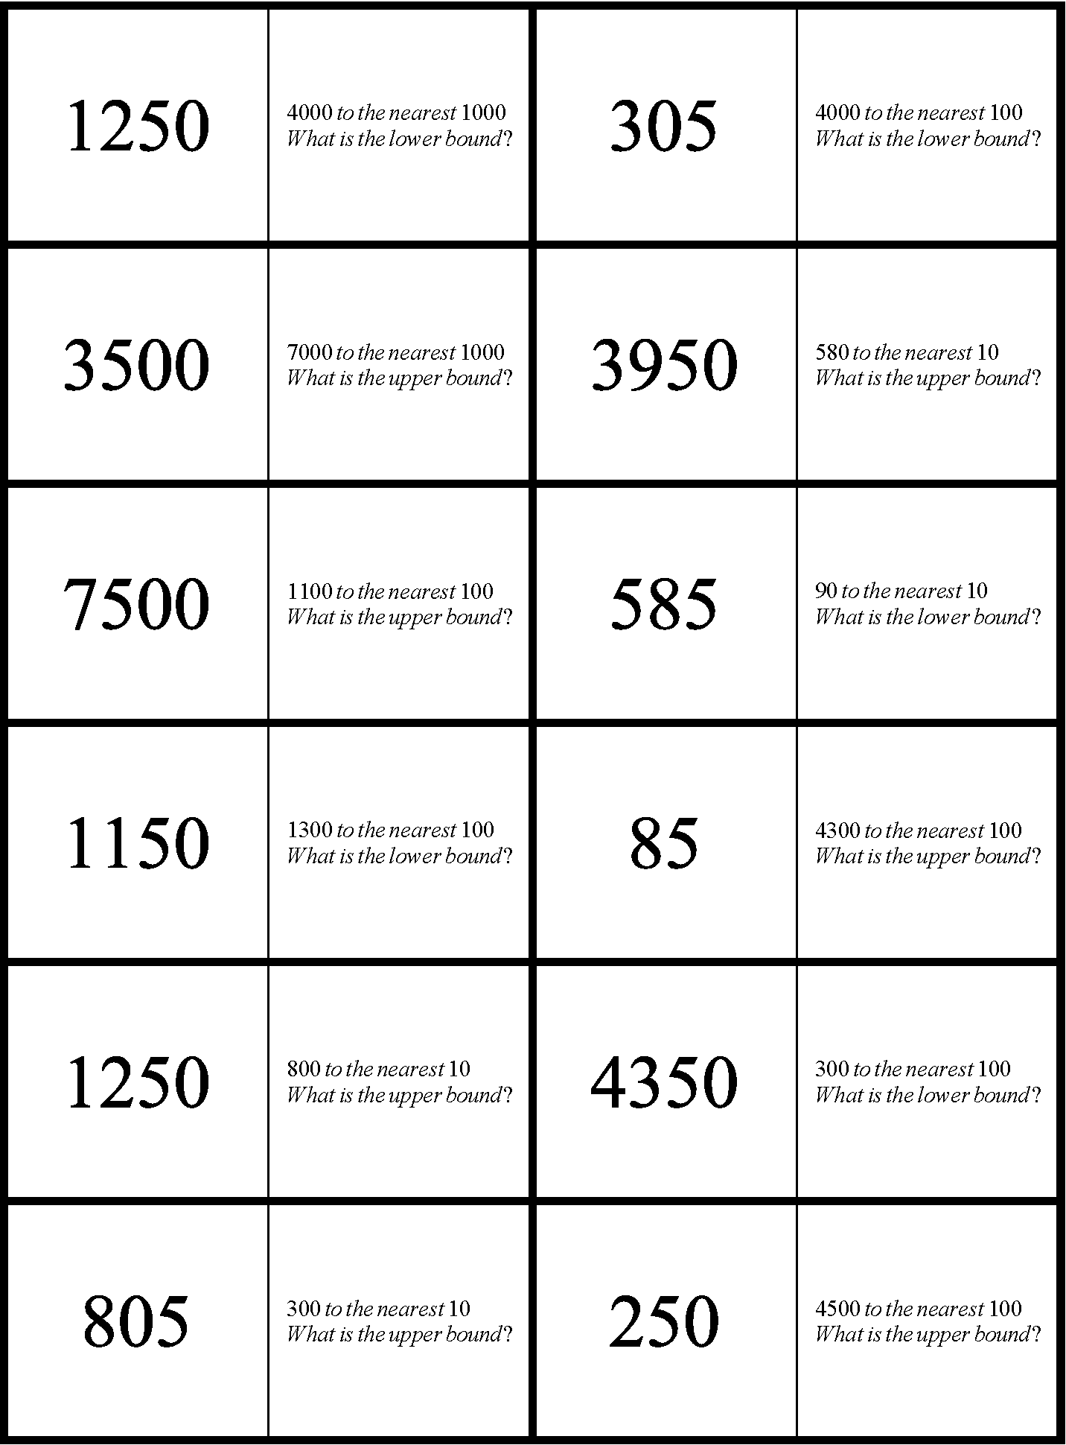

Worksheet 2a: Bounds for numbers to the nearest whole number
- Each of the following numbers has been rounded to the nearest whole number. For each one give:
- the lower bound
- the upper bound
 | Lower bound | Upper bound
- 8
- 15
- 23
- 10
- 29
- 30

- Each of the following lengths has been rounded to the nearest centimetre. For each length give:
- the lower bound
- the upper bound
- the inequality statement.
 | Lower bound | Upper bound | Inequality statement (l cm)
- 16 cm |  |  | ______≤ l <______
- 27 cm |  |  | ______≤ l <______
- 36 cm |  |  | ______≤ l <______
- 30 cm |  |  | ______≤ l <______
- 37 cm |  |  | ______≤ l <______
- 50 cm |  |  | ______≤ l <______

Worksheet 2a: Bounds for numbers to the nearest whole number continued
- Each of the following masses has been rounded to the nearest kilogram.
For each mass give:
- the lower bound
- the upper bound
- the inequality statement.

 | Lower bound | Upper bound | Inequality statement (m kg)
- 12 kg |  |  | _____≤ m <_____
- 42 kg |  |  | _____≤ m <_____
- 54 kg |  |  | _____≤ m <_____
- 60 kg |  |  | _____≤ m <_____
- 75 kg |  |  | _____≤ m <_____
- 10 kg |  |  | _____≤ m <_____

- Each of the following distances has been rounded to the nearest kilometre.
For each distance give:
- the lower bound
- the upper bound
- the inequality statement.
 | Lower bound | Upper bound | Inequality statement (d km)
- 87 km |  |  | _____≤ d <_____
- 120 km |  |  | _____≤ d <_____
- 54 km |  |  | _____≤ d <_____
- 41 km |  |  | _____≤ d <_____
- 72 km |  |  | _____≤ d <_____
- 100 km |  |  | _____≤ d <_____

Worksheet 2a: Bounds for numbers to the nearest whole number continued


- Here is part of a visitor guide for a woodland nature reserve.

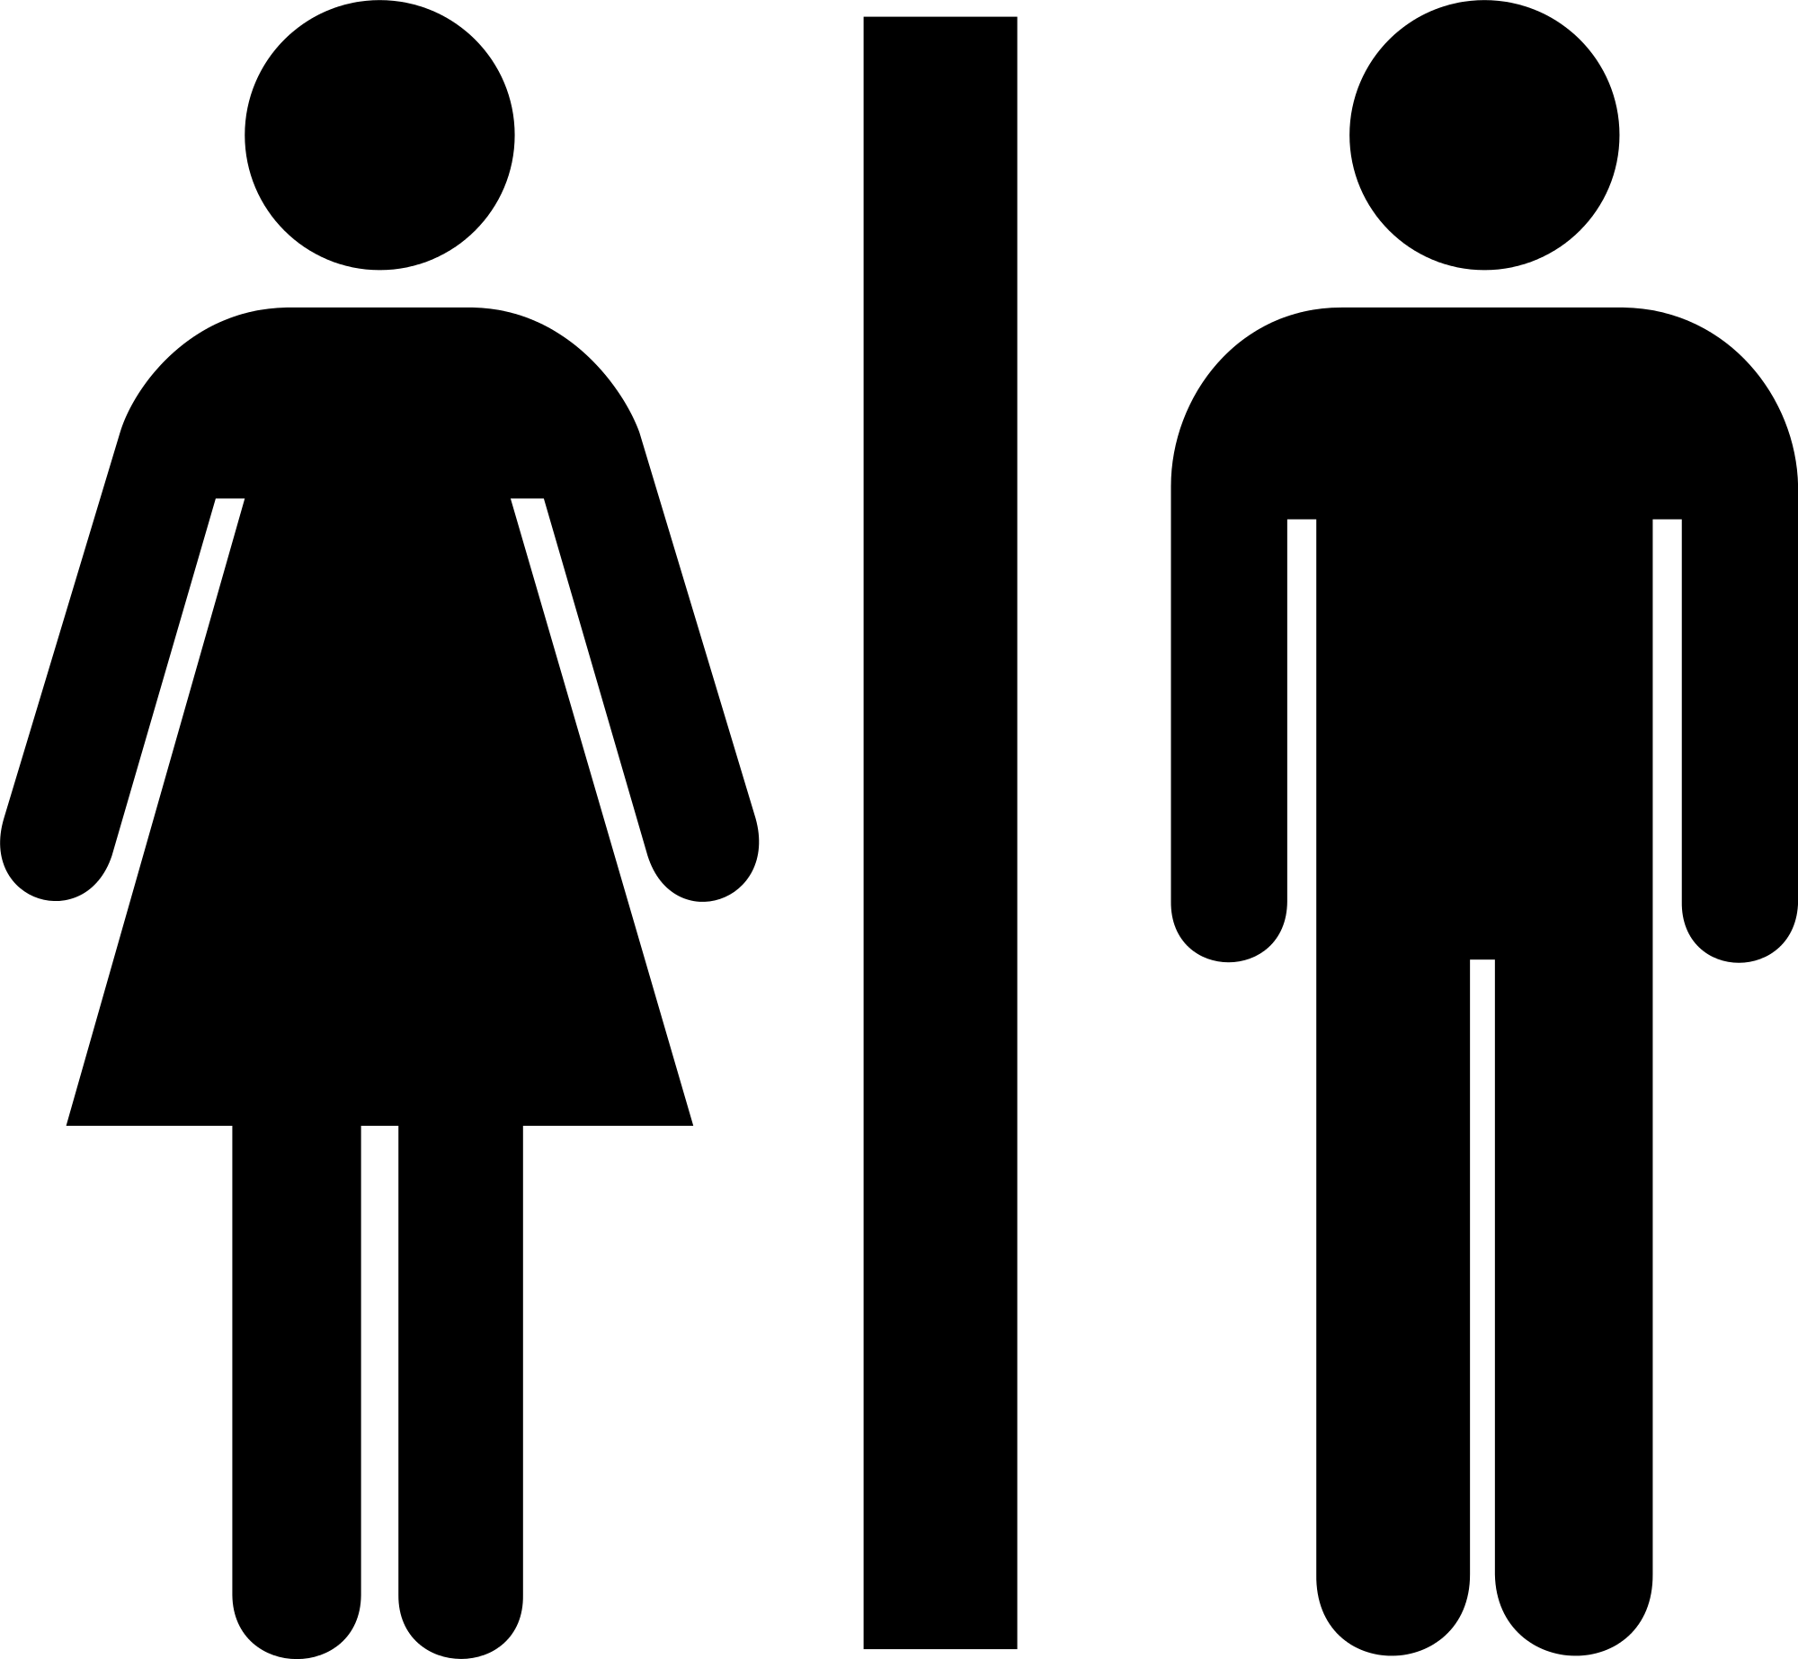
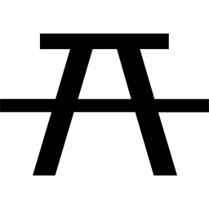
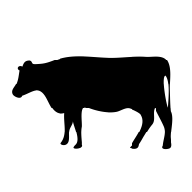
red walk 8 km
blue walk 11 km
green walk 15 km
yellow walk 20 km


The lengths of the walks have been corrected to the nearest kilometre. For each of the walks give:
- the lower bound
- the upper bound of the length of the walk.
 | Lower bound | Upper bound
Red walk
Blue walk
Green walk
Yellow walk

Worksheet 2a: Bounds for numbers to the nearest whole number continued
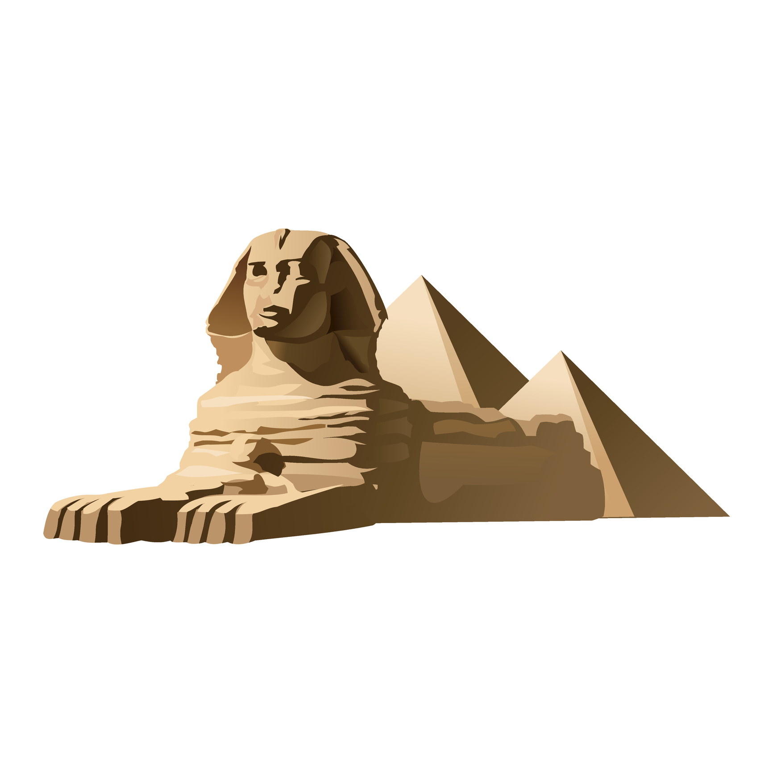
- Here is an extract from a guidebook:
Head length 10 m
Head width 4 m
Paw length 15 m
Overall length 45 m
Overall height 20 m
The Sphynx

- Assuming these measurements are correct to the nearest metre, give:
- the lower bound
- the upper bound for each length.

 | Lower bound | Upper bound
Head length
Head width
Paw length
Overall length
Overall height

Worksheet 2a: Bounds for numbers to the nearest whole number continued
- Complete inequality statements for each measurement.
Inequality statement
Head length
Head width
Paw length
Overall length
Overall height

- Here is part of an exam question.
The mass of Ahmed’s bag is 5 kg, correct to the nearest kilogram.
Write down the upper bound of the mass of his bag.
Ben has given this answer:
6 kg
Lena has given this answer:
5.4 kg
Marta has given this answer:
5.5 kg
Chris has given this answer:
4.5 kg

- Who is right? Explain why this is the right answer.

- Can you explain what mistakes the other three people have made?

Worksheet 2a: Bounds for numbers to the nearest whole number continued
- Ben has been collecting information on different measurements. The measurements are given to different accuracies. Copy and complete the table.

Measurement and accuracy | Lower bound | Upper bound
63 kg (nearest kg)
10 km (nearest km)
25 m (nearest m)
 | 11.5 cm | 12.5 cm
 | 78.5 km | 79.5 km
(nearest m) |  | 10.5 m
(nearest kg) | 19.5 kg

Worksheet 2b: Bounds for numbers to 1, 2 or 3 decimal places
- Each of the following numbers has been rounded to 1 decimal place.
For each number give:
- the lower bound
- the upper bound
- the inequality statement.
 | Lower bound | Upper bound | Inequality statement (n)
- 9.6 |  |  | _____≤ n <_____
- 7.3 |  |  | _____≤ n <_____
- 0.8 |  |  | _____≤ n <_____
- 9.0 |  |  | _____≤ n <_____
- 5.9 |  |  | _____≤ n <_____
- 10.0 |  |  | _____≤ n <_____

- Each of the following numbers has been rounded to 2 decimal places.
For each number give:
- the lower bound
- the upper bound
- the inequality statement.
 | Lower bound | Upper bound | Inequality statement (n)
- 0.42 |  |  | _____≤ n <_____
- 6.54 |  |  | _____≤ n <_____
- 9.03 |  |  | _____≤ n <_____
- 5.00 |  |  | _____≤ n <_____
- 3.87 |  |  | _____≤ n <_____
- 8.20 |  |  | _____≤ n <_____

Worksheet 2b: Bounds for numbers to 1, 2 or 3 decimal places continued
- Each of the following numbers has been rounded to 3 decimal places.
For each number give:
- the lower bound
- the upper bound
- the inequality statement.
 | Lower bound | Upper bound | Inequality statement (n)
- 0.342 |  |  | _____≤ n <_____
- 0.098 |  |  | _____≤ n <_____
- 3.026 |  |  | _____≤ n <_____
- 4.370 |  |  | _____≤ n <_____
- 6.080 |  |  | _____≤ n <_____
- 5.200 |  |  | _____≤ n <_____

- Each of the following lengths has been rounded to the nearest millimetre.
For each length give:
- the lower bound
- the upper bound
- the inequality statement.
 | Lower bound | Upper bound | Inequality statement (l)
- 12.4 cm |  |  | _____≤ l <_____
- 23.1 cm |  |  | _____≤ l <_____
- 17.7 cm |  |  | _____≤ l <_____
- 16.0 cm |  |  | _____≤ l <_____
- 21.4 cm |  |  | _____≤ l <_____
- 20.0 cm |  |  | _____≤ l <_____

Worksheet 2b: Bounds for numbers to 1, 2 or 3 decimal places continued
- Each of the following distances has been rounded to the nearest 100 m.
For each distance give:
- the lower bound
- the upper bound
- the inequality statement.
 | Lower bound | Upper bound | Inequality statement (d)
- 12.4 km |  |  | _____≤ d <_____
- 9.7 km |  |  | _____≤ d <_____
- 17.0 km |  |  | _____≤ d <_____
- 23.1 km |  |  | _____≤ d <_____
- 28.5 km |  |  | _____≤ d <_____
- 20.0 km |  |  | _____≤ d <_____

- Each of the following lengths has been rounded to the nearest centimetre.
For each length give:
- the lower bound
- the upper bound
- the inequality statement.
 | Lower bound | Upper bound | Inequality statement (l)
- 2.74 m |  |  | _____≤ l <_____
- 4.30 m |  |  | _____≤ l <_____
- 0.68 m |  |  | _____≤ l <_____
- 5.07 m |  |  | _____≤ l <_____
- 8.06 m |  |  | _____≤ l <_____
- 9.00 m |  |  | _____≤ l <_____

Worksheet 2b: Bounds for numbers to 1, 2 or 3 decimal places continued
- Each of the following masses has been rounded to the nearest gram.
For each mass give:
- the lower bound
- the upper bound
- the inequality statement.
 | Lower bound | Upper bound | Inequality statement (m)
- 0.268 kg |  |  | _____≤ m <_____
- 0.406 kg |  |  | _____≤ m <_____
- 1.035 kg |  |  | _____≤ m <_____
- 2.480 kg |  |  | _____≤ m <_____
- 5.095 kg |  |  | _____≤ m <_____
- 8.560 kg |  |  | _____≤ m <_____

- Here is some information about the world’s biggest cats by mass:

Himmy 21.3 kg
Meow 18.0 kg
Elvis 17.5 kg

The masses are recorded in kilograms to the nearest 1 decimal place.
For each of these masses give:
- the lower bound
- the upper bound
- the inequality statement.

 | Lower bound | Upper bound | Inequality statement (m)
Himmy
Meow
Elvis

Worksheet 2b: Bounds for numbers to 1, 2 or 3 decimal places continued
- Here are some World Records (correct at the time of writing):
World’s tallest man ever 2.72 m
World’s tallest living man 2.51 m
World’s shortest living woman 0.63 m
World’s shortest living man 0.55 m
The heights are recorded in metres to the nearest 2 decimal places.

For each of these heights give:
- the lower bound
- the upper bound
- the inequality statement.

 | Lower bound | Upper bound | Inequality statement (h)
- 2.72m |  |  | _____≤ h <_____
- 2.51m |  |  | _____≤ h <_____
- 0.63m |  |  | _____≤ h <_____
- 0.55m |  |  | _____≤ h <_____

Worksheet 2c: Card sort numbers and bounds
Cut out the cards to create a pack for each group of learners.

Ask pairs of learners to match up the inequality that defines the bounds for the stated value.

3.1075⩽n <3.1085 | 5.55⩽n <5.65
5.3(1dp) | 3.09(2dp)
3.0(1dp) | 5.475⩽n <5.485
5.4775⩽n<5.4785 | 5.298(3dp)
3.108(3dp) | 3.085⩽n <3.095
5.25⩽n<5.35 | 5.30(2dp)
5.295⩽n<5.305 | 5.48(2dp)
5.2975⩽n <5.2985 | 2.95⩽n <3.05
5.6(1dp) | 5.478(3dp)

Worksheet 2d: Identifying the number

Lower and upper bounds are shown in the table. Identify the number for which these are bounds and the accuracy that was used.
Number | Accuracy | Lower bound | Upper bound
 |  | 10.35 | 10.450
 |  | 13.5 | 14.5
 |  | 1.3465 | 1.3475
 |  | 23.15 | 23.25
 |  | 25.5 kg | 26.5 kg
 |  | 3.555 | 3.565
 |  | 5.675 m | 5.685 m
 |  | 24.5 cm | 25.5 cm
 |  | 9.5 | 10.5
 |  | 3.495 m | 3.505 m
 |  | 0.7925 | 0.7935
 |  | 1.3565 kg | 1.3575 kg
 |  | 335 km | 345 km
 |  | 3.4995 km | 3.5005 km
 |  | 0.0335 | 0.0345

Worksheet 3a: Card sort – whole numbers
Cut out the numbers below to create the cards. Learners should create sets of 3 consisting of a number, its lower bound and upper bound. All numbers are rounded to 1 significant figure.

45 000 | 0.4 | 0.65
0.55 | 650 | 35 000
4500 | 75 | 6500
85 | 2500 | 250
6000 | 0.45 | 15
7.5 | 5000 | 6500
350 | 900 | 1500
2000 | 5500 | 5500
9.5 | 25 | 20
700 | 0.9 | 300
95 | 750 | 4.5
7500 | 6.5 | 500
8 | 90 | 8.5
950 | 7000 | 850
65 | 45 | 70
8.5 | 40 000 | 0.85
55 | 9 | 0.6
450 | 50 | 6
3.5 | 0.95 | 550
5.5 | 0.35 | 4

Worksheet 3b: Card sort – decimal places
Cut out the numbers below to create the cards. Learners should create sets of 4 consisting of a number, its accuracy, lower bound and upper bound.

4040 | 1 significant figure | 364.5 | 4150
365 | 1 significant figure | 4.5 | 450.05
4 | 1 significant figure | 3500 | 3.865
35 600 | 1 significant figure | 0.065 | 4500
3.86 | 1 significant figure | 0.025 | 45.245
4000 | 2 significant figures | 4.35 | 3.5
0.03 | 2 significant figures | 4050 | 2695
300 | 2 significant figures | 3.8525 | 3.85
4100 | 2 significant figures | 3.855 | 35 605
0.36 | 2 significant figures | 0.055 | 1950
2000 | 3 significant figures | 4035 | 4085
4090 | 3 significant figures | 39 525 | 3.95
3.852 | 3 significant figures | 0.355 | 4095
3.9 | 3 significant figures | 35 595 | 4.25
45.24 | 3 significant figures | 0.365 | 350
4.3 | 4 significant figures | 0.035 | 4045
0.06 | 4 significant figures | 2050 | 2705
2700 | 4 significant figures | 250 | 39 515
450.1 | 4 significant figures | 450.15 | 45.235
39 520 | 4 significant figures | 365.5 | 3.8515

Worksheet 3c: Rounding to significant figures
- Each of these numbers has been rounded to 1 significant figure.
For each number give:
- the lower bound
- the upper bound.

 | Lower bound | Upper bound
- 70
- 900
- 8
- 4000
- 0.6
- 0.008

- Each of these numbers has been rounded to 2 significant figures.
For each number give:
- the lower bound
- the upper bound.

 | Lower bound | Upper bound
- 560
- 4700
- 700
- 3.5
- 0.48
- 5000

Worksheet 3c: Rounding to significant figures continued
- Each of these numbers has been rounded to 3 significant figures.
For each number give:
- the lower bound
- the upper bound.

 | Lower bound | Upper bound
- 4260
- 148
- 11 000
- 34.7
- 0.0403
- 9000

- Each of these numbers has been rounded to the accuracy indicated.
For each number give:
- the lower bound
- the upper bound.

 | Lower bound | Upper bound
- 400 (1 significant figure)
- 570 (2 significant figures)
- 3620 (3 significant figures)
- 0.8 (1 significant figure)
- 2.7 (2 significant figures)
- 0.06 (1 significant figure)
- 14.0 (3 significant figures)
- 400 (2 significant figures)
- 5.60 (3 significant figures)

Worksheet 3c: Rounding to significant figures continued
- Each of these numbers has been rounded to 1 significant figure. Give the lower bound and the upper bound for each figure.

$400 000 cost of cutting two shows
Supermarket faces $4 billion equal pay claim

 | Lower bound | Upper bound
- $400 000 cost of cutting two shows
- Supermarket faces $4 billion equal pay claim

- Here is a table giving the length of some of the longest land borders of countries in the world.

Country | Length of land borders (km)
People’s Republic of China | 22 000
Russia | 20 000
Brazil | 15 000
India | 14 000
United States | 12 000

Each length has been given correct to 2 significant figures. Give the lower bound and the upper bound for each length.

 | Lower bound | Upper bound
- People’s Republic of China
- Russia
- Brazil
- India
- United States

Worksheet 3c: Rounding to significant figures continued
- The masses of some animals in a zoo are shown in a guide book.

Elephant 4900 kg
Giraffe 1200 kg
Rhinoceros 1400 kg
Tiger 140 kg
Bear 180 kg
Camel 300 kg

All of these masses were given correct to 2 significant figures. Give the lower bound and upper bound for each mass.

 | Lower bound | Upper bound
- Elephant
- Giraffe
- Rhinoceros
- Tiger
- Bear
- Camel

- Lucy has been collecting information on different measurements. The measurements are given to different accuracies. Complete the table.

Measurement and accuracy | Lower bound | Upper bound
90 kg (1 significant figure)
2300 km (2 significant figures)
4.6 m (2 significant figures)
2300 g (3 significant figures)
 | 2500 km | 3500 km
 | 195 cm | 205 cm
(1 significant figure) |  | 8500 m
(2 significant figures) | 4250 kg

Worksheet 3d: Rounding to significant figures optional task
- Round each of these numbers to 1 significant figure.
- 352
- 1703
- 27.4
- 0.3802
- 0.05407

- Round each of these numbers to 2 significant figures.
- 4361
- 618.3
- 9.861
- 0.4037
- 0.05874

- Round each of these numbers to 3 significant figures.
- 50 723
- 29 370
- 37.486
- 6.0953
- 0.21752

- Round each of these numbers to 4 significant figures.
- 5 036 413
- 63 404
- 45.8952
- 6.03274
- 3.589951

Worksheet 3d: Rounding to significant figures optional task continued
- By rounding each of the numbers in the calculations below to 1 significant figure, find an estimate of the answer to each calculation.
- $\frac{\text{3.1} \text{×} \text{7.9}}{{\text{1.9}}^{\text{2}}}$
- $\text{5.7} \text{×} {\text{20.9}}^{\text{2}} – {\text{9.8}}^{\text{3}}$
- ${\text{(19.8} \text{×} \text{4.7)}}^{\text{2}} \text{÷} \text{78.7}$

Worksheet 3e: Card sort
Learners should create sets of 3 cards consisting of a number, its lower bound and upper bound. All numbers are rounded to 1 significant figure.

45 000 | 0.4 | 0.65
0.55 | 650 | 35 000
4500 | 75 | 6500
85 | 2500 | 250
6000 | 0.45 | 15
7.5 | 5000 | 6500
350 | 900 | 1500
2000 | 5500 | 5500
9.5 | 25 | 20
700 | 0.9 | 300
95 | 750 | 4.5
7500 | 6.5 | 500
8 | 90 | 8.5
950 | 7000 | 850
65 | 45 | 70
8.5 | 40 000 | 0.85
55 | 9 | 0.6
450 | 50 | 6
3.5 | 0.95 | 550
5.5 | 0.35 | 4

Worksheet 3f: Card sort alternative
Learners should create sets of 4 cards consisting of a number, its accuracy, lower bound and upper bound

4040 | 1 significant figure | 364.5 | 4150
365 | 1 significant figure | 4.5 | 450.05
4 | 1 significant figure | 3500 | 3.865
35 600 | 1 significant figure | 0.065 | 4500
3.86 | 1 significant figure | 0.025 | 45.245
4000 | 2 significant figures | 4.35 | 3.5
0.03 | 2 significant figures | 4050 | 2695
300 | 2 significant figures | 3.8525 | 3.85
4100 | 2 significant figures | 3.855 | 35 605
0.36 | 2 significant figures | 0.055 | 1950
2000 | 3 significant figures | 4035 | 4085
4090 | 3 significant figures | 39 525 | 3.95
3.852 | 3 significant figures | 0.355 | 4095
3.9 | 3 significant figures | 35 595 | 4.25
45.24 | 3 significant figures | 0.365 | 350
4.3 | 4 significant figures | 0.035 | 4045
0.06 | 4 significant figures | 2050 | 2705
2700 | 4 significant figures | 250 | 39 515
450.1 | 4 significant figures | 450.15 | 45.235
39 520 | 4 significant figures | 365.5 | 3.8515

Worksheet 4a: Card sort
Learners should create sets of 3 cards consisting of a number, its lower bound and upper bound.

35 (nearest whole) | 385 | 0.2565
370 (nearest ten) | 375 | 0.2555
1200 (nearest hundred) | 0.9525 | 395
4000 (nearest hundred) | 0.2025 | 365
315 000 (nearest thousand) | 0.175 | 0.1535
35.2 (1 decimal place) | 34.5 | 35.25
28.31 (2 decimal places) | 1450 | 0.95
7.20 (2 decimal places) | 314 500 | 35.5
0.154 (3 decimal places) | 28.305 | 8.75
390 (2 significant figures) | 1245 | 4050
1500 (2 significant figures) | 1150 | 35.15
1240 (3 significant figures) | 0.1545 | 0.9325
0.9 (1 significant figure) | 28.315 | 3950
0.18 (2 significant figures) | 1250 | 315 500
0.08 (1 significant figure) | 9.535 | 7.195
0.203 (3 significant figures) | 0.085 | 0.85
9.32 (2 significant figures) | 7.205 | 1235
8.7 (1 decimal place) | 0.185 | 1550
9.53 (2 decimal places) | 8.65 | 0.2035
0.256 (3 significant figures) | 9.315 | 0.075

Worksheet 4b: Matching activity
Learners should match the formulae to the answer.

$$\text{V} \text{=} \text{IR}$$  $$\text{I} \text{=} \text{5, }\text{R} \text{=} \text{12}$$ | 48
$$\text{v} \text{=} \text{u} \text{+} \text{at}$$  $$\text{u} \text{=} \text{12, }\text{a} \text{=} \text{4, }\text{t} \text{=} \text{8 }$$ | 59
$$\text{A =}\frac{\text{1}}{\text{ 2}}\text{bh}$$  $$\text{b} \text{=} \text{16, }\text{h} \text{=} \text{6}$$ | 72
$$\text{P} \text{=} \text{2}\text{l} \text{+} \text{2}\text{w}$$  $$\text{l} \text{=} \text{18, }\text{w} \text{=} \text{8}$$ | 49
$$\text{V = }{\text{s}}^{\text{3}}$$  $$\text{s} \text{=} \text{4}$$ | 60
$$\text{A =}\frac{\text{ 1}}{\text{2}}\text{(a + b)h}$$  $$\text{a} \text{=} \text{7, }\text{b} \text{=} \text{11, }\text{h} \text{=} \text{8}$$ | 54
$$\text{A} \text{=}{ \text{s}}^{\text{2}}$$  $$\text{s} \text{=} \text{7}$$ | 64
$$\text{Surface area} \text{=} \text{6}{\text{s}}^{\text{2}}$$  $$\text{s}\text{ = 3}$$ | 52
$$\text{P} \text{=} \text{4}\text{s}$$  $$\text{s} \text{=} \text{14}$$ | 44
$$\text{Surface area} \text{=} \text{2}\text{lw} \text{+} \text{2}\text{lh} \text{+} \text{2}\text{wh}$$  $$\text{l} \text{=} \text{4, }\text{w} \text{=} \text{3, }\text{h} \text{=} \text{2.5}$$ | 56

Worksheet 4c: Lower and upper bounds for calculations
- A square has side length of 12 cm measured to the nearest centimetre.
- Write down the lower bound and upper bound of the side length.
- Work out the lower bound and upper bound for the perimeter of the square.
- Work out the lower bound and upper bound for the area of the square.

- A field is in the shape of a rectangle. It has length 21.7 m and width 56.3 m correct to 1 decimal place.
- Write down the lower bound and upper bound of the length and width of the field.
- Work out the lower bound and upper bound for the perimeter of the field.
- Work out the lower bound and upper bound for the area of the field.

- The length, width and height of a cuboid are measured to the nearest centimetre.
6 cm
8 cm
5 cm

- What is the least possible value of the volume of the cuboid?
- What is the greatest possible value of the volume of the cuboid?

- A rug is in the shape of a circle. It has a diameter of 4.5 m correct to the nearest half metre.
- Write down the lower bound and upper bound of the diameter of the rug.
- Work out the lower bound and upper bound for the circumference (give your answers correct to 3 significant figures).
- Work out the lower bound and upper bound for the area of the rug (give your answers correct to 3 significant figures).

Worksheet 4c: Lower and upper bounds for calculations continued
- $a=5.2$, $b=4.1$ and $c=6.7$ are all measured to one decimal place.

Calculate the lower bound and upper bound for:
- $a+b$
- $ab$
- $\frac{c}{b}$ to 3 decimal places
- $\frac{ab}{c}$ to 3 decimal places
- $a(b+c)$
- $a(c-b)$

- A cylindrical drum has a radius of 60 cm to the nearest 5 cm and a height of 1.3 m correct to 1 decimal place.

[You may use $Volume=πr^{2}h$, $Surface area=2πr^{2}+2πrh$]
- Calculate the lower bound and upper bound for the volume of the drum. Give your answer correct to 3 significant figures.
- Calculate the lower bound and upper bound for the surface area of the drum. Give your answer correct to 3 significant figures.

- Blessy runs a 100 m race. The track length is accurate to the nearest metre.
Her time to complete the race was 18.3 seconds, correct to the nearest 0.1 seconds.

Calculate the lower bound and upper bound for her average speed.
[You may use $average speed=distance÷time$]

- A force of 120 Newtons (correct to 2 significant figures) is applied to a square area with side 0.6 metres (correct to the nearest 0.1 metres).

Calculate the lower bound and upper bound of the pressure.
[You may use $pressure=force÷area$]

Worksheet 4c: Lower and upper bounds for calculations continued
- An iron bar has a volume of 62 cm³ (correct to the nearest cm³) and a mass of 490 g (correct to 2 significant figures).

Calculate the lower bound and upper bound of the density of the iron.
[You may use $density=mass÷volume$]

- The circumference of a circle is 36.8 cm (correct to the nearest mm).
- Write down the lower bound and the upper bound for the circumference of the circle.
- Calculate the lower bound of the diameter.
- Calculate the upper bound of the diameter.
- Calculate the lower bound of the area.
- Calculate the upper bound of the area.

Worksheet 1a: Answers

The notation used to show mathematical inequalities are listed below. Describe each of them using plain English. One has been completed for you.
= Equals

≠ Not equal to

> Greater than

< Less than

⩾ Greater than or equal to

⩽ Less than or equal to

Worksheet 1b: Answers
Question | Lower bound | Upper bound
1 | 25% | 34%
2 | 650 | 749
3 | 35 500 | 36 499
4 | 495 | 504
5 | 55 | 64
6 | 6750 | 6849
7 | 2500 | 3499
8 | 7195 | 7 204
9 | 155 500 | 156 499
10 | 900 950 | 1 000 049
11 | 50 | 149
12 | 5 | 14
13 | 70 500 | 71 499
14 | 385 | 394
15 | 3000 | 3999

Worksheet 1c: Answers

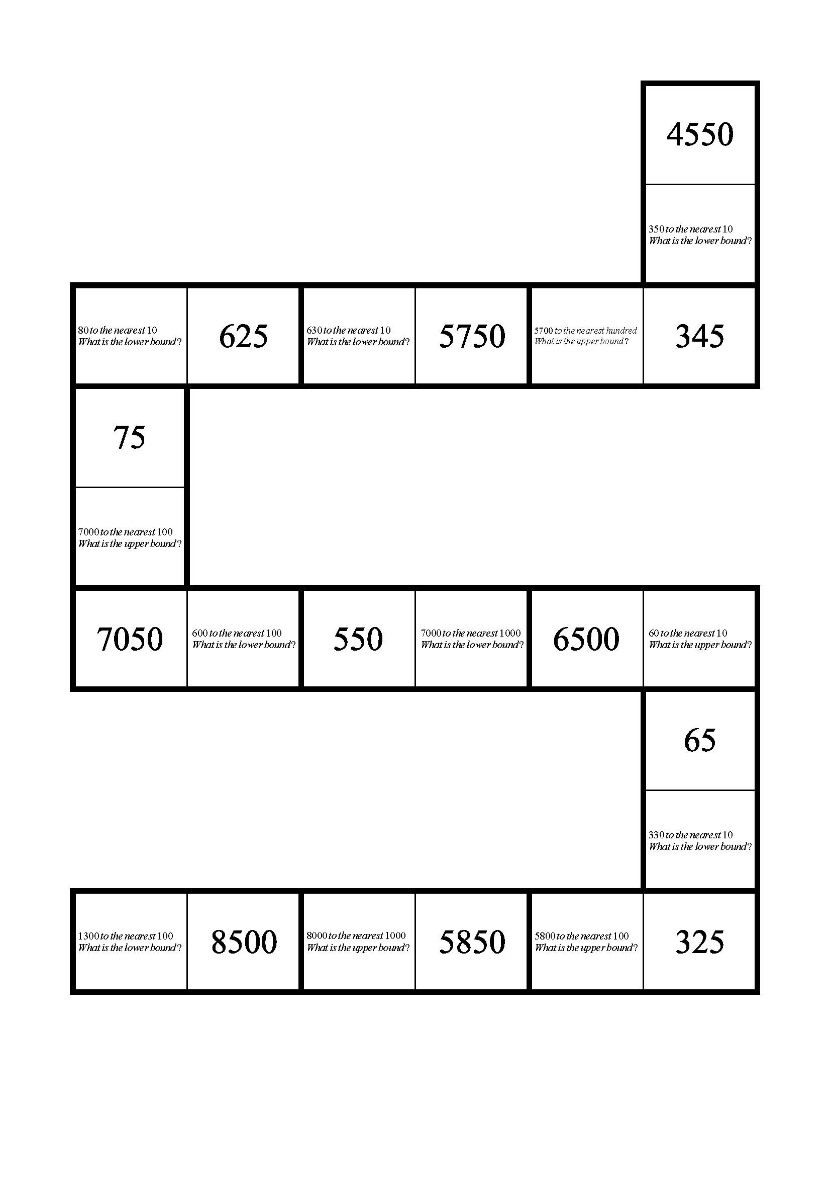
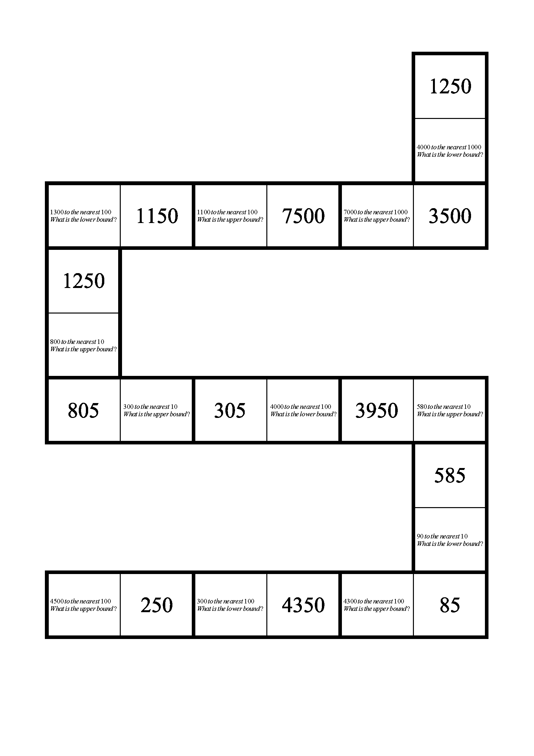

Worksheet 2c: Answers
5.3(1dp) | 5.25⩽n <5.35
3.0(1dp) | 2.95⩽n <3.05
5.61dp) | 5.55⩽n <5.65
5.30(2dp) | 5.295⩽n <5.305
3.09(2dp) | 3.085⩽n <3.095
5.48(2dp) | 5.475⩽n <5.485
5.298(3dp) | 5.2975⩽n <5.2985
3.108(3dp) | 3.1075⩽n <3.1085
5.478(3dp) | 5.4775⩽n <5.4785

Worksheet 2d: Answers
Number | Accuracy | Lower bound | Upper bound
10.4 | 1 decimal place | 10.35 | 10.450
14 | Nearest whole | 13.5 | 14.5
1.347 | 3 decimal places | 1.3465 | 1.3475
23.2 | 1 decimal place | 23.15 | 23.25
26kg | Nearest whole OR  nearest kg | 25.5kg | 26.5kg
3.56 | 2 decimal places | 3.555 | 3.565
5.68m | 2 decimal places OR  nearest cm | 5.675m | 5.685m
25cm | 1 decimal place OR  nearest mm | 24.5cm | 25.5cm
10 | Nearest whole | 9.5 | 10.5
3.50m | 2 decimal places OR  nearest cm | 3.495m | 3.505m
0.793 | 3 decimal places | 0.7925 | 0.7935
1.357kg | 3 decimal places OR  nearest gram | 1.3565kg | 1.3575kg
340km | Nearest whole OR  nearest km | 335km | 345km
3.500km | 3 decimal places or nearest m | 3.4995km | 3.5005km
0.034 | 3 decimal places | 0.0335 | 0.0345

Worksheet 3c: Answers
- Each of these numbers has been rounded to 1 significant figure. For each number give:
- the lower bound
- the upper bound.
- 65, 75
- 850, 950
- 7.5, 8.5
- 3500, 4500
- 0.55, 0.65
- 0.0075, 0.0085

- Each of these numbers has been rounded to 2 significant figures.
For each number give:
- the lower bound
- the upper bound.

- 555, 565
- 4650, 4750
- 695, 705
- 3.45, 3.55
- 0.475, 0.485
- 4950, 5050

- Each of these numbers has been rounded to 3 significant figures.
For each number give:
- the lower bound
- the upper bound.
- 4255, 4265
- 147.5, 148.5
- 10950, 11050
- 34.65, 34.75
- 0.04025, 0.04035
- 8995, 9005

- Each of these numbers has been rounded to the accuracy indicated.
For each number give:
- the lower bound
- the upper bound.

- 395, 405
- 565, 575
- 3615, 3625
- 0.75, 0.85
- 2.65, 2.75
- 0.055, 0.065
- 13.95, 14.05
- 395, 405
- 5.595, 5.605

Worksheet 3c: Answers continued
- Each of these numbers has been rounded to 1 significant figure. Give the lower bound and the upper bound for each number.

- $400 000 cost of cutting two shows. ($350 000 and $450 000)
- Supermarket faces $4 billion equal pay claim. ($3.5 billion and $4.5 billion)

- Here is a table giving the length of some of the longest land borders of some countries in the world. Each length has been given correct to 2 significant figures. Give the lower bound and the upper bound for each length.

Country | Length of land borders (km)
People’s Republic of China | 22 000
Russia | 20 000
Brazil | 15 000
India | 14 000
United States | 12 000

Country | Lower bound | Upper bound
People’s Republic of China | 21 500 | 22 500
Russia | 19 500 | 20 500
Brazil | 14 500 | 15 500
India | 13 500 | 14 500
United States | 11 500 | 12 500

- The masses of some animals in a zoo are shown in a guide book. All of these masses were given correct to 2 significant figures. Give the lower bound and upper bound for each mass.

Elephant | 4900 kg
Giraffe | 1200 kg
Rhinoceros | 1400 kg
Tiger | 140 kg
Bear | 180 kg
Camel | 300 kg

Worksheet 3c: Answers continued
 | Lower bound | Upper bound
Elephant | 4850 kg | 4950 kg
Giraffe | 1150 kg | 1250 kg
Rhinoceros | 1350 kg | 1450 kg
Tiger | 135 kg | 145 kg
Bear | 175 kg | 185 kg
Camel | 295 kg | 305 kg

- Lucy has been collecting information on different measurements. The measurements are given to different accuracies. Complete the table.

Measurement and accuracy | Lower bound | Upper bound
90 kg (1 significant figure) | 85 kg | 95 kg
2300 km (2 significant figures) | 2250 km | 2350 km
4.6 m (2 significant figures) | 4.55 m | 4.65 m
2300 g (3 significant figures) | 2295 g | 2305 g
3000 km (1 significant figure) | 2500 km | 3500 km
200 cm (2 significant figures) | 195 cm | 205 cm
8000 m (1 significant figure) | 7500 m | 8500 m
4300 kg (2 significant figures) | 4250 kg | 4350 kg

Worksheet 3d: Answers
- Round each of these numbers to 1 significant figure.
- 400
- 2000
- 30
- 0.4
- 0.05

- Round each of these numbers to 2 significant figures.
- 4400
- 620
- 10.0
- 0.40
- 0.059

- Round each of these numbers to 3 significant figures.
- 50 700
- 29 400
- 37.5
- 6.10
- 0.218

- Round each of these numbers to 4 significant figures.
- 5 036 000
- 63 400
- 45.90
- 6.033
- 3.590

- By rounding each of the numbers in the calculations below to 1 significant figure, find an estimate of the answer to each calculation.
- $\frac{\text{3} \text{×} \text{8}}{{\text{2}}^{\text{2}}} \text{=} \frac{\text{24}}{\text{4}} \text{=} \text{6}$
- $\text{6} \text{×} {\text{20}}^{\text{2}} – {\text{10}}^{\text{3}} \text{=} \text{6} \text{×} \text{400} – \text{1000} \text{=} \text{2400} – \text{1000} \text{=} \text{1400}$
- ${\text{(20} \text{×} \text{5)}}^{\text{2}} \text{÷} \text{80} \text{=} {\text{100}}^{\text{2}} \text{÷} \text{80} \text{=} \text{10} \text{000} \text{÷} \text{80} \text{=} \text{125}$

Worksheet 4c: Answers
- (a) Lower bound = 11.5 cm Upper bound = 12.5 cm
(b) Lower bound = $\text{4×11.5=46} \text{cm}$ Upper bound $\text{=4×12.5=50} \text{cm}$
(c) Lower bound $\text{=11.5×11.5=132.25} {\text{cm}}^{\text{2}}$
Upper bound$\text{=12.5×12.5=156.25} {\text{cm}}^{\text{2}}$

- (a) Lower bound length = 21.65 m Upper bound length = 21.75 m
Lower bound width = 56.25 m Upper bound width = 56.35 m
(b) Lower bound perimeter $\text{=2×21.65+2×56.25=155.8} \text{m}$
Upper bound perimeter $\text{=2×21.75+2×56.35=156.2} \text{m}$
- Lower bound area $\text{=21.65×56.25=1217.8125} {\text{m}}^{\text{3}}$
Upper bound area $\text{=21.75×56.35=1225.6125} {\text{m}}^{\text{3}}$

- (a) Least possible volume $\text{=5.5×7.5×4.5=185.625}{ \text{cm}}^{\text{3}}$
(b) Greatest possible volume $=6.5×8.5×5.5=303.875{ cm}^{3}$

- (a) Lower bound diameter = 4.25 m Upper bound diameter = 4.75 m
(b) Lower bound circumference $\text{=2×π×r=2×π×4.25=26.7} \text{m}$ (3 s.f.)
Upper bound circumference $\text{=2×π×r=2×π×4.75=29.8} \text{m}$ (3 s.f.)
(c) Lower bound area $\text{=π×}{\text{4.25}}^{\text{2}}\text{=56.7} {\text{m}}^{\text{2}}$ (3 s.f.)
Upper bound area $\text{=π×}{\text{4.75}}^{\text{2}}\text{=70.9} {\text{m}}^{\text{2}}$ (3 s.f.)

- $\text{5.15≤a<5.25}$ $\text{4.05≤b<4.15}$ $\text{6.65≤c<6.75}$

- $\text{Lower bound }\text{a+b}\text{=5.15+4.05=9.2}$
$\text{Upper bound }\text{a+b}\text{=5.25+4.15=9.4}$
- $\text{Lower bound ab=5.15×4.05=20.8575}$
$\text{Upper bound ab=5.25×4.15=21.7875}$
- $\text{Lower bound }\frac{\text{c}}{\text{b}}\text{=}\frac{\text{Lower bound c}}{\text{Upper bound b}}\text{=}\frac{\text{6.65}}{\text{4.15}}\text{=1.602}$ (3 d.p.)
$\text{Upper bound }\frac{\text{c}}{\text{b}}\text{=}\frac{\text{Upper bound c}}{\text{Lower bound b}}\text{=}\frac{\text{6.75}}{\text{4.05}}\text{=1.667}$ (3 d.p.)
- $\text{Lower bound }\frac{\text{ab}}{\text{c}}\text{=}\frac{\text{Lower bound a × lower bound b}}{\text{Upper bound c}}\text{=}\frac{\text{5.15×4.05}}{\text{6.75}}\text{=3.09}$
$\text{Upper bound }\frac{\text{ab}}{\text{c}}\text{=}\frac{\text{Upper bound a × upper bound b}}{\text{Lower bound c}}\text{=}\frac{\text{5.25×4.15}}{\text{6.65}}\text{=3.276}$ (3 d.p.)
- $\text{Lower bound a}\left(\text{b+c}\right)\text{=lower bound a(lower bound }\text{b+lower}\text{ bound c)}$
$$\text{=5.15×}\left(\text{4.05+6.65}\right)\text{=55.105}$$
$\text{Upper bound a}\left(\text{b+c}\right)\text{=upper bound a(upper bound }\text{b+upper}\text{ bound c)}$
$$\text{=5.25×}\left(\text{4.15+6.75}\right)\text{=57.225}$$
- $\text{Lower bound a}\left(\text{c-b}\right)\text{=lower bound a(lower bound c-upper bound b)}$
$$\text{=5.15×}\left(\text{6.65-4.15}\right)\text{=12.875}$$
$\text{Upper bound a}\left(\text{b+c}\right)\text{=upper bound a(upper bound c-lower bound b)}$
$$\text{=5.25×}\left(\text{6.75-4.05}\right)\text{=14.175}$$

Worksheet 4c: Answers continued
- $\text{57.5 cm ≤radius<62.5 cm}$ $\text{1.25 }\text{m≤height}\text{<1.35 m}$

- $\text{Lower bound volume=π×}{\text{57.5}}^{\text{2}}\text{×125=1298361.3…=1300000 }{\text{cm}}^{\text{3}}\text{(3 }\text{s.f.}\text{)=1.30}{\text{m}}^{\text{3}}\text{ (3 }\text{s.f.}\text{)}$
$\text{Upper bound volume=π×}{\text{62.5}}^{\text{2}}\text{×135=1656699.25…=1660000 }{\text{cm}}^{\text{3}}\text{(3 }\text{s.f.}\text{)=1.66}{\text{m}}^{\text{3}}\text{ (3 }\text{s.f.}\text{)}$
- $\text{Lower bound surface area=2×π×}{\text{57.5}}^{\text{2}}\text{+2×π×57.5×1.25=21225.38…}$
$$\text{=21200}{\text{ cm}}^{\text{2}} \left(\text{3 s.f.}\right)\text{= 2.12}{\text{ m}}^{\text{2}}\text{ (3 }\text{s.f.}\text{)}$$
$\text{Upper bound surface area=2×π×}{\text{62.5}}^{\text{2}}\text{+2×π×62.5×1.35=25073.83…}$
$$\text{=25100}{\text{ cm}}^{\text{2}} \left(\text{3 s.f.}\right)\text{=2.51 }{\text{m}}^{\text{2}}\text{ (3 }\text{s.f.}\text{)}$$

- $\text{99.5 }\text{m≤track}\text{ length<100.5 m}$ $\text{18.25 }\text{seconds≤time}\text{<18.35 seconds}$

$\text{Lower bound of average speed=}\frac{\text{Lower bound track length}}{\text{Upper bound time}}\text{=}\frac{\text{99.5}}{\text{18.35}}\text{=5.42 m}{\text{s}}^{\text{-1}}$ (3 s.f.)
$\text{Upper bound of average speed=}\frac{\text{Upper bound track length}}{\text{Lower bound time}}\text{=}\frac{\text{100.5}}{\text{18.25}}\text{=5.51 m}{\text{s}}^{\text{-1}}$ (3 s.f.)

- $\text{115≤Force<125}$ $\text{0.55≤side length<0.65}$

$$\text{Lower bound pressure= }\frac{\text{Lower bound force}}{\text{Upper bound area}}\text{=}\frac{\text{115}}{\text{0.65×0.65}}\text{=272.189…N}{\text{m}}^{\text{-2}}$$
$$\text{Upper bound pressure= }\frac{\text{Upper bound force}}{\text{Lower bound area}}\text{=}\frac{\text{125}}{\text{0.55×0.55}}\text{=413.223…N}{\text{m}}^{\text{-2}}$$

- $\text{61.5 }{\text{cm}}^{\text{3}}\text{≤Volume<62.5}{\text{ cm}}^{\text{3}}$ $\text{485 }\text{g≤Density}\text{<495 g}$

$$\text{Lower bound density=}\frac{\text{Lower bound mass}}{\text{Upper bound volume}}\text{=}\frac{\text{485}}{\text{62.5}}\text{=7.76 g }{\text{cm}}^{\text{-3}}$$
$$\text{Upper bound density=}\frac{\text{Upper bound mass}}{\text{Lower bound volume}}\text{=}\frac{\text{495}}{\text{61.5}}\text{=8.048… g }{\text{cm}}^{\text{-3}}$$

- (a) $\text{36.75 }\text{mm≤circumference}\text{<36.85 mm}$

(b) $\text{Circumference=π×d}$ $\text{Lower bound circumference= π×lower bound d}$
$\text{Lower bound d=}\frac{\text{lower bound circumference}}{\text{π}}\text{=}\frac{\text{36.75}}{\text{π}}\text{=11.6978…cm}$
- $\text{Circumference=π×d}$ $\text{Upper bound circumference= π×upper bound d}$
$\text{Upper bound d=}\frac{\text{Upper bound circumference}}{\text{π}}\text{=}\frac{\text{36.85}}{\text{π}}\text{=11.7297…cm}$
(d) $\text{Lower bound area=π×}{\text{(lower bound r)}}^{\text{2}}\text{=π×}{\left(\frac{\text{11.6978…}}{\text{2}}\right)}^{\text{2}}\text{=107.47… }{\text{cm}}^{\text{3}}$
(e) $\text{Upper bound area=π×}{\text{(upper bound r)}}^{\text{2}}\text{=π×}{\left(\frac{\text{11.7297…}}{\text{2}}\right)}^{\text{2}}\text{=108.06… }{\text{cm}}^{\text{3}}$

Cambridge Assessment International Education
The Triangle Building, Shaftsbury Road, Cambridge, CB2 8EA, United Kingdom
t: +44 1223 553554
e: info@cambridgeinternational.org www.cambridgeinternational.org

© Cambridge University Press & Assessment 2022

