

Teaching Pack
Vectors
Cambridge IGCSE™
Mathematics 0580

This Teaching Pack can also be used with the following syllabuses:
• Cambridge IGCSE™ (9–1) Mathematics 0980
• Cambridge IGCSE™ International Mathematics 0607
• Cambridge O Level Mathematics 4024

© Cambridge University Press & Assessment 2024
Cambridge Assessment International Education is part of Cambridge University Press & Assessment. Cambridge University Press & Assessment is a department of the University of Cambridge.

Cambridge University Press & Assessment retains the copyright on all its publications. Registered centres are permitted to copy material from this booklet for their own internal use. However, we cannot give permission to centres to photocopy any material that is acknowledged to a third party even for internal use within a centre.
Contents
Introduction 4
Skill: Vectors 5
Common misconceptions: Vectors 7
Lesson 1: Properties of vectors 8
Lesson 2: Vectors and translations 10
Lesson 3: Adding and subtracting vectors 11
Lesson 4: Vectors in real life contexts (extended only) 13
Lesson 5: Vectors geometry (extended only) 15
Links to websites: Vectors 16
Worksheets and answers 17

Icons used in this pack:
 | Lesson
 | Video
 | Assessment opportunity

Introduction
This pack will help you to develop your learners’ mathematical skills as defined by assessment objective 1 (AO1 Knowledge and understanding of mathematical techniques) in the course syllabus.

Important note
Our Teaching Packs have been written by classroom teachers to help you deliver topics and skills that can be challenging. Use these materials to supplement your teaching and engage your learners. You can also use them to help you create lesson plans for other skills.

This content is designed to give you and your learners the chance to explore mathematical skills. It is not intended as specific practice for exam papers.

This is one of a range of Teaching Packs. Each pack is based on one mathematical topic with a focus on specific mathematical techniques. The packs can be used in any order to suit your teaching sequence.

In this pack you will find the lesson plans and worksheets for learners you will need to successfully complete the teaching of this mathematical skill.

Skill: Vectors
This Teaching Pack links to the following syllabus content (see syllabus for detail):
- C7.1 Describe a translation by using a vector represented by e.g. $\left(\begin{aligned}\text{x} \\ \text{y}\end{aligned}\right)\text{, }\vec{\text{AB}}$ or a. Add and subtract vectors. Multiply a vector by a scalar.
- E7.1 Describe a translation by using a vector represented by e.g. $\left(\begin{aligned}\text{x} \\ \text{y}\end{aligned}\right)\text{, }\vec{\text{AB}}$ or a. Add and subtract vectors. Multiply a vector by a scalar.

Note that for the 2025 syllabus that there have been significant changes to what appears as part of core or extended content. The lessons developed for this teaching pack were developed when the core and extended syllabus content for this topic were identical. Therefore, so of the detail in lesson plans when used for the 2025 syllabus will now be relevant only to extended learners, or as extension material for core learners.
For assessments from 2025
- C/E7.1 Recognise, describe and draw the following transformations: 4. Translation of a shape by a given vector $\left(\begin{aligned}\text{x} \\ \text{y}\end{aligned}\right)$
- E7.2 Describe a translation using a vector represented by $\left(\begin{aligned}\text{x} \\ \text{y}\end{aligned}\right), \vec{AB}$ or a.
Add and subtract vectors
Multiply a vector by a scalar

The pack covers the following mathematical skills, adapted from AO1: Demonstrate knowledge and understanding of mathematical techniques (see syllabus for assessment objectives):
- using and interpreting mathematical notation correctly
- recognising and using spatial relationships in two and three dimensions.
For assessments from 2025
AO1: Knowledge and understanding of mathematical techniques
- understand and use mathematical notation and terminology
- recognise and use spatial relationships in two and three dimensions.

Prior knowledge
Knowledge from the following syllabus topics is useful for the development of skills in this unit.
- C7.2 Reflect simple plane figures in horizontal or vertical lines. Rotate simple plane figures about the origin, vertices or midpoints of edges of the figures, through multiples of 90°. Construct given translations and enlargements of simple plane figures. Recognise and describe reflections, rotations, translations and enlargements.
- E7.2 Reflect simple plane figures. Rotate simple plane figures through multiples of 90°. Construct given translations and enlargements of simple plane figures. Recognise and describe reflections, rotations, translations and enlargements.
Extended learners will also need to know:
- E6.2 Apply Pythagoras’ theorem and the sine, cosine and tangent ratios for acute angles to the calculation of a side or of an angle of a right-angled triangle. Solve trigonometric problems in two dimensions involving angles of elevation and depression. Know that the perpendicular distance from a point to a line is the shortest distance to the line.
For assessments from 2025
- C/E7.1 Recognise, describe and draw the following transformations:
1. Reflection of a shape in a vertical or horizontal line.
2. Rotation of a shape about the origin, vertices or midpoints of edges of the shape through multiples of 90°.
3. Enlargement of a shape from a given centre by a given scale factor.
Extended learners will also need to know:
- E6.1 Know and use Pythagoras’ theorem.
- E6.2 Know and use the sine, cosine and tangent ratios for acute angles in calculations involving sides or angles of a right-angled triangle.
Solve problems in two dimensions using Pythagoras’ theorem and trigonometry.
Know that the perpendicular distance from a point to a line is the shortest distance to the line.
Carry out calculations involving angles of elevation and depression.

Going forward
The knowledge and skills gained from this Teaching Pack can be used for when you teach learners about calculating the magnitude of a vector.
- E7.3 Calculate the magnitude of a vector $\left(\begin{aligned}\text{x} \\ \text{y}\end{aligned}\right)$ as $\sqrt{{\text{x}}^{\text{2}}\text{+}{\text{y}}^{\text{2}}}$. Represent vectors by directed line segments. Use the sum and difference of two vectors to express given vectors in terms of two coplanar vectors. Use position vectors.
For assessments from 2025
- E7.3 Calculate the magnitude of a vector $\left(\begin{aligned}\text{x} \\ \text{y}\end{aligned}\right)$ as $\sqrt{{\text{x}}^{\text{2}}\text{+}{\text{y}}^{\text{2}}}$.
- E7.4 Represent vectors by directed line segments.
Use position vectors.
Use the sum and difference of two or more vectors to express given vectors in terms of two coplanar vectors.
Use vectors to reason and to solve geometric problems.

Before you begin
This Teaching Pack includes a Teacher Introduction video to which you should refer before
using the resources in this pack. The video is available to watch in Resource Plus within the topic section relevant to this Teaching Pack.

The video introduces the resources available for teaching this topic, and explains how they can be used to successfully deliver the topic to your students. In particular, the video highlights typical student misconceptions and common errors this Teaching Pack will help you to overcome.

Common misconceptions: Vectors
Students can have difficulty with the difference between vector and scalar quantities. They often forget that vectors need a direction as well as a magnitude. Students can confuse the language of vectors for example speed and velocity. This is reinforced by the interchangeable way these terms are sometimes used. It is important to be rigorous when using the language of vectors and scalars in the classroom. Students can also be confused by the range of different notation used for vectors.

Some of the students think that the magnitude of a component is equal to the magnitude of the vector, and others know the “rule” that components are shorter than the vector but have problems to identify the magnitude of the components graphically. Students can also get confused with the resultant vector when tackling vector geometry problems. When finding the magnitude of a vector students can fail to take the square root and so not have a complete method for the magnitude of the vector.
Lesson 1: Properties of vectors

- Whiteboard
- Lesson 1 Properties of vectors presentation
- Worksheet 1a, 1b, 1c.
Learning objectives |  | By the end of the lesson:  - all learners should be able to identify and use vector notation  - all learners should be able to understand the difference between a vector and a scalar quantity and multiply a vector by a scalar.
Timings | Activity
 | Starter/Introduction  Teach this lesson using Lesson 1 Properties of vectors presentation. This is a non-calculator lesson.  Ask learners to informally consider vectors in a real-life situation, in this case a water skier (slide 3). The example of the water skier is an illustration of the sort of real-life questions that can be modelled with the use of vectors.
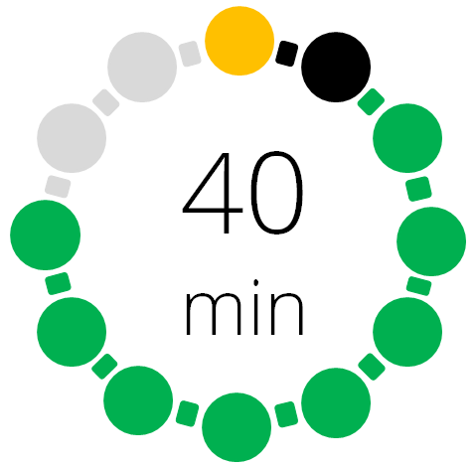 | Main lesson  Begin by giving your learners Worksheet 1a Scalars or vectors? (The worksheet will stretch core students) Ask them to complete the quiz, which can then be peer marked by their fellow learners as you read out the answers. Either show slide 4 before the quiz, or use it for discussion after the quiz  This interactive activity allows learners to consolidate/develop an understanding of the difference between a vector and a scalar. Learners need to decide if the measures listed are scalars (which only have magnitude or size) or vectors (which have magnitude and direction). Learners may find it useful to draw on their work in science for this activity.  Depending on the group you are working with you may want to show this video before presenting the activity:  https://www.youtube.com/watch?v=EUrMI0DIh40  Learners do not need to know the detail at this stage, but they should appreciate the difference between a scalar and a vector.  Introduce and work through Slides 5 to 8 with you learners. These formalise prior learning by describing a translation in terms of horizontal and vertical shifts, and introduces vector notations. A vector can be written as a and as $\vec{\text{AB}}$ (Extended content from 2025). The arrow above the letters shows the direction of movement, which in this case is from A to B.  After showing learners slide 8, hand out Worksheet 1b Column vectors for them to complete.  Slides 9 to 12 Introduce multiplying a vector by a scalar (extended content from 2025). When we multiply a vector by a scalar quantity, it is called scaling the vector as it changes the magnitude, while the overall direction of the vector will be the same (although it can be in the opposite direction). Slide 11 provides examples and checks that learners appreciate that scaler multiples of vectors are all parallel to the original vector (learners will need some squared paper for this activity).
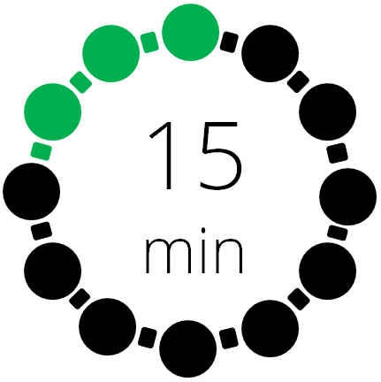 | Plenary  Slide 12 consolidates learners understanding of vector notation and multiplying a vector by scaler.  Worksheet 1c Vector properties quiz provides an assessment opportunity.  Extension: Ask learners:  Can you suggest some assumption we will / have made? (Starter Extension)  How can you tell if 2 vectors are parallel?

Lesson 2: Vectors and translations

Resources |  | - Whiteboard  - Lesson 2 Vectors and translations presentation  - Worksheets 2a, 2b, 2c.
Learning objectives |  | By the end of the lesson:  - all learners should be able to illustrate translations using vectors.
Timings | Activity
Starter/Introduction
Teach this lesson using Lesson 2 Vectors and translations presentation. This is a non-calculator lesson.
Using slide 3, ask learners which one of the vectors is the odd one out.
Main lesson
Show your learners slides 4 and 5, demonstrating to learners to how to use vectors to describe translations (some of this will be extended content from 2025).

Handout Worksheet 2a Transformations using vectors.

Slide 6 introduces an activity for learners, focusing on using vectors to describe the translation of shapes. You can use this link to demonstrate it:

https://ggbm.at/QQz9s4Ac

You can use this interactively, by asking students to predict where the shape will go based on a given vector. You could also ask them “if you wanted to move the object so that point a was on the coordinate (2,2) what vector would you need to use” for example.

There is a worksheet version of the grid (Worksheet 2b Shape translation) that students can use alongside or as an alternative.

Differentiation: allow students to explore translations of shapes independently using the link above.

Plenary
Learners revisit the problem that they meet at the start of this lesson. Discuss with them whether they could identify the coordinates of point B without drawing the diagram? This will start them thinking about the topic for the next lesson, which is adding and subtracting vectors.
Worksheet 2c Vector translations quiz provides an assessment opportunity.

Lesson 3: Adding and subtracting vectors
(2025: extended only)

Resources |  | - Lesson 3 Adding and subtracting vectors video introduction  - Whiteboard  - Lesson 3 Adding and subtracting vectors presentation  - Worksheets 3a, 3b, 3c, 3d.
Learning objectives |  | By the end of the lesson:  - all learners will be able to add and subtract vectors  - some learners will be able to use vectors to solve multi step real life questions.
Timings | Activity
Starter/Introduction
Teach this lesson using Lesson 3 Adding and subtracting vectors presentation. This is a non-calculator lesson.
This lesson looks at how to add and subtract vectors and scalar multiples of vectors. Introduce the content of this lesson by showing learners Lesson 3 Adding and subtracting vectors video introduction.
Main lesson
Having watched the video, give your learners Worksheet 3a Adding and subtracting vectors to work through.

Extension: For more capable learners, give them Worksheet 3b Adding and subtracting vectors extension to work through.

Next, give learners a real life vector query to solve. Handout Worksheet 3c Vector walks to complete. Use this link, Vector Walks, to explore some other squares and find the vectors that would describe a journey around the perimeter. Some additional teaching ideas are available from the following web pages:
Vectors Round a Square
Vector Journeys
Plenary
Using slides 3 and 4, introduce and discuss the questions on the slides:
Is vector addition commutative? In other words, is a + b the same as b + a? Explain why or why not.
Explain to a partner, in your own words, how to add any 2 vectors geometrically.
Is it ever possible for the resultant (sum) of two vectors to be the zero vector? If so, describe the relationship that must be true between these 2 vectors.
Differentiation: this plenary can be differentiated based on the amount of support provided and the depth of the explanation required. Identify specific students to share their explanations.

Worksheet 3d Vector translations quiz provides an assessment opportunity.

Lesson 4: Vectors in real life contexts (extended only)

Resources |  | - Whiteboard  - Lesson 4 Vectors in real life contexts presentation  - Geogebra animation  - Worksheets 4a, 4b, 4c, 4d.
Learning objectives |  | By the end of the lesson:  - all learners should be able to solve multi step real life vector questions.
Timings | Activity
Starter/Introduction
Teach this lesson using Lesson 4 Vectors in real life contexts presentation.
Check your learners’ understanding of Pythagoras’ theorem, as they will need knowledge of this in this lesson. Use Worksheet 4a Pythagoras. Note that the use of a, b and c is different to normal, and this is to check that learners really do understand what Pythagoras’ theorem says, and are not just following a procedure.
Learners will also need to remember the basic rules of trigonometry, if you need to check/remind them you can use this link:
https://www.mathsisfun.com/algebra/trigonometry.html
Main lesson
Slide 3 demonstrates how students can use what they already know about Pythagoras and trigonometry to find the magnitude and the direction of a vector.
Slides 4 – 5 work through some real life examples of using vectors that can be used with your learners. The first example includes the use of a Geogebra animation or a hardcopy version in Worksheet 4b Finding ice cream.

You may want to remind students that speed is a scalar quantity (velocity is a vector quantity). Direction is a scalar quantity (the vector quantity is displacement). You may also want to remind learners that bearings are given as three figures, taken clockwise from north.

Next, handout Worksheet 4c Real life examples to your learners to complete.
Differentiation: as well as solutions there are hints that can be used to support learners who struggle with this worksheet.

Differentiation: as well as solutions there are hints that can be used to support learners who struggle with this activity. For those learners, handout Worksheet 4d Real life examples hints.

Plenary
Introduce learners to slide 6:
- Now design your own exam question using some of what you have learnt in the last 4 lessons on vectors. Could be an opportunity for students to design a non-calculator question if exact trigonometric values (E6.3) has already been covered.
- See if you can design a question that starts fairly easily but then gets harder as you go along.
- You will also need to think about a mark scheme for your question.
This can be used as an assessment for this lesson and also pulls together the work of the last 3 lessons on vectors.

Lesson 5: Vectors geometry (extended only)

Resources |  | - Whiteboard  - Lesson 5 Vector geometry presentation  - Worksheets 5a, 5b.
Learning objectives |  | By the end of the lesson:  - all learners should be able to solve simple geometrical problems in 2D using vectors.
Timings | Activity
Starter/Introduction
Teach this lesson using Lesson 5 Vector geometry presentation. This is a non-calculator lesson.
Use the question in slide 3 to remind learners of the work they did in the last lesson, on finding the magnitude and direction of a vector.
Main lesson
The lesson begins by revisiting the work on adding and subtracting vectors, but in a slightly different way that will prepare learners for the problems in this lesson.

Introduce slides 4-6 to your learners and work through them onscreen.

Next, work through the problems using vector geometry on slides 7-8 with your learners.

Hand out Worksheet 5a Vector geometry to learners to complete.

Differentiation: There are two hints you can use to support learners if they struggle with this worksheet. These are available to handout on Worksheet 5b Vector geometry hints.

Plenary
Hand out Worksheet 5c Vector geometry exam question for your leaners to work through. This is a past paper question (0580 Question 18, Paper 21 May/June 2017) of the type learners are likely to see when they take their exams.

Links to websites: Vectors
https://www.mathsisfun.com/geometry/translation.html
https://www.youtube.com/watch?v=EUrMI0DIh40

https://nrich.maths.org/10734
https://nrich.maths.org/7453
https://www.mathsisfun.com/algebra/trigonometry.html
http://www.mathopolis.com/questions/q.php?id=3025

Worksheets and answers

 | Worksheets | Answers
For use in Lesson 1:
1a: Scalars or vectors? | 18 | 43
1b: Column vectors | 19 | 44
1c: Vector properties quiz | 20 | 45
For use in Lesson 2:
2a: Transformations using vectors | 22 | 46
2b: Shape translation | 25
2c: Vector translations quiz | 26 | 49
For use in Lesson 3:
3a: Adding and subtracting vectors | 28 | 50
3b: Adding and subtracting vectors extension | 29 | 51
3c: Vector walks | 31 | 52
3d: Adding and subtracting vectors quiz | 32 | 53
For use in Lesson 4:
4a: Pythagoras | 35 | 54
4b: Finding ice cream | 36
4c: Real life examples | 37 | 55
4d: Real life examples hints | 38
For use in Lesson 5:
5a: Vector geometry | 39 | 57
5b: Vector geometry hints | 41
5c: Vector geometry exam question | 42 | 59

Worksheet 1a: Scalars or vectors?
This activity checks your understanding of the difference between a vector and a scalar. This is an interactive activity and you need to decide if the measures listed here are scalars or vectors?
Circle your answers to each of the questions below.

Scalar | Vector
- Force

Scalar | Vector
- Mass

Scalar | Vector
- Speed

Scalar | Vector
- Acceleration

Scalar | Vector
- Distance

Scalar | Vector
- Weight

Scalar | Vector
- Displacement

Scalar | Vector
- Temperature

Scalar | Vector
- Height

Worksheet 1b: Column vectors
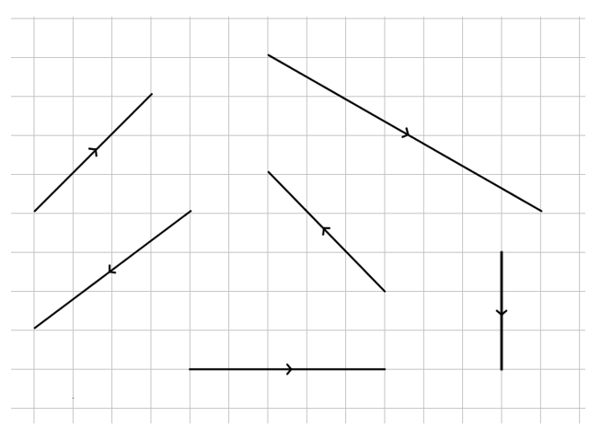
- Write down the column vector that represents each of the vectors on this grid. The first one is done for you.

$$\left(\begin{aligned}\text{3} \\ \text{3}\end{aligned}\right)$$

- Now draw these vectors on the grid. The starting point for each vector is marked on the grid and once again the first one is done for you.
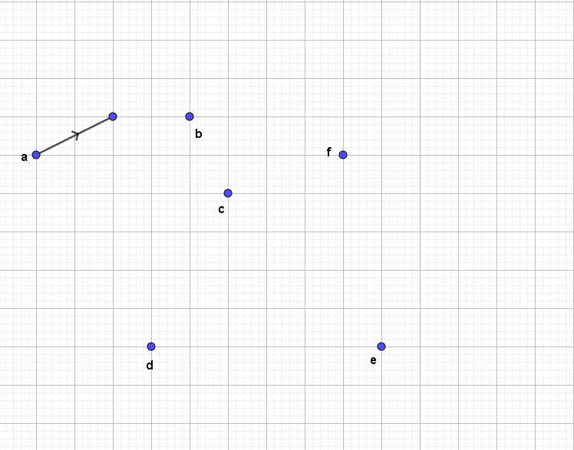
a $\left(\begin{aligned}\text{2} \\ \text{1}\end{aligned}\right)$ b $\left(\begin{aligned}\text{-1} \\ \text{2}\end{aligned}\right)$ c $\left(\begin{aligned}\text{1} \\ \text{3}\end{aligned}\right)$ d $\left(\begin{aligned}\text{-2} \\ \text{4}\end{aligned}\right)$ e $\left(\begin{aligned}\text{-4} \\ \text{2}\end{aligned}\right)$ f $\left(\begin{aligned}\text{6} \\ \text{-2}\end{aligned}\right)$

Worksheet 1c: Vector properties quiz
This quiz checks your understanding of basic vector properties. It is a multiple-choice assessment, and the questions are designed to highlight any misconceptions or misunderstandings. Please choose the answer you think is correct and explain why you think it is correct.
- Which option below best describes the vector $\left(\begin{aligned}\text{4} \\ \text{-6}\end{aligned}\right)$
- 4 up, 6 left
- 4 right, 6 down
- 4 left, 6 down
- 4 right, 6 up.

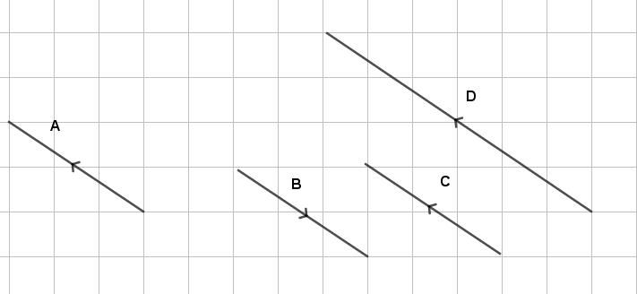
- Which vector in this diagram are the same?

- A and B
- A and C
- A and D
- All

Worksheet 1c: Vector properties quiz continued
- Which vector is the same as the column vector $\left(\begin{aligned}\text{-2} \\ \text{3}\end{aligned}\right)$
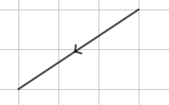

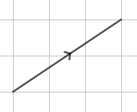
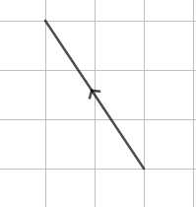
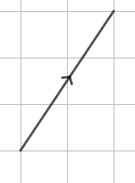

Worksheet 2a: Transformations using vectors
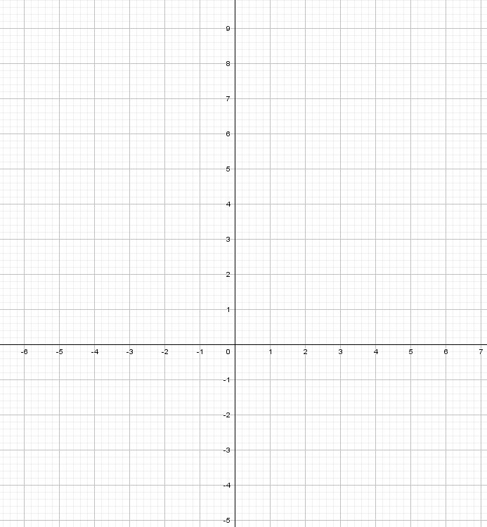
- A is the point (–4, 3). $\vec{\text{AB}}$ = $\left(\begin{aligned}\text{4} \\ \text{-2}\end{aligned}\right)$ and $\vec{\text{AC}}$ = $\left(\begin{aligned}\text{3} \\ \text{5}\end{aligned}\right)$. Plot the points A, B and C on the grid.

  - Write down the coordinates of B and C.

  - What is the column vector for $\vec{\text{BC}}$ ?

Worksheet 2a: Transformations using vectors continued

- A translation described by vector t transforms the point A(3, –2) to A’(5, 2).
- What will be the coordinates of point B(2, 4) after the same translation?

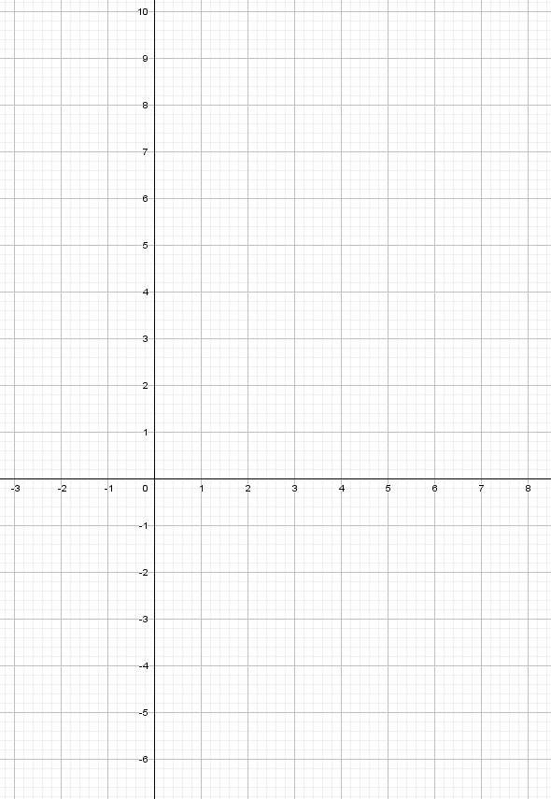
- C’(6, –2) has been transformed by t. What were the original coordinates of point C?
Worksheet 2a: Transformations using vectors continued
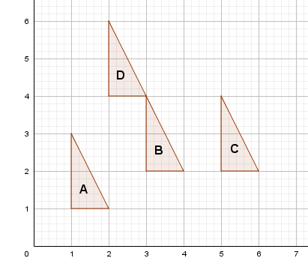
- Look at this image. The vector describing the translation from A to B is $\left(\begin{aligned}\text{2} \\ \text{1}\end{aligned}\right)$ as each point on the triangle is moved 2 places right and 1 place up the grid.
Can you describe the following vectors
- The vector describing the translation from B to C

- The vector describing the translation from C to D

- The vector describing the translation from D to A

Worksheet 2b: Shape translation

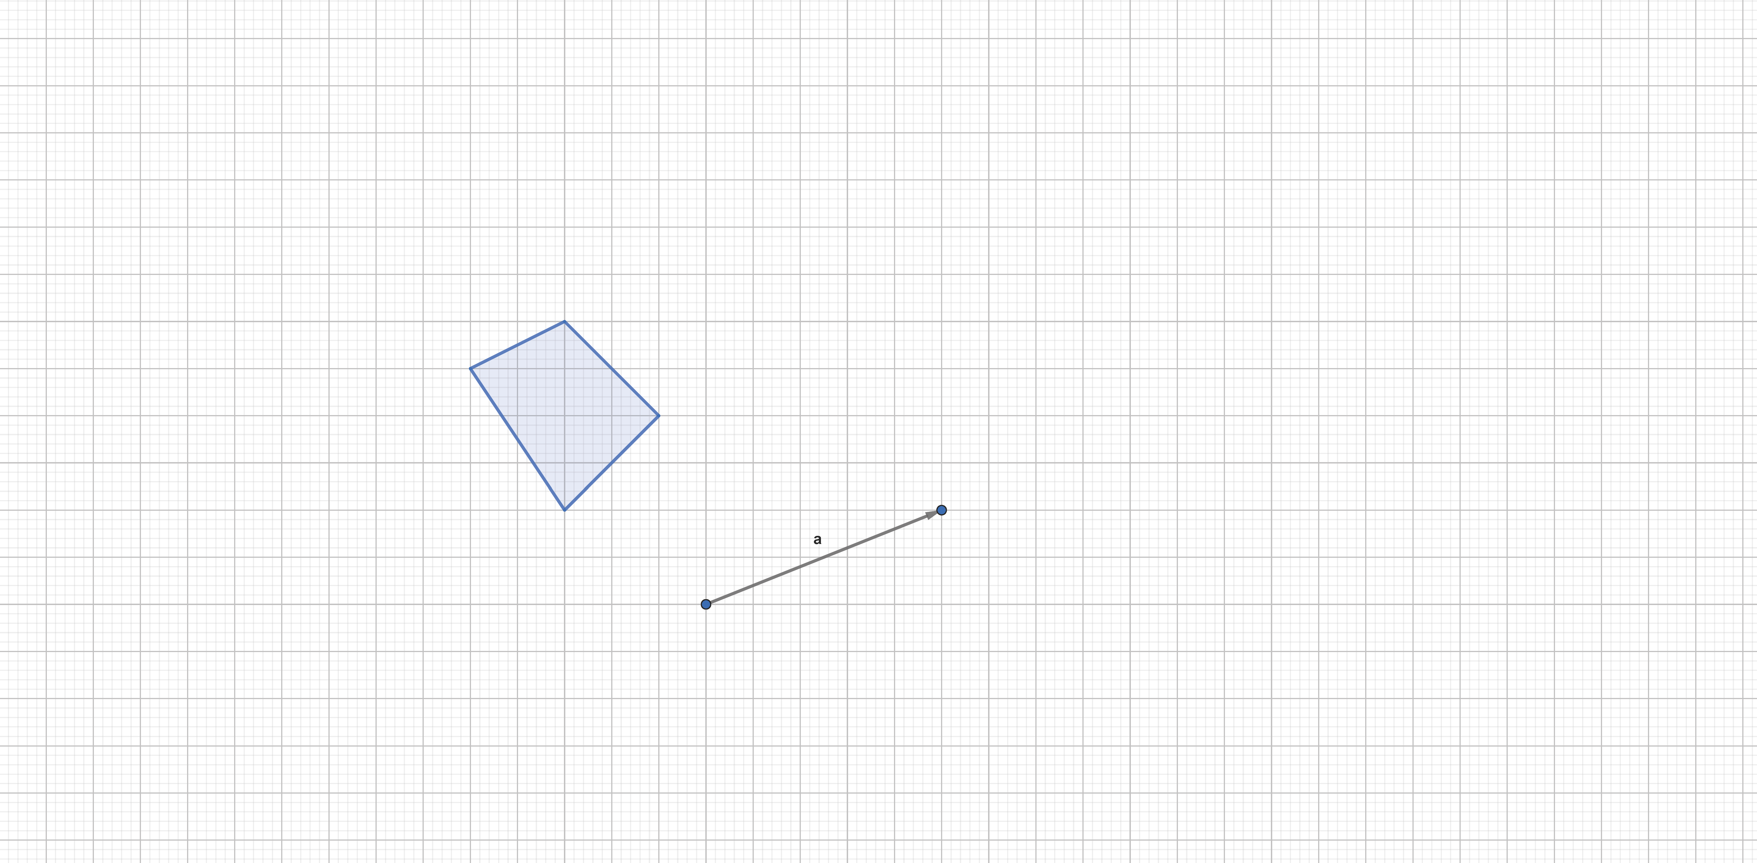

Worksheet 2c: Vector translations quiz
This quiz checks your understanding of vectors and transformations. It is a multiple-choice assessment and the questions are designed to highlight any misconceptions or misunderstandings. Please choose the answer you think is correct and explain why you think it is correct.
- What is the vector notation for a translation of 4 right? Circle your choice.
- $\left(\begin{aligned}\text{0} \\ \text{4}\end{aligned}\right)$
- $\left(\begin{aligned}\text{4} \\ \text{0}\end{aligned}\right)$
- $\left(\begin{aligned}\text{-4} \\ \text{0}\end{aligned}\right)$
- $\left(\begin{aligned}\text{0} \\ \text{-4}\end{aligned}\right)$

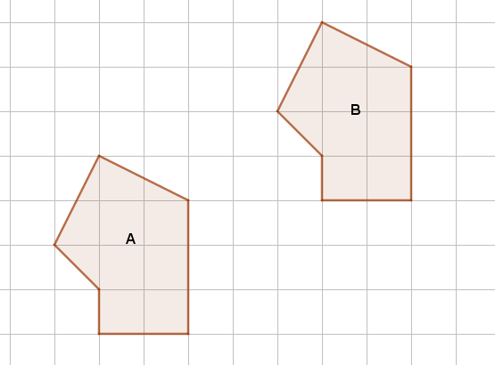
- Describe the translation from shape B to shape A (tick your choice):

  - 5 squares to the right and 3 squares up.
  - 5 squares to the right and 3 squares down.
  - 5 squares to the left and 3 squares down.
  - 5 squares to the left and 3 squares up.

Worksheet 2c: Vector translations quiz continued
- What is the vector notation for a translation of 5 down?
  - $\left(\begin{aligned}\text{5} \\ \text{0}\end{aligned}\right)$
  - $\left(\begin{aligned}\text{0} \\ \text{5}\end{aligned}\right)$
  - $\left(\begin{aligned}\text{-5} \\ \text{0}\end{aligned}\right)$
  - $\left(\begin{aligned}\text{0} \\ \text{-5}\end{aligned}\right)$

Worksheet 3a: Adding and subtracting vectors
- You are given two vectors, a and b:
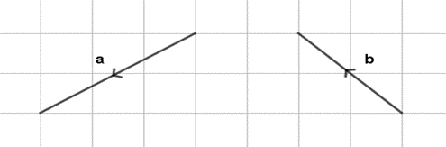
Which one of the following shows the vector (write your choice):
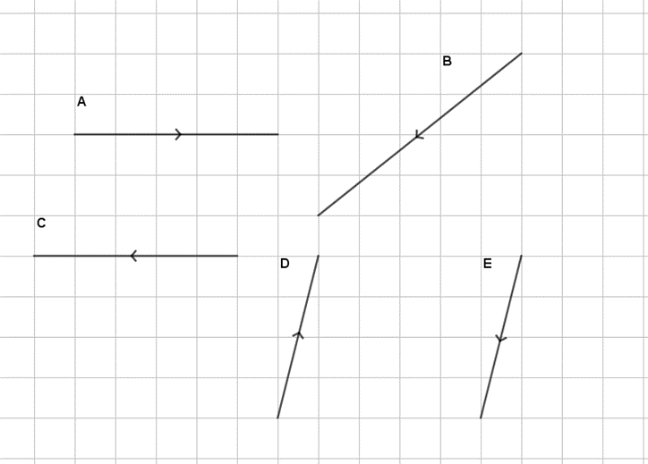
- a + b
- a – b
- –a + b

- If s = $\left(\begin{aligned}\text{4} \\ \text{2}\end{aligned}\right)$ and t = $\left(\begin{aligned}–\text{2} \\ \text{3}\end{aligned}\right)$ what is:
- s + t =
- s – t =
- 2s – t=

Worksheet 3b: Adding and subtracting vectors extension
This worksheet will give you the opportunity to formalise what you have learnt in this lesson.

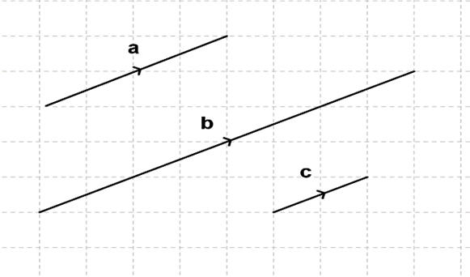

  - Write out the column vectors for a, b and c.

  - What can you say about the relationships between these lines and the column vectors you have just written?

  - Can you make a general statement about the relationships you have described?

Worksheet 3b: Adding and subtracting vectors extension continued
- The points U, T and S lie on a straight line. The vector $\vec{\text{UT}}$ is a+2b, where a and b are vectors.

Work out which of these vectors could be the vector $\vec{\text{US}}$, and which could not be the vector. Make sure you explain your answers.
  - 2a + 4b

  - 4a + 2b

  - 2a – b

  - –3a – 6b

Worksheet 3c: Vector walks
Here is a diagram that could describe a walk around a square.
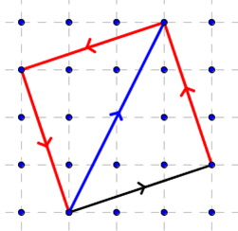

If you started by walking along the black vector What vectors would you need to walk around the perimeter of the square?

Can you describe and explain any relationships between the vectors that determine the journey around any square park?

Once you know the first vector of a journey, can you work out what the second, third and fourth vectors will be? Is there more than one possibility?

Worksheet 3d: Adding and subtracting vectors quiz
This quiz checks your ability to add and subtract vectors. It is a multiple-choice assessment, and the questions are designed to highlight any misconceptions or misunderstandings. Please choose the answer you think is correct, and explain why you think it is correct.

- This diagram shows vectors a and b.

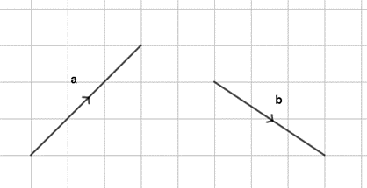

Which vector is shown in this second diagram? (tick your choice)

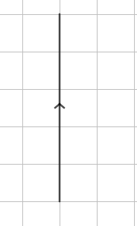

  - a + b
  - a + 2b
  - a – b
  - b – a

Worksheet 3d: Adding and subtracting vectors quiz continued
- What is the missing vector?
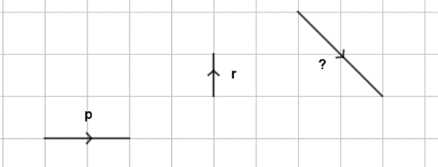
  - p – r
  - p – 2r
  - p + 2r
  - p + r
- Complete this vector addition:
$\left(\begin{aligned}\text{6} \\ \text{–3}\end{aligned}\right)\text{+}\left(\begin{aligned}\text{4} \\ \text{6}\end{aligned}\right)$ =
  - $\left(\begin{aligned}\text{10} \\ \text{3}\end{aligned}\right)$
  - $\left(\begin{aligned}\text{24} \\ \text{-18}\end{aligned}\right)$
  - $\left(\begin{aligned}\text{64} \\ \text{-36}\end{aligned}\right)$
  - $\left(\begin{aligned}\text{10} \\ \text{9}\end{aligned}\right)$

Worksheet 3d: Adding and subtracting vectors quiz continued
- Complete this vector subtraction:
$\left(\begin{aligned}\text{4} \\ \text{5}\end{aligned}\right)-\left(\begin{aligned}\text{–6} \\ \text{7}\end{aligned}\right)$ =
  - $\left(\begin{aligned}\text{–2} \\ \text{–2}\end{aligned}\right)$
  - $\left(\begin{aligned}\text{2} \\ \text{–12}\end{aligned}\right)$
  - $\left(\begin{aligned}\frac{\text{–3}}{\text{2}} \\ \frac{\text{7}}{\text{5}}\end{aligned}\right)$
  - $\left(\begin{aligned}\text{10} \\ \text{–}\text{2}\end{aligned}\right)$
- g = $\left(\begin{aligned}\text{3} \\ \text{–5}\end{aligned}\right)$, h = $\left(\begin{aligned}\text{–2} \\ \text{–3}\end{aligned}\right)$
Work out the vector 2g + h.
  - $\left(\begin{aligned}\text{10} \\ \text{–4}\end{aligned}\right)$
  - $\left(\begin{aligned}\text{4} \\ \text{–7}\end{aligned}\right)$
  - $\left(\begin{aligned}\text{4} \\ \text{13}\end{aligned}\right)$
  - $\left(\begin{aligned}\text{25} \\ \text{–22}\end{aligned}\right)$

Worksheet 4a: Pythagoras
    - Each of these triangles is a right angled triangle. For each triangle, the right angle and one other angle has been labelled. Use this information to label the sides.
a = Hypotenuse
b = Adjacent
c = Opposite
2. If b = 4 and c = 3 for one of these triangles, what would a be?

Worksheet 4b: Finding ice cream

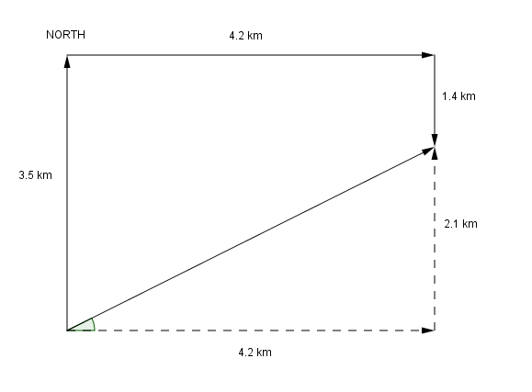

Worksheet 4c: Real life examples
In this activity you will use vectors to solve a range of problems. The problems are based on real-life situations and involve forces or motion in more than one dimension.

1. Velocity and displacement
The unit vectors i and j are directed east and north respectively. Find the magnitude and direction of each of the following vectors.

a. the displacement $\left(\begin{aligned}\text{110} \\ \text{150}\end{aligned}\right)$ m
b. the velocity $\left(\begin{aligned}\text{-11} \\ \text{9}\end{aligned}\right)$ ms-1

2. Swimmer
A woman is swimming with velocity v_{s} ms^{–1} where v_{s} = $\left(\begin{aligned}\text{2.5} \\ \text{1.3}\end{aligned}\right)$

She meets a current with velocity v_{c} ms^{–1} where v_{c} = $\left(\begin{aligned}\text{0.6} \\ \text{-2.0}\end{aligned}\right)$
Find the magnitude and direction of the swimmer's resultant velocity. Give the direction as a bearing.

3. Ship
A ship is travelling in a straight line and its displacement vector from its starting point is

d = $\left(\begin{aligned}\text{2.5} \\ \text{5.0}\end{aligned}\right)$ km

What is the distance from the ship to the starting point?

The ship is aiming for a buoy which has position vector $\left({x \atop 100}\right)$ relative to the ships starting point. Assuming the ship continues to travel in a straight line and reaches the buoy, find x.

Worksheet 4d: Real life examples hints
1.
a.  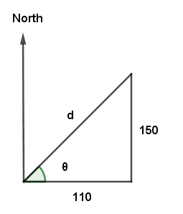 | b.  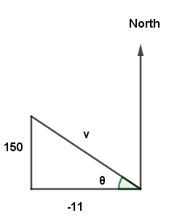  9

2.

${\text{v}}_{\text{s}} \text{= }\left(\begin{aligned}\text{2.5} \\ \text{1.3}\end{aligned}\right)$

$${\text{v}}_{R}\text{ = }\left(\begin{aligned}\text{0.6} \\ \text{-2.0}\end{aligned}\right)$$

3.
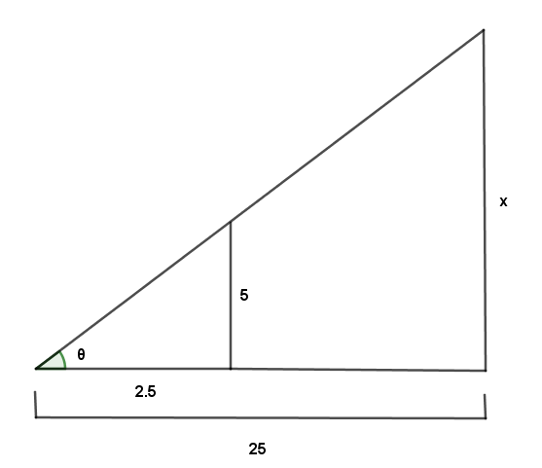
Worksheet 5a: Vector geometry
Here are two problems with vectors for you to solve.

1. ABCDEF is a regular hexagon. The vectors p and q are as shown in the diagram.

E
D

F
C

q

B
A
p

a) Find in terms of p and q

(i) $\vec{\text{AC}}$

(ii) $\vec{\text{FD}}$

(iii) $\vec{\text{FC}}$

b) What can be deduced from part a) about

(i) $\vec{\text{AC}}$ and $\vec{\text{FD}}$?

(ii) $\vec{\text{FC}}$ and $\vec{\text{AB}}$?

2. C is the point on the line AB such that AC : CB = 4 : 3. Express c in terms of a and b.
B
A
O
a
b

Worksheet 5a: Vector geometry continued
3. The midpoint theorem.

This well-known theorem states that if a straight line is drawn between two midpoints of any two sides of a triangle ZXY, this line is parallel to the third side and half its length. If S and T are the midpoints of two sides of a triangle, prove the midpoint theorem.

Worksheet 5b: Vector geometry hints
1. Hint 1: Remember this is a regular hexagon so the sides are the same length and opposite sides are parallel.

Hint 2: Try tracing the routes with your fingers and saying out loud to a partner what you are doing in terms of the vectors p and q.

2. HINT: You might find this diagram useful
B
A
O
a
b
c
c
4
3

3. HINT 1: start by drawing the diagram

HINT 2:
X
a
b
T
S

Z
Y

HINT 3: Remember go route via known vectors. In this case along the sides of the triangle.

HINT 4: Remember a scalar multiple of a vector is parallel to that vector

Worksheet 5c: Vector geometry exam question
The diagram shows a parallelogram OCEG.
E
C
D

NOT TO
SCALE
B
F
H
b

O
A
G
a

O is the origin, $\vec{\text{OA}} \text{=} \text{a}$ and $\vec{\text{OB}} \text{=} \text{b}$.
BHF and AHD are straight lines parallel to the sides of the parallelogram.
$\vec{\text{OG}}\text{ = 3}\vec{\text{OA}}$and $\vec{\text{OC}}\text{ = 2}\vec{\text{OB}}$.

(a) Write the vector $\vec{\text{HE}}$ in terms of a and b.

$\vec{\text{HE}}=$……………………………………………. [1]

(b) Complete this statement.

a + 2b is the position vector of point …………………………………… [1]

(c) Write down two vectors that can be written as 3a – b.

…………………………………… and …………………………………… [2]

Worksheet 1a: Answers
Scalar | Vector
- Force

Scalar | Vector
- Mass

Scalar | Vector
- Speed

Scalar | Vector
- Acceleration

Scalar | Vector
- Distance

Scalar | Vector
- Weight

Scalar | Vector
- Displacement

Scalar | Vector
- Temperature

Scalar | Vector
- Height

Worksheet 1b: Answers
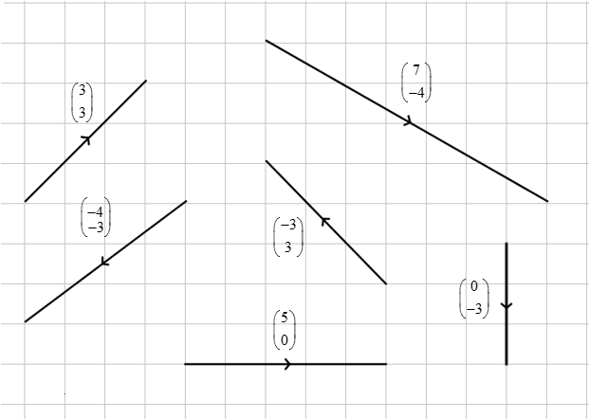

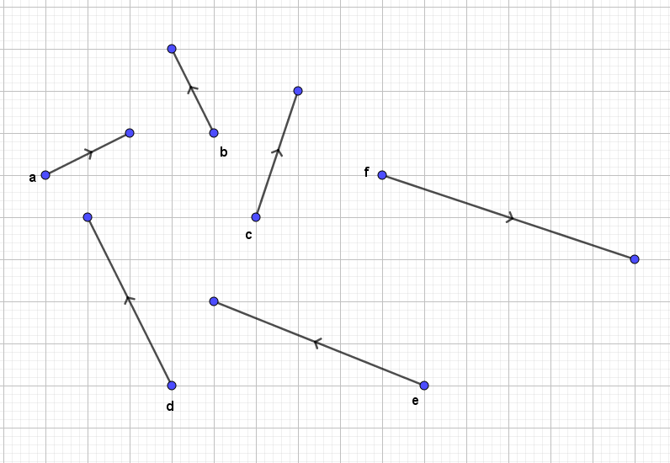

Worksheet 1c: Answers
- a - Remember the horizontal component of the translation is at the top of the column vector and the vertical component of the translation is below.
b - This is the correct answer well done
c - A positive horizontal component means the vector is describing a movement to the right
d - A negative vertical component means the vector is describing a movement down

- a - Whilst these vectors are parallel and the lines are the same length, they are pointing in the opposite direction of travel.
b - This is the correct answer well done
c - Whilst these two vectors are parallel and pointing in the same direction D is twice the magnitude of A.
d - Whilst all these vectors are parallel only two of them are of the same magnitude and direction.

- a - Remember the horizontal component of the translation is at the top of the column vector and the vertical component of the translation is below.
b - Remember the horizontal component of the translation is at the top of the column vector and the component of the translation is below. Also, a negative x component would describe a downward movement.
c - This is the correct answer well done
d - A negative horizontal component means the vector is describing a movement to the left.

Worksheet 2a: Answers
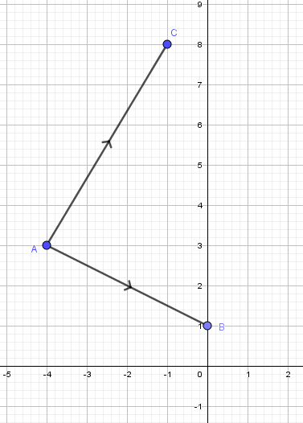

- The coordinates of:
B (0,1)
C (-1,8).
- $\left(\begin{aligned}\text{-1} \\ \text{7}\end{aligned}\right)$

Worksheet 2a: Answers continued
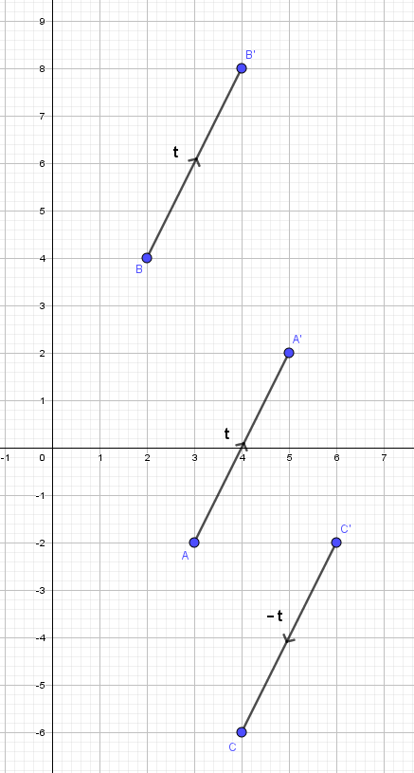

- The coordinates of:
B (2,4)
B’(4,8)

- (4, -6)
Note: the translation from C’ to C can be described by the vector – t. $\vec{\text{C'C}}$ = $\left(\begin{aligned}\text{-2} \\ \text{-4}\end{aligned}\right)$

Worksheet 2a: Answers continued

- $\vec{\text{BC}}$ = $\left(\begin{aligned}\text{2} \\ \text{0}\end{aligned}\right)$
- $\vec{\text{CD}}$ = $\left(\begin{aligned}\text{-3} \\ \text{2}\end{aligned}\right)$
- $\vec{\text{DA}}$ = $\left(\begin{aligned}\text{-1} \\ \text{-3}\end{aligned}\right)$

Worksheet 2c: Answers
- a - This vector describes a translation 4 up.
b - This is the correct answer well done.
c - This vector describes a translation 4 left.
d - This vector describes a translation 4 down.

- a - This describes the translation from shape A to shape B.
b - This mixes up a horizontal translation from shape A to shape B followed by a vertical translation from shape B to shape A.
c - This is the correct answer well-done.
d - This mixes up a horizontal translation from shape B to shape A followed by a vertical translation from shape A to shape B

- a - This vector describes a translation of five right.
b - This vector describes a translation of five up.
c - This vector describes a translation of five left.
d - This is the correct answer well-done.

Worksheet 3a: Answers
- a. C
b. E
c. D

- s + t = $\left(\begin{aligned}\text{4 + (–2)} \\ \text{2 + 3}\end{aligned}\right)$ = $\left(\begin{aligned}\text{2} \\ \text{5}\end{aligned}\right)$
- s – t = $\left(\begin{aligned}\text{4 – (–2)} \\ \text{2 – 3}\end{aligned}\right)$ = $\left(\begin{aligned}\text{6} \\ –\text{1}\end{aligned}\right)$
- 2s – t = $\left(\begin{aligned}\text{2 x 4 – (–2)} \\ \text{2 x 2 – 3}\end{aligned}\right)$ = $\left(\begin{aligned}\text{10} \\ \text{1}\end{aligned}\right)$
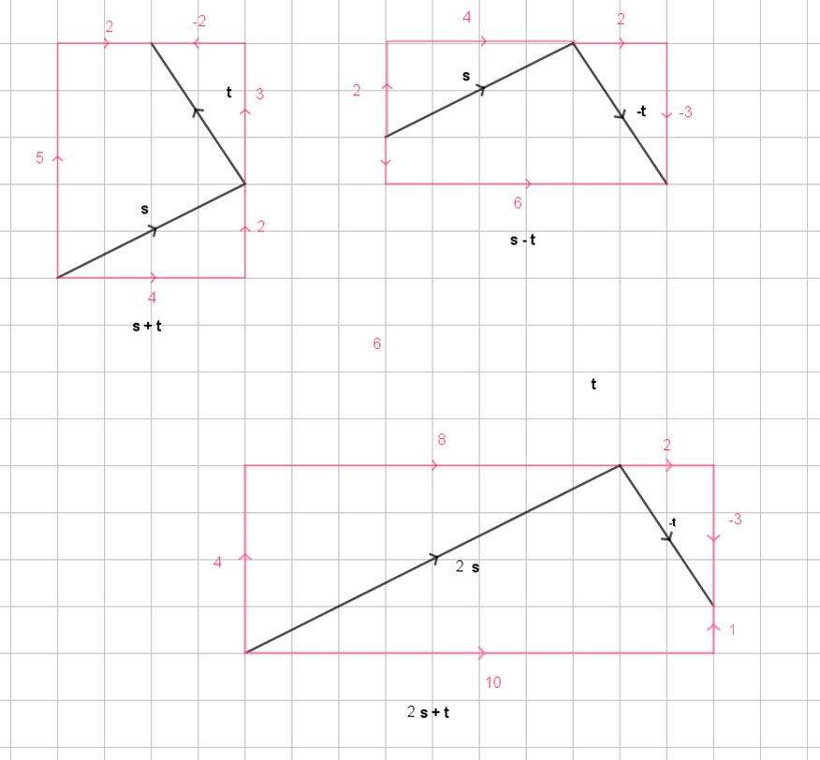

Worksheet 3b: Answers
- a. a = $\left({\text{4} \atop \text{2}}\right)$ , b = $\left({\text{8} \atop \text{4}}\right)$ , c = $\left({\text{2} \atop \text{1}}\right)$
b. When the vector line is twice as long, the numbers in the column vector are doubled, when the vector line is half as long, the numbers in the column vector are halved.
c. The column vectors are multiplied by the same scalar as the vector line is enlarged by the scale factor.

- a. 2a + 4b = 2(a + 2b) so could be a vector describing $\vec{\text{US}}$, as it is a scalar multiple of $\vec{\text{UT}}$.
b. 4a + 2b = 2(2a + b) so could not be a vector describing $\vec{\text{US}}$, as it is not a scalar multiple of $\vec{\text{UT}}$.
c. 2a – b could not be a vector describing $\vec{\text{US}}$, as it is not a scalar multiple of $\vec{\text{UT}}$.
d –3a – 6b = –3(a + 2b) so could be a vector describing $\vec{\text{US}}$, as it is a scalar multiple of $\vec{\text{UT}}$.

Worksheet 3c: Answers
The vector journey goes $\left(\begin{aligned}\text{3} \\ \text{1}\end{aligned}\right)\left(\begin{aligned}-\text{1} \\ \text{3}\end{aligned}\right)\left(\begin{aligned}-\text{3} \\ -\text{1}\end{aligned}\right)\left(\begin{aligned}\text{1} \\ -\text{3}\end{aligned}\right)$

These vectors must only consist of four numbers: x,y,−x and −y.

It can only be two numbers, and their negatives, so that all the sides of the square are equal in length.

After travelling along the first vector, you can then move left or right. So, if the first vector is $\left(\begin{aligned}\text{x} \\ \text{y}\end{aligned}\right)$, if you go right then the second vector will be $\left(\begin{aligned}-\text{y} \\ \text{x}\end{aligned}\right)$. The third vector must then be parallel to the first one, but in the opposite direction, so the vector will be $\left(\begin{aligned}-\text{x} \\ -\text{y}\end{aligned}\right)$. The final vector will be parallel to the second vector, but again in the opposite direction so you get back where you started $\left(\begin{aligned}\text{y} \\ -\text{x}\end{aligned}\right)$.

If you add all these vectors together you will get:

$\left(\begin{aligned}\text{x} \\ \text{y}\end{aligned}\right)$ + $\left(\begin{aligned}-\text{y} \\ \text{x}\end{aligned}\right)$ + $\left(\begin{aligned}-\text{x} \\ -\text{y}\end{aligned}\right)$ + $\left(\begin{aligned}\text{y} \\ -\text{x}\end{aligned}\right)$ = $\left(\begin{aligned}\text{x} - \text{y} - \text{x} + \text{y} \\ \text{y} \text{+} \text{x} - \text{y} - \text{x}\end{aligned}\right)$ = $\left(\begin{aligned}\text{0} \\ \text{0}\end{aligned}\right)$

The vectors must add up to zero if you are going to get back to where you started.

Worksheet 3d: Answers
- a – b
Look carefully at this diagram:
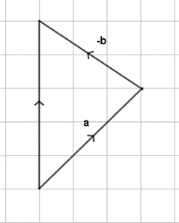

- p – 2r
Look carefully at this diagram:
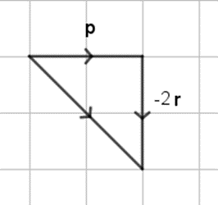

- a. $\left(\begin{aligned}\text{10} \\ \text{3}\end{aligned}\right)$

- d. $\left(\begin{aligned}\text{10} \\ –\text{2}\end{aligned}\right)$

- c. $\left(\begin{aligned}\text{4} \\ –\text{13}\end{aligned}\right)$

Worksheet 4a: Answers
- Each of these triangles is a right angled triangle. For each triangle, the right angle and one other angle has been labelled. Use this information to label the sides.
a = Hypotenuse
b = Adjacent
c = Opposite
c

c

c

c

c

b

b

b

b

b

a

a

a

a

a

- If b = 4 and c = 3 for one of these triangles, what would a be?
$${\text{a}}^{\text{2}}\text{+}{\text{b}}^{\text{2}}\text{=}{\text{c}}^{\text{2}} \\ \text{a= }\sqrt{{\text{b}}^{\text{2}}\text{+}{\text{c}}^{\text{2}}} \\ \text{a= }\sqrt{{\text{4}}^{\text{2}}\text{+}{\text{3}}^{\text{2}}} \\ \text{a= }\sqrt{\text{16+9}} \\ \text{a= }\sqrt{\text{25}} \\ \text{a= 5}$$

Worksheet 4c: Answers
1.
a.
The displacement d = m
d = 186m (to nearest meter)
θ = 54˚ to nearest degree

So the distance is 186m on a bearing of 90 – 54 = 36˚

b.
The velocity v = ms-1
v =
v =
9
v = 14.2ms⁻¹ (to 1dp)
θ = 39˚ (to the nearest degree)
So the bearing is 270 + 39 = 309˚

Worksheet 4c: Answers continued
2.
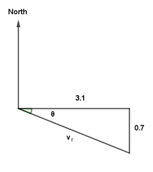
The resultant velocity, v_{R}, is the sum of the velocity of the woman and the velocity of the current
$$v_{r}= \left({2.5 \atop 1.3}\right)+\left({0.6 \atop -2.0}\right)=\left({3.1 \atop -0.7}\right)$$
The woman’s speed (magnitude of v_{R}) is

3.2ms⁻¹ (to 2 sf)

The direction is given by
= 12.7° (to 1 dp)

90°+12.7°= 102.7°, so the swimmer will travel at 3.2 ms⁻¹ on bearing 102° (nearest degree).

3.
d = = 5.59 (to 3 sf)
The ship is aiming for a buoy which has position vector
relative to the ships starting point. Assuming the ship continues to travel in a straight line and reaches the buoy, find x.
x = 50km

Worksheet 5a: Answers
1. ABCDEF is a regular hexagon. The vectors p and q are as shown in the diagram.

E
D

F
C

q

B
A
p

a) Find in terms of p and q

(i) $\vec{\text{AC}}$ = p + q

(ii) $\vec{\text{FD}}$ = q + p

(iii) $\vec{\text{FC}}$ = 2p

b) What can be deduced from part a) about

(i) $\vec{\text{AC}}$ and $\vec{\text{FD}}$ are parallel.

(ii) $\vec{\text{FC}}$ and $\vec{\text{AB}}$ are parallel

2. C is the point on the line AB such that AC : CB = 4 : 3. Express c in terms of a and b.

As C divides the line AB in the ratio 4 : 3, C must therefore lie $\frac{\text{4}}{\text{7}}$ of the way along line AB.
B
A
O
a
b
c
c
4
3
So $\text{c}\text{=}\vec{\text{OC}}\text{=}\vec{\text{OA}}\text{+}\vec{\text{AC}}$

= $\text{a}\text{+}\frac{\text{4}}{\text{7}}\vec{\text{AB}}$

As $\vec{\text{AB}} \text{=-}\text{a}\text{+}\text{b}$ this can be written as:

$\text{=a+}\frac{\text{4}}{\text{7}}\text{(}\text{b}\text{-}\text{a}\text{)}$

$\text{=}\frac{\text{3}}{\text{7}}\text{a}\text{+}\frac{\text{4}}{\text{7}}\text{b}$

You can use a similar argument starting with $\vec{\text{OC}}\text{=}\vec{\text{OB}}\text{+}\vec{\text{OC}}$ which as you would expect gives you the same answer. Try it if you haven’t already.

Worksheet 5a: Answers continued
3. The midpoint theorem.

This well-known theorem states that if a straight line is drawn between two midpoints of any two sides of a triangle ZXY, this line is parallel to the third side and half its length. If S and T are the midpoints of two sides of a triangle, prove the midpoint theorem.

$\vec{\text{ST}}\text{=}\text{a}\text{+}\text{b}$
a
b
T
S
Z
Y
X

$$\vec{\text{ZY}}\text{=}\text{2}\text{a}\text{+}\text{2}\text{b}$$

Therefore:

$$\vec{\text{ST}}\text{=}\frac{\text{1}}{\text{2}}\vec{\text{ZY}}$$

This means that $\vec{\text{ST}}$ and $\vec{\text{ZY}}$ are scalar multiples of each other which means they are parallel and the multiplier is a half. This proves the midpoint theorem.

Worksheet 5c: Answers
(a) 2a + b

(b) D

(c) $\vec{\text{CF}}$ and $\vec{\text{BG}}$

Examiners comments
The majority of candidates were able to give the correct answer in part (a), but there were many who gave incorrect multiples of a or b, most commonly 3a + 2b $\vec{\text{OE}}$ , or 3a + b. Equivalent vectors such as AF were also seen. Part (b) was the most successful part of the question and part (c) the most challenging with a whole variety of responses, the incorrect ones usually involving just one point, such as F and G.

Cambridge Assessment International Education
The Triangle Building, Shaftsbury Road, Cambridge, CB2 8EA, United Kingdom
t: +44 1223 553554
e: info@cambridgeinternational.org www.cambridgeinternational.org

© Cambridge University Press & Assessment 2022

