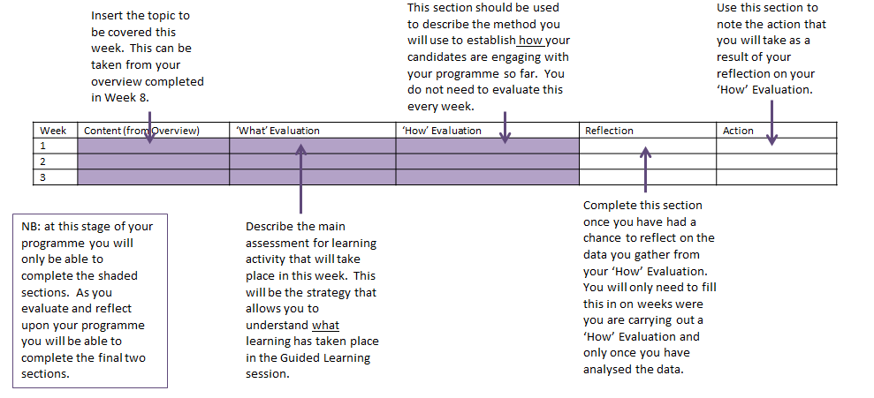
Evaluation and Reflection guidance
Evaluation and Reflection Exemplar
Cambridge International Certificate / Diploma in Teaching and Learning
Cambridge International Certificate / Diploma in Educational Leadership
Cambridge International Certificate / Diploma in Teaching Bilingual Learners
Cambridge International Certificate / Diploma in Teaching with Digital Technologies
Week | Content (from Overview) | ‘What’ Evaluation | ‘How’ Evaluation | Reflection | Outcome
1 | Introduction to PDQ | Quiz to assess understanding of PDQ | Quick survey on quality of information received so far – follow up with individual meetings with those who need more support. | Some confusion over the role of the mentor. | Revisit mentoring slides in Wk 2.
2 | Introduction to theories of learning | Minute paper on theories of learning
3 | Understanding the purposes of assessment | Group presentations on assessment | Random sample focus group to ascertain level of satisfaction and understanding so far. | In general there is excitement over the range of ideas and the opportunities to be explored. Risk: over enthusiasm may lead to some teachers experimenting with new ideas before they are ready. | Mentors to be briefed fully so that they can support the candidates’ progression.
4 | Understanding the principals of an effective lesson #1 | Exit tickets on principles of an effective lesson
5 | Understanding the principals of an effective lesson #2 | Add to exit tickets from last week and create a learning wall
6 | Planning a lesson with clear aims and objectives | Group planning projects, plus jigsawing activity. | Survey to understand level of confidence before first observed lesson. Follow up with those who need more support – mentors to be involved.
7 | Teaching a lesson #1 | Micro teaching plus evaluation
8 | Teaching a lesson #2 | Micro teaching plus reflection
9 | Assessing that lesson | Self-assessment
10 | Evaluating that lesson | Peer-assessment of quality of evaluation
11 | Planning a series of lessons | Individual presentations | Random interviews to understand how candidates feel they are progressing. Extra support can be brought in at this stage for those in danger of failing.
12 | Approaches to teaching and learning | Learning wall – to stay up and to be added to.
13 | Assessment for learning | Pair projects
14 | Evaluating to develop practice | Self-evaluation. | Survey for all candidates plus focus groups to explore answers in depth.

