Cambridge Professional Development Qualifications
Cambridge International Certificate in Teaching and Learning

International School Programme Handbook

Introduction
Welcome to your Cambridge Professional Development Qualification. This handbook will give you all the information that you will need whilst you are studying for your PDQ.
Section One:
The Programme Team
- Programme Leader: John Smith – john.smith@Internationalschool.com 07799 445376
- Trainers:
  - Mary Johnson – mary.johnson@internationalschool.com 07799 674538
  - Clare Baker – clare.baker@internationalschool.com 07799 234890
- Mentors:
  - Daniel Trent – daniel.trent@internationalschool.com 08456 354678
  - David Carver – david.carver@internationalschool.com 09867 287654
  - Jenny Clarke – jenny.clarke@internationalschool.com 07654 234678

Timing of Sessions
Guided Learning Sessions will take place every Saturday morning between 9am and 12.30pm, starting on the 31st March. There will be refreshments upon arrival and there will be a thirty minute break at a convenient point during each session.
You are expected to attend every Guided Learning Session, but if an unavoidable situation occurs and you cannot attend, please let the programme leader know as soon as possible.
Work-based learning will be conducted during your normal teaching hours, but should be agreed in advance with your mentor so that they can support you or observe you as necessary.
You should meet with your mentor each week for an hour. The timing of these meetings can be decided between your mentor and yourself.
You should engage in your individual reading and research and collaborative tasks as directed by the programme leader or trainers in your sessions.
Communication
The programme leader, trainers and mentors can all be contacted at any time on the email addresses above and they will endeavor to get back to you as soon as possible. The mobile numbers are provided for emergency situations.
In addition, a PDQ area has been developed as part of the school’s Professional Development page on the internal Learning Management System. This can be accessed here: www.internationalschool.com/professionaldevelopment/PDQ. The programme team will use this area to post information about the programme and about the weekly learning tasks. You will be able to find copies of the slides and any links to resources that have been used. This page will also house an ongoing forum to allow you to post questions to the programme team and to one another.
Finally, at the end of the programme after your portfolios have been submitted to Cambridge we will have one final session on a Saturday morning to allow us to understand the results and to reflect on the successes of the programme and to think about any opportunities for improvement. This session will be scheduled at a later date.

Section Two:
Mentoring
In the Cambridge Guide for Mentors (Cambridge Assessment International Education 2015) it states:
“Learning in a PDQ programme is based on the principle that professional learning is most effective and beneficial when it involves collaboration with an experienced colleague who acts as a mentor.
Learning from a mentor is a core feature of the PDQ syllabus design. … Every learner in every Cambridge programme must have regular support from an experienced and trusted mentor who understands the essential principles of the appropriate PDQ syllabus and who can observe practice and provide guidance and support.”
You will work with your mentor to decide how you can put what you have been learning in your Guided Learning Sessions into practice in your classrooms. Your mentor will help you to put the theory into practice, will observe you and will guide your reflections after your lesson. It is important that your mentor is someone who you trust and with whom you have a good working relationship.
Choosing a Mentor
In the Cambridge Guide for Mentors it suggests that a good mentor would be:
- Someone who has a genuine desire to be personally involved in the professional development of others
- Someone who has the ability to communicate with others in an open and non-judgemental way
- Someone who has the ability to empower others by responding to their priorities and needs rather than imposing their own.
We are fortunate to have the support of our mentors Daniel, David and Jenny who are committed to the PDQ programme and to you as PDQ candidates. In the first week of the programme we will be helping you to select one of these mentors based on the best fit for you.

Scheduling a Mentoring Session
Once you have been assigned a mentor they will work with you to find a slot that suits you both. This will become a firm meeting time and should only be rearranged if absolutely necessary. Your mentor will talk you through the documentation that will be used to support your mentoring sessions and you will devise a timetable of topics for discussion so that you can make the most of the theory from your Guided Learning sessions and the practical application of these in your Work-based learning.
What your mentor will be doing
Your mentor is fully aware of the demands of the PDQ programme and they have received or are in the process of receiving training on the assessment criteria and the portfolio requirements. The mentors will be present at a range of our Guided Learning sessions as and when it is applicable for them to be there.
Issues with the Mentoring Process
We are confident that our three mentors are committed to your success and to the good of the PDQ programme; however, very occasionally problems can arise. If either you or your mentor feels that the pairing isn’t working and that it would be in your interest to work with another mentor then please see the programme leader as soon as possible.

Section Three:
Assessment and academic expectations
As you will know from the application process for this programme, Cambridge has very clear guidelines about the level of English language competency needed to succeed in the Cambridge PDQ. To remind you, these are as follows:
- All candidates should have English language competence comparable to Level B2 in the Common European Framework of Reference for Languages (CEFR). This framework is provided by the Council for Europe. Further details can be found on the Council’s website at http://coe.int/t/dg4/education/elp-reg/cefr grids EN.asp
- We recommend a minimum requirement of 5.5 on the International English Language Testing System. See www.ielts.org/ for more details.
Academic Expression (from Middlesex University UniHub, 2017)
Your ability to write clearly and precisely is an important part of your development across the PDQ and is one of the key assessment criteria on which your portfolio will be assessed.
It may have been some time since you last had to write in this way and so you may have forgotten some of the features of academic writing. Here is a useful overview of the typical features of academic writing style.
1. Academic writing is usually quite formal, and avoids the following:

a) Contracted forms (e.g. It’s, don’t, haven’t). Full forms are generally used instead (e.g. It is, do not, have not).
There is little or no coverage of this important feature of academic writing.

There’s little or no coverage of this important feature of academic writing.
b) Colloquialisms and slang (e.g. freak out, daft). These may be labelled in dictionaries as idiom, colloq or sl and should be avoided in academic writing.
The government funds a significant amount of research in this area.
The government funds loads of research in this area.
c) Phrasal verbs (e.g. help out, get rid of). More formal equivalents may be used instead (e.g. assist, eliminate).
Recent research supports the importance of early diagnosis.
Recent research backs up the importance of early diagnosis.

d) Direct questions (e.g. Is it worth having a mentor?). An indirect question may be used instead (e.g. Some people wonder whether it is worth having a mentor.)
2. Academic writing usually attempts to be impersonal. It avoids:
a) The use of personal pronouns (I, we, you).
This essay will discuss the relationship between theory and practice…
In this essay, I will discuss the relationship between theory and practice…
b) Highly emotional or subjective adjectives.
Jones’s theory has had a profound effect on public policy.
Jones’s theory has had an amazing effect on public policy.
3. Academic writing is usually quite cautious, and may use phrases that show degrees of certainty or probability, rather than absolute certainty (e.g. it is more likely that…, it is perhaps the case that…).
The results of the study may provide a solution to the problem.
The results of the study provide a solution to the problem.
Avoiding Plagiarism
What is Plagiarism? Plagiarism is using someone else’s words or work or ideas or thinking, and failing to give a reference/s to that person when you are writing your assignment; “giving a reference” means giving both a short reference [family name & year] inside your assignment when you are writing about the ideas etc [so-called “in-text citation” or “in-body / in-text reference”], and a longer fully-detailed reference in your “List of References” / “Bibliography”. Failing to do these things can result in you being accused of “plagiarism”.
Plagiarism includes:
• copying – this means submitting someone else’s entire work as your own work. The original work could be:
o from a book;
o from the internet;
o from another PDQ candidate;
• copying parts from a number of different books, journals, or internet sites, and failing to give a reference for the different parts.
• failing to indicate a direct quotation from a source; a direct quotation [or quote] means the exact original words as written by someone else in a book / journal / internet site etc (quotation marks should be used).
• paraphrasing or synthesising material from a book, journal article or internet site etc without giving a reference for it in your writing.
• composing a paragraph by joining together sentences from a number of sources and not acknowledging them in the text (this is called “patch-writing”).
• using your own previous work in another assignment without acknowledging it; this could be your work from an earlier year at the same university, or work from your time at a different university.
It is important to remember that plagiarism can be accidental or deliberate. Although the latter [deliberate plagiarism] is viewed as worse, both forms will create difficulties for you. Accidental plagiarism can easily happen when you take notes from a book or a journal etc, and you forget / don’t bother to make a clear record of exactly where the notes are from when you’re writing them. This can easily happen when you’re in a rush or tired etc.
Avoiding Plagiarism:
• Write notes in your own words where possible [i.e. paraphrasing & summarising]; try to avoid copying and pasting from your sources
• Be fanatical about keeping accurate records of where you get your information from when making notes [i.e. the author, year & publication]
• In your own writing, use a clear & consistent system of referencing [often this will be the Harvard system. Check your module / programme handbook for the relevant information]
• Always provide a full list of references in your Bibliography / List of References
• When in doubt – give a reference!!
What to Reference:
• All ideas & information you get from books & journal articles & the internet
• Distinctive ideas / facts ‘belonging’ to someone who originally proposed the idea/s
• Information/data from a particular source [e.g. statistical info, case studies, reports]
• Any quotation/s you use
How to Reference
The preferred method of referencing for this programme is the Harvard style. Below are some hints and tips (University of Cambridge. Judge Business School. 2017). Harvard referencing involves:

1. Including an in-text reference in a piece of work, citing the Author, Year and Page No.
2. Followed by a full reference in the List of References (or Bibliography) at the end.

In-text References
‘Essentially, when writing you need to acknowledge the hard work of the scholars on whose work you are
drawing’ (Parker, 2009, p.107).
N.B. Even if you are not quoting directly you still need to cite the author, year and page no. in your text.

Full References (for your BIBLIOGRAPHY)
This is how references should be presented in Harvard Style for different types of sources.

Books (printed or electronic)
Author(s). (Year) Title. Edition. Place of publication: Publisher.
e.g. Sloman, J. (2010) Essentials of economics. 5th ed. London: FT Prentice Hall.
Hint! Don’t include the edition number if it’s a first edition.

Books with three or more authors
Author et al. (Year) Title. Edition. Place of publication: Publisher.
e.g. Patterson, K. et al. (2005) Crucial confrontations: tools for resolving broken promises, violated expectations, and bad behavior. New York: McGraw-Hill.
Hint! Include the first author only.

Books with editors
Editor(s). (ed./eds.) (Year) Title. Edition. Place of publication: Publisher.
e.g. Warner, M. and Rowley, C. (eds.) (2011) Chinese management in the 'harmonious society': managers, markets and the globalized economy. London: Routledge.

Chapters in books
Author(s). (Year) ‘Chapter title.’ In: Author(s)/Editor(s). Book title. Edition. Place of publication: Publisher, page numbers.
e.g. Collier, J. and Esteban, R. (2011) ‘Systemic leadership: ethical and effective’. In: Werhane, P.H. and Painter-Morland, M. (eds.) Leadership, gender, and organization. Dordrecht: Springer, pp. 49-62.

Journal articles (printed or electronic)
Author(s). (Year) ‘Article title.’ Journal title, Volume number (part no./issue/month), page numbers. e.g. Erickson, T. J. (2010) ‘The leaders we need now.’ Harvard Business Review, 88(5): pp. 62-66.

Newspaper articles
Author(s). (Year) ‘Article title.’ Newspaper title, Day and Month, page number(s).
e.g. Pfeifer, S. (2011) ‘BP eyes Gulf disposals to achieve $45bn goal.’ Financial Times, 26 October,p. 15.

Market research and company reports
Author / Organisation. (Year) Title. Place of publication: Publisher.
e.g. Key Note (2011) Renewable energy: Key Note market report. Richmond upon Thames: Key Note.

Conference papers
Author(s). (Year) ‘Paper title’. Conference title. Location and date of conference. Place of publication: Publisher, page number(s).
e.g. Zeng, K. and Luo, X. (2011) 'Performance measurement systems for e-business.' Proceedings of the 6th International Forum on Strategic Technology, Harbin, China, August 22-24. Piscataway, NJ: IEEE, pp. 1310-1313.

Thesis
Author. (Year) Title. Type of thesis. Academic institution.
e.g. Hardy, B. (2009) Morale: definitions, dimensions and measurement. Unpublished PhD thesis. University of Cambridge.

Web pages
Author/Organisation. (Year site was last updated) Title. Available at: URL (Accessed: date).
e.g. Cambridge Judge Business School Information & Library Services (2011) Information and Library Services: providing quality business research and resources. Available at:
http://www.jbs.cam.ac.uk/infolib/ (Accessed: 3 October 2013).

General points
• The references should be arranged alphabetically by author/editor/organisation within your bibliography.
• If you use data from a database (e.g. Bloomberg, Passport GMID etc) you’ll need to indicate this at the point where you include it: e.g. Source: Bloomberg

Producing Complete and Authentic Portfolios
The following information is from the Cambridge PDQ Administrative Guide

Portfolio preparation
Overview
You will be submitting your work via an ePortfolio which is a method whereby a candidate can digitally collect evidence of learning, practice and reflection. One of our guided learning sessions will focus on how to use an ePortolio. In addition to this, Cambridge advises that:
• Each portfolio must be the candidate’s original work.
• Portfolios submitted without all the necessary evidence will be returned as a ‘Fail’.
• The Programme Leader should ensure that candidate portfolios submitted for marking contain all the necessary evidence.

Portfolio templates
Candidates must use the portfolio templates and forms which will be provided for you.

Presentation of portfolios
Authenticity
For assessment purposes the portfolio cover sheet must be completed accurately, i.e. the work should be clearly marked with the candidate’s name and Unique Candidate Identifier, Centre number, the module title and module code. The Programme Leader is also responsible for ensuring that all staff supervising candidates’ work for the qualification are aware of current regulations set out in this document and carry out assessments and record-keeping.

In cases where there is doubt about the authenticity of any work submitted for assessment,
Cambridge reserve the right to undertake appropriate checks, such as telephone or other interviews, to determine whether the work is authentic.

Portfolio Evidence
The scope of what can be submitted via an ePortfolio for assessment is wide ranging. Candidates can submit a variety of artefacts - graphics, pictures, multimedia, stories, journals or projects. An ePortfolio can provide ways for candidates to use feedback from assessment to support their learning and reflection.

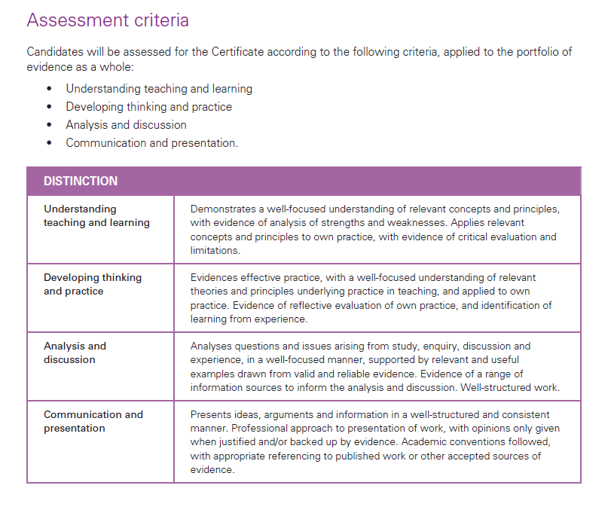
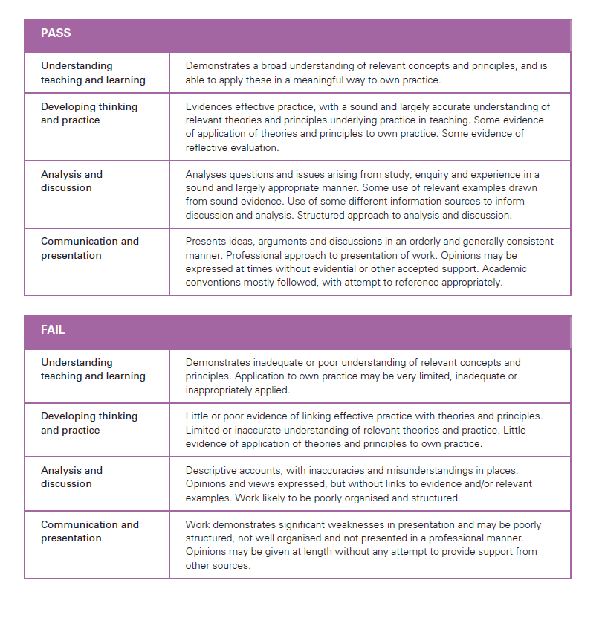

Bibliography
Cambridge Assessment international Education (2015) Cambridge Guide for Mentors. Available at: http://www.cambridgeinternational.org/images/304230-a-guide-for-mentors.pdf
Middlesex University UniHub (2017) Using Academic Language. Available at: http://unihub.mdx.ac.uk/your-study/learning-enhancement-team/online-resources/using-academic-language
University of Cambridge. Judge Business School (2017) Harvard Referencing Style. Available at: http://libguides.cam.ac.uk/managementstudies/referencing

