

Teaching Pack
Statistics – Cumulative Frequency and Histograms
Cambridge IGCSE™
Mathematics 0580

® IGCSE is a registered trademark

© Cambridge University Press & Assessment 2025
Cambridge Assessment International Education is part of Cambridge University Press & Assessment. Cambridge University Press & Assessment is a department of the University of Cambridge.

Cambridge University Press & Assessment retains the copyright on all its publications. Registered centres are permitted to copy material from this booklet for their own internal use. However, we cannot give permission to centres to photocopy any material that is acknowledged to a third party even for internal use within a centre.
.
Contents
Contents 3
Introduction: Statistics 4
Lesson plans 6
Teacher’s notes 9
Lesson resources 10
Worksheet 1: Cumulative Frequency Graphs 11
Worksheet 2: Introduction to Histograms 11
Worksheet 3: Calculating with Histograms Error! Bookmark not defined.

Icons used in this pack:
 | Lesson plan
 | Teacher’s notes
 | Lesson resources

Introduction: Statistics
This Teaching Materials Pack focuses on supporting learners to develop a confidence and fluency in working with two types of data diagram: cumulative frequency diagrams and histograms. The students will initially learn how to draw these diagrams but then move on to using them to make statistical calculations and estimates.
The lesson presented here is designed for learners that are already proficient at calculating statistical values using their calculator. The lessons will build your students' understanding and confidence at working with two of the harder statistical drawings that work with continuous data presented in a grouped data table.

It is expected that learners should already be able to calculate basic statistical measures such as mean, median and range, and are proficient at drawing some of the simpler statistical graphs such as bar charts.

Important note
Our Teaching Packs have been written by classroom teachers to help you deliver topics and skills that can be challenging. Use these materials to supplement your teaching and engage your learners. You can also use them to help you create lesson plans for other skills.

This content is designed to give you and your learners the chance to explore mathematical skills. It is not intended as specific practice for exam papers.

This is one of a range of Teaching Packs. Each pack is based on one mathematical topic with a focus on specific mathematical techniques. The packs can be used in any order to suit your teaching sequence.
In this pack you will find the lesson plans and worksheets you will need to successfully complete the teaching of this topic.

Syllabus links
This Teaching Pack links to the following syllabus content (see syllabus for detail):
- E9.6 Draw and interpret cumulative frequency tables and diagrams. Estimate and interpret median, percentiles, quartiles, and interquartile range from cumulative frequency diagrams.
- E9.7 Draw and interpret histograms.
Calculate with frequency density

The pack covers mathematical skills, adapted from AO1: Demonstrate knowledge and understanding of mathematical techniques and AO2: Reason, interpret and communicate mathematically when solving problems.


Before you begin
This Teaching Pack includes a Teacher Introduction video to which you should refer before
using the resources in this pack. The video is available to watch in Resource Plus within the topic section relevant to this Teaching Pack.

The video introduces the resources available for teaching this topic, and explains how they can be used to successfully deliver the topic to your learners. In particular, the video highlights typical learner misconceptions and common errors this Teaching Pack will help you to overcome.


Lesson 1 – Cumulative Frequency Graphs
Resources | - Lesson 1 PowerPoint presentation  - Worksheet 1  - Graph Paper
Learning objectives | By the end of the lesson learners should be able to:  - Understand the concept of cumulative frequency, and calculate it for a table  - Plot an accurate cumulative frequency diagram  - Estimate statistical values, such as the median, from a cumulative frequency diagram

Timings |  |  | Activity
5 mins | Starter / Introduction  Slides 2 and 3 – Use this slide to give the students a quick sense of what cumulative frequency is, and how it is calculated. Check their understanding of this by getting them to fill in the gaps in the cumulative frequency table on slide 3. They should not find this technique particularly challenging.
10-15 mins  5 mins  5 mins  Rest of the lesson | Main lesson  Slides 4 and 5 – Start to click through the step-by-step instructions given on slide 4. Remind the students that cumulative frequency should always go on the y axis, and that they should use the numbers in the table to determine how big to draw their set of axes and what numbers to label them with. The key thing that students often forget is that they need to plot the cumulative frequency values at the endpoints, not the midpoints. Slide 5 brings back the cumulative frequency the students previously calculated on slide 3 and gets them to plot their own cumulative frequency diagram. Be sure to circulate as they are drawing their axes, trying to spot, and correct, any errors before they start plotting their points. Explain to the students that their graphs might not be identical to each other, but very similar instead due to them being hand-drawn.  Slides 6 and 7 Use slide 6 to demonstrate how to estimate the median from a cumulative frequency diagram by using horizontal and vertical lines. Calculating the range is simpler and can be completed just by looking at the graph. Slide 7 then asks them to calculate both values using their previous hand-drawn diagram from slide 5. Allow a slight tolerance on the median as they could have drawn a slightly more curved line. The range however should be exact.  Slides 8, 9 and 10 Slide 8 has some useful notes to help students remember how to calculate which position the quartiles are in. Remember to stress that the calculations are for position and not the actual values of the quartiles. Slide 9 uses a new graph to show how to calculate the quartiles and uses them to calculate the interquartile range. Slide 10 gets the students to return to their hand-drawn graphs one more time to estimate the quartiles and then calculate the interquartile range. As both quartiles could be slightly out, the IQR has a larger tolerance to compensate.  Now work through Worksheet 1

Lesson 2 – Introduction to Histograms
Resources | - Lesson 2 PowerPoint  - Worksheet 2  - Graph paper
Learning objectives | By the end of the lesson:  - all learners will be able to calculate the frequency density of a class in a table  - most learners will be able to draw a complete histogram with correctly labelled frequency densities  - most learners will be able to use a histogram to calculate frequencies.

Timings |  |  | Activity
10 mins | Starter / Introduction  Slide 2 – Get the students to draw a frequency diagram. It is important to remind your students that this is different from a bar chart (which has gaps and is used for discrete data). The correct diagram is displayed on slide 3. Ensure that students understand how the bars join along the $x$ axis before moving forwards with the lesson.
5 mins  5 mins  10 mins  5 mins  Rest of the lesson | Main lesson  Slides 4, 5 and 6 – Introduce the new table of data, drawing your students’ attention to the fact that the class widths are no longer equal. Slide 5 shows how this data looks if we were to draw it using the same technique as a frequency diagram. Get the students to discuss why the graph is misleading. They should hopefully see that the 14-18 bar looks disproportionately large. As the class width for that bar is larger, it would naturally lead to that class having a higher frequency. Slide 6 shows how the graph would look if it was scaled correctly and introduces the idea of frequency density. Explain to the students that, in a histogram, it is the area of the bar that represents the frequency.  Slides 7 and 8 – Ask your students to copy the formula for frequency density. Slide 8 demonstrates the previous histogram again, but this time with a correctly labelled frequency density on the $y$ axis.  Slides 9, 10 and 11 – Ask the students to draw a histogram of the data given in the table on slide 9. They should start by completing the table to calculate the relevant frequency density values first. The answers to the table are on slide 10, and the correct histogram are on slide 11. Check this with the students carefully before moving on.  Slides 12, 13 and 14 – Explain to the students that sometimes you must work backwards to find frequencies from a histogram. Slide 13 has a quick demonstration of the calculation involved in finding the frequency of the first bar. Check that the students have understood this by asking them to calculate the rest of the missing frequencies in the table on slide 14.  Work through Worksheet 2

Lesson 3 – Calculating with Histograms
Resources | - Lesson 3 PowerPoint presentation  - Worksheet 3  - Graph paper
Learning objectives | By the end of the lesson learners should be able to:  - estimate the median from a histogram  - estimate the quartiles and interquartile range from a histogram  - estimate how many data points lie in a given range.

Timings |  |  | Activity
5-10 mins | Starter / Introduction  Slides 2 and 3 - This starter activity is a recap on how to draw a histogram using frequency density (taught in lesson 2). Once finished, display the answer on slide 3 so students can check their work.
5 mins  5 mins  5-10 mins  Rest of the lesson | Main lesson  Slides 4 and 5 – Use the histogram on slide 5 to demonstrate to your students how to answer the question shown on the screen. You might ask them to think about how they would find a fraction of a rectangle before you provide the answers. In this first example, the fractions are relatively straight forward to help students understand how it works.  Slide 6 – Finding the median involves the students knowing how to find where the n/2th item is. In this particular example, that involves breaking up the rectangle into 10/36 of the width of the bar, which is 10. This is likely to be the hardest part to understand for the students, so take the time to ask them whether they have any questions before proceeding.  Slides 7 – 10 – Slide 7 has 3 questions for the students to complete on a histogram that is given on the slide. Use this to help you determine whether they have understood the key concepts of the lesson. It might take them 5 minutes or more, so use that time to continue to circulate the room and address any issues that may arise. Slides 8, 9 and 10 show the fully worked solutions to each of the 3 questions, allowing students to see exactly where they went wrong or to help them understand how to complete each type of question.  Work through Worksheet 3


Teacher’s notes
Key words / concepts you could highlight during the lesson, or have pre-taught before the lesson:
Key words
- Cumulative
- Grouped data table
- Mean, median and mode
- Interquartile range and range
- Continuous data
- Histogram
- Frequency density
The content covered in lessons 2 and 3 are ideas that students often find some of the most challenging in the statistics section of the course. These lessons will involve your students having to draw graphs, which can take longer than anticipated depending on the class. Therefore, this topic could take longer than the expected three lessons to complete.
A common misconception with the cumulative frequency diagrams is for the students to plot the points from the table at the midpoint of class interval as opposed to the endpoint. Ensure that you keep reminding the students of this key point.


Lesson resources

Worksheet 1: Cumulative Frequency Graphs
Worksheet 2: Introduction to Histograms
Worksheet 3: Calculating with Histograms

Worksheet 1: Cumulative Frequency Graphs
1. David collects the heights of ​$80$ flowers and records the data in the table below.
Draw a cumulative frequency graph for the data in the table.
Height (​$x$ cm) | Cumulative frequency
​$0< x ≤ 10$ | ​$5$
​$0< x ≤ 20$ | ​$15$
​$0< x ≤ 30$ | ​$65$
​$0< x ≤ 40$ | ​$76$
​$0< x ≤ 50$ | ​$80$
2. Oumou collects the running times of ​$100$ athletes and records the data in the table below.
Draw a cumulative frequency graph for the data in the table.
Time (​$x$ seconds) | Cumulative frequency
​$20< x ≤ 25$ | ​$6$
​$20< x ≤ 30$ | ​$16$
​$20< x ≤ 35$ | ​$48$
​$20< x ≤ 40$ | ​$64$
​$20< x ≤ 45$ | ​$74$
​$20< x ≤ 50$ | ​$100$
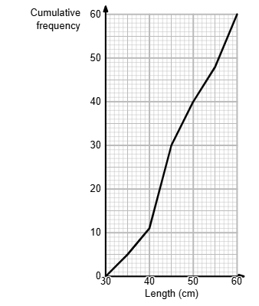
​​3. Jack collects the lengths of some animals and plots the values on the cumulative frequency graph below.
Use the cumulative frequency graph to estimate the median of the data.

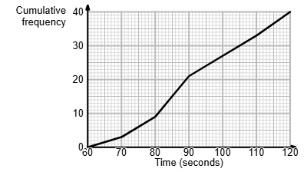
4. Jack collects the running times of some athletes and plots the values on the cumulative frequency graph below.
Use the cumulative frequency graph to estimate the median of the data.

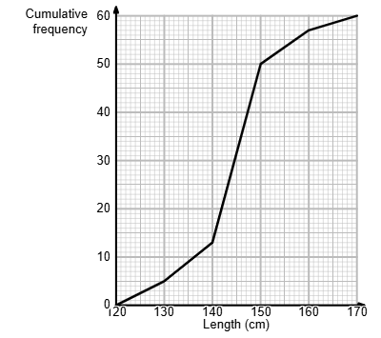
5. John collects the lengths of some animals and plots the values on the cumulative frequency graph (on the right). Use the cumulative frequency graph to estimate the interquartile range (IQR) of the data.

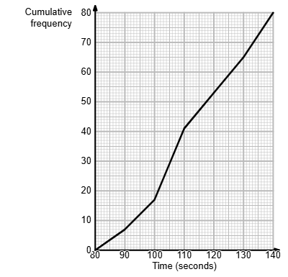

6. Jenny collects the running times of some athletes and plots the values on the cumulative frequency graph (on the left). Use the cumulative frequency graph to estimate the interquartile range (IQR) of the data.

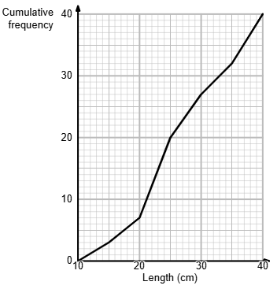

7. John collects the lengths of some animals and plots the values on the cumulative frequency graph (on the right).
Use the cumulative frequency graph to estimate how many animals are smaller than 32 cm.

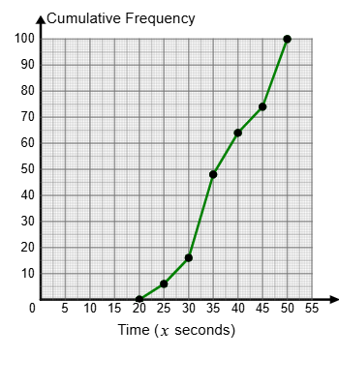
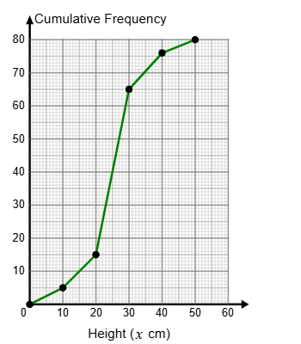
Worksheet 1: Cumulative Frequency Graphs ANSWERS
1. 2.
​​

3. The median is 45.
4. The median is 89.
5. IQR is ​$148.6 - 140.5 = 8.1$
6. The IQR is ​$125.8 - 101.3 = 24.5$
7. The answer is 29.
*For questions 3 – 7, allow for a slight difference in answer ($±1)$*

Worksheet 2: Introduction to Histograms
Time (​$y$ seconds) | Frequency
​$40< y ≤ 55$ | 15
​$55< y ≤ 65$ | 20
​$65< y ≤ 80$ | 45
​$80< y ≤ 100$ | 55
​$100< y ≤ 120$ | 50
​$120< y ≤ 135$ | 30
1. Dave collects the running times of 215 athletes and records the data in the table below.

Calculate the values for the frequency density for every row in the table.

Time (​$x$ seconds) | Frequency
​$40< x ≤ 55$ | 15
​$55< x ≤ 75$ | 10
​$75< x ≤ 90$ | 15
​$90< x ≤ 105$ | 30
​$105< x ≤ 110$ | 5

2. Lesley collects the running times of 75 athletes and records the data in the table below. Draw a histogram for the data in the table.

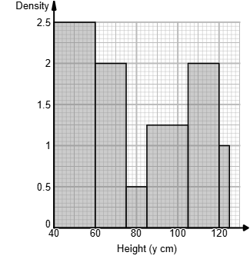
3. Lloyd collects the heights of 145 plants and
represents the data on the histogram drawn below.

Use the histogram to create, and complete, the
frequency table.

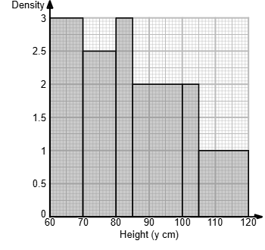

4. Liam collects the heights of 125 plants and
represents the data on the histogram drawn below.

Use the histogram to complete the frequency table.

5. Sandra measures the masses of pebbles in a sample taken from a beach.
Look at the histogram below. It shows the masses of the pebbles in the sample taken from the beach.

Calculate the percentage of pebbles in Sandra’s sample that had a mass less than 100 g.
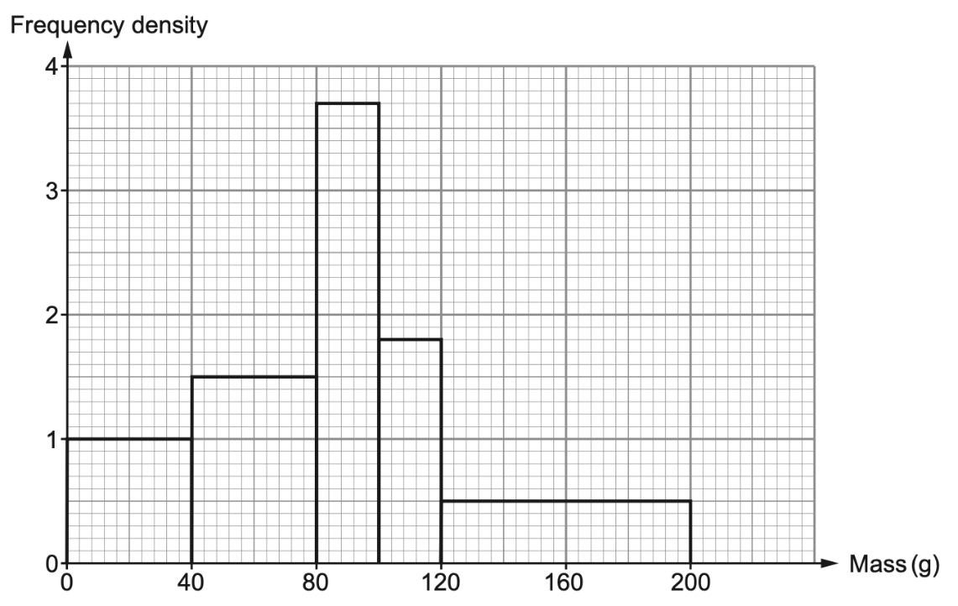

Worksheet 2: Introduction to Histograms ANSWERS
Time (​$y$ seconds) | Frequency
​$40< y ≤ 55$ | 15
​$55< y ≤ 65$ | 20
​$65< y ≤ 80$ | 45
​$80< y ≤ 100$ | 55
​$100< y ≤ 120$ | 50
​$120< y ≤ 135$ | 30
1. Dave collects the running times of 215 athletes and records the data in the table below.

Calculate the values for the frequency density for every row in the table.

Frequency density in order: 1, 2, 3, 2.75, 2.5, 2

Time (​$x$ seconds) | Frequency
​$40< x ≤ 55$ | 15
​$55< x ≤ 75$ | 10
​$75< x ≤ 90$ | 15
​$90< x ≤ 105$ | 30
​$105< x ≤ 110$ | 5

2. Lesley collects the running times of 75 athletes and records the data in the table below. Draw a histogram for the data in the table.
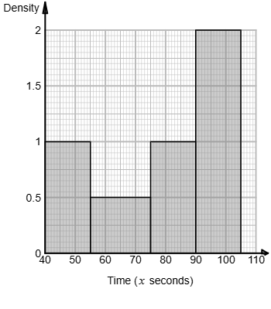

3. Lloyd collects the heights of 145 plants and represents the data on the histogram drawn below.
Use the histogram to create, and complete, the
​Height (​$y$ cm) | ​Frequency
​​$40< y ≤ 60$ | ​50
​​$60< y ≤ 75$ | ​30
​​$75< y ≤ 85$ | ​5
​​$85< y ≤ 105$ | ​25
​​$105< y ≤ 120$ | ​30
​​$120< y ≤ 125$ | ​5
frequency table.

4. Liam collects the heights of 125 plants and
represents the data on the histogram drawn below.

Use the histogram to complete the frequency table.
​Height (​$y$ cm) | ​Frequency
​​$60< y ≤ 70$ | ​30
​​$70< y ≤ 80$ | ​25
​​$80< y ≤ 85$ | ​15
​​$85< y ≤ 100$ | ​30
​​$100< y ≤ 105$ | ​10
​​$105< y ≤ 120$ | ​15

5. Sandra measures the masses of pebbles in a sample taken from a beach.
Look at the histogram below. It shows the masses of the pebbles in the sample taken from the beach.

Calculate the percentage of pebbles in Sandra’s sample that had a mass less than 100 g.

Total number of pebbles = 250
Sum of the three bars less than 100g = 174
Percentage = 174/250 x 100% = 69.7%
Worksheet 3: Calculating with Histograms
1. A researcher is studying the number of hours, ​$T$, a person stays in a restaurant after finishing their meals. The histogram below summarises the results for a random sample of 90 people.

- Find an estimate for the number of people who stayed between 10 minutes and 30 minutes.
- Find an estimate for the median time that people stayed after their meals.
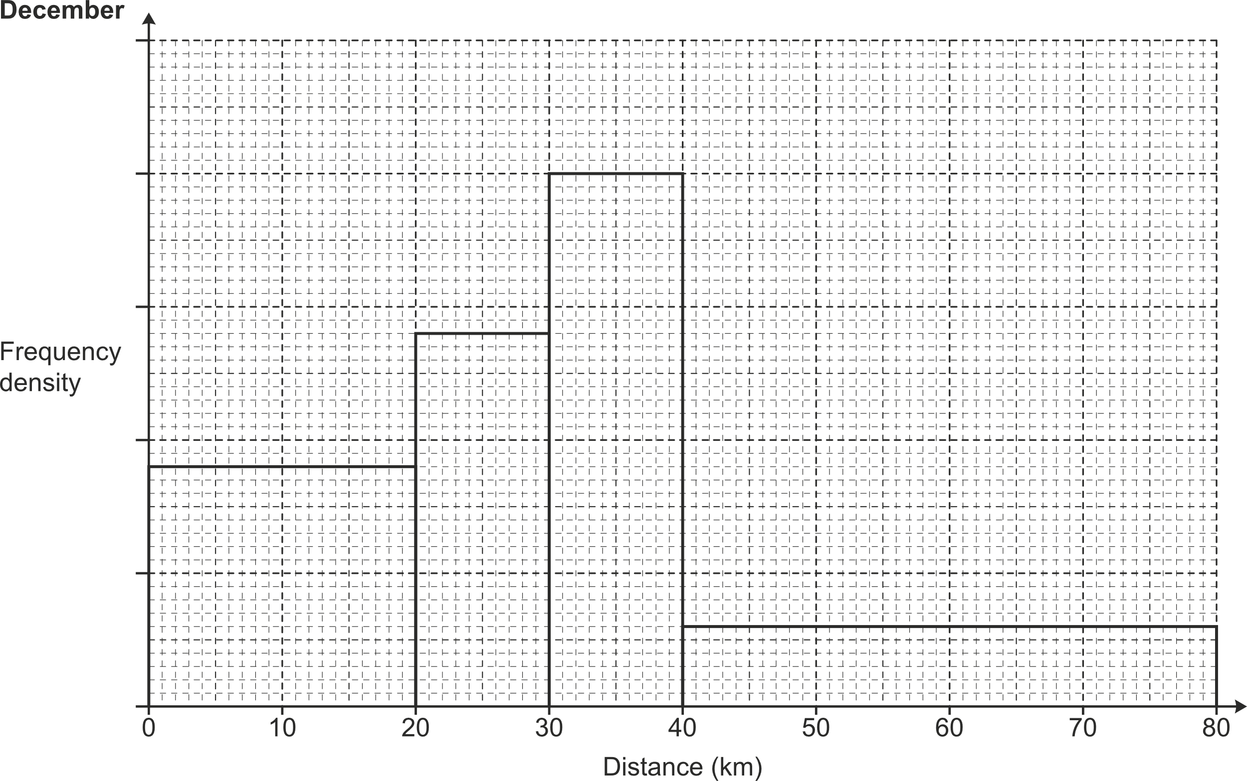
2. A running club records the distances run by each member during March.
The results are shown in this histogram.
18 members run less than 20 km.
Work out the number of members who run more than 30 km.

3. The histogram below shows the heights, in cm, of female students at a certain school.
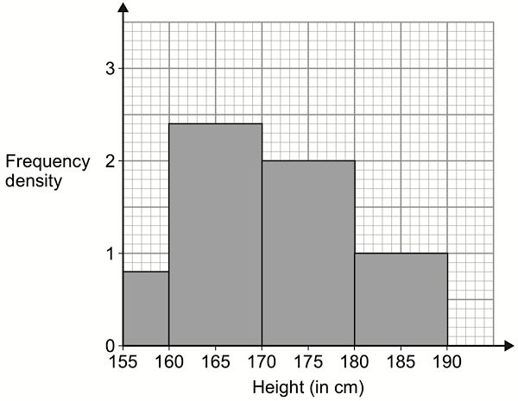
- Which class interval contains the median height?
- Estimate the value of the median height.
- Estimate the value of the interquartile range.

Worksheet 3: Calculating with Histograms ANSWERS
1. A researcher is studying the number of hours, ​$T$, a person stays in a restaurant after finishing their meals. The histogram below summarises the results for a random sample of 90 people.

21

14
16

9
10
20

- Find an estimate for the number of people who stayed between 10 minutes and 30 minutes.
- Find an estimate for the median time that people stayed after their meals.
- = (2 x 4.2) + 16 + 14 + (10 x 1) = 48.4 Allow 48 or 49.
- Median = 45th person. First 3 bars = 40 Need 5 from bar 4. 5/16 of 4 = 1.25
Median = 12 + 1.25 = 13.25
2. A running club records the distances run by each member during March.
The results are shown in this histogram.
18 members run less than 20 km.
Work out the number of members who run more than 30 km.
Height of first bar = 18/20 = 0.9 Members > 30 = 20 + 12 = 32
3. The histogram below shows the heights, in cm, of female students at a certain school.
10
20
24
4
- Which class interval contains the median height?
- Estimate the value of the median height.
- Estimate the value of the interquartile range.
- 170 – 180 n=58 median is the 29th female
- 29th female is 1 person into the 3rd rectangle Median = 170 + (1/20 x 10) = 170 + 0.5 = 170.5
- Lower quartile = 14.5th female: 160 + (10.5/24 x 10) = 164.375
Upper quartile = 33.5th female: 170 + (5.5/20 x 10) = 172.75
IQR = 172.75 – 164.375 = 8.375

Cambridge Assessment International Education
The Triangle Building, Shaftsbury Road, Cambridge, CB2 8EA, United Kingdom
t: +44 1223 553554
e: info@cambridgeinternational.org www.cambridgeinternational.org

© Cambridge University Press & Assessment 2025

