

Teaching Pack

Exact Trigometric Values

Cambridge IGCSE™ / Cambridge IGCSE (9-1)

Mathematics 0580 / 0980



® IGCSE is a registered trademark

© Cambridge University Press & Assessment 2024

Cambridge Assessment International Education is part of Cambridge University Press & Assessment. Cambridge University Press & Assessment is a department of the University of Cambridge.

Cambridge University Press & Assessment retains the copyright on all its publications. Registered centres are permitted to copy material from this booklet for their own internal use. However, we cannot give permission to centres to photocopy any material that is acknowledged to a third party even for internal use within a centre.

.

Contents

Contents 3

Introduction: Exact Trigonometric Values 5

Syllabus links 6

Trigonometry – exact values 7

Teacher’s notes 11

Lesson resources 12

Worksheet 1: 13

Worksheet 1: Answers 14

Worksheet 2: 15

Worksheet 2: Answers 17

Worksheet 3: 18

Worksheet 3: Answers 20

Worksheet 4: 21

Worksheet 4: Answers 22

Worksheet 5: 23

Worksheet 5: 24

Worksheet 6: 25

Worksheet 6: Answers 27

|  |  |
| --- | --- |
| **Icons used in this pack:** | |
| **C:\Users\elliss\AppData\Local\Microsoft\Windows\Temporary Internet Files\Content.Outlook\RZWGLKTN\Teacher icon.jpg** | **Lesson plan** |
| **C:\Users\elliss\AppData\Local\Microsoft\Windows\Temporary Internet Files\Content.Outlook\RZWGLKTN\Information icon.jpg** | **Teacher’s notes** |
| **C:\Users\elliss\AppData\Local\Microsoft\Windows\Temporary Internet Files\Content.Outlook\RZWGLKTN\Resources icon.jpg** | **Lesson resources** |

Introduction: Exact Trigonometric Values

This *Teaching Materials* *Pack* focuses on supporting learners to develop an understanding of working with exact values in trigonometric problems.

The lesson presented here is designed for learners that are already familiar with the trigonometric ratios and applying them in 2 dimensional problems, including in non-right-angled triangles and for angles 0° ≤ *x* ≤ 360°.

It is expected that learners should already be confident in the manipulation of surds and the use of Pythagoras’ Theorem.

It would be useful if students could also multiply a whole number by a fraction using written methods. It would also be useful if they could simplify fractions.

**Important note**

Our *Teaching Packs* have been written by **classroom teachers** to help you deliver topics and skills that can be challenging. Use these materials to supplement your teaching and engage your learners. You can also use them to help you create lesson plans for other skills.

***This content is designed to give you and your learners the chance to explore mathematical skills. It is not intended as specific practice for exam papers.***

This is one of a range of Teaching Packs. Each pack is based on one mathematical topic with a focus on specific mathematical techniques. The packs can be used in any order to suit your teaching sequence.

In this pack you will find the lesson plans and worksheets you will need to successfully complete the teaching of this topic.

Syllabus links

This *Teaching Pack* links to the following syllabus content (see syllabus for detail):

* E6.3 Know the exact values of:  
   sin *x* and cos *x* for *x* = 0°, 30°, 45°, 60° and 90°. tan *x* for *x* = 0°, 30°, 45° and 60°.

The pack covers mathematical skills, adapted from **AO1: Demonstrate knowledge and understanding of mathematical techniques** and **AO2: Reason, interpret and communicate mathematically when solving problems**.

**Trigonometry – exact values**

|  |  |
| --- | --- |
| **Resources** | * Lesson 1 presentation * Worksheets 1 - 3 |
|  |  |
| **Learning objectives** | By the end of the lesson:   * **all learners** will know the exact trigonometric values of the standard angles * **most learners** will be able to perform trigonometric calculations with exact values |

| **Timings** | |  | **Activity** |
| --- | --- | --- | --- |
| 10 minutes | **Starter / Introduction**  **Slide 2**  Use this activity to check learners’ recall the terminology for trigonometry and the trigonometric ratios.  Explain to learners that some trigonometric values can be found exactly, so can be remembered and used without a calculator. Calculators will not be required for this lesson and they will be using their knowledge of surds. | | |
| 40 minutes | **Main lesson**  **Slide 3** This uses prior knowledge from geometry of the properties of triangles and Pythagoras to find all the required lengths and angles. This can be completed as a class activity, with prompts about lengths of sides and angles as the slide is presented.  **Slides 4 – 5**  Slide 4 is reproduced as Worksheet 1. 60° is the example angle, ask the learners to identify the angle in the ‘helpful triangles’ and then use the angle this angle to identify the sides. Ask the learners to find sin, cos and tangent in sequence, which can be recorded in the table.  The learners then complete the remainder of the table working in pairs. Slide 5 is the completed table.  **Slides 6 – 7** Use this activity to show how the exact values can be used to find lengths without the use of a calculator.  Worksheet 2 has some further examples of non-calculator trigonometric problems as reinforcement | | |
| 10 minutes | **Plenary**  **Slide 8** Worksheet 1 should not be visible as this activity is to check learners’ recall of the exact values of the standard angles. Here, the value is given, and the trigonometric relationship is required.  **Homework:** Worksheet 3 | | |

**Trigonometry – exact values 90° < *x*° ≤ 360°**

|  |  |
| --- | --- |
| **Resources** | * Lesson 2 presentation * Worksheets 4 and 5 |
|  |  |
| **Learning objectives** | By the end of the lesson:   * **all learners** will be able to find the exact trigonometric values of the standard angles $90°<x°≤360°$* **most learners** will be able to solve simple trigonometric equations with exact values |

| **Timings** | |  | **Activity** |
| --- | --- | --- | --- |
| 10 minutes | **Starter / Introduction**  **Slide 2**  Use this activity to check learners’ recall the relationship between angles and the nature (positive or negative) of the different trigonometric ratios in each quadrant.  If this is not building upon prior knowledge from trigonometry, then consider extending the activity considering examples where a calculator is required. | | |
| 40 minutes | **Main lesson**  **Slides 3 – 5** These slides review illustrate the process of finding trigonometric values of angles greater than 90° without the use of a calculator.  Remind the learners that as some trigonometric values can be found exactly, so can be remembered and used without a calculator. Calculators will not be required for this lesson and they will be using their knowledge of surds.  **Slides 6** Slide 6 is reproduced as Worksheet 3. The values from the previous slides can be inserted in the table Ask the learners to find sin, cos and tangent in sequence, which can be recorded in the table.  The learners then complete the remainder of the table working in pairs. Slide 7 is the completed table.  **Slides 8 – 9** Use this activity to show how simple trigonometric equations can now be solved without the use of a calculator. Learner should be aware that there will normally be 2 solutions to find in the range 0° ≤ *x*° ≤ 360°as this is anticipated as extending prior knowledge.  Worksheet 5 has some further examples of non-calculator trigonometric equations as reinforcement and extension to more challenging simple trigonometric equations. | | |
| 10 minutes | **Plenary**  **Slide 10** Worksheets 1 and 4 should not be visible as this activity is to check learners’ recall of the exact values of the standard angles. Direct the learners to solve the simple trigonometric equation individually. Ask a learner to explain their solution using the whiteboard – and compare with the slide.  **Homework:** Complete worksheet 5 | | |

**Trigonometry – non-right-angled triangles**

|  |  |
| --- | --- |
| **Resources** | * Lesson 3 presentation * Worksheets 6 |
|  |  |
| **Learning objectives** | By the end of the lesson:   * **all learners** will be able to use the exact trigonometric values of the standard angles in non-right-angled triangles * **most learners** will be able to use the trigonometric area of a triangle formula and the sine rule with exact trigonometric values * **some learners** will be able to use the cosine rule with exact trigonometric values. |

| **Timings** | |  | **Activity** |
| --- | --- | --- | --- |
| 10 minutes | **Starter / Introduction**  **Slide 2**  Use one or two of the learners trigonometric equations generated for question 11 on Worksheet 5 to reinforce the previous activity.  Remind learners that calculators will not be required for this lesson as they are using exact trigonometric values and they will be using their knowledge of surds to evaluate calculations. | | |
| 40 minutes | **Main lesson**  **Slides 3 – 4** Slide 3 is an opportunity for learners to be asked to recall the trigonometric formula for the area of the triangle. It is also an opportunity to remind learners that it will be provided on the formula page for the extended curriculum papers. Slide 4 is a worked example to show how to use their knowledge of exact trigonometric values and surds to find the area of a triangle.  Question 1 of worksheet 6 can be used at this stage as reinforcement.  **Slides 5 – 6** Slide 5 is an opportunity for learners to be asked to recall the Sine Rule and how to identify the sides and angles. It is also an opportunity to remind learners that it will be provided on the formula page for the extended curriculum papers. Slide 8 is a worked example to show how to use their knowledge of exact trigonometric values and surds evaluate the cosine rule. Ask individual learners about what each new step should be.  Question 6 of worksheet 6 can be used at this stage as reinforcement.  **Slides 7 – 8** Slide 7 is an opportunity for learners to be asked to recall the 2 forms of the Cosine Rule that they are expected to be aware of. It is also an opportunity to remind learners that it will be provided on the formula page for the extended curriculum papers. Slide 8 is a worked example to show how to use their knowledge of exact trigonometric values and surds evaluate the sine rule. Ask individual learners about what each new step should be.  Question 7 of worksheet 6 can be used at this stage as reinforcement.  **Slide 9** is a summary of all 3 formulas.  The remainder of Worksheet 6 is reinforcement questions for this topic | | |
| 10 minutes | **Plenary**  **Slide 10** can be used to confirm understanding of the trigonometric area of a triangle formula and the use of the cosine rule. Ask the learners to answer the question by themselves and the selected different learners to explain the steps.  **Homework:** Complete Worksheet 6. A suitable non-calculator example from a recent examination paper should also be included, for example 0580 Set B Specimen Paper 2 question 21. | | |

Teacher’s notes

Key words / concepts you could highlight during the lesson, or have pre-taught before the lesson:

Students need a basic understanding of trigonometry in a right-angled triangle, Pythagoras and manipulating surds before tackling lesson 1.

**Key words**

* opposite
* adjacent
* hypotenuse
* sine (sin)
* cosine (cos)
* tangent (tan)
* quadrant
* surd

Lessons 2 and 3 support the use of exact trigonometric values in solving trigonometric equations for angles 0° ≤ *x* 360° and using exact trigonometric values in non-right-angled triangles. They are not intended to introduce the concept to the learner.

****Lesson resources

|  |
| --- |
| **Worksheet 1:** |
| **Worksheet 2:** |
| **Worksheet 3:** |
| **Worksheet 4:** |
| **Worksheet 5:** |

**Worksheet 1:**

1. Complete the table of exact trigonometric values

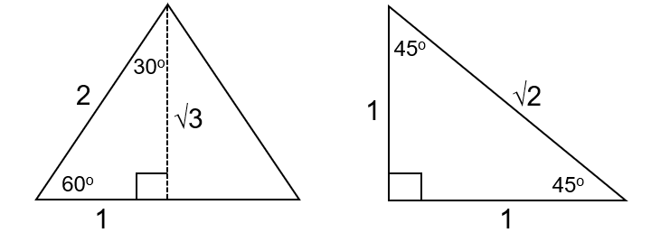

|  |  |  |  |
| --- | --- | --- | --- |
| Angle | sin | cos | tan |
| 0° |  |  |  |
| 30° |  |  |  |
| 45° |  |  |  |
| 60° |  |  |  |
| 90° |  |  |  |

**Worksheet 1:** Answers

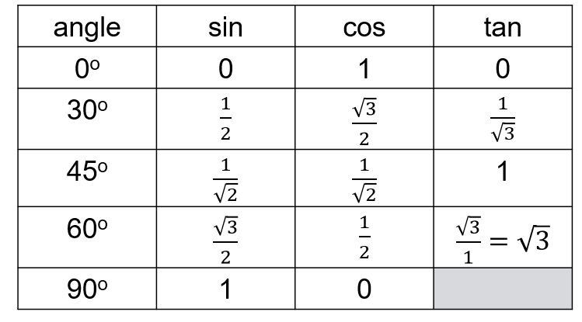

**Worksheet 2:**

Work out the missing lengths using exact trigonometric values:

1

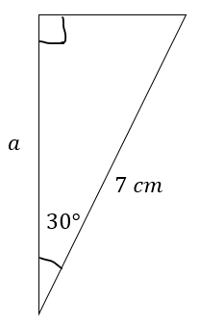Length a = …………………cm

2

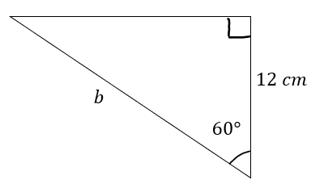Length b = …………………cm

3

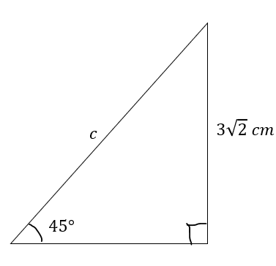Length c = …………………cm

Use trigonometry to find the missing angles:

4

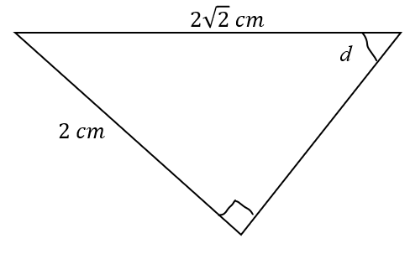

Angle d = …………………

5

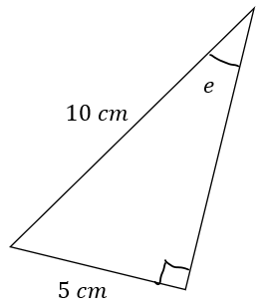

Angle e = …………………

6

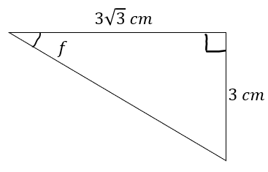

Angle f = …………………

**Worksheet 2:** Answers

Work out the missing lengths using exact trigonometric values:

1 $7×\cos{30}=7×\frac{\sqrt{3}}{2}=\frac{7\sqrt{3}}{2}$ Length a = …… $\frac{7\sqrt{3}}{2}$……………cm

2 $b×\cos{60}=12$

$\frac{12}{\cos{60}}=\frac{12}{\frac{1}{2}}=12×2=24$ Length b = ………24…………cm

3 $c×\sin{45}=3\sqrt{2}$

$c=\frac{3\sqrt{2}}{\sin{45}}=\frac{3\sqrt{2}}{\frac{1}{\sqrt{2}}}=3\sqrt{2}×\sqrt{2}=6$ Length c = ………6…………cm

4 $\sin{d}=\frac{2}{2\sqrt{2}}=\frac{1}{\sqrt{2}}$

$d=\sin^{-1}{\frac{1}{\sqrt{2}}}=45°$ Angle d = …………45………

5 $\sin{e}=\frac{5}{10}=\frac{1}{2}$

$e=\sin^{-1}{\frac{1}{2}}=30°$ Angle e = …………30………

6 $\tan{f}=\frac{3}{3\sqrt{3}}=\frac{1}{\sqrt{3}}$

$f=\tan^{-1}{\frac{1}{\sqrt{3}}}=30°$ Angle f = …………30………

**Worksheet 3:**

Without using a calculator, find the value of *x* in the following triangles

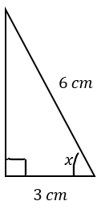

1

*x* = ………………………..

2

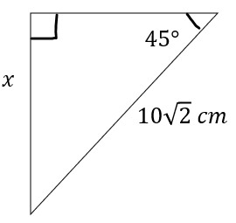

*x* = ………………………..

3

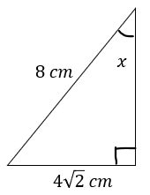

*x* = ………………………..

4

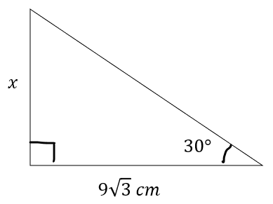

*x* = ………………………..

5

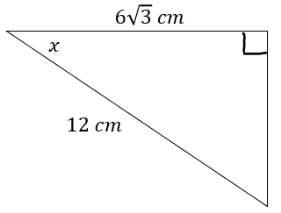

*x* = ………………………..

6

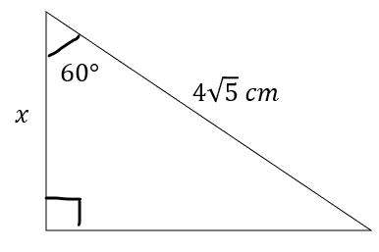

*x* = ………………………..

7 Find the area of the trapezium

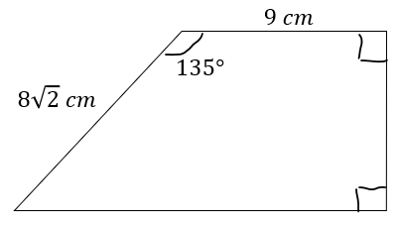

Area = …………

**Worksheet 3:** Answers

Without using a calculator, find the value of *x* in the following triangles

1 $\cos{x}=\frac{3}{6}=\frac{1}{2}$ =

$x=\cos^{-1}{\frac{1}{2}}=60°$*x* = ……………60…………..

2 $x=10\sqrt{2}×\sin{45}=10\sqrt{2}×\frac{1}{\sqrt{2}}=10$*x* = ……………10…………..

3 $\sin{x}=\frac{4\sqrt{2}}{8}=\frac{\sqrt{2}}{2}=\frac{\sqrt{2}}{\sqrt{2}×\sqrt{2}}=\frac{1}{\sqrt{2}}$

$x=\sin^{-1}{\frac{1}{\sqrt{2}}}=45°$*x* = ……………45…………..

4 $x=9\sqrt{3}×\tan{30}=9\sqrt{3}×\frac{1}{\sqrt{3}}=9$*x* = ……………9…………..

5 $\cos{x}=\frac{6\sqrt{3}}{12}=\frac{\sqrt{3}}{2}$

$x=\cos^{-1}{\frac{\sqrt{3}}{2}}=30°$*x* = ……………30…………..

6 $x=4\sqrt{5}×\cos{60}=4\sqrt{5}×\frac{1}{2}=2\sqrt{5}$*x* = …………… $2\sqrt{5}$…………..

7 Find the area of the trapezium

$Angle CAB=135-90=45$

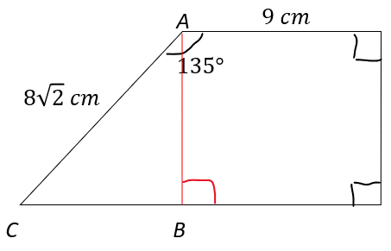

$BC=8\sqrt{2}×\sin{45}=8\sqrt{2}×\frac{1}{\sqrt{2}}=8$

$AB=8\sqrt{2}×\cos{45}=8\sqrt{2}×\frac{1}{\sqrt{2}}=8$

Area of triangle = $\frac{1}{2}×8×8=32$

Area of rectangle = $9×8=72$

Area of trapezium = $32+72=104$

**Worksheet 4:**

1. Complete the table of exact trigonometric values

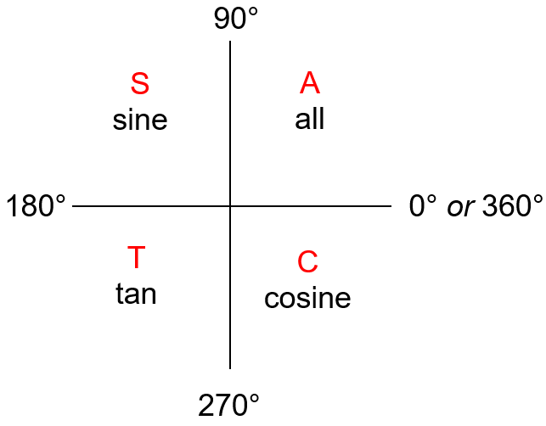

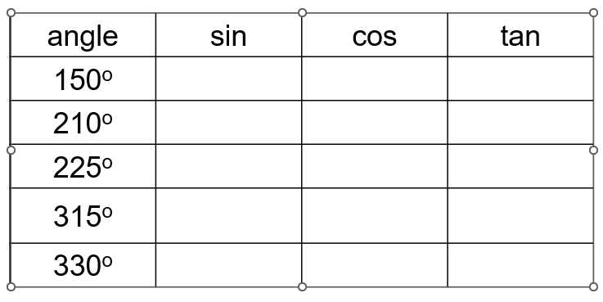

**Worksheet 4:** Answers

1 Complete the table of exact trigonometric values



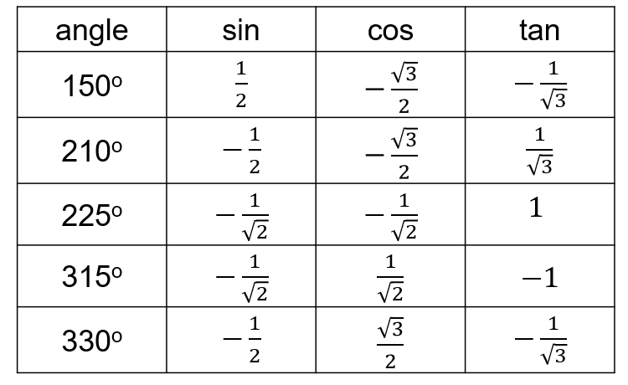

**Worksheet 5:**

1. Solve $\sin{x}=\frac{\sqrt{3}}{2}$ for $0°≤x≤360°$.
2. Solve $\cos{x}=\frac{\sqrt{3}}{2}$ for $0°≤x≤360°$.
3. Solve $\tan{x}=-\sqrt{3}$ for $0°≤x≤360°$.
4. Solve $2\cos{x}=-\sqrt{3}$ for $0°≤x≤360°$.
5. Solve $3\tan{x}=\sqrt{3}$ for $0°≤x≤360°$.
6. Solve $2\sin{x}=-\sqrt{2}$ for $0°≤x≤360°$.
7. Solve $\sqrt{2}\cos{x}+5=4$ for $0°≤x≤360°$.
8. Solve $2\sqrt{3}\sin{x}-1=2$ for $0°≤x≤360°$.
9. Solve $\sqrt{3}\tan{x}-2=1$ for $0°≤x≤360°$.

Extension:

1. Solve $2{\left(\cos{x}\right)}^{2}=\frac{1}{2}$ for $0°≤x≤360°$.
2. Create your own trigonometric equation and provided a worked solution for $0°≤x≤360°$ to share with the class.

**Worksheet 5:**

1. Solve $\sin{x}=\frac{\sqrt{3}}{2}$ for $0°≤x≤360°$.

$x=60 or 180-60=120$

1. Solve $\cos{x}=\frac{\sqrt{3}}{2}$ for $0°≤x≤360°$.

$x=30 or 360-30=330$

1. Solve $\tan{x}=-\sqrt{3}$ for $0°≤x≤360°$.

$x=180-60=120 or 120+180=300$

1. Solve $2\cos{x}=-\sqrt{3}$ for $0°≤x≤360°$.

$\cos{x}=-\frac{\sqrt{3}}{2}, x=180-30=150 or 180+30=210$

1. Solve $3\tan{x}=√3$ for $0°≤x≤360°$.

$\tan{x}=\frac{\sqrt{3}}{3}=\frac{\sqrt{3}}{\sqrt{3}×\sqrt{3}}=\frac{1}{\sqrt{3}} x=30 or 30+180=210$

1. Solve $2\sin{x}=-\sqrt{2}$ for $0°≤x≤360$.

$\sin{x}=-\frac{\sqrt{2}}{2}=-\frac{\sqrt{2}}{\sqrt{2}×\sqrt{2}}=-\frac{1}{\sqrt{2}} x=180+45=225 or x=360-45=315$

1. Solve $\sqrt{2}\cos{x}+5=4$ for $0°≤x≤360°$.

$\sqrt{2}\cos{x}= -1 \cos{x}=-\frac{1}{\sqrt{2}} x=180-45=135 or 180+45=225$

1. Solve $2\sqrt{3}\sin{x}-1=2$ for $0°≤x≤360°$.

$2\sqrt{3}\sin{x}=3 \sin{x}=\frac{3}{2\sqrt{3}}=\frac{\sqrt{3}×\sqrt{3}}{2\sqrt{3}}=\frac{\sqrt{3}}{2} x=60 or 180-60=120$

1. Solve $\sqrt{3}\tan{x}-2=1$ for $0°≤x≤360°$.

$\sqrt{3}\tan{x}=3 \tan{x}=\frac{3}{\sqrt{3}}=\frac{\sqrt{3}×\sqrt{3}}{\sqrt{3}}=\sqrt{3} x=60 or 60+180=240$

1. Solve $2{\left(\cos{x}\right)}^{2}=\frac{1}{2}$ for $0°≤x≤360°$.

${\left(\cos{x}\right)}^{2}=\frac{1}{4} \cos{x}=\sqrt{\frac{1}{4}}=\frac{1}{2}or-\frac{1}{2}$

$x=60 or 360-60=300 or 180-60=120 or 180+60=240$

**Worksheet 6:**

Work out the area of each triangle

1

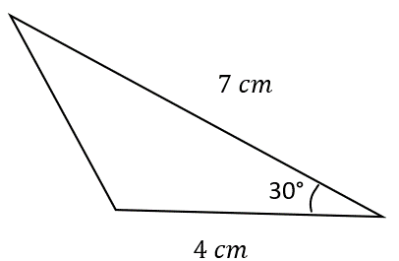

2

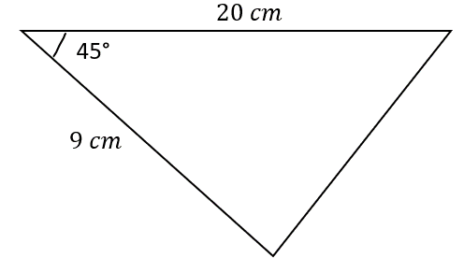

3

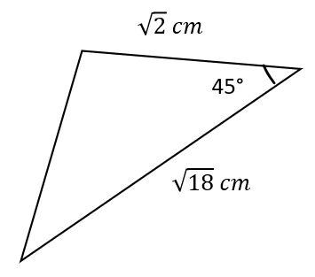

4

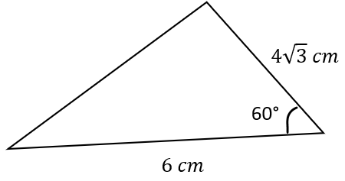

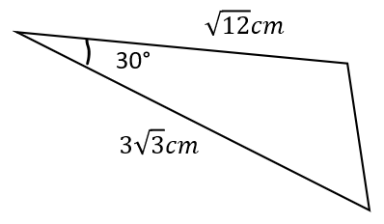

5

Work out the value of *x* in each triangle

6

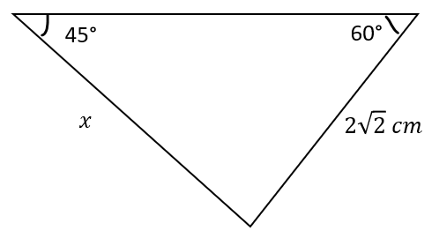

7

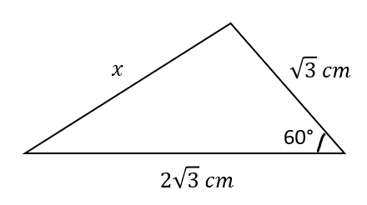

8

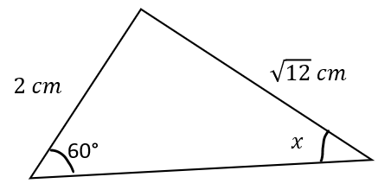

9

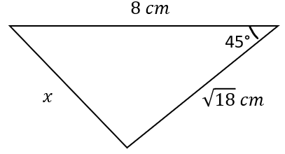

10

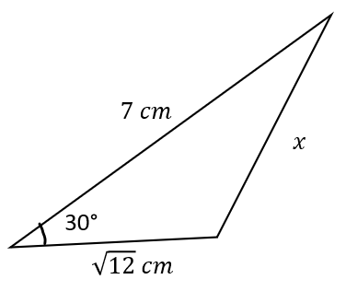

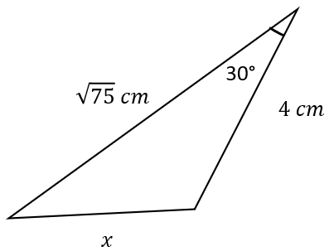

11

**Worksheet 6:** Answers

Work out the area of each triangle

1 $\frac{1}{2}×7×4×\sin{30}=\frac{1}{2}×7×4×\frac{1}{2}=7 cm^{2}$

2 $\frac{1}{2}×9×20×\sin{45}=\frac{1}{2}×9×20×\frac{1}{\sqrt{2}}=\frac{90}{\sqrt{2}}=\frac{90\sqrt{2}}{2}=45\sqrt{2}$

3 $\frac{1}{2}×\sqrt{2}×\sqrt{18}×\sin{45}=\frac{1}{2}×\sqrt{2}×3\sqrt{2}×\frac{1}{\sqrt{2}}=\frac{3\sqrt{2}}{2}$

4 $\frac{1}{2}×6×4\sqrt{3}×\sin{60}=\frac{1}{2}×6×4\sqrt{3}×\frac{\sqrt{3}}{2}=18$

5 $\frac{1}{2}×\sqrt{12}×3\sqrt{3}×\sin{30}=\frac{1}{2}×2\sqrt{3}×3\sqrt{3}×\frac{1}{2}=\frac{9}{2}=4\frac{1}{2}, 4.5$

6 $\frac{2\sqrt{2}}{\sin{45}}=\frac{x}{\sin{60}}, x=\frac{2\sqrt{2}×\sin{60}}{\sin{45}}= \frac{2\sqrt{2}×\frac{\sqrt{3}}{2}}{\frac{1}{\sqrt{2}}}=2\sqrt{2}×\frac{\sqrt{3}}{2}×\frac{\sqrt{2}}{1}=2\sqrt{3}$

7 $x^{2}={\left(\sqrt{3}\right)}^{2}+{\left(2\sqrt{3}\right)}^{2}-2\sqrt{3}×\sqrt{3}×\cos{60}=3+12-2×3×\frac{1}{2}=12, x=\sqrt{12}=2\sqrt{3} cm$

8 $\frac{\sin{x}}{2}=\frac{\sin{60}}{\sqrt{12}}, \sin{x}=\frac{2×\frac{\sqrt{3}}{2}}{2\sqrt{3}}=\frac{\sqrt{3}}{2\sqrt{3}}=\frac{1}{2}, x=\sin^{-1}{\frac{1}{2}}=30°$

9 $x^{2}=8^{2}+{\left(\sqrt{18}\right)}^{2}-2×8×\sqrt{18}×\cos{45}=64+18-16×3\sqrt{2}×\frac{1}{\sqrt{2}}=82-48=34$

$x=√34$

10 $x^{2}=7^{2}+{\left(\sqrt{12}\right)}^{2}-2×7×\sqrt{12}×\cos{30}=49+12-14×2\sqrt{3}×\frac{\sqrt{3}}{2}=61-42=19$

$x=\sqrt{19}$

11 $x^{2}=4^{2}+{\left(\sqrt{75}\right)}^{2}-2×4×\sqrt{75}×\cos{30}=16+75-8×5\sqrt{3}×\frac{\sqrt{3}}{2}=91-60=31$

$x=\sqrt{31}$

Cambridge Assessment International Education  
The Triangle Building, Shaftsbury Road, Cambridge, CB2 8EA, United Kingdom  
t: +44 1223 553554

e: [info@cambridgeinternational.org](mailto:info@cambridgeinternational.org)[www.cambridgeinternational.org](http://www.cambridgeinternational.org)

© Cambridge University Press & Assessment 2024