

Teaching Pack

Geometry – Pythagoras’ Theorem and Trigonometry in 3D

Cambridge IGCSE™

Mathematics 0580

P16#y1

® IGCSE is a registered trademark

© Cambridge University Press & Assessment 2023

Cambridge Assessment International Education is part of Cambridge University Press & Assessment. Cambridge University Press & Assessment is a department of the University of Cambridge.

Cambridge University Press & Assessment retains the copyright on all its publications. Registered centres are permitted to copy material from this booklet for their own internal use. However, we cannot give permission to centres to photocopy any material that is acknowledged to a third party even for internal use within a centre.

.

Contents

Contents 3

Introduction: Pythagoras’ Theorem and Trigonometry in 3D 4

Syllabus links 5

Lesson 1 – Pythagoras’ Theorem in 3D 6

Lesson 2 – Trigonometry in 3D #1 7

Lesson 3 – Trigonometry in 3D #2 8

Teacher’s notes 9

Lesson resources 10

Worksheet 1: Pythagoras’ Theorem in 3D 11

Worksheet 1: Pythagoras’ Theorem in 3D ANSWERS 12

Worksheet 2: Trigonometry in 3D #1 13

Worksheet 2: Trigonometry in 3D #1 ANSWERS 14

Worksheet 3: Trigonometry in 3D #2 15

Worksheet 3: Trigonometry in 3D #2 ANSWERS 16

|  |  |
| --- | --- |
| **Icons used in this pack:** | |
| **P73C2T1#yIS1** | **Lesson plan** |
| **P76C4T1#yIS1** | **Teacher’s notes** |
| **P79C6T1#yIS1** | **Lesson resources** |

Introduction: Pythagoras’ Theorem and Trigonometry in 3D

This *Teaching Materials* *Pack* focuses on supporting learners to develop a confidence and fluency with the formulas and diagram drawing required to break down three-dimensional shape problems into the two-dimensional problems they are more familiar with. This is one of the most challenging topics in the IGCSE, and time will need to be factored in to allow learners to complete plenty of question practice for them to get to grips with the techniques involved.

The lesson presented here is designed for learners that are already secure in problem solving to find missing sides or lengths in two dimensional shapes. It will use this knowledge to build up to applying these techniques to three dimensional shapes in a methodical way.

It is expected that learners should already understand the concept of Pythagoras’ theorem in two dimensions. They will also need to be secure in their use of trigonometry on right-angled triangles to find missing sides and missing angles.

It would be useful if learners were proficient in using both the sine and cosine rules for finding missing sides and missing angles. This will be required for the second, and more challenging lesson and the worksheet provided for it.

**Important note**

Our *Teaching Packs* have been written by **classroom teachers** to help you deliver topics and skills that can be challenging. Use these materials to supplement your teaching and engage your learners. You can also use them to help you create lesson plans for other skills.

***This content is designed to give you and your learners the chance to explore mathematical skills. It is not intended as specific practice for exam papers.***

This is one of a range of Teaching Packs. Each pack is based on one mathematical topic with a focus on specific mathematical techniques. The packs can be used in any order to suit your teaching sequence.

In this pack you will find the lesson plans and worksheets you will need to successfully complete the teaching of this topic.

Syllabus links

This *Teaching Pack* links to the following syllabus content (see syllabus for detail):

E6.6 Pythagoras’ theorem and trigonometry Notes and examples in 3D

Carry out calculations and solve problems in three dimensions using Pythagoras’ theorem and trigonometry, including calculating the angle between a line and a plane.

The pack covers mathematical skills, adapted from **AO1: Demonstrate knowledge and understanding of mathematical techniques** and **AO2: Reason, interpret and communicate mathematically when solving problems**.

****Lesson 1 – Pythagoras’ Theorem in 3D

|  |  |
| --- | --- |
| **Resources** | * Lesson 1 PowerPoint presentation * Worksheet 1 |
|  |  |
| **Learning objectives** | By the end of the lesson:   * **all learners** will be able to use the formula to find the longest diagonal on any given cuboid. * **most learners** will be able to use the formula to problem solve * **some learners** will understand the proof that underpins the formula |

| **Timings** | |  | **Activity** |
| --- | --- | --- | --- |
| 10 mins | **Starter / Introduction**  Three retrieval practice questions on using Pythagoras’ theorem on two dimensional shapes. One finds the hypotenuse, one finds a shorter side and the other has a problem-solving element. | | |
| 5 mins  5 mins  5 mins  5 mins  10 mins  Rest of the lesson | **Main lesson**  **Slides 3 and 4** – A brief introduction to the formula for 3D Pythagoras’ by relating the 2D version back to a rectangle.  **Slide 5** – One simple worked through example. Highlight to the learners that the order in which you put the number in doesn’t matter.  **Slide 6** – Give the learners a similar problem to try. Answers are on the PP.  **Slide 7** – A second worked example by the teacher. This one has a problem-solving element, where the question doesn’t specifically ask the learner to use 3D Pythagoras’ theorem.  **Slide 8** – This is the proof for the formula. It is optional, as it is non-examinable, but for learners looking at getting top grades the algebra is at a level they can access. It helps build the links between 2D and 3D Pythagoras’ theorem.  **Worksheet #1** | | |
|  | **Plenary:** Check answers with learners using the answer worksheet. | | |

****Lesson 2 – Trigonometry in 3D #1

|  |  |
| --- | --- |
| **Resources** | * Lesson 2 PowerPoint presentation * Worksheet 2 |
|  |  |
| **Learning objectives** | By the end of the lesson:   * **all learners** will be able to break a 3D shape into 2D sections to help them find missing sides and angles * **most learners** will be able to find the angle between a plane and a line segment * **some learners** will be able to complete questions involving a problem-solving element, and may also utilise 3D Pythagoras’ theorem |

| **Timings** | |  | **Activity** |
| --- | --- | --- | --- |
| 10 mins | **Starter / Introduction**  Two retrieval practice questions on using trigonometry on two dimensional shapes. One finds the hypotenuse, one finds an angle. | | |
| 5 mins  10 mins  10 mins  Rest of the lesson | **Main lesson**  **Slide 3** – A quick introduction to the idea of a ‘plane’.  **Slide 4** – One reasonably long example of finding the angle between a line segment and the base of a cuboid. There are a lot of processes here, so don’t cover each step too quickly. Learners being able to visualise the ‘yellow triangle’ is arguably the most important step, as it sets up the rest of the question.  **Slide 5** – A second, more challenging, example of using trigonometry in 3D. As with the previous example, take your time going through each step.  **Worksheet #2** | | |
|  | **Plenary:** Check answers using the answer worksheet. | | |

****Lesson 3 – Trigonometry in 3D #2

|  |  |
| --- | --- |
| **Resources** | * Lesson 3 PowerPoint presentation * Worksheet 3 |
|  |  |
| **Learning objectives** | By the end of the lesson:   * **all learners** will be able to break a 3D shape into 2D sections to help them find missing sides and angles * **most learners** will be able to find any angle on a 3D shape, utilising all elements of trigonometry and Pythagoras’ theorem * **some learners** will be able to complete questions involving a problem-solving element with any element of Pythagoras’ theorem or trigonometry |

| **Timings** | |  | **Activity** |
| --- | --- | --- | --- |
| 10 mins | **Starter / Introduction**  Two retrieval practice questions on using the sine rule and one using the cosine rule. | | |
| 10 mins  5 mins  5 mins  Rest of the lesson | **Main lesson**  **Slide 3 and 4** – Introduce the concept that some 3-dimensional shapes may require learners to utilise the sine and cosine rules. This is a challenging concept for even the best learners.  Each of the parts to this question involve learners picking the ‘correct’ triangle, and then applying the correct rule in order to find the missing value. Part a) requires the use of the cosine rule for missing side lengths.  **Slide 5** – part b) Follow up example on the same tetrahedron. Again, stress the importance of using the ‘correct’ triangle and picking the right method to use. In this instance, the sine rule for a missing side is needed.  **Slide 6** – part c) Follow up example on the same tetrahedron. In this instance, the cosine rule for a missing angle is needed.  **Worksheet #3** | | |
|  | **Plenary:** Check answers using answer worksheet.  **Homework:** | | |

Teacher’s notes

Key words / concepts you could highlight during the lesson, or have pre-taught before the lesson:

Learners need a secure understanding of Pythagoras’ theorem and trigonometry before tackling lesson 1.

**Key words**

* Diagonal
* Longest diagonal
* Plane
* Angle
* Hypotenuse
* Opposite
* Adjacent

The time required for teaching the 2 lesson on trigonometry in 3D will vary greatly depending on the ability of your learners. Please be prepared to slow the lessons down to accommodate for classes who already find the two-dimensional work challenging. Those 2 lessons could easily be spread out to 3, or even 4 lessons.

****Lesson resources

|  |
| --- |
| **Worksheet 1:** Pythagoras’ theorem in 3D  **Worksheet 1:** Pythagoras’ theorem in 3D Answers |
| **Worksheet 2:** Trigonometry in 3D #1  **Worksheet 2:** Trigonometry in 3D #1 Answers |
| **Worksheet 3:** Trigonometry in 3D #2  **Worksheet 3:** Trigonometry in 3D #2 Answers |

**Worksheet 1:** Pythagoras’ Theorem in 3D

1. Calculate the length of the longest diagonal in the following cuboids. Leave your answers to 3 significant figures where appropriate.

a) b)

2 cm

1 cm

8 cm

1 cm

2 cm

4 cm

c) d)

2 cm

6 cm

5 cm

6 cm

6 cm

10 cm

2. Below is a triangular prism. The cross-sectional end is a right-angled triangle.

Find the length of: a) BC b) CF c) CE

D

C

F

E

3 cm

4 cm

8 cm

B

A

3. A van has a has a storage hold that is in the shape of a cuboid. The dimensions of the storage hold are 2 metres wide, 4 metres long and 2 metres tall. Would this van be able to fit a long thin stick that is 4.8 metres long in the storage hold?

4. Extension: A cuboid is put inside a sphere so that it fits perfectly, meaning that all 8 vertices of the cuboid are touching the surface of the sphere. The cuboid is 2 cm by 6 cm by 9 cm. The cuboid is then removed, and the sphere is filled with water. What is the volume of water the sphere?

**Worksheet 1:** Pythagoras’ Theorem in 3D ANSWERS

1. Calculate the length of the longest diagonal in the following cuboids. Leave your answers to 3 significant figures where appropriate.

a) b)

**= 9 cm**

**= 3 cm**

2 cm

1 cm

8 cm

1 cm

2 cm

4 cm

c) d)

2 cm

6 cm

**= 10.4 cm**

5 cm

6 cm

**= 11.4 cm**

6 cm

10 cm

2. Below is a triangular prism. The cross-sectional end is a right-angled triangle.

Find the length of: a) BC b) CF c) CE

**BC = $\sqrt{3^{2}+4^{2}}=5 cm$**

D

C

**CF = $\sqrt{3^{2}+8^{2}}=8.54 cm$**

F

**CF = $\sqrt{3^{2}+8^{2}+4^{2}}= 9.43$ cm**

E

3 cm

4 cm

8 cm

B

A

3. A van has a has a storage hold that is in the shape of a cuboid. The dimensions of the storage hold are 2 metres wide, 4 metres long and 2 metres tall. Would this van be able to fit a long thin stick that is 4.8 metres long in the storage hold?

**Van diagonal =**

4. Extension: A cuboid is put inside a sphere so that it fits perfectly, meaning that all 8 vertices of the cuboid are touching the surface of the sphere. The cuboid is 2 cm by 6 cm by 9 cm. The cuboid is then removed, and the sphere is filled with water. What is the volume of water the sphere?

**Diameter of sphere = longest diagonal of cuboid**

$\sqrt{2^{2}+6^{2}+9^{2}}=11 cm$**Radius of sphere $=5.5 cm$**

**Volume of water = = 697 cm3**

**Worksheet 2:** Trigonometry in 3D #1

1. Using the following cuboid, find the angles that these line segments make with the given plane.

F

G

C

B

4 cm

E

H

D

A

7 cm

5 cm

1. The angle that $BD$ makes with the plane $AEHD$
2. The angle that $CH$ makes with the plane $EFGH$
3. The angle that $BH$ makes with the plane $AEHD$
4. The angle that $BH$ makes with the plane

2. Below is a triangular prism. The cross-sectional end is a right-angled triangle.

a) Find the angle that $CF$ makes with the plane $ABFE$

b) Find the angle that $CE$ makes with the plane $ABFE$

D

C

F

E

3 cm

4 cm

8 cm

B

A

3. A rectangular based prism is pictured below.

a) Find the angle $ADE$

b) Find the angle that $ED$ makes with the base $ABCD$

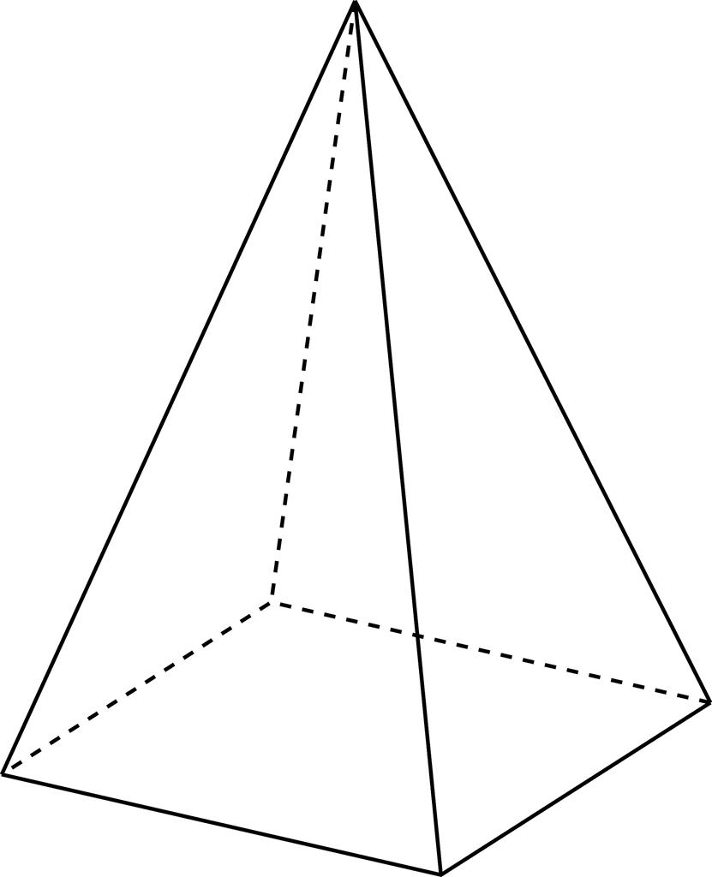

E

20 cm

16 cm

10 cm

D

C

B

A

**Worksheet 2:** Trigonometry in 3D #1 ANSWERS

1. Using the following cuboid, find the angles that these line segments make with the given plane.

F

G

C

B

4 cm

E

H

D

A

7 cm

**= 38.70**

5 cm

**= .30**

1. The angle that makes with the plane
2. The angle that makes with the plane

**= 0**

1. The angle that makes with the plane
2. The angle that makes with the plane

**= 0**

2. Below is a triangular prism. The cross-sectional end is a right-angled triangle.

a) Find the angle that makes with the plane

b) Find the angle that makes with the plane

1. **= 0**

D

C

1. **= 0**

F

E

3 cm

4 cm

8 cm

B

A

3. A rectangular based prism is pictured below.

a) Find the angle $ADE$

b) Find the angle that $ED$ makes with the base $ABCD$



$$\cos{ADE}= \frac{{20}^{2}+{16}^{2}-{20}^{2}}{2×20×16}$$

$$\cos{ADE}= 0.4$$

$ADE=66.4°$

E

$\cos{EDB}=$**0.4716…**

$$EDB=61.9°$$

$$\cos{EDB}= \frac{{20}^{2}+{\sqrt{356}}^{2}-{20}^{2}}{2×20×\sqrt{356}}$$

20 cm

16 cm

10 cm

D

C

B

A

**Worksheet 3:** Trigonometry in 3D #2

1. Using the following cuboid:

F

G

C

B

14 cm

E

H

D

A

50 cm

42 cm

1. Calculate the length
2. Calculate the angle that the diagonal makes with the plane

2. Using the following tetrahedron:

B

560

22 cm

C

22 cm

24 cm

A

20 cm

D

1. Calculate the length of
2. Calculate angle

3. Calculate the volume of following square-based pyramid:



E

16 cm

B

C

A

10 cm

D

10 cm

**Worksheet 3:** Trigonometry in 3D #2 ANSWERS

1. Using the following cuboid:

F

G

C

B

14 cm

E

**=**

H

**=**

D

A

50 cm

42 cm

1. Calculate the length
2. Calculate the angle that the diagonal makes with the plane

2. Using the following tetrahedron:

B

560

22 cm

C

22 cm

**=**

24 cm

A

**=**

20 cm

**=**

D

1. Calculate the length of
2. Calculate angle

**=**

3. Calculate the volume of following square-based pyramid:



$E$

E

$Height$**= $\sqrt{{16}^{2}-{7.07}^{2}}$**

16 cm

$Height$**= $14.4$ cm**

16 cm

$Volume$**= $\frac{1}{3}×\left(10×10\right)×14.4$**

$D$

14.1 cm

$B$

B

$Volume$**= $480 {cm}^{3}$**

C

A

10 cm

D

10 cm

Cambridge Assessment International Education  
The Triangle Building, Shaftsbury Road, Cambridge, CB2 8EA, United Kingdom  
t: +44 1223 553554

e: [info@cambridgeinternational.org](mailto:info@cambridgeinternational.org)[www.cambridgeinternational.org](http://www.cambridgeinternational.org)

© Cambridge University Press & Assessment 2023