

Teaching Pack

Sketching Curves

Cambridge IGCSE™

Mathematics 0580



® IGCSE is a registered trademark

© Cambridge University Press & Assessment 2024

Cambridge Assessment International Education is part of Cambridge University Press & Assessment. Cambridge University Press & Assessment is a department of the University of Cambridge.

Cambridge University Press & Assessment retains the copyright on all its publications. Registered centres are permitted to copy material from this booklet for their own internal use. However, we cannot give permission to centres to photocopy any material that is acknowledged to a third party even for internal use within a centre.

.

Contents

Introduction 5

Syllabus links 6

Lesson plan 1 – Sketching linear graphs 7

Lesson plan 2 – Sketching quadratic graphs 8

Lesson plan 3 – Sketching cubic graphs 9

Lesson plan 4 – Sketching reciprocal and exponential graphs 10

Teacher’s notes 11

Lesson resources 12

Worksheet 1: Sketching linear graphs 13

Worksheet 1: Sketching linear graphs answers 14

Worksheet 2: Sketching quadratic graphs 16

Worksheet 2: Sketching quadratic graphs answers 17

Worksheet 3: Sketching cubic graphs 18

Worksheet 3: Sketching cubic graphs answers 19

Worksheet 4: Sketching reciprocal and exponential graphs 20

Worksheet 4: Sketching reciprocal and exponential graphs answers 21

|  |  |
| --- | --- |
| **Icons used in this pack:** | |
| **C:\Users\elliss\AppData\Local\Microsoft\Windows\Temporary Internet Files\Content.Outlook\RZWGLKTN\Teacher icon.jpg** | **Lesson plan** |
| **C:\Users\elliss\AppData\Local\Microsoft\Windows\Temporary Internet Files\Content.Outlook\RZWGLKTN\Information icon.jpg** | **Teacher’s notes** |
| **C:\Users\elliss\AppData\Local\Microsoft\Windows\Temporary Internet Files\Content.Outlook\RZWGLKTN\Resources icon.jpg** | **Lesson resources** |

Introduction

This *Teaching Pack* focuses on supporting learners to develop a confidence and fluency with sketching an array of different functions including linear graphs, quadratics, cubics, exponentials and reciprocal graphs. Learners will develop a feel for the shape of each graph, as well as any roots or intercepts they might have.

The lesson presented here is designed for learners that are already familiar with the different types of graphs contained in this topic, and can now apply their knowledge of roots, intercepts and turning points to produce sketches of each of the graphs.

It is expected that learners should already understand a range of algebraic techniques. Being able to factorise and solve quadratics is a vital skill that your students must be able to do confidently. There is also a need to rearrange equations and substitute into equations accurately.

It would be useful if students were confident in completing the square for quadratics, as this will be required to find the turning points of quadratic graphs.

**Important note**

Our *Teaching Packs* have been written by **classroom teachers** to help you deliver topics and skills that can be challenging. Use these materials to supplement your teaching and engage your learners. You can also use them to help you create lesson plans for other skills.

***This content is designed to give you and your learners the chance to explore mathematical skills. It is not intended as specific practice for exam papers.***

This is one of a range of Teaching Packs. Each pack is based on one mathematical topic with a focus on specific mathematical techniques. The packs can be used in any order to suit your teaching sequence.

In this pack you will find the lesson plans and worksheets you will need to successfully complete the teaching of this topic.

Syllabus links

This *Teaching Pack* links to the following syllabus content (see syllabus for detail).

E2.11 Recognise, sketch and interpret graphs of the following functions:

(a) linear

(b) quadratic

(c) cubic

(d) reciprocal

(e) exponential.

The pack covers mathematical skills, adapted from **AO1: Demonstrate knowledge and understanding of mathematical techniques** and **AO2: Reason, interpret and communicate mathematically when solving problems**.

****Lesson plan 1 – Sketching linear graphs

|  |  |
| --- | --- |
| **Resources** | * Lesson 1 PowerPoint presentation * Worksheet 1 * Squared/graph paper |
|  |  |
| **Learning objectives** | By the end of the lesson:   * **all learners** will be able to recognise if an equation will give us a linear graph. * **most learners** will be able to sketch some linear graphs using the root and intercept method. * **some learners** will be able to sketch *any* linear graph using either of the two methods. |

| **Timings** | |  | **Activity** |
| --- | --- | --- | --- |
| 5 minutes | **Starter / Introduction**  There are four linear equations on this slide. Learners rearrange each one so that is the subject, and provide the answers for them to check their work. Ensure any misconceptions are addressed before starting the lesson, as this is an important skill used later in the lesson. | | |
| 5–8 minutes  5 minutes  2–3 minutes  5 minutes  5 minutes | **Main lesson**  **Slides 3–4** The first slide gives learners a feel for how you can tell a particular equation with generate a linear graph. There are a general set of rules for the learners to read and understand before they attempt the quiz on slide 4. Bring up each equation one at a time and learners decide whether the graph will be linear or not.  **Slides 5–6** Use this slide to demonstrate the method of sketching linear graphs by finding the root and the intercept. For both examples learners are shown the easiest method of finding the root and intercept, and then how to plot them on a graph.  **Slide 7** Learners complete the next example by using the method demonstrated previously. Once finished, present the answer on the screen so they can check their work.  **Slide 8–11** Introduce the gradient and intercept method for sketching graphs. In the next three slides go through three examples of how to carry out the technique. Emphasise that the equation must be in the form Explain each example as the PowerPoint demonstrates how to sketch each one.  **Slide 12** There are now three examples for learners to work through. As you circulate the room, check that learners are interpreting the gradient correctly. Once they have finished the task display the answers on the board to enable to learners to mark their own work.  **Work on Worksheet 1.** | | |

****Lesson plan 2 – Sketching quadratic graphs

|  |  |
| --- | --- |
| **Resources** | * Lesson 2 PowerPoint presentation * Worksheet 2 * Squared/graph paper |
|  |  |
| **Learning objectives** | By the end of the lesson:   * **all learners** will be able to sketch a simple quadratic that is already factorised. * **most learners** will be able to solve any quadratic in order to find the roots, and subsequently sketch the quadratic. * **some learners** will be able to sketch *any* quadratic and label the turning point using completing the square. |

| **Timings** | |  | **Activity** |
| --- | --- | --- | --- |
| 5–10 minutes | **Starter / Introduction**  **Slide 2** This activity practices the two main skills involved in the lesson, and it is vital that you establish whether learners can do this confidently. For each of the three quadratics in the middle, factorise to solve it and also complete the square. | | |
| 5–10 minutes  (slides 3-6)  10 minutes  10 minutes | **Main lesson**  **Slide 3** This slide gives learners some notes on the basic shape of quadratic graphs along with the two versions of the graph.  **Slide 4** This slide gives learners the chance to discover how the solutions to the equation and the intercept can be used to find the key points required to make a sketch of a quadratic curve.  **Slide 5** Use this second example to embed the key previous ideas. You could get learners to sketch the curve before you display it on the PowerPoint.  **Slide 6** Using the previous example, explain how completing the square can be used to find the coordinate of the minimum point of a function.  **Slide 7** There are two quadratics for learners to work through. As these questions take a little longer than most, it might be an idea to tackle them one at a time. Ensure that the students are sketching their curves properly, and that they are not jagged or not going through the points marked on the axes accurately enough.  **Slide 8** Two final questions for the students to work through. As you circulate, focus on making sure the students have the finer points correct.  **Work on Worksheet 2.** | | |

****Lesson plan 3 – Sketching cubic graphs

|  |  |
| --- | --- |
| **Resources** | * Lesson 3 PowerPoint presentation * Worksheet 3 * Squared/graph paper |
|  |  |
| **Learning objectives** | By the end of the lesson:   * **all learners** will be able to sketch a cubic graph if given the roots and intercept. * **most learners** will sketch most cubic graphs with 3 distinct linear factors. * **some learners** will be able to sketch all of the different types of cubic graph, including the special cases. |

| **Timings** | |  | **Activity** |
| --- | --- | --- | --- |
| 2–3 minutes | **Starter / Introduction**  **Slide 2** Use this slide to introduce the different shapes of cubic graphs. Get the students to recognise that the negative coefficients of flip the curve upside down. | | |
| 5–10 minutes  5 minutes  5 minutes  2–3 minutes  5 minutes | **Main lesson**  **Slides 3–7** The first slide introduces the three key pieces of information required to successfully sketch a cubic graph. The description of these three pieces of information stays at the top-right of the screen whilst you work through the first example. Slide 4 demonstrates how to find the correct shape of the graph, slide 5 demonstrates how to find the roots, and slide 6 demonstrates how to find the intercept.  Slide 7 then puts all of the above information together in order to demonstrate how to sketch the final curve.  **Slides 8–11** This is the same format as the previous example, but models a different cubic equation. The main difference with this cubic is that it has a negative coefficient of and will lead to the graph being  **Slide 12** Give learners an example of a cubic to sketch for themselves. As you circulate, check that they are finding the three key pieces of information correctly. You should ensure that their sketches are drawn with one flowing curved line. Get them to re-draw the curve if it is too jagged or doesn’t accurately pass through their roots or intercept. Reveal the answer on the screen so learners can mark their own graphs.  **Slides 13–14** There are two special cases of cubic graph that learners need to be aware of. Show them the examples of both, and ensure they understand how the shape of the graphs are affected by this.  **Slide 15** Two final sketches for the students to complete using the information about special cases. The shape of these graphs is very important, so ensure that the first graph is a tangent to the x axis, and the second graph only has a root in one place.  **Work on Worksheet 3.** | | |

****Lesson plan 4 – Sketching reciprocal and exponential graphs

|  |  |
| --- | --- |
| **Resources** | * Lesson 4 PowerPoint presentation * Worksheet 4 * Squared/graph paper |
|  |  |
| **Learning objectives** | By the end of the lesson:   * **all learners** will know how to sketch the basic 1/x graph and an exponential growth graph * **most learners** will be able to sketch a graph of the form a/x and an exponential decay graph * **some learners** will be able to sketch *any* reciprocal or exponential |

| **Timings** | |  | **Activity** |
| --- | --- | --- | --- |
| 2–3 minutes | **Starter / Introduction**  **Slide 2** Give a quick introduction to the idea of an exponential function, where we substitute values into the power of a function rather than the base value (like in quadratics and cubics). | | |
| 5 minutes  5 minutes  5 minutes  5 minutes  5 minutes  5 minutes | **Main lesson**  **Slide 3** Show learners the two different shapes of exponential graphs.  **Slides 4–5** This slide introduces the idea of an asymptote, which is present for the negative inputs of an exponential growth graph. Explain that the curve will get continually closer to the axis but will never reach it. Learners should be aware that you should be able to give the equation of an asymptote. Slide 5 gives two examples of exponential graphs to help learners become more familiar with their shape.  **Slide 6** There are two exponentials for learners to have a go at sketching. When going through the answers, the key things to focus on are the shape of the graph being correct, it passing through the point and that it approaches the axis but never touches it.  **Slides 7–8** This slide introduces reciprocal graphs. Learners think about the answers to the two questions. Once you go through the answer you can then bring up the graph. The next slide highlights the key features of the graph. Emphasise the importance of the asymptotes.  **Slides 9-10** There are two transformations of the reciprocal graph that learners need to know. The first is when you have a different number in the numerator. Show learners the example of on this slide, and explain that it holds the same shape. Slide 10 shows the effect of adding a constant to the reciprocal. It translates the graph vertically by the value being added on. The easiest way to sketch this is to draw the asymptotes first, then sketch the curves afterwards.  **Slide 11** Learners sketch three graphs. Display the answers afterwards so they can check their answers, and make corrections if required.  **Work on Worksheet 4.** | | |

Teacher’s notes

Key words / concepts you could highlight during the lesson, or have pre-taught before the lesson:

Students need a basic understanding of plotting coordinates on a graph.

**Key words**

* Sketch
* Linear
* Quadratic
* Cubic
* Exponential
* Reciprocal
* Roots
* intercept
* Asymptote

Each of the lessons, combined with the respective worksheet, will provide around an hour of lesson time. This could take longer if your students are slower at sketching their graphs.

****Lesson resources

|  |
| --- |
| **Worksheet 1:** Sketching linear graphs  **Worksheet 1:** Sketching linear graphs answers |
| **Worksheet 2:** Sketching quadratic graphs  **Worksheet 2:** Sketching quadratic graphs answers |
| **Worksheet 3:** Sketching cubic graphs  **Worksheet 3:** Sketching cubic graphs answers |
| **Worksheet 4:** Sketching reciprocal and exponential graphs  **Worksheet 4:** Sketching reciprocal and exponential answers |

**Worksheet 1:** Sketching linear graphs

**1.** Which of the following equations would produce a linear graph?

**(a)** **(b)** **(c)** **(d)** **(e)** **(f)**

**2.** Sketch the following graphs using the gradient/intercept method.

**(a)** **(b)**

**(c)**   **(d)**

**(e)**  **(f)**

**3.** Sketch the following graphs by using the root and y intercept method.

**(a)** **(b)**

**(c)** **(d)**

**4.** A straight line has a gradient of 2, and passes through the point .

**(a)** Plot the coordinate on a graph.

**(b)** Using this point, and by correctly interpreting the gradient, sketch the line.

**(c)** What is the equation of the line you have sketched?

**Worksheet 1:** Sketching linear graphs answers

**1.** Which of the following equations would produce a linear graph?

**(a)** Yes **(b)** Yes **(c)** No **(d)** Yes  **(e)** No  **(f)** No

**2.**

**(a)** **(b)**

**(c)**  **(d)**

**(e)** **(f)**

**3.**

**(a)** **(b)**

**(c)** **(d)**

**4.**

**(a)**

**(b)**

**(c)**

**Worksheet 2:** Sketching quadratic graphs

**1.** Match the graphs with the correct equation. Explain your reasoning for each one.

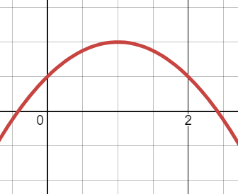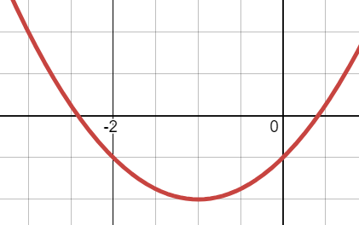

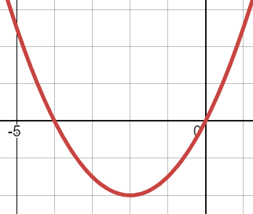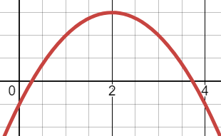

**2.**

**(a)** Find the roots of the equation

**(b)** Use completing the square to find the minimum point of the equation.

**(c)** Using your answers to parts **a** and **b**, sketch the graph of

**3.** Sketch the graphs of the following quadratic functions. Include all roots, intercepts and turning points.

**(a)**

**(b)**

**(c)**

**(d)**

**(e)**

**(f)**  Hint: Write it as first.

**Worksheet 2:** Sketching quadratic graphs answers

**1.**

**2.**

**(a)**

**(b)**

**(c)**

***3** Sketch the graphs of the following quadratic functions. Include all roots, intercepts and turning points.

**(a)** (**b) (c)**

**** (d) (e)**

**(f)**

**Worksheet 3:** Sketching cubic graphs

**1** Sketch the following cubic graphs:

**(a)**

**(b)**

**(c)**

**2**

**(a)** Factorise fully the equation .

**(b)** Use your answer to solve find the values of for which .

**(c)** Sketch the graph of

**3** Sketch the graphs of the following cubic functions. Include all roots and the intercept.

**(a)**

**(b)**

**(c)**

**(d)**

**(e)**

**(f)**  Hint: factorise the cubic fully first

**Worksheet 3:** Sketching cubic graphs answers

**1.**

**(a) (b) (c)**

**2.**

**(a)**

**(b)** (repeated)

**(c)**

**3.**

**(a)** **(b)**

**(c) (d)**

**(e) (f)**

**Worksheet 4:** Sketching reciprocal and exponential graphs

**1.** Sketch the following reciprocal graphs on the same set of axes:

**(a)**

**(b)**

**(c)**

**2.** Sketch the following exponential graphs on the same set of axes:

**(a)**

**(b)**

**(c)**

**3.** Describe 2 features that all exponential graphs share.

**4.** Sketch the following reciprocal graphs. For each one, write the equation of the asymptote.

**(a)**

**(b)**

**(c)**

**5.** Extension - use graphing software. Plot the graphs of and

Can you show algebraically why they are the same?

**Worksheet 4:** Sketching reciprocal and exponential graphs answers

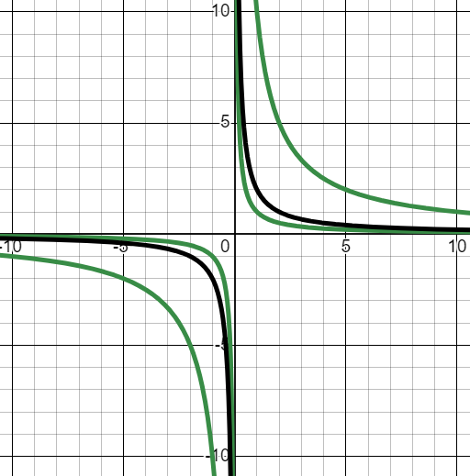**1.**

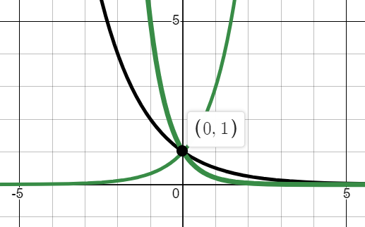

**2.**

**3.** Passes through (0,1), axis is the asymptote.

**4.**

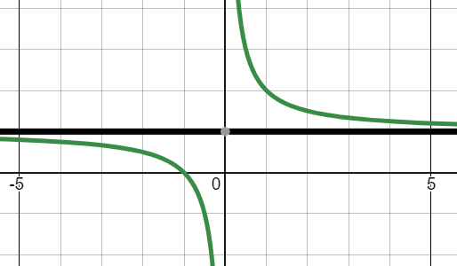**(a)**

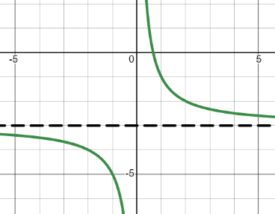

**(b)**

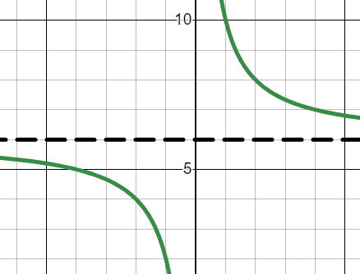**(c)**

**5.**

Cambridge Assessment International Education  
The Triangle Building, Shaftsbury Road, Cambridge, CB2 8EA, United Kingdom  
t: +44 1223 553554

e: [info@cambridgeinternational.org](mailto:info@cambridgeinternational.org)[www.cambridgeinternational.org](http://www.cambridgeinternational.org)

© Cambridge University Press & Assessment 2024