

Teaching Pack

Unseen Poetry – Personal response

Cambridge IGCSE™

Literature in English 0475



In order to help us develop the highest quality resources, we are undertaking a continuous programme of review; not only to measure the success of our resources but also to highlight areas for improvement and to identify new development needs.

We invite you to complete our survey by visiting the website below. Your comments on the quality and relevance of our resources are very important to us.

[www.surveymonkey.co.uk/r/GL6ZNJB](https://www.surveymonkey.co.uk/r/GL6ZNJB)

Would you like to become a Cambridge consultant and help us develop support materials?

Please follow the link below to register your interest.

[www.cambridgeinternational.org/cambridge-for/teachers/teacherconsultants/](http://www.cambridgeinternational.org/cambridge-for/teachers/teacherconsultants/)

Copyright © UCLES 2018

Cambridge Assessment International Education is part of the Cambridge Assessment Group. Cambridge Assessment is the brand name of the University of Cambridge Local Examinations Syndicate (UCLES), which itself is a department of the University of Cambridge.

UCLES retains the copyright on all its publications. Registered Centres are permitted to copy material from this booklet for their own internal use. However, we cannot give permission to Centres to photocopy any material that is acknowledged to a third party, even for internal use within a Centre.

Contents

[Introduction 4](#_Toc509500062)

[Lesson plan – Personal response (Unseen Poetry) 5](#_Toc509500063)

[Teacher notes 9](#_Toc509500064)

[Lesson resources 10](#_Toc509500065)

[Worksheet 1: Personal responses to education 11](#_Toc509500066)

[Worksheet 2: Model analysis 12](#_Toc509500067)

[Worksheet 3: Self-/peer-assessment sheet 13](#_Toc509500068)

|  |  |
| --- | --- |
| **Icons used in this pack:** | |
| \\filestorage\CIE\Development\Curriculum_Services\Templates\2017 Templates\11. Icons\Skills Packs\1. Briefing lesson.png | **Lesson plan** |
| **C:\Users\elliss\AppData\Local\Microsoft\Windows\Temporary Internet Files\Content.Outlook\RZWGLKTN\Information icon.png** | **Teacher notes** |
| **C:\Users\elliss\AppData\Local\Microsoft\Windows\Temporary Internet Files\Content.Outlook\RZWGLKTN\Resources icon.png** | **Lesson resources** |

Introduction

This *Teaching* *Pack* focuses on supporting learners in communicating a considered personal response (directly and by implication). We have chosen to demonstrate this by using ‘The Lesson’ by Roger McGough, but this lesson plan could be adapted to use any other similar poem which is quite contentious. The lesson is designed for learners that already understand common poetic techniques such as:

* rhyme
* powerful lexis
* alliteration
* symbolism
* metaphor.

It is expected that learners should already know how to approach an unseen poem. The mnemonic **CATS** is useful as a basic aid to getting learners started in this manner:

* **C**ontent
* **A**ttitudes
* **T**echniques: rhyme, powerful lexis, alliteration, symbolism, metaphor etc.
* **S**tructure.

It would be useful if the learners know what the literary canon is. This can be set as homework in advance of this lesson.

In this *Teaching Pack* we have suggested resources and online links you may like to use as well as some worksheets to print off and use in the classroom with your learners.

A PowerPoint presentation ‘Unseen Poetry: Communicate a considered personal response (directly and by implication)’ is also provided for you to use alongside this pack (**PowerPoint slides 1−7**).

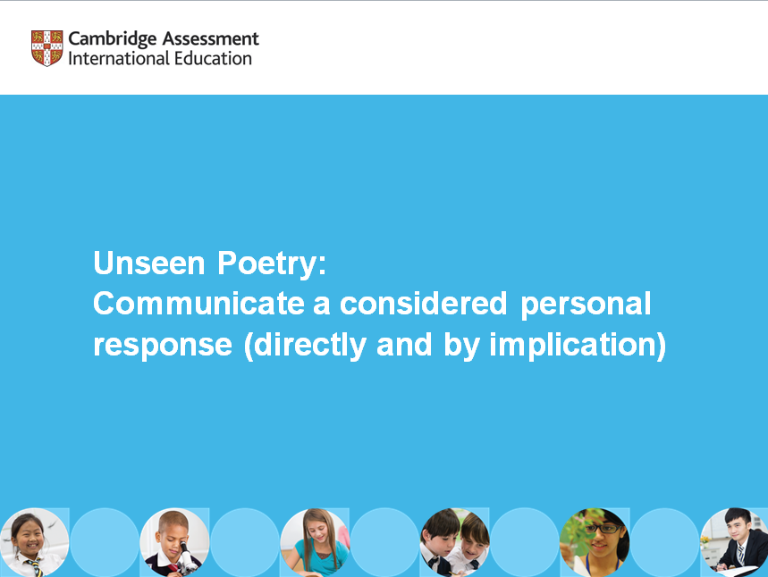

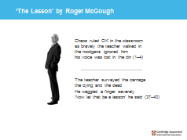

Lesson plan – Personal response (Unseen Poetry)

|  |  |
| --- | --- |
| **Resources** | * Copy of a poem the learners have (preferably) not seen before, for example, ‘The Lesson’ by Roger McGough: [www.poemhunter.com/best-poems/roger-mcgough/the-lesson](https://www.poemhunter.com/best-poems/roger-mcgough/the-lesson) * **Worksheet 1:** Personal responses to education (displayed around the classroom for discussion) * **Worksheet 2:** Review sheet * **Worksheet 3:** Model analysis * **PowerPoint slides** (1−7) * **Teacher notes** * Access to ‘Expanding the literary canon’ on Youtube at [www.youtube.com/watch?v=UHgzEDFRXJY&t=5s](https://www.youtube.com/watch?v=UHgzEDFRXJY&t=5s) * Highlighters and pens to annotate the poem |
|  |  |
| **Learning objectives** | By the end of the lesson:   * ***all*** learners should be able to: Offer up a personal response to the poem * ***most*** learners will be able to: Offer up a considered personal response contextualising the poem against a basic definition of the literary canon * ***some*** learners will be able to: Offer up an implied considered personal response by using evaluative words and phrases. |

| **Timings** | **Activity** |
| --- | --- |
| Y:\Development\Curriculum_Services\Projects\Resource Plus\Resource Plus_Wave 2\IGCSE_Literature_0486\2_Templates&Icons\LP_time_images\10_0.png | **Starter/Introduction**  Show learners an image of your chosen poet. Choose one where the poet is looking quite serious. **PowerPoint slide 1** features an image of Roger McGough, who wrote the poem, ‘The Lesson’.  Ask what type of poetry you would expect from this poet. Allow learners to freely answer this question with their own opinions. It is good if they are biased with their expectations (serious, stern, old fashioned, etc.) as the poem chosen should surprise them in its content.  Hand out or display the quotations from **Worksheet 1** (or **PowerPoint slide 2**), and allow learners to discuss their own opinions about education.  Introduce the name of the poem, e.g. ‘The Lesson’.  Ask them to predict what perspectives on education they might expect the poet to refer to. |
| Y:\Development\Curriculum_Services\Projects\Resource Plus\Resource Plus_Wave 2\IGCSE_Literature_0486\2_Templates&Icons\LP_time_images\10_10_0.png  Y:\Development\Curriculum_Services\Projects\Resource Plus\Resource Plus_Wave 2\IGCSE_Literature_0486\2_Templates&Icons\LP_time_images\20_5_0.png | **Main lesson**  Hand out copies of the poem and highlighter pens. Read the poem out loud to the class. Ask how their initial expectations have been challenged, if at all. Are they surprised at the content? Why?  Learners complete the tasks in **PowerPoint slide 3** (Reading the poem – initial responses) in their books. Starter answers:   * **Where is the poem set?** The classroom * **What are the feelings expressed in the poem?** Anger, hurt, fear, bravado, pain, etc. * **How does this poem compare to others you have studied?**   Unusual content and perspective, challenging the nature of learning and education.   * **Write down two questions in relation to this poem.**   - Why does the teacher go in?  - Why does the Head react in this manner?   * **Pass these on to someone in the room to answer.** * **Share the most interesting questions and responses from other learners.**   Explain that these initial thoughts are a personal response and that the rest of the lesson will be spent looking at developing and informing these responses considering the idea of the literary canon and using evaluative phrases to imply a response.  **Task**  Define the idea and purpose of the literary canon.  The term ‘literary canon’ refers to a body of books, narratives and other texts considered to be the most important and influential of a particular time period or place.  A suggested video link to help think about the purpose: [www.youtube.com/watch?v=UHgzEDFRXJY&t=5s](https://www.youtube.com/watch?v=UHgzEDFRXJY&t=5s)  Read each statement on **PowerPoint slide 4** in turn:   * ‘I felt, with my first poem, that I had entered this brotherhood [the poetry canon]. Which turned out not to be the case.’   Ask learners why McGough did not enter into the literary canon with his poem, ‘The Lesson’.  Read the answer:   * ‘The implication was that if we were Liverpool poets we couldn't be serious.’   Learners discuss whether ‘The Lesson’ is a serious poem.  Learners discuss:   * Should ‘The Lesson’ be part of the literary canon?   Give the learners a few minutes to add to their discussions to their initial responses from the starter. Learners can use the following sentence starter to help them add to their notes:  ‘The Lesson’ should be /should not be added to the literary canon because…  **Optional additional task:**  Learners read the comment taken from a member of the public from the Poem Hunter website on **PowerPoint slide 5**.   * What is their reaction to this? * Do they agree or disagree with the idea that this is a genius poem? |
| Y:\Development\Curriculum_Services\Projects\Resource Plus\Resource Plus_Wave 2\IGCSE_Literature_0486\2_Templates&Icons\LP_time_images\25_10_0.png  Y:\Development\Curriculum_Services\Projects\Resource Plus\Resource Plus_Wave 2\IGCSE_Literature_0486\2_Templates&Icons\LP_time_images\35_10_0.png | **Analysis**  Divide up the poem amongst the learners. 10 pairs of learners will cover the 10 stanzas. Ask the learners to focus on identifying **CATS** and their effects:   * **C**ontent * **A**ttitudes * **T**echniques: rhyme, powerful lexis, alliteration, symbolism, metaphor, etc. * **S**tructure.   Reinforce that, as long as they can justify opinions, all reasonable answers are acceptable in Unseen exams.  Share their ideas.  **Application**  Set the essay question:  **Based on your thoughts on *education*, the *canon* and your consideration of the *content* of the poem, what is your reaction to McGough’s ‘The Lesson’?**  Read the model analysis on **Worksheet 2** (or **PowerPoint slide 6**).  Explain the structure of this considered personal response to the poem. Highlight the evaluative phrases that imply a considered response (‘indeed’, ‘notably’, ‘particularly’, etc.).  Learners create their own considered, personal response to the poem. |
| Y:\Development\Curriculum_Services\Projects\Resource Plus\Resource Plus_Wave 2\IGCSE_Literature_0486\2_Templates&Icons\LP_time_images\45_5_0.png | **Plenary**  Using **Worksheet 3** (**PowerPoint slide 7**) learners should read each other’s work and offer up opinions as to how they can improve their considered responses to unseen poetry.  **Homework**  Learners research the idea of the literary canon and create a poster. This will help to contextualise any further analysis of unseen poetry for learners. |

****Teacher notes

**What type of poetry would you expect from this poet?**

Allow learners to freely answer this question with their own opinions. It is good if they are biased with their expectations (serious, stern, old fashioned, etc.) as the poem chosen should surprise them in its content.

Once the poem has been read to the class, then hopefully this should have challenged their initial expectations about the content and style of poetry.

Starting points for the answers to the questions on **PowerPoint slide 3**:

|  |  |
| --- | --- |
| **Where is it set?** | The classroom |
| **What are the feelings expressed?** | Anger, hurt, fear, bravado, pain, etc. |
| **How does this poem compare to others you have studied?** | Unusual content and perspective, challenging the nature of learning and education. |
| **Write down two questions in relation to this poem.** | Why does the teacher go in?  Why does the Head react in this manner? |

Explain that these initial thoughts are a personal response and that the rest of the lesson will be spent looking at developing and informing these responses considering the idea of the literary canon and using evaluative phrases to imply a response.

The term ‘literary canon’ refers to a body of books, narratives and other texts considered to be the most important and influential of a particular time period or place. A suggested video link to help think about the purpose: [www.youtube.com/watch?v=UHgzEDFRXJY&t=5s](https://www.youtube.com/watch?v=UHgzEDFRXJY&t=5s)

Give learners a few minutes to add to their discussions to their initial responses from the starter. Learners can use the following sentence starter to help them add to their notes:

‘The Lesson’ should be / should not be added to the literary canon because…

Optional additional task:

Learners read the comment taken from a member of the public from the Poem Hunter website on **PowerPoint slide 6**.

What is their reaction to this?

Do they agree or disagree with the idea that this is a genius poem?

Reinforce that, as long as they can justify opinions, all reasonable answers are acceptable in Unseen exams. Highlight the evaluative phrases that imply a considered response (indeed, notably, particularly, etc.) on **Worksheet 2:** Model analysis.

****Lesson resources

|  |
| --- |
| **Worksheet 1:** Personal responses to education |
| **Worksheet 2:** Model analysis |
| **Worksheet 3:** Self-/peer-assessment sheet |

Worksheet 1: Personal responses to education

Here are some personal responses to the concept of ‘education’:

I’ve never let my school interfere with my education.

**Mark Twain**

Education is what remains after one has forgotten what one has learned in school.   
**Albert Einstein**

My mother said I must always be intolerant of ignorance but understanding of illiteracy. That some people, unable to go to school, were more educated and more intelligent than college professors.   
**Maya Angelou**

We are taught you must blame your father, your sisters, your brothers, the school, the teachers – but never blame yourself. It's never your fault. But it's always your fault, because if you wanted to change you're the one who has got to change.   
**Katharine Hepburn**

Worksheet 2: Model analysis

A true education should aim to shock and inspire action and reading texts that broaden a reader’s capacity to humanise teachers is an often-used plotline.

However, McGough’s poem does not cover this topic safely. **Indeed,** it captures a bloody and visceral sense of a teacher’s frustration by describing the dark levels of violence he stoops to; this is bound to be controversial and divisive at a time when political violence is rife.

By positioning the reader in such a way as to make them feel very unsafe themselves, through his teacher’s unrestrained and bloodthirsty violent actions, McGough is deeply effective in his engaging and accessible style.

**Notably,** the clever way in which the alliterative rhythm, with the repetition of the ‘H’ consonant, mirrors the action and sound of his ‘sword’ as the teacher moves between the rhyming ‘rows’ to rhythmically cut off 'fingers, feet or toes’ to teach the ‘undisciplined students’ a lesson is **particularly** effective.

**My thoughts on education**

**My initial response to the poem – overview**

**Why I think this**

**What techniques make me think this**

Worksheet 3: Self-/peer-assessment sheet

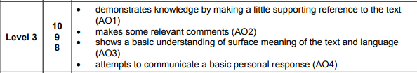

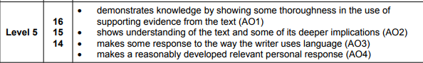

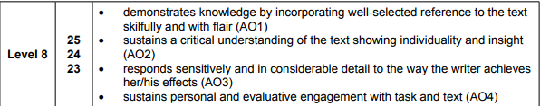

**What went well:**





**What could be improved:**





Cambridge Assessment International Education  
The Triangle Building, Shaftesbury Road, Cambridge, CB2 8EA, United Kingdom  
t: +44 1223 553554      
e: [info@cambridgeinternational.org](mailto:info@cambridgeinternational.org)    [www.cambridgeinternational.org](http://www.cambridgeinternational.org)

Copyright © UCLES March 2018