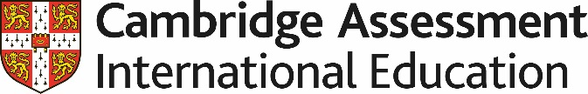

Teaching pack

Geometry – Circle theorems

Cambridge IGCSETM

Mathematics 0580

This *Teaching Pack* can also be used with the following syllabuses:

• Cambridge IGCSE™ (9–1) Mathematics **0980**

• Cambridge IGCSE™ International Mathematics **0607**

• Cambridge O Level Mathematics **4024**



© Cambridge University Press & Assessment 2022

Cambridge Assessment International Education is part of Cambridge University Press & Assessment. Cambridge University Press & Assessment is a department of the University of Cambridge.

Cambridge University Press & Assessment retains the copyright on all its publications. Registered centres are permitted to copy material from this booklet for their own internal use. However, we cannot give permission to centres to photocopy any material that is acknowledged to a third party even for internal use within a centre.

Contents

Introduction 4

Lesson 1 Drawing and describing circles 7

Lesson 2 Angle in a semicircle 8

Lesson 3 Angle at the centre of a circle 10

Lesson 4 Angles in the same and opposite segments 11

Lesson 5 The remaining circle theorems 12

Teacher’s notes 14

Lesson resources 15

Actvitites and worksheets 16

Circle theorems problem solving grid 17

|  |  |
| --- | --- |
| **Icons used in this pack:** | |
| **C:\Users\elliss\AppData\Local\Microsoft\Windows\Temporary Internet Files\Content.Outlook\RZWGLKTN\Teacher icon.jpg** | **Lesson plan** |
| **C:\Users\elliss\AppData\Local\Microsoft\Windows\Temporary Internet Files\Content.Outlook\RZWGLKTN\Information icon.jpg** | **Teacher’s notes** |
| **C:\Users\elliss\AppData\Local\Microsoft\Windows\Temporary Internet Files\Content.Outlook\RZWGLKTN\Resources icon.jpg** | **Lesson resources** |

Introduction

This pack focuses on securing learners’ knowledge and application of the circle theorems. It also shows the structure and presentation of a mathematical proof. Learners do not need to know the circle theorem proofs and only need to use these properties to calculate the unknown angles. Depending on the group you are working with lesson 1 may not take the time suggested and you can move straight on to the first circle theorem lesson 2.For core students you may want to omit the extended work on proofs and miss out lessons 3 – 5.

The lessons presented here are designed for learners that are already confident and fluent with the angle facts they have learnt, such as angles on a straight line and angle facts related to parallel lines. It is expected that learners should already know the different types, features and angle facts associated with triangles.

It would be useful if they had experience of justifying and explaining answers to simple problem-solving mathematical questions.

**Important note**

Our *Teaching Packs* have been written by **classroom teachers** to help you deliver topics and skills that can be challenging. Use these materials to supplement your teaching and engage your learners. You can also use them to help you create lesson plans for other skills.

***This content is designed to give you and your learners the chance to explore mathematical skills. It is not intended as specific practice for exam papers.***

This is one of a range of *Teaching Packs*. Each pack is based on one mathematical topic with a focus on specific mathematical techniques. The packs can be used in any order to suit your teaching sequence.

In this pack you will find the lesson plans and worksheets you will need to successfully complete the teaching of this mathematical skill.

Circle angle properties (Circle theorems)

This *Teaching Pack* links to the following syllabus content (see syllabus for detail):

* C4.7 Calculate unknown angels using the following geometrical properties:

- angle in a semicircle

- angle between tangent and radius of a circle.

* E4.7 Calculate unknown angels using the following geometrical properties:

- angle at the centre of a circle is twice the angle at the circumference

- angles in the same segment are equal

- angles in opposite segments are supplementary; cyclic quadrilaterals

- alternate segment theorem.

|  |
| --- |
| For assessments from 2025 |
| * C/E4.7 Calculate unknown angles and give explanations using the following geometrical properties of circles:  ● angle in a semi circle = 90°  ● angle between tangent and radius = 90° * E4.7 ● angle at the centre is twice the angle at the circumference  ● angles in the same segment are equal  ● opposite angles of a cyclic quadrilateral sum to 180° (supplementary)  ● alternate segment theorem. * E4.8 ●tangents from an external point are equal in length. |

Prior knowledge

Knowledge from the following syllabus topics is useful for development of skills in this topic.

* C4.7 Calculate unknown angels using the following geometrical properties:

- angles at a point

- angles at a point on a straight line and intersecting straight lines

- angles formed within parallel lines

- angle properties of triangles and quadrilaterals

- angle properties of regular polygons.

* E4.7 Calculate unknown angles using the following geometrical properties:

- angle properties of irregular polygons.

|  |
| --- |
| For assessments from 2025 |
| * C/E4.6 Calculate unknown angles and give simple explanations using the following geometrical properties:  ● sum of angles at a point = 360°  ● sum of angles at a point on a straight line = 180°  ● vertically opposite angles are equal  ● angle sum of a triangle = 180° and angle sum of a quadrilateral = 360°  Calculate unknown angles and give geometric explanations for angles formed within parallel lines:  ● corresponding angles are equal  ● alternate angles are equal  ● co-interior (supplementary) angles sum to 180°  Know and use angle properties of regular polygons. |

****Before you begin

This *Teaching Pack* includes an introductory video to which you should refer before   
using the resources in this pack. The video is available to watch in Resource Plus within the topic section relevant to this **Teaching Pack**.

The video introduces the resources available for teaching this topic, and explains how they can be used to successfully deliver the topic to your learners. In particular, the video highlights typical learner misconceptions and common errors this *Teaching Pack* will help you to overcome.

Lesson 1 – Drawing and describing circles

|  |  |  |
| --- | --- | --- |
| **Resources** | | * Lesson 1 presentation * Video to demonstrate how to use a compass to draw a circle. * Compass |
|  | |  |
| **Learning objectives** | | By the end of the lesson ***all*** learners should be able to:   * use and interpret vocabulary of circles * recognise order of rotational symmetry of circles * use a compass to draw a circle. |
|  | |  |
| **Timings** | | **Activity** |
|  | **Starter / Introduction**  **Slide 2** Introduces some technical language related to circles. Before starting, ask learners what they think a circle is? Build on these informal definitions to unpick the formal language used on the slide. | |
|  | **Main lesson**  **Slide 3** Introduce the concept that a circle has infinite rotational symmetry. Ask students to think about this before giving them the answer. You can use the HINT on the slide to help them.  **Slide 4 Reminder for learners – Ask them to name different parts of a circle.**  **Slide 5** Use the lesson one video which demonstrates how to use a compass to draw a circle.  Student should then be given the opportunity to draw several examples. Some students may need more practice than others. For students who need more practice here is an activity you could also use to give them this opportunity in a more engaging way. <https://nrich.maths.org/5357>  **NOTE:** Depending on the group you are working with this lesson may not take the time allocated. If so you can move straight on to the first circle theorem lesson. | |
|  | **Plenary**  Use **slide 6** to check students understanding of some of the language used so far and some of the language they will need for the next series of lessons. | |

Lesson 2 – Angle in a semicircle

|  |  |  |
| --- | --- | --- |
| **Resources** | | * Lesson 2 presentation * Mini Whiteboards * Worksheet 1 * Worksheet 2: Circle theorems Problem Solving grid * Worksheet 3 |
|  | |  |
| **Learning objectives** | | By the end of the lesson learners will:   * know the angle in a semicircle is a right-angle (Thales theorem) * be able to use Thales theorem to solve simple problems involving missing angles. |
|  | |  |
| **Timings** | | **Activity** |
|  | **Starter / Introduction**  **Slide 2** Ask learners if they can make a right-angled triangle on the peg-board diagrams by joining up three points round the edge? (Worksheet 1 part 1). This is a non-calculator lesson. | |
|  | **Main lesson**  Ask learners if they can make a statement about when they could draw the right-angled triangle and when they could not? (they can only do this when two of the points join to make a diameter of the circle). You could ask these questions to help them formalise what they have found.   * What is the relationship between the angle at the centre and the angle at the circumference? * What are the implications of your findings for circles in general (without dots)?   Tell learners that stating what you think is the implication of your findings and that is what mathematicians call making a conjecture. In mathematics, the term **"conjecture"** refers to a specific statement that is thought to be true but has not been proven**.** CompleteWorksheet 1 part 2**.**  Once everyone has completed part 2, ask learners to share their conjectures. Then work with the class to agree a combined statement of the conjecture.  **Slide 3** Introduce to learners the concept of an ‘inscribed shape’.  **Slide 4** Use this slide to summarise what their conjecture might say and therefore what they are trying to prove. Tell them that this conjecture can be described as: **“**Angle in a semicircle equals 90˚**”**.  **Slide 5** Ask learners if they can prove this conjecture? Learners should work in 2’s or 3’s. Introduce the problem-solving grid (Worksheet 2: Circle theorems Problem Solving grid) and tell learners that each small group should use a copy of the grid to help develop their own proof.  Once each small group has completed their own proof they can compare them with the exemplar proof provided. Learners who struggle can look at the exemplar proof first and ask any questions to make sure they understand it.  **Slide 6 and slide 7** Examples for learners to check whether they can recall Thales theorem to find unknown angles. | |
|  | **Plenary**  Ask learners to explain to their classmate sitting next to them what the Thales theorem is and see if they can remember how to prove it.  **Homework**  - Worksheet 3 | |

 Lesson 3 – Angle at the centre of a circle

|  |  |  |
| --- | --- | --- |
| **Resources** | | * Lesson 3 presentation * Worksheet 2: Circle theorems problem solving grid * Cut-up copies of Worksheet 4 (one copy between two students). You may want to laminate these if possible * Worksheet 5 |
|  | |  |
| **Learning objectives** | | By the end of the lesson learners will know:   * the angle at the centre is twice the angle at the circumference and will be able to apply this theorem to find unknown angles. |
| **Timings** | | **Activity** |
|  | **Starter / Introduction – What facts might you need?**  This is a non-calculator lesson.  **Slide 1 and 2** Before we build on what we did in last lesson we need to check what you already know. Ask learners to write down as many angle facts/properties they know about triangles and straight lines including parallel lines. For example, the angles in a triangle add up to 180 degrees.  This list may not be exhaustive, tell students they might have some things on their list that they think needs to be there to remind them of some key point before they start working on a proof. They may not use all these facts in the proof they are going to look at but that doesn’t matter either. | |
|  | **Slide 4** Tell learners that in the last lesson you looked at proving one of the circle theorems. In fact, there are 8 different circle theorems. This slide introduces a new theorem; angle at the centre of a circle is twice the angle at the circumference. Discuss with learners what this statement means in terms of the diagram. (Angle *COB* is twice Angle *CAB*). **(Extension only)**  **Slide 5** Cut up Worksheet 4 so each statement is on a separate card. Tell them that a hint is that there are two cards with BLUE writing on. One of these is the start of the proof the other is the finish. Learners can work in pairs. If learners struggle show them the slide and correct order and then ask them to reproduce it independently.  When looking at this slide ask learners to explain each step. Stress the importance of explaining each step based on the prior knowledge. Alternatively, you could use a visualiser and ask a learner who has completed the card sort correctly to demonstrate with explanations or you can demonstrate yourself. | |
|  | **Plenary** Explain why the circle theorem you learnt in the last lesson:  *The angle in a semi-circle is a right angle: Thales' Theorem*  is a special case of the theorem you have learnt in this lesson  *The angle at the centre is twice the angle at the circumference.*  **Slide 8 and 9** Examples for learners to check whether they can recall theorems they learnt so far to find unknown angles.  **Homework –** Worksheet 5 | |

Lesson 4 – Angles in the same and opposite segments

**NOTE: For core students you may want to skip this lesson.**

|  |  |  |
| --- | --- | --- |
| **Resources** | | * Lesson 4 presentation * Worksheet 2: Circle theorems Problem Solving grid * Worksheet 6 |
|  | |  |
| **Learning objectives** | | By the end of the lesson learner will know:   * that angles in the same segment are equal * that the opposite angles in a cyclic quadrilateral add up to 180°. |
| **Timings** | | **Activity** |
|  | **Starter / Introduction**  **Slide 2** Remind learners that the angle at the centre of a circle is twice the angle at the circumference. This is a non-calculator lesson.  Tell them that we are now going to build some more proofs based on this first proof. Remind learners how a mathematical proof is developed by either building on axioms (things we assume to be true) and/or things we have already proved to be true. | |
| 15-20    25-45 | **Main lesson**  **Slide 3** we are going to start by looking at the proof of “Angles in the same segment are equal”. Tell learners that you are going to work through this proof and demonstrate how it builds on this theorem. Tell them not to write anything down but just to listen carefully because learners are not required to reproduce the proofs. Work through the proof on **slide 4** as a class. Pause before the animation at each stage to allow the learners to think about the next step and share their thoughts before seeing the exemplar. Provide an opportunity to ask any questions that have emerged as a result.  **Slide 4 Angles in a cyclic quadrilateral**- The opposite angles in a cyclic quadrilateral sum to 180°. Tell learners that this time you are going to give them the opportunity to derive the proof themselves first. Learners could use copies of the problem-solving grids again to help them with this proof. IF necessary, as a HINT you can click on the diagram of a cyclic quadrilateral on the slide and discuss what the first circle theorem tells them about the blue angles in the new diagram that appears. You could split the class into small groups to work on this proof. Provide support and guidance and identify any groups who have a particularly good response, you can ask them to present their proof to the rest of the class. An exemplar solution is provided on **slide 6.** Once you have worked through this solution with the class learners can make any amendments/additions they want to make to their own solutions. Make sure learners understand the need to explain what they are doing/using at each step of the proof. | |
|  | **Plenary**  Ask learners to find unknown angles on slides 7 – 9, using circle theorems they have learnt so far.  **Homework** – Worksheet 6 | |

Lesson 5 – The remaining circle theorems

**NOTE: For core learners you may want to skip this lesson.**

|  |  |
| --- | --- |
| **Resources** | * Lesson 5 presentation * Worksheet 2: Circle theorems Problem Solving grid * Worksheet 7 – You will need to cut up copies of these (approximately one copy of each card sort between four students). You may want to laminate these although students will need to write on them as well so they will need suitable pens for this. * Worksheet 8 |
|  |  |
| **Learning objectives** | By the end of the lesson learners will know:   * that tangents which meet at the same point are equal in length * that the angle between the tangent and the cord at the point of contact is equal to the angle in the alternate segment. |

| **Timings** | | **Activity** |
| --- | --- | --- |
|  | **Starter / Introduction**  **Slide 2** The starter is an activity to remind students about congruency as they will use this in the proofs in this lesson. Animate the slide to show an answer. This is a non-calculator lesson  **Slide 3 and slide 4** go through slides and work with learners to remind learners the criteria for two triangles to be congruent. This will not be examined from 2025, but recognising congruency is still expected for this sort of problem. | |
|  | **Main lesson**  **Slide 5**  Tangents which meet at the same point are equal in length. Remind students of how we build a mathematical proof by building on axioms (things we assume to be true) and/or things we have already proved to be true. Tell them that to prove circle theorem on slide 5 we are going to assume “The angle between a tangent and a radius is 90°” is true. (If you are working with more able students and want to show a proof of this theorem, you can use this link <https://www.khanacademy.org/math/geometry/hs-geo-circles/hs-geo-tangents/v/proving-radius-is-perpendicular-to-tangent-line>)  Tell learners that the first step to any geometrical proof set out in words is to draw a picture. Working in pairs gives learners a couple of minutes to draw a picture which will illustrate what theorem on slide 5 says. Then animate the slide and learners can compare their picture to the one of the slide and amend their pictures if necessary. Take any questions at this stage. Tell learners it can be useful to extract a further diagram that focuses on the elements you are trying to prove.  Now let learners work in pairs to produce a proof for this theorem. Remind them they are going to assume “The angle between a tangent and a radius is 90°” and that what they did in the starter will be useful to them. Tell them they must explain and justify what they are doing at each stage and build subsequent proofs on things they have assumed or identified as true or things you have already proved to be true. Remind them that they can use anything they need from their geometrical toolbox!  Alternatively, if you think the group you are working with would find producing a proof independently too challenging you could go straight to the proof provided on **Slide 6** and work through this as a class instead, pausing to ask questions before you animate each step. Students could then reproduce the proof independently.  **Slide 7 and slide 8** - Alternate segment theorem. The angle (α) between the tangent and the chord at the point of contact (D) is equal to the angle (β) in the alternate segment. Tell learners that this is probably the most difficult theorem to visualise. Animate the slide and work through exactly what this theorem means explaining any terminology.  Students now work in small groups on Worksheet 7 which has a card sort that complete the proof of circle theorem 8. Learners could work in groups of four. Each pair works on one of the card sorts. This time the proof is not complete and learners will need to fill in. | |
|  | **Plenary**  Learners are given the solution to the card sort completed by the other pair. They then look at the proof completed by the other pair and provide constructive feedback on it. Learners then returned to their own card sort to reflect on the feedback provided.  **Homework:**  Learners reproduce both proofs independently. Complete Worksheet 8. | |

Teacher’s notes

Key words / concepts you could highlight during the lesson, or have pre-taught before the lesson:

Learners need to be confident and fluent with the angle facts they have learnt, such as angles in a triangle, on a straight line and angle facts related to parallel lines,

**Key words**

* Circle
* Proof
* Conjecture
* Theorem
* Euclid
* Geometry

Lesson resources

|  |  |  |
| --- | --- | --- |
|  | **Worksheets** | **Answers** |
| **For use in *Lesson 2:*** |  |  |
| **Worksheet 1** | **16** |  |
| **Worksheet 2** | **17** |  |
| **Worksheet 3** | **18** | **19** |
|  |  |  |
| **For use in *Lesson 3:*** |  |  |
| **Worksheet 4** | **20** |  |
| **Worksheet 5** | **21** | **22** |
|  |  |  |
| **For use in *Lesson 4:*** |  |  |
| **Worksheet 6** | **23** | **24** |
|  |  |  |
| **For use in *Lesson 5:*** |  |  |
| **Worksheet 7** | **25** |  |
| **Worksheet 8** | **26** | **27** |

Worksheet 1

**Part 1**   
Use this sheet to explore the starter for this lesson.  
Can you make a right-angled triangle on the peg-board diagrams by joining up three points round the edge?

**Part 2 Making a conjecture**   
Can you make a statement about when you can do this and when you cannot?

What is the relationship between the angle at the centre and the angle at the circumference?  
What are the implications of your findings for circles in general (without dots)?

Stating what you think is the implication of your findings is what mathematicians call making a **conjecture. In mathematics, the term "conjecture" refers to a specific statement that is thought to be true but has not been proven.**

**Part 3**

**Can you prove your conjecture? You can use the problem-solving grid to help you.**

Worksheets 2: Circle theorems problem solving grid

|  |  |
| --- | --- |
| **Initial thoughts**  Jot down some brief notes on how you will progress with this proof. Start by stating your conjecture clearly. | **Useful diagrams to aid your thinking** |
|  |  |
| **Workings**  Show all workings and organise them in a sensible order. | **Solution**  Use this box to write a complete proof of your conjecture (this will now be a theorem) with full explanation. |
|  |  |

Worksheet 3

**Make sure you set your work out clearly stating at each step the information you are using to make that step.**

1. Find angle NOP.

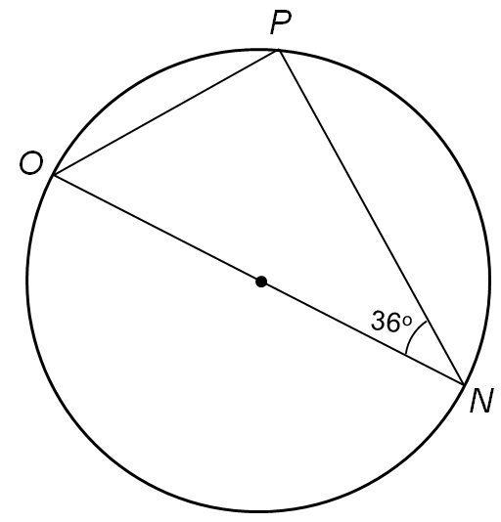

1. 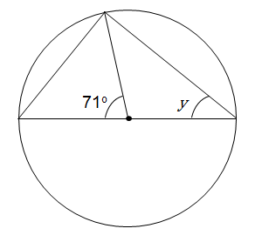Find angle y using two different methods.

Worksheet 3 – Answers

1 The angle at the circumference in a semicircle is 90°.

Angle OPN = 90°

Angles in a triangle add up to 180°.

NOP = 180 – (90 + 36)   
NOP = 180 – 126

NOP = 54˚

2 Triangle 1 and 2 are both Isosceles triangles because AC, AE and AD are all radii of the circle.

**Method 1**

Angles on a straight line = 180˚

Angle z = (180o – 71o)   
 z = 109 ˚

2y + 109o = 180o Sum of the angles in a triangle = 180˚

2y = 180o- 109o  Rearrange the equation to find y  
2y = 71o  
y = 35.5°  
**Method 2**

2x + 71o = 180o  Sum of the angles in a triangle = 180˚

2x = 180o- 71o Rearrange the equation to find x  
2x = 109o  
x = 54.5o  
   
The angle at the circumference in a semicircle is 90°.

Angle x + y = 90o  
54.5o + y = 90o  
y = 90o – 54.5o Rearrange the equation to find y.

y = 35.5°

Worksheet 4

|  |
| --- |
| **To prove that the angle subtended by an arc or chord at the centre of a circle is twice the angle subtended at the circumference by the same arc or chord.** |
|  |
| To prove that angle COB = 2 x angle CAB |
| Extend AO to D |
| AO = BO = CO (radii of same circle) |
| Triangle AOB is isosceles (base angles equal) |
| Triangle AOC is isosceles (base angles equal) |
| Angle AOB = 180° - 2α (angle sum in a triangle) |
| Angle AOC = 180° - 2β (angle sum in a triangle) |
| Angle COB = 360° – (AOB + AOC) (angles at point) |
| Angle COB = 360° – (180° - 2α + 180 - 2β) |
| Angle COB = 2α + 2β = 2(β+ β)  = 2 x angle CAB **As required** |

Worksheet 5

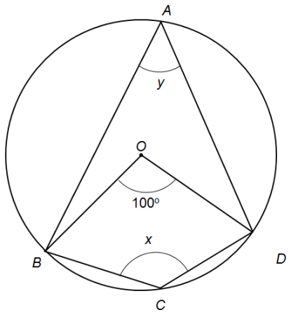

1. *A*, *B*, *C* and *D* lie on a circle, centre *O*.

Find the value of *x* and the value of *y*.

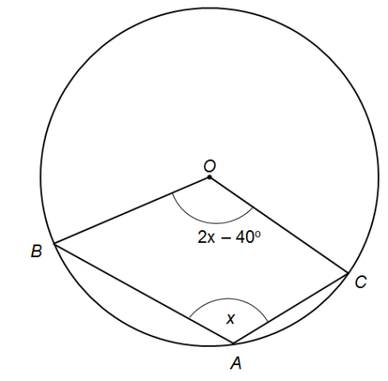

1. A, B and C lie on a circle, centre O.

Find the value of *x*.

Worksheet 5 – Answers

1. 

*y* = Angle at the centre of the circle is twice the angle at the   
circumference

Reflex angle *BOD* = 360° – 100° = 260°

*x* = Angle at the centre of the circle is twice the angle at the   
circumference





Reflex angle BOC = 360° – (2x – 40°)

*x* =

x =

x = 200° - x

2x = 200°

x = 100°

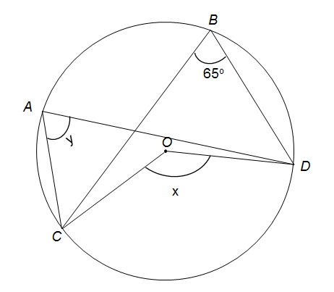Worksheet 6

1. *A*, *B*, *C* and *D* lie on a circle, centre *O*.

Find the value of *x* and the value of *y*.

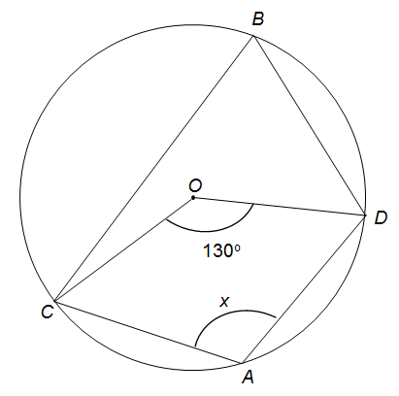

1. *A*, *B*, C and *D* line on a circle, centre *O*.

Find the value of *x*.

Worksheet 6 – Answers



*y* = 65o  Angles in the same segment are equal.

*x* = Angle at the centre of the circle is twice the   
angle at the circumference.



Angle *CBD* =

x + angle *CBD* = 180o  Opposite angles of a cyclic quadrilateral sum   
to 180°

x = 180o – 65o = 115o

Worksheet 7 – Angle between a tangent and a cord

|  |
| --- |
| **To prove that the angle between a tangent and a chord is equal to the angle in the alternate segment.** |
| To prove that angle CDB = angle DAB |
| Construct the Radii *DO* and *BO*. |
| *BO* = *DO* (Radii of the same circle) |
| Angle *CDB* + Angle *BDO* = 90˚ |
| Angle *BDO* = 90o – Angle *CDB* |
| Angle *DBO* = 90o – angle *CDB* (Triangle *DOB* is Isosceles so the base angles are equal) |
| Angle *DOB* = 180o – angle *BDO* – angle *DBO* (angle sum in a triangle) |
| Angle *DOB* = 180o – (90o – angle *CDB*) – (90o – angle *CDB*) |
| Angle *DOB* = 2 x angle *CDB* |
| Angle *DOB* = 2 x angle *DAB* |
| Angle *DAB* = angle *CDB* |

Worksheet 8

1. 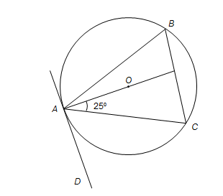*A*, *B* and *C* are on a circle, centre *O*.

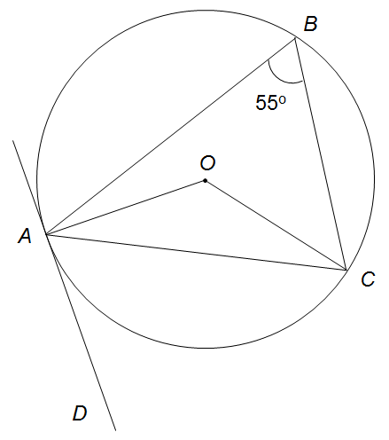 *AD* is the tangent to the circle. Find angle *ABC*.

1. *A*, *B* and *C* are on a circle, centre *O*.

*AD* is the tangent to the circle. Find angle *OCA*.

Worksheet 8 – Answers

1. 

Angle *DAC* = 90o

Angle *CAD* = 90o – 25o = 65o

Angle *ABC* = Angle *DAC* = 65o





Angle *DAC* = Angle *ABC* = 55o

Angle *CAO* = 90o – 55o = 35o

Angle *CAO* = *OCA* = 35o *AOC* is an isosceles triangle

Cambridge Assessment International Education  
The Triangle Building, Shaftsbury Road, Cambridge, CB2 8EA, United Kingdom  
t: +44 1223 553554

e:[info@cambridgeinternational.org](mailto:info@cambridgeinternational.org)[www.cambridgeinternational.org](http://www.cambridgeinternational.org)

© Cambridge University Press & Assessment 2022