****Worksheet B: Parallel and perpendicular lines notes

**Parallel lines**

* 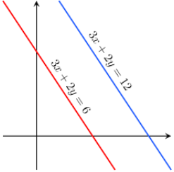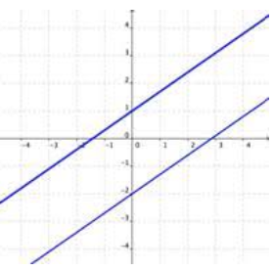**Parallel lines have the same gradient.**

**Perpendicular lines**

* **If two lines are perpendicular, their gradients have a product of –1**
* If two lines are perpendicular, they are at right-angles to each other. A line perpendicular to the line with equation *y* = *mx* + *c* has gradient .

