Worksheet E: You are the teacher: mark this work

Find the errors in the work presented and explain what is wrong. Decide the number of marks to award and make 3 comments praising the work and set 1 target for improvement.

15 pop groups apply to star in a show. Sasha chooses 5 of these pop groups to appear on the show.

1. (i) Sasha makes a list to show the order in which they will sing on the show.
2. How many different lists can she make? [2]



(ii) Of the original 15 pop groups, 10 have a drummer and 5 have no drummer. Find the number of lists in which

the first group has no drummer,

the second group has a drummer,

the third group has no drummer,

the fourth group has a drummer and

the fifth group has no drummer. [2]

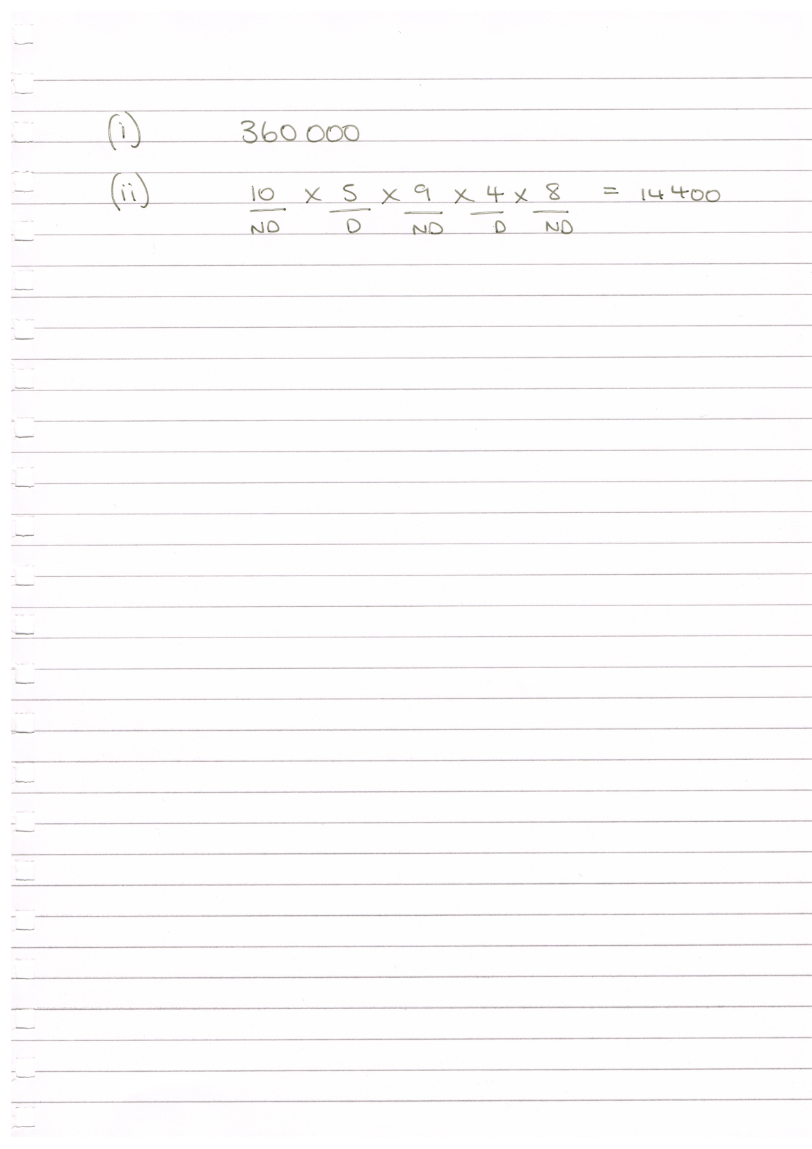

**Mark scheme**

**(i)** 15 × 14 × 13 × 12 × 11 1 mark

Correct answer 360 360 1 mark

**(ii)** Multiplies 5 relevant numbers e.g. 5 × 10 × 4 × 9 × 3 1 mark

Correct answer 5400 1 mark