

Teaching Pack

Unseen Prose – Tone and voice

Cambridge IGCSE™

Literature in English 0475



In order to help us develop the highest quality resources, we are undertaking a continuous programme of review; not only to measure the success of our resources but also to highlight areas for improvement and to identify new development needs.

We invite you to complete our survey by visiting the website below. Your comments on the quality and relevance of our resources are very important to us.

[www.surveymonkey.co.uk/r/GL6ZNJB](https://www.surveymonkey.co.uk/r/GL6ZNJB)

Would you like to become a Cambridge consultant and help us develop support materials?

Please follow the link below to register your interest.

[www.cambridgeinternational.org/cambridge-for/teachers/teacherconsultants/](http://www.cambridgeinternational.org/cambridge-for/teachers/teacherconsultants/)

Copyright © UCLES 2018

Cambridge Assessment International Education is part of the Cambridge Assessment Group. Cambridge Assessment is the brand name of the University of Cambridge Local Examinations Syndicate (UCLES), which itself is a department of the University of Cambridge.

UCLES retains the copyright on all its publications. Registered Centres are permitted to copy material from this booklet for their own internal use. However, we cannot give permission to Centres to photocopy any material that is acknowledged to a third party, even for internal use within a Centre.

Contents

[Introduction 4](#_Toc509500270)

[Lesson plan – Tone and voice (Unseen prose) 5](#_Toc509500271)

[Teacher notes 10](#_Toc509500272)

[Lesson resources 11](#_Toc509500273)

[Worksheet 1: Words to appreciate 12](#_Toc509500274)

[Worksheet 2: Sample answer 13](#_Toc509500275)

[Worksheet 3: Self-assessment sheet 14](#_Toc509500276)

|  |  |
| --- | --- |
| **Icons used in this pack:** | |
| \\filestorage\CIE\Development\Curriculum_Services\Templates\2017 Templates\11. Icons\Skills Packs\1. Briefing lesson.png | **Lesson plan** |
| **C:\Users\elliss\AppData\Local\Microsoft\Windows\Temporary Internet Files\Content.Outlook\RZWGLKTN\Information icon.png** | **Teacher notes** |
| **C:\Users\elliss\AppData\Local\Microsoft\Windows\Temporary Internet Files\Content.Outlook\RZWGLKTN\Resources icon.png** | **Lesson resources** |

Introduction

This *Teaching* *Pack* focuses on supporting learners to appreciate the tone and voice/viewpoint conveyed in a text. We have chosen to demonstrate this by using *Heidi* by Johanna Spyri, but this lesson plan could be adapted to use any other similar opening to an unseen text that has diverse narrative style and voice.

This lesson is designed for learners that already understand and can identify different sentence structures and literary techniques.

It would be advantageous if the text had been assigned to the learners to read as homework before this lesson so that they are familiar with the content.

This lesson is designed to develop the learners’ vocabulary (their definitions of tone and the appreciative vocabulary list). This section can be omitted or developed over two lessons depending on the vocabulary needs and skills of the learners.

In this *Teaching Pack* we have suggested resources and online links you may like to use as well as some worksheets to print off and use in the classroom with your learners.

A PowerPoint presentation ‘Unseen Prose: Tone and voice’ is also provided for you to use alongside this pack (**PowerPoint slides 1−16**).

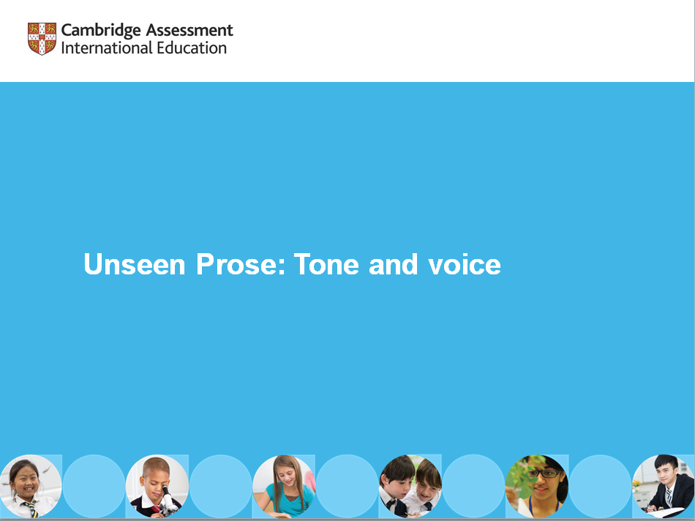

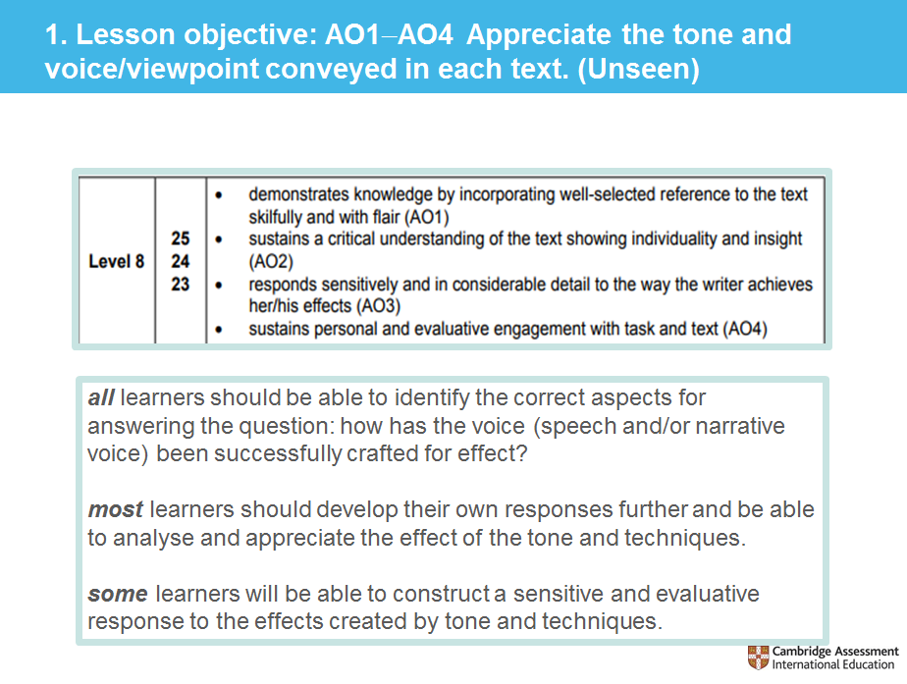

Lesson plan – Tone and voice (Unseen prose)

|  |  |
| --- | --- |
| **Resources** | * An online timer at [www.online-stopwatch.com/countdown-timer/](http://www.online-stopwatch.com/countdown-timer/) * Access to online dictionaries or a similar search browser: * Access to YouTube ‘People are awesome’: [www.youtube.com/watch?v=qF25vRr7eKs](https://www.youtube.com/watch?v=qF25vRr7eKs) * **Worksheet 1:** Words to appreciate * Definitions of narrative voice and direct speech or access to <https://writingmanual.pressbooks.com/chapter/types-of-narrative-voice-2/> * Copies of the opening to *Heidi* by Johanna Spyri from [www.fullbooks.com/Heidi1.html](http://www.fullbooks.com/Heidi1.html) or other similar opening to an unseen text. * **Worksheet 2:** Sample answer * Whiteboards and board pens for learners’ analytical writing * A range of literary novels (*Dracula, Little Women, The Lion the Witch* *and the Wardrobe*, etc.) that learners can use for their independent extension work * **Worksheet 3:** Self-assessment sheet * **Teacher notes** * **PowerPoint slides** (1−16) |
|  |  |
| **Learning objectives** | By the end of the lesson:   * ***all*** learners should be able to: Identify the correct aspects for answering the question ‘how has the voice (speech and/or narrative voice) been successfully crafted for effect?’ * ***most*** learners will be able to: Develop their own responses further and be able to analyse and appreciate the effect of the tone and techniques * ***some*** learners will be able to: Construct a sensitive and evaluative response to the effects created by tone and techniques. |

| **Timings** | **Activity** |
| --- | --- |
| **Y:\Development\Curriculum_Services\Projects\Resource Plus\Resource Plus_Wave 2\IGCSE_Literature_0486\2_Templates&Icons\LP_time_images\10_0.png** | **Starter/Introduction**  Learners work in pairs.  **PowerPoint slide 1**: Introduce the lesson objective, linking it to the assessment objectives 1–4 (AO1–AO4).  **PowerPoint slide 2**: Say ‘WHAT’ to a partner:   * like you are asking a question * like you are angry * like you are answering someone * like you are confused.   Model this process, modulating your voice as necessary: rising intonation for asking a question; emphasising the plosive ‘t’ sound to imply anger; undulating to answer; higher-pitched to imply confusion, etc.  Ask learners to discuss what tone means in this situation.  Display the definition of ‘tone’ on PowerPoint slide 2. Learners make a note of this.   * A modulation of the voice expressing a particular feeling or mood.   **PowerPoint slide 3**: Set learners the one-minute challenge using an online timer to find as many definitions of tone as they can.  Higher ability learners will need to be in pairs and lower abilities perhaps in groups of four. Learners write down the definitions.  Display the answers and ask learners to write down any they have missed from [www.google.co.uk/search?q=define+tone](http://www.google.co.uk/search?q=define+tone)  Explain the focus of today’s lesson is to look at two particular notions of tone:   * how a voice’s tone is crafted * how a character or place can have a tone.   Learners will need to identify and then appreciate both types of voice/viewpoint in their analytical responses to the Unseen prose and poetry questions. |
| **Y:\Development\Curriculum_Services\Projects\Resource Plus\Resource Plus_Wave 2\IGCSE_Literature_0486\2_Templates&Icons\LP_time_images\10_5_0.png**  **Y:\Development\Curriculum_Services\Projects\Resource Plus\Resource Plus_Wave 2\IGCSE_Literature_0486\2_Templates&Icons\LP_time_images\15_10_0.png**  **Y:\Development\Curriculum_Services\Projects\Resource Plus\Resource Plus_Wave 2\IGCSE_Literature_0486\2_Templates&Icons\LP_time_images\25_10_0.png**  **Y:\Development\Curriculum_Services\Projects\Resource Plus\Resource Plus_Wave 2\IGCSE_Literature_0486\2_Templates&Icons\LP_time_images\35_10_0.png** | **Main lesson**  **Task 1**  In order to ‘appreciate’, learners will need to embed **loaded**, **judgemental** words into their analysis. This is what the next activity aims to model.  Watch one or two clips of people achieving amazing feats from any YouTube videos from the ‘People are awesome’ series: [www.youtube.com/watch?v=qF25vRr7eKs](https://www.youtube.com/watch?v=qF25vRr7eKs)  As they watch the clip, learners describe what they are seeing and explain what they appreciate about that person’s achievement.  **PowerPoint slide 4**: Learners use the vocabulary list as these words are evaluative and the key to embedding a detailed, critical evaluation.  Example:  *Notably, the man in the wheelchair rather inspiringly performs several really successful deep bench presses, crucially and impressively using his entire body weight.*  **Worksheet 1**: Learners choose their own clip, watch it again and then write their own evaluative appreciation of what that person has achieved. Share the best examples.  **Task 2**  **PowerPoint slide 5**: Define narrative voice and direct speech. Explain there are two key questions that can guide the learner in their identification of AO1.   1. How has the narrative voice been crafted for effect? (tone/viewpoint of narrator) 2. How the direct speech been crafted for effect? (tone of voice)   Any unseen prose can be used to apply these questions to it but the example used in this lesson plan is the opening of *Heidi* by Johanna Spyri.  Define narrative voice (the voice telling the reader the story) and ensure the distinction between narrative voice and direct speech (when a character speaks) is clear. See ‘Types of Narrative Voice: <https://writingmanual.pressbooks.com/chapter/types-of-narrative-voice-2/>  Give learners copies, display and read the opening 54 lines of *Heidi* from [www.fullbooks.com/Heidi1.html](http://www.fullbooks.com/Heidi1.html) (‘The old and pleasantly situated village … will soon send you and your proposal packing off home again!’), or your choice of literary fiction. Ask learners to use their own browsers to define any vocabulary they are unsure of.  **Task 3**  **PowerPoint slide 6**: Choose a compound sentence that creates a significant build-up of a description. Ask the learners to discuss:  **How has the narrative voice been crafted for effect?** (tone/viewpoint of narrator)  Elicit from them, whilst they annotate:  *Compound sentence = build-up of a description that mirrors the overwhelming amounts of clothes that Heidi has on, hinting that she is carrying/wearing everything she owns and is uncomfortable for it on this long, mountainous walk. Coupled with noun phrases (‘nailed mountain-shoes’, ‘little body’) to contrast her figure and her unsuitable clothing.*  **PowerPoint slide 7**: Choose direct speech from your choice of fiction that creates a sense of character. Ask the learners to discuss:  **How has the direct speech been crafted for effect?** (tone of voice)  Elicit from them, whilst they annotate:  Focus on the use of direct speech = Dete is setting the agenda and part of her crafted idiolect means she is using compound sentences which indicate she is thinking quickly as to what to say to reassure Heidi. This is reinforced by the use of ‘bravely’ to get Heidi to walk and of the word ‘encouraging’ to describe the tone she has selected to speak to Heidi.  Focus also on the use of the modal ‘must’ and the forcefulness with which this implication is delivered in contrast with the tone.  **PowerPoint slide 8**: Choose direct speech from your choice of fiction that reveals a character’s shock. Ask the learners to discuss:  **How has the direct speech been crafted for effect?** (tone of voice)  Elicit from them, whilst they annotate:   * What does the punctuation imply about the tone of the voice?   The exclamation mark implies strong shock.   * How does the repetition add to this?   It heightens and reinforces her shock at the decision made for the child, Heidi.  **Task 4**  **PowerPoint slide 9**: Introduce the idea that ‘creating an appreciative response’ means that learners need to ‘judge’ the *overall* mood and tone. Explain the three part structure of what the learners have read:   1. Sympathy for a young girl 2. An adult with a plan 3. A second adult who is appalled by the plan   Words to describe the overall effect on the tone = disturbing, unsettling, curious.  Give learners one minute to develop more synonyms to describe the tone. Some suggestions include: Intriguing, puzzling, irregular, bizarre, weird, strange.  **PowerPoint slide 10**: Now learners have a word bank to describe the effect of the overall tone of the piece, they need to build a response that supports the judgements they have made. Slide 10 allows learners to see a thought process which will help guide them in building a response:    **PowerPoint slides 11**–**13**: Distribute copies of the sample answer (**Worksheet 2**). Learners read the text and identify words and phrases to do with:   1. tone effect (highlight in blue) 2. evaluation (highlight in red) 3. technique (highlight in green).   Lower ability learners should work in pairs and write their own analysis of one of the quotations annotated during this lesson.  Middle ability learners should work on an annotated quotation alone.  Higher ability learners should choose their own quotation and write their own analysis.  **PowerPoint slide 14**: Learners should use whiteboards so they can craft their response as needed, ensuring they use the words from the earlier vocabulary exercises.   1. How has the narrative voice been crafted for effect? (tone/viewpoint of narrator) 2. How has the direct speech been crafted for effect? (tone of voice) |
| **Y:\Development\Curriculum_Services\Projects\Resource Plus\Resource Plus_Wave 2\IGCSE_Literature_0486\2_Templates&Icons\LP_time_images\45_5_0.png** | **Plenary**  **PowerPoint slide 15**: Learners can review and amend their work in pairs or individually using the levelled criteria on the self-assessment sheet (**Worksheet 3**).  **Homework**  **PowerPoint slide 16**: Give learners a copy of extracts from a range of literary novels.  Ask them to read the first pages.  Create a presentation in pairs answering the basic questions:   1. How has the narrative voice been crafted for effect? (tone/viewpoint of narrator) 2. How has the direct speech been crafted for effect? (tone of voice) |

****Teacher notes

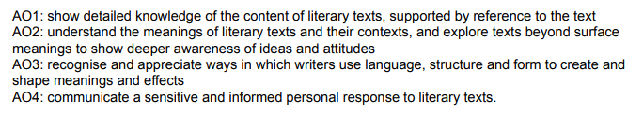

PowerPoint slide 1: When referring to the assessment objectives, briefly explain how they are linked by learners’ responses – first by their understanding in AO2, finding evidence in AO1, then by being able to appreciate and be sensitive in their personal responses in AO3 and AO4.

PowerPoint slide 2: Model the process of saying ‘WHAT’, modulating your voice as necessary (rising intonation for asking a question, emphasising the plosive ‘t’ sound to imply anger; undulating to answer; higher pitched to imply confusion, etc.).

Display the ‘Words to appreciate’ (**PowerPoint slide 4**) for reference throughout the lesson.

If there is a lack of time then the vocabulary exercises can be omitted from this lesson and the tasks can start from defining the narrative voice and direct speech.

PowerPoint slide 5: When defining narrative voice (the voice telling the reader the story) ensure the distinction between that and direct speech (when a character speaks) is clear by getting learners to write examples of narrative voice and direct speech and share them using their whiteboards.

When defining and identifying compound sentences the mnemonic FANBOYS is useful and easily accessible for learners: For, And, Nor, But, Or, Yet, So.

When teaching learners to judge the overall mood and tone, reinforce that their opinion is crucial to success in the Unseen paper which specifically asks for their own opinion. Forming an opinion and an informed reaction then using synonyms to develop and refine that judgement will be critical in ensuring that they can write in a sustained and detailed manner.

PowerPoint slide 10:When learners write their analysis on their whiteboards, circulate to ensure they have developed an informed response answering the questions on the slide.

PowerPoint slide 15: If time, then discussing the differences between Levels 3, 5 and 8 (basic/developed/sensitive opinion) will be helpful in assisting learners in their ability to review and improve their own analytical responses.

****Lesson resources

|  |
| --- |
| **Worksheet 1:** Words to appreciate |
| **Worksheet 2:** Sample answer |
| **Worksheet 3:** Self-assessment sheet |

Worksheet 1: Words to appreciate

|  |  |
| --- | --- |
| Words to appreciate | Example sentences |
| Successful | Notably, the man in the wheelchair rather inspiringly performs several really successful deep bench presses, crucially and impressively using his entire body weight.  **Now write some examples of your own:** |
| Impactful |
| Clever |
| Notably |
| Noteworthy |
| Influential |
| Crucial |
| Pivotal |
| Inspiring |
| Impressively |
| Persuasive |
| Authoritative |
| Realistic |
| Brilliantly |

Worksheet 2: Sample answer

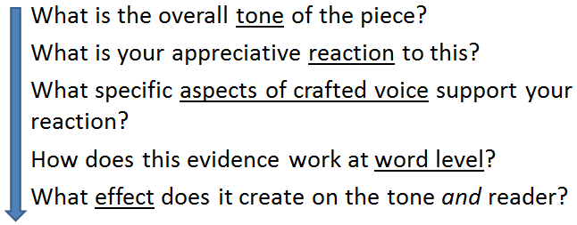

There is a distinctly puzzling tone in the opening extract of *Heidi* which really successfully forces the reader to quickly sympathise with the smaller, younger child. The clever use of the compound sentence is notable in that the description of the many clothes worn by Heidi is mirrored in the structurally overwhelming clauses that lead the reader to suspect that she may be wearing everything she owns on this long, mountainous walk. This hint at such a young child’s vulnerability is further heightened by the use of noun phrases that oddly contrast her ‘little body’ and the heaviness of her inappropriate attire: ‘nailed mountain-shoes’. The constant throwing up of these questions creates a disturbingly effective scene that leaves the reader feeling helpless and unsettled by the plight Heidi is in.

Highlight the text using the colours for:

* tone effect
* evaluation
* technique**.**

*There is a distinctly puzzling tone in the opening extract of* Heidi *which really successfully forces the reader to quickly sympathise with the smaller, younger child. The clever use of the compound sentence in the narrator’s viewpoint is notable in that the description of the many clothes worn by Heidi is mirrored in the structurally overwhelming clauses that lead the reader to suspect that she may be wearing everything she owns on this long, mountainous walk. This narrative hint at such a young child’s vulnerability is further heightened by the use of noun phrases that oddly contrast her ‘little body’ and the heaviness of her inappropriate attire: ‘nailed mountain-shoes’. The constant throwing up of these questions creates a disturbingly effective scene that leaves the reader feeling helpless and unsettled by the plight Heidi is in.*

Worksheet 3: Self-assessment sheet

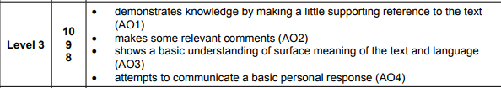

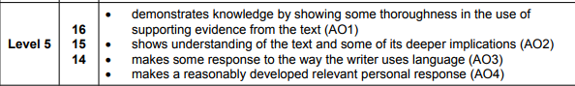

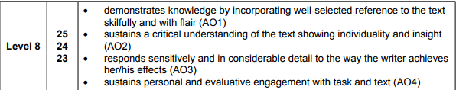

**What went well:**





**What could be improved:**





Cambridge Assessment International Education  
The Triangle Building, Shaftesbury Road, Cambridge, CB2 8EA, United Kingdom  
t: +44 1223 553554       
e: [info@cambridgeinternational.org](mailto:info@cambridgeinternational.org)    [www.cambridgeinternational.org](http://www.cambridgeinternational.org)

Copyright © UCLES March 2018