****Worksheet H: Tarsia puzzle

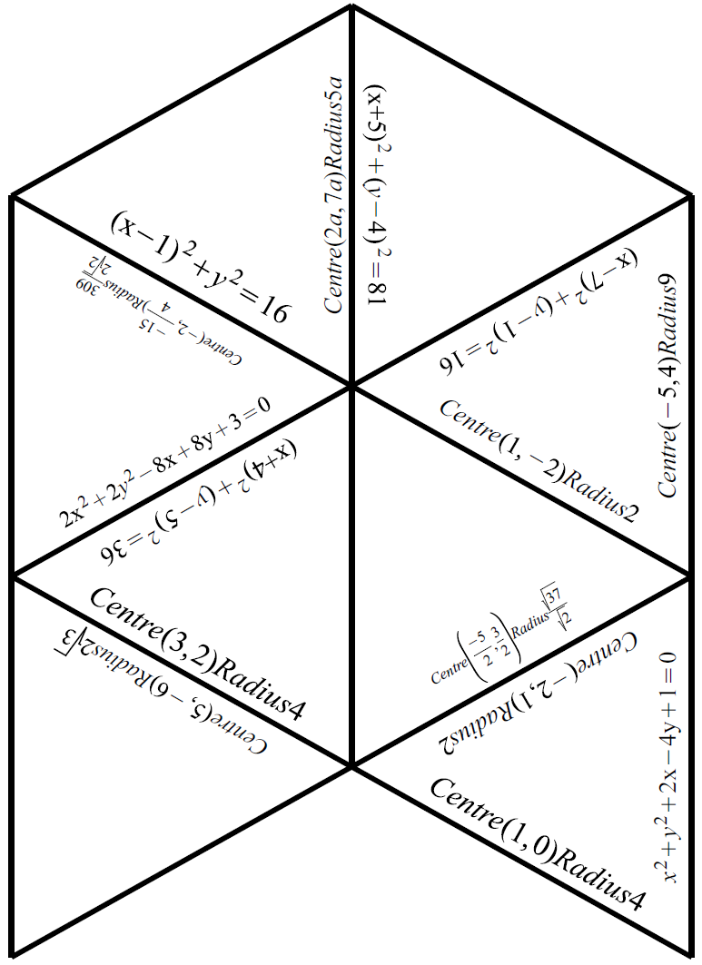

****Worksheet H: Tarsia puzzle continued

