

Teaching Pack

Poetry – Personal response to ‘Caged Bird’ by Maya Angelou

Cambridge IGCSE™ / IGCSE (9–1)

Literature in English 0475 / 0992

Cambridge O Level

Literature in English 2010



Copyright © UCLES 2018 (updated 2025)

Cambridge Assessment International Education is part of the Cambridge Assessment Group. Cambridge Assessment is the brand name of the University of Cambridge Local Examinations Syndicate (UCLES), which itself is a department of the University of Cambridge.

UCLES retains the copyright on all its publications. Registered Centres are permitted to copy material from this booklet for their own internal use. However, we cannot give permission to Centres to photocopy any material that is acknowledged to a third party, even for internal use within a Centre.

Contents

[Introduction 4](#_Toc509499631)

[Lesson plan – Personal response to ‘Caged Bird’ by Maya Angelou 5](#_Toc509499632)

[Teacher notes 8](#_Toc509499633)

[Lesson resources 9](#_Toc509499635)

[Worksheet 1: Associating words and images 10](#_Toc509499636)

[Worksheet 2: What’s the big idea? 11](#_Toc509499637)

[Worksheet 3: Our big ideas 12](#_Toc509499638)

[Worksheet 4: My considered, personal response 13](#_Toc509499639)

[Worksheet 5: My considered, personal response 14](#_Toc509499640)

|  |  |
| --- | --- |
| **Icons used in this pack:** | |
| \\filestorage\CIE\Development\Curriculum_Services\Templates\2017 Templates\11. Icons\Skills Packs\1. Briefing lesson.png | **Lesson plan** |
| **C:\Users\elliss\AppData\Local\Microsoft\Windows\Temporary Internet Files\Content.Outlook\RZWGLKTN\Information icon.png** | **Teacher notes** |
| **C:\Users\elliss\AppData\Local\Microsoft\Windows\Temporary Internet Files\Content.Outlook\RZWGLKTN\Resources icon.png** | **Lesson resources** |

Introduction

This *Teaching* *Pack* focuses on supporting learners to develop a personal response to poetry.

The lesson presented here is designed for learners that already understand what a personal response is. That means they should know how they apply the meaning, themes and poet’s attitude within a poem in relation to their own ideas about the world and contemporary or historical events.

It would be useful if the text ‘Caged Bird’ by Maya Angelou is read by your learners before this lesson so that they are familiar with the content of the poem and can focus on the application of their skills. The lesson plan may be adapted to other poems.

In this *Teaching Pack* we have suggested resources and online links you may like to use as well as some worksheets and teacher notes to print off and use in the classroom with your learners.

Lesson plan – Personal response to ‘Caged Bird’   
by Maya Angelou

|  |  |
| --- | --- |
| **Resources** | * ‘Caged Bird’ by Maya Angelou * **Worksheet 1:** Associating words and images * **Worksheet 2:** What’s the big idea? * **Worksheet 3:** Our big ideas * **Worksheet 4:** My considered, personal response * **Worksheet 5:** My considered, personal response (teacher’s example) * **Teacher notes** |
|  |  |
| **Learning objectives** | By the end of the lesson:   * ***all*** learners should be able to: Develop a considered, personal response to the poem ‘Caged Bird’ by investigating the meaning and themes of the poem * ***most*** learners should be able to: Develop a considered, personal response to the poem ‘Caged Bird’ by investigating the meaning, themes and poet’s attitude expressed in the poem * ***some*** learners will be able to: Develop a considered personal response to the poem ‘Caged Bird’ by investigating the meaning, themes and poet’s attitude expressed in the poem, supporting their ideas with relevant evidence from the text. |

| **Timings** | **Activity** | |
| --- | --- | --- |
|  | | **Starter/Introduction**  Using **Worksheet 1**, learners should create a mind map for each image and write down anything that they associate with a caged bird and what they associate with a free bird.  **Extension activity:** How could these images be used to symbolise problems to do with difference and inequality that exist in our modern world? Make sure you give reasons for your ideas.  Gather the ideas that the pairs have collated on their mind maps. Use these to develop the discussion onto the questions in the extension activity to get thoughts and ideas about this from your learners. Explain the concept of an allegory, and that the poem ‘Caged Bird’ is allegorical. |
|  | | **Main lesson**  Hand out a copy of the poem out to each learner, and then read the poem ‘Caged Bird’ aloud to class.  Now assign each learner one of four colours: blue, red, green and yellow. Hand out **Worksheet 2** and ask learners to complete the task based on their colour.   * **Blue:** Take notes on the meaning of the poem (suitable for mid- to lower-ability learners) * **Red:** Take notes on the themes of the poem (suitable for lower-ability learners) * **Green:** Take notes on the poet’s attitude (suitable for higher-ability learners) * **Yellow:** Take notes on the three most important quotations in the poem and why they are so important.   Although each learner has a different focus to write up, the group should work together to discuss and decide upon their ideas together.  Now ask learners of the same colour to join together, so all the blues sit together, as do all the reds, etc. In these new groups, the learners should share what they have decided in their original groups and decide upon a definitive response between them. They should write up this response on **Worksheet 3**.  Ask each group to read out their definitive ideas about each area, and stick each of the sheets they have completed on the board. You should emphasise that when we form a personal response to a poem, we must consider the meaning, themes and poet’s attitude that are evident in the text. Ask the learners to think back to the ideas that they thought about during the starter activity and decide what this poem’s meaning, themes and the poet’s attitude makes them think about in today’s world. |
|  | | **Plenary**  Learners go back to their normal seats and by using the ideas they have discussed and thought about (and which are now stuck on the board), write up a paragraph detailing their personal response to the poem by using **Worksheet 4**.  Alternatively, you may wish to seat your learners in their original ‘rainbow’ groups and get them to write up a considered, personal opinion that reflects their group’s consensus. This might help lower-ability learners understand how to complete the sheet. If this plenary is used then ensure that all learners in a group write up the agreed opinion. It is no use if just one person writes it as others will have no access to it before the next lesson, or later in the year when they are at home revising.  **Homework:** Learners finalise their considered, personal responses and post them on a shared platform, e.g. a Padlet page that you have prepared before the lesson (see example at [padlet.com/](https://padlet.com/iain_davis/setmefree)). You will need to give your learners the URL of the Padletpage you have prepared. This will allow you to use these responses at the start of the next lesson to reflect and build on the learning that has taken place. For example, you could identify two effective responses and two not-so-effective responses and ask the class to comment on the strength and weaknesses of these to help them understand what an effective, considered, personal response should look like. |

****Teacher notes

Develop a personal response to poetry.

Key words

Key words / concepts you could highlight during the lesson, or teach before the lesson:

**Meaning** *–* The narrative of the poem / what happens in the poem.

**Poet’s attitude** *–* Why the poet wrote the poem / what the poet wants us to explore and think about.

**Allegory** *–* A story that can be enjoyed on two levels. On the one hand, it can be understood literally; on the other, it can be understood metaphorically.

**Considered** *–* Linking the poet’s meaning, themes and attitude in the poem with our understandings of the world around us.

**Communicate** *–* Express in a developed and coherent way. Remember to use ‘as’, ‘because’ or ‘since’ to give reasons for your ideas when you express your personal response.

Notes

* A considered, personal response should be explicitly expressed throughout the response. It must stem from an understanding of why the poet wrote the piece, but it is an opportunity for learners to show ownership over the text and engage with its meanings, themes and the poet’s attitude expressed by exploring what the text means to them.
* An essay is of course a learner’s personal response. It is how the learner understands the ways in which the poet has communicated meaning through the poet’s use of language and structural devices. However, learners must not just deliver their own personal take on a poem. They must show an awareness of the poet’s intended meanings and attitudes. These are, after all, set texts.
* Learners should not go into detail about the author’s life and the historical context. A considered personal response is one that stems from the meaning, themes and messages of the poem.
* Once your learners are clear about how to write a considered, personal opinion then you can assign this as a homework task after you finish teaching each poem. Encourage them to keep a separate notebook or a section in their class book for this purpose. For each poem, if learners can summarise:
  + the meaning of the poem in three to four sentences (an introduction)
  + the structure points (a structure paragraph to follow the introduction)
  + their considered, personal response (throughout the response)

then they will be prepared for whichever poem is in the exam paper. The above three aspects of the poems will not change no matter what the essay question is on the day of the examination.

****Lesson resources

|  |
| --- |
| **Worksheet 1:** Associating words and images |
| **Worksheet 2:** What’s the big idea? |
| **Worksheet 3:** Our big ideas |
| **Worksheet 4:** My considered, personal response |
| **Worksheet 5:** My considered, personal response (teacher example) |

Worksheet 1: Associating words and images

In pairs, create a mind map around each image with anything you associate with a caged bird or a free bird. An example for each has been done for you.

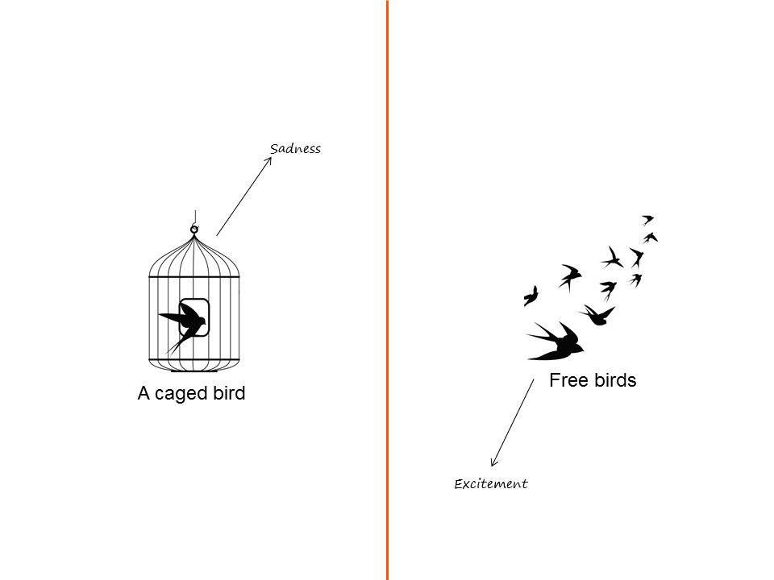

Worksheet 2: What’s the big idea?

Use this sheet to take notes on the focus you have been given in your rainbow group.

I need to gather ideas about \_\_\_\_\_\_\_\_\_\_\_\_\_\_\_\_\_\_\_\_\_\_\_\_\_\_\_\_\_\_\_\_\_\_\_\_\_\_\_\_\_\_\_\_\_\_\_\_\_\_\_\_\_\_\_\_\_\_.



Worksheet 3: Our big ideas

Use this space to gather together all of your ideas. Be prepared to share this with the rest of the class.

Worksheet 4: My considered, personal response

|  |
| --- |
| Now that you have considered the meaning, themes and poet’s attitude of the poem (and explored some of the key quotations), what does this poem make you think about in terms of what is happening in the world at the moment. Write up your thoughts using the writing frame below. |

The meaning of this poem makes me think about \_\_\_\_\_\_\_\_\_\_\_\_\_\_\_\_\_\_\_\_\_\_\_\_\_\_\_\_\_\_\_\_\_\_\_\_\_\_\_

\_\_\_\_\_\_\_\_\_\_\_\_\_\_\_\_\_\_\_\_\_\_\_\_\_\_\_\_\_\_\_\_\_\_\_\_\_\_\_\_\_\_\_\_\_\_\_\_\_\_\_\_\_\_\_\_\_\_\_\_\_\_\_\_\_\_\_\_\_\_\_\_\_\_\_\_\_\_

\_\_\_\_\_\_\_\_\_\_\_\_\_\_\_\_\_\_\_\_\_\_\_\_\_\_\_\_\_\_\_\_\_\_\_\_\_\_\_\_\_\_\_\_\_\_\_\_\_\_\_\_\_\_\_\_\_\_\_\_\_\_\_\_\_\_\_\_\_\_\_\_\_\_\_\_\_\_

\_\_\_\_\_\_\_\_\_\_\_\_\_\_\_\_\_\_\_\_\_\_\_\_\_\_\_\_\_\_\_\_\_\_\_\_\_\_\_\_\_\_\_\_\_\_\_\_\_\_\_\_\_\_\_\_\_\_\_\_\_\_\_\_\_\_\_\_\_\_\_\_\_\_\_\_\_\_

because \_\_\_\_\_\_\_\_\_\_\_\_\_\_\_\_\_\_\_\_\_\_\_\_\_\_\_\_\_\_\_\_\_\_\_\_\_\_\_\_\_\_\_\_\_\_\_\_\_\_\_\_\_\_\_\_\_\_\_\_\_\_\_\_\_\_\_\_\_\_\_

\_\_\_\_\_\_\_\_\_\_\_\_\_\_\_\_\_\_\_\_\_\_\_\_\_\_\_\_\_\_\_\_\_\_\_\_\_\_\_\_\_\_\_\_\_\_\_\_\_\_\_\_\_\_\_\_\_\_\_\_\_\_\_\_\_\_\_\_\_\_\_\_\_\_\_\_\_\_

\_\_\_\_\_\_\_\_\_\_\_\_\_\_\_\_\_\_\_\_\_\_\_\_\_\_\_\_\_\_\_\_\_\_\_\_\_\_\_\_\_\_\_\_\_\_\_\_\_\_\_\_\_\_\_\_\_\_\_\_\_\_\_\_\_\_\_\_\_\_\_\_\_\_\_\_\_\_

The themes of \_\_\_\_\_\_\_\_\_\_\_\_\_\_\_\_\_ and \_\_\_\_\_\_\_\_\_\_\_\_\_\_\_\_\_\_\_ in the poem also apply to this as

\_\_\_\_\_\_\_\_\_\_\_\_\_\_\_\_\_\_\_\_\_\_\_\_\_\_\_\_\_\_\_\_\_\_\_\_\_\_\_\_\_\_\_\_\_\_\_\_\_\_\_\_\_\_\_\_\_\_\_\_\_\_\_\_\_\_\_\_\_\_\_\_\_\_\_\_\_\_

\_\_\_\_\_\_\_\_\_\_\_\_\_\_\_\_\_\_\_\_\_\_\_\_\_\_\_\_\_\_\_\_\_\_\_\_\_\_\_\_\_\_\_\_\_\_\_\_\_\_\_\_\_\_\_\_\_\_\_\_\_\_\_\_\_\_\_\_\_\_\_\_\_\_\_\_\_\_

Furthermore, given the poet’s attitude in the poem, I believe the poet would feel \_\_\_\_\_\_\_\_\_\_\_\_\_\_\_

\_\_\_\_\_\_\_\_\_\_\_\_\_\_\_\_\_\_\_\_\_\_\_\_\_\_\_\_\_\_\_\_\_\_\_\_\_\_\_\_\_\_\_\_\_\_\_\_\_\_\_\_\_\_\_\_\_\_\_\_\_\_\_\_\_ about this since

\_\_\_\_\_\_\_\_\_\_\_\_\_\_\_\_\_\_\_\_\_\_\_\_\_\_\_\_\_\_\_\_\_\_\_\_\_\_\_\_\_\_\_\_\_\_\_\_\_\_\_\_\_\_\_\_\_\_\_\_\_\_\_\_\_\_\_\_\_\_\_\_\_\_\_\_\_\_

\_\_\_\_\_\_\_\_\_\_\_\_\_\_\_\_\_\_\_\_\_\_\_\_\_\_\_\_\_\_\_\_\_\_\_\_\_\_\_\_\_\_\_\_\_\_\_\_\_\_\_\_\_\_\_\_\_\_\_\_\_\_\_\_\_\_\_\_\_\_\_\_\_\_\_\_\_\_

\_\_\_\_\_\_\_\_\_\_\_\_\_\_\_\_\_\_\_\_\_\_\_\_\_\_\_\_\_\_\_\_\_\_\_\_\_\_\_\_\_\_\_\_\_\_\_\_\_\_\_\_\_\_\_\_\_\_\_\_\_\_\_\_\_\_\_\_\_\_\_\_\_\_\_\_\_\_

\_\_\_\_\_\_\_\_\_\_\_\_\_\_\_\_\_\_\_\_\_\_\_\_\_\_\_\_\_\_\_\_\_\_\_\_\_\_\_\_\_\_\_\_\_\_\_\_\_\_\_\_\_\_\_\_\_\_\_\_\_\_\_\_\_\_\_\_\_\_\_\_\_\_\_\_\_\_

|  |
| --- |
| **Extension activity:**  Choose one of the key quotations that your group identified and discussed. How does this quotation relate to the personal response you have written above? Write a paragraph in your notebook explaining your ideas carefully. |

Worksheet 5: My considered, personal response

(teacher example)

**The meaning of this poem makes me think about** all the persecution and suffering that takes place in the world **because** like the ‘caged bird’ so many people like refugees and asylum seekers are denied basic human rights and freedoms. They do not enjoy the same way of life that we do.

**The themes of** difference **and** inequality **in the poem also** **apply to this as** refugees and asylum seekers are often made to long for equal rights, freedom and safety, but often face persecution in their own country and the one that they escape to.

**Furthermore, given the poet’s attitude in the poem, I believe the poet would feel** disappointed and frustrated.

Cambridge Assessment International Education  
The Triangle Building, Shaftesbury Road, Cambridge, CB2 8EA, United Kingdom  
t: +44 1223 553554       
e: [info@cambridgeinternational.org](mailto:info@cambridgeinternational.org)[www.cambridgeinternational.org](http://www.cambridgeinternational.org)

© UCLES 2018 (updated 2025)