Worksheet C: Making lines

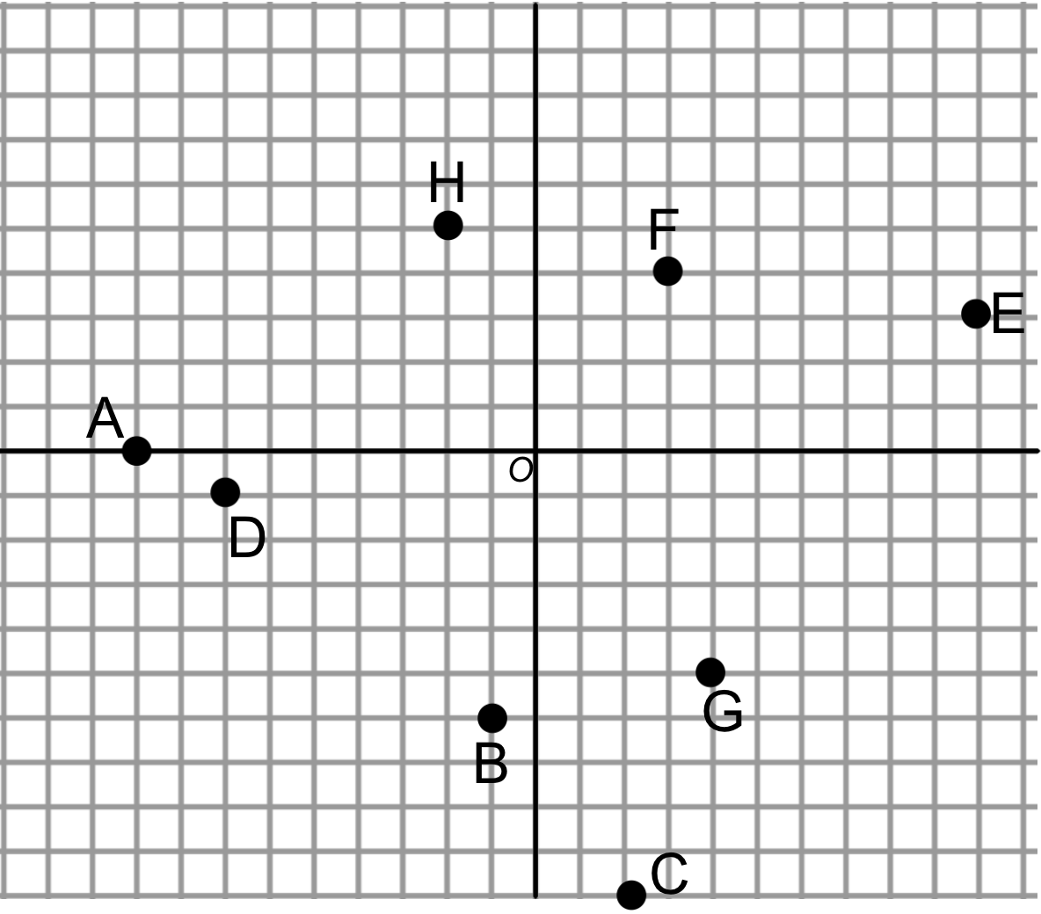

Can you construct a vector equation for the following lines?

**Write down how you got your equation and any choices that you made along the way.**

1) A line that passes through the origin O and the point F.

2) A line that passes through the points B and D.

3) A line that passes through E and is in the direction of

4) A line that passes through C and is parallel to the *y*-axis.

5) A line that passes through C and is parallel to the *x*-axis.

6) A line that passes through D and is parallel to *y*=-*x*.

7) A line that passes through H and is perpendicular to *y*=2*x*+3.

8) A line that passes through A and is parallel to 4*x*+5*y*=10.