Worksheet A: Match the vectors

Match up the column vector with an arrow from the grid. Then determine which vectors describe the movement between the points A to H in the coordinate axis grid.

**Grid** **Coordinate axes**

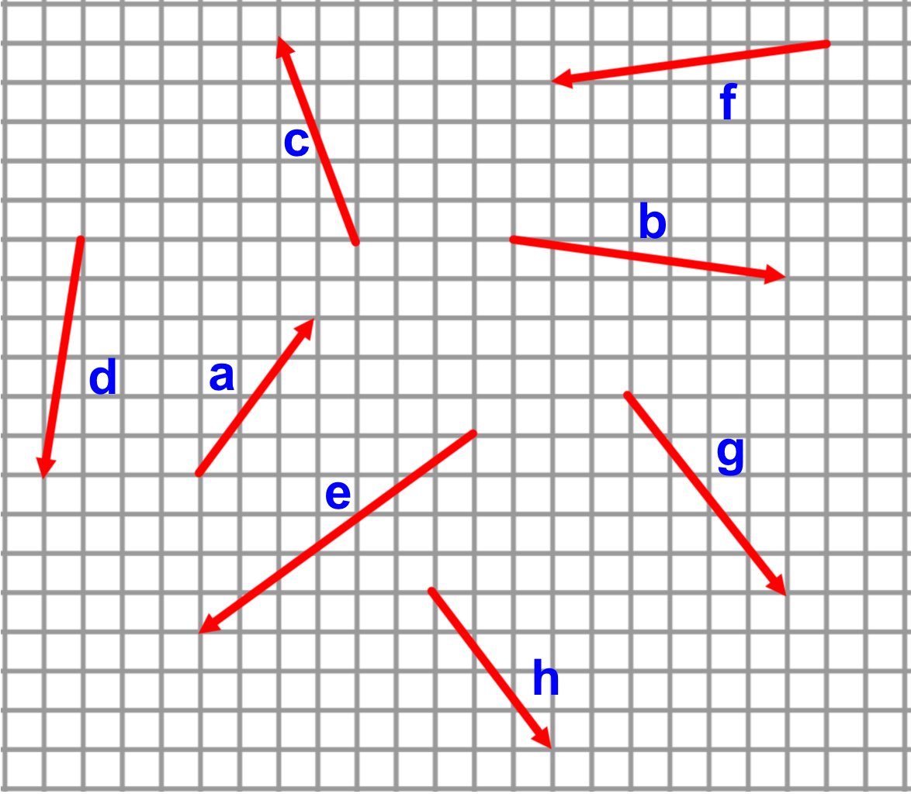 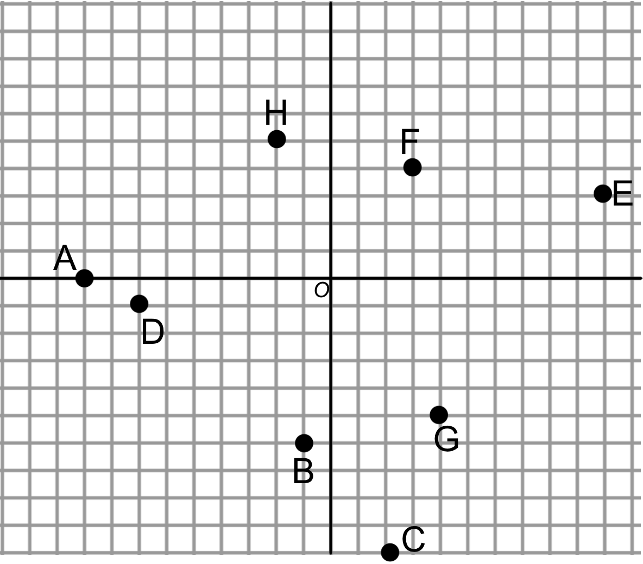

**Column vectors**

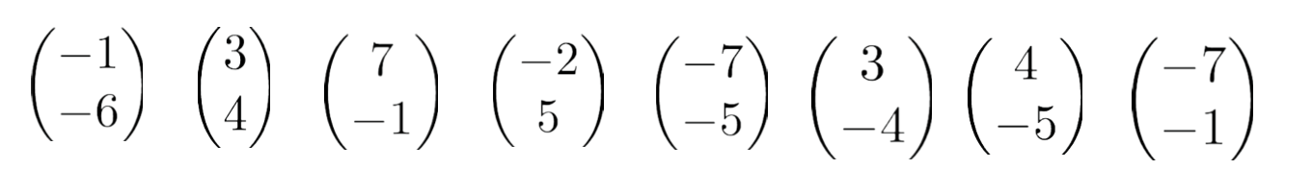

**Movement between points**

Once you have matched all the given vectors to the points in the coordinate axis grid, find the following vector paths (i) as a simplified column vector, (ii) using the vectors named in the Grid section.

1) 4)

2) 5)

3) 6)