**Teaching and learning support materials**

**(Layer 1)**

1. Our remit (this can just be said)
2. How we do it
3. Examples of what we do
4. The reach of our products
5. What holds us back?

**Our remit:** To provide support to classroom teachers at every stage of the teaching and learning journey for over 240 qualifications for customers in 160 countries across a range of abilities and contexts. All materials are available to teachers through the School Support Hub.

**(Layer 2)**

2 **How do we do it** [just show the section title and image, text in red will be spoken]

* We do this by utilising candidate script evidence, examiner reports and marking commentary and synthesising this information with up-to-date teaching strategies and practice in our product designs. In addition, these designs are developed with a view to their production at scale, their consistency and their ease of maintenance, distribution and administration.
* We select the most effective medium and platform for presenting this information according to how they will be used, the stage of the journey they cover, the nature of the subject matter and any specific known problems with the performance of the cohort. Platforms can include School Support Hub, Vimeo, Moodle (our Online Learning Area), Kahoot, any number of similar online platforms and tools.

**(Layer 2)**

3 **Examples of what we do** [I suggest we only show the titles, images and the figures in each case of these examples. I will speak the text, which I will show in red so as not to be included on screen.]

**Specimen Paper Answers and Example Candidate Responses**

We publish 300 ECRs with 60K downloads in 2019.

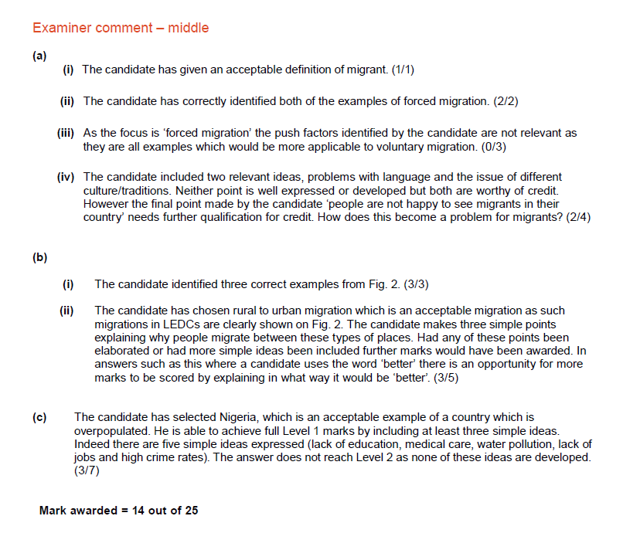

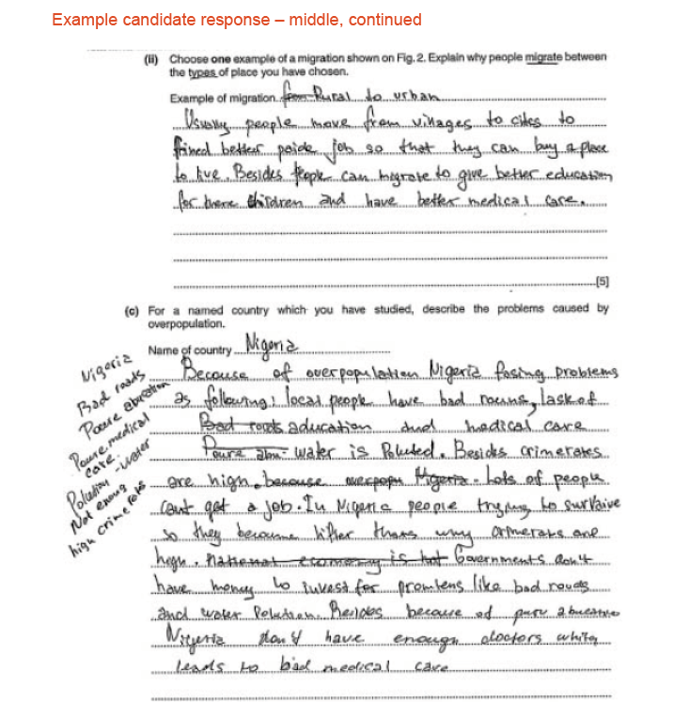

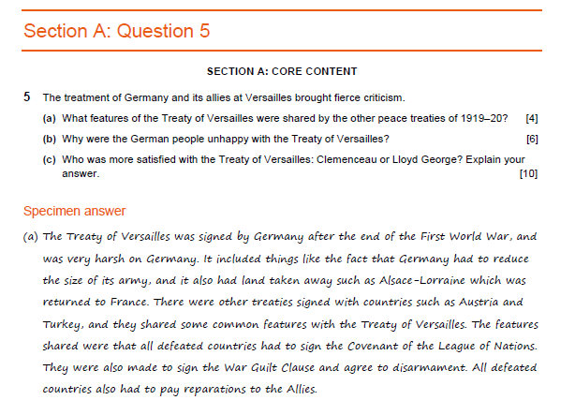

Specimen Paper Answers and Example Candidate Responses provide exemplification of the standards and a guide to expectations with detailed commentaries by examiners demonstrating how the mark scheme is applied. These are provided before and after first sitting for both preparation and improvement. (screenshots). We publish 300 ECRs with 60K downloads in 2019.

**Schemes of work**

We publish 450 schemes of work with 70+K downloads in 2019.

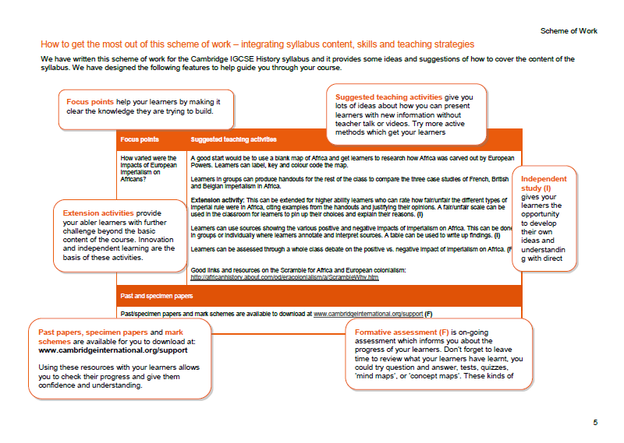

Schemes of work provide a suggested teaching programme for the entire syllabus content including teaching activities linked to resources and past papers. These are available as PDFs and in Word to allow personalisation by teachers. This support is unparalleled by our competitors. We publish 450 schemes of work with 70+K downloads in 2019. (screenshot)

**Video resources**

We have published over 300 videos on Vimeo since 2018

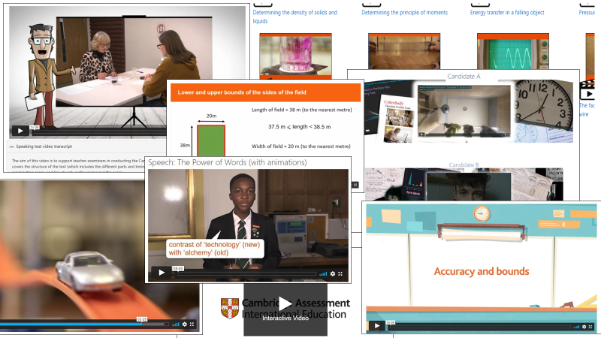

**We have produced videos and animations in house**

Using our own filming kit (Maths skills videos in Resource Plus)

Developed PowerPoint presentations from which we produce animations (Marine Science biological drawing skills video)

Using technologies like Videoscribe to animate resources (English Literature set text explainers)

Working with the studio to produce exam guidance for Speaking Tests

Commissioning coursework video submissions and using moderation samples

Using Adobe Creative Cloud (Adobe Premiere to edit videos) and Audacity at virtually no cost to the organisation.

**We have found, developed and managed high quality external suppliers** to produce videos and animations where we think a professional touch on the project is required, while also keeping a tight control on budgets and schedules to successfully deliver content.

Practical skills videos enhanced by adding interactive layers using H5P technology to produce virtual experiments

Filmed lesson delivery

Commissioned sophisticated animations to explain complex processes

**Resource Plus**

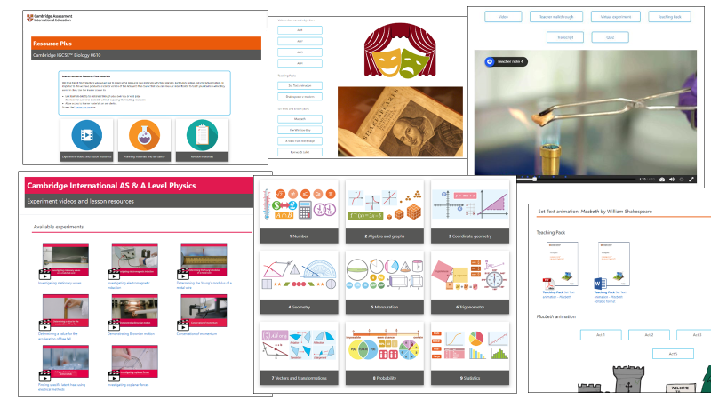

Resource Plus is a specific package which draws together and builds on all available support. These products contain experiment videos and lesson resources (lesson plans and worksheets) including an interactive version and a virtual experiment for the sciences, planning materials and safety considerations, revision materials – iECRs, Topic questions for formative assessment (allowing teachers to choose linked questions within RP), suggested connections between topics, detailed materials for developing skills as defined by the AOs, SOWs, TGs. (screenshot)

**(Layer 2)**

4 **What is the reach of these products?**

**School Support Hub**

There are currently over 32K resources on SSH plus syllabus and examination content.

There are 5000 past papers on the site and in 2019 there were 5 million downloads of these.

Teachers repeatedly visit SSH in 2019 over 90K teachers logged in to 880K sessions.

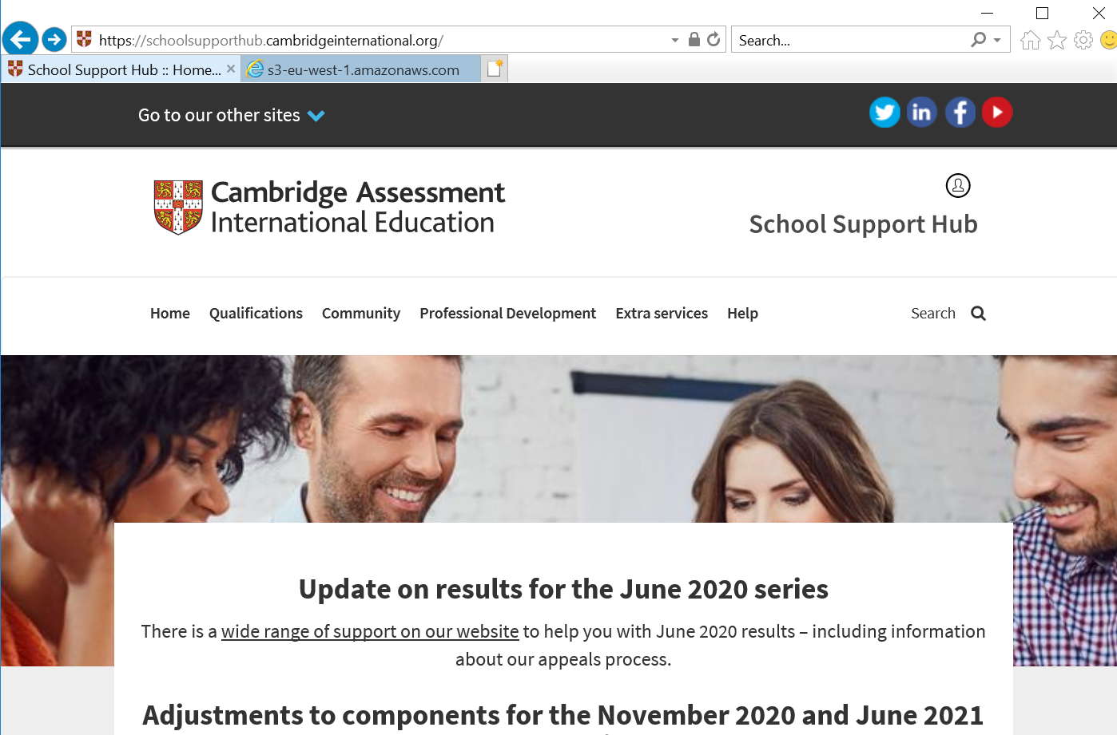

Teachers repeatedly visit SSH in 2019 over 90K teachers logged in to 880K sessions.

Since Single Sign On was implemented in August, Primary and Lower Secondary teachers will also be funnelled through SSH to reach 20 new Primary and Lower Secondary syllabuses.

There are currently over 32K resources on SSH plus syllabus and examination content.

There are 5000 past papers on the site and in 2019 there were 5 million downloads of these.

**Accesses to the Online Learning area**

* Pre March 2020 around 50,000 accesses a month
* Hit peak of 1,300,000 at end of March 2020
* For past five months (to end October 2020) is around 200,000

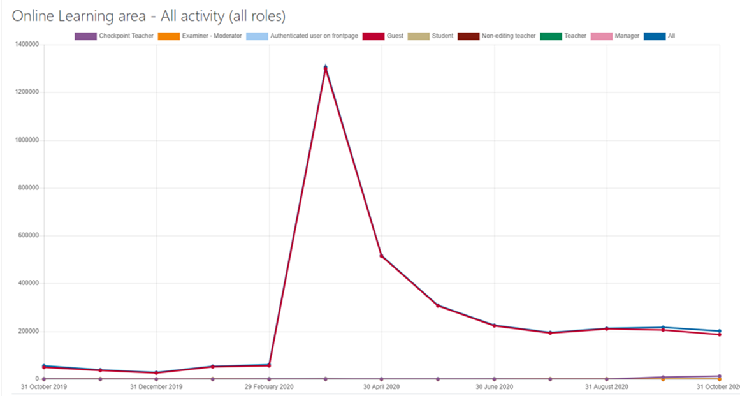

Accesses to the Online Learning area (the /classroom part of the Online Learning portal where Resource Plus, Global Perspectives and additional support materials are hosted). Each time someone triggers a page or visits one of our resources

* Pre March 2020 around 50,000 accesses a month
* Hit peak of 1,300,000 at end of March 2020
* For past five months (to end October 2020) is around 200,000

**Resource Plus users in the last 12 months**

Until March 2020 this was only available on subscription after that it was made available on the public website to all schools for the COVID crisis.

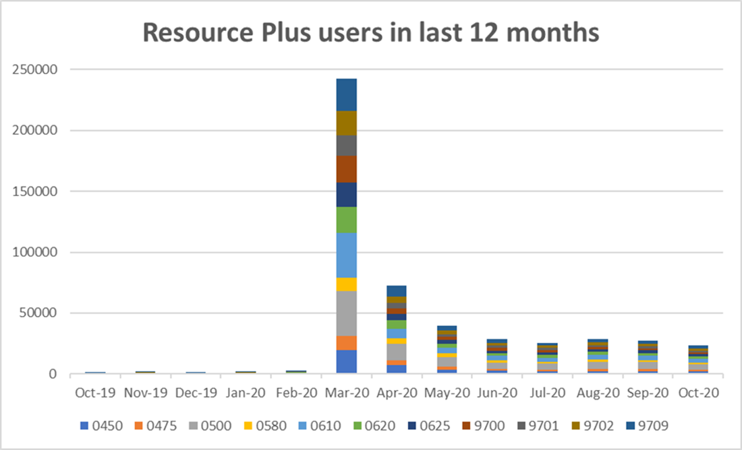

Resource Plus users in the last 12 months – each time a user access the start page of one of the 11 most popular Resource Plus products  
[Note – how do these graphs tie together? The analytics suggest that on average a user visits five pages or triggers five actions]

Until March 2020 this was only available on subscription after that it was made available on the public website to all schools for the COVID crisis.

**Vimeo watches of Curriculum Support resources** – during October 2020  
In the last month, there were 20,135 Curriculum Support video streams from different countries around the world, the top five being shown in the table below:

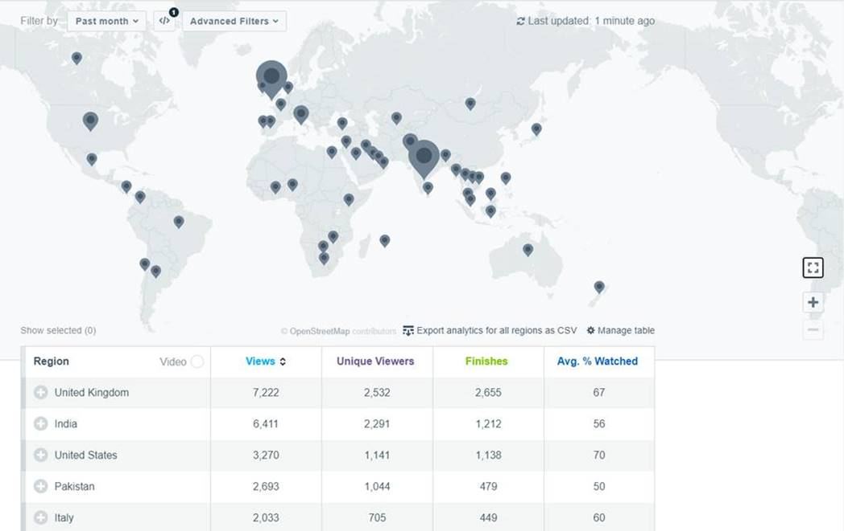

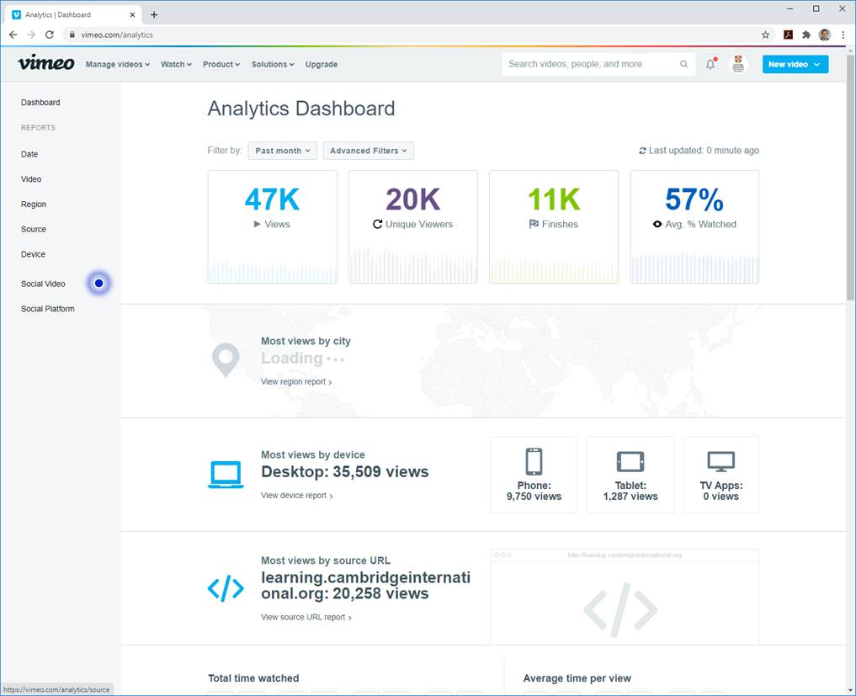

This data suggests that still the vast majority are consumed using desktops and laptops. I believe we could summarise that this is because they are being watched in schools and whereas some are very technically proficient, most will be being viewed through teacher laptops/projectors. We specifically made learner versions of this product in order that learners could use these directly during COVID.

**(Layer 2)**

5 **What holds us back?**

With a CMS we could:

* allow teachers to rearrange the suggested teaching sequence of our schemes of work to suit their own personal circumstances*
* allow teachers to view multiple product versions that cater for different abilities and contexts
* Manage the uploading of past papers automatically onto SSH. There are 5000 of these to manage after each series and this is currently achieved manually via spreadsheets. In 2019 there were 5 million downloads of these from the site.
* track usage much more effectively
* potentially supply publishers with content as licenced IP
* Reuse all types of content without having to rekey or redevelop including video
* Conceivably serve up appropriate content to customers as a result of tagging

We are currently unable to respond with sufficient nuance to the range of needs of our customers given the lack of a functioning CMS and the limitations of the SSH platform. The lack of centrally distributed data (including scripts and syllabuses) affects our ability to produce at scale and to allow customers to choose how and what they wish to see both on SSH and within the products themselves.

*We are already preparing to pilot this type of approach with regard to our schemes of work in a project called ‘Scope and Sequencing’. This will model what could be done if we had a CMS.