Worksheet F: Forces around a point experiment

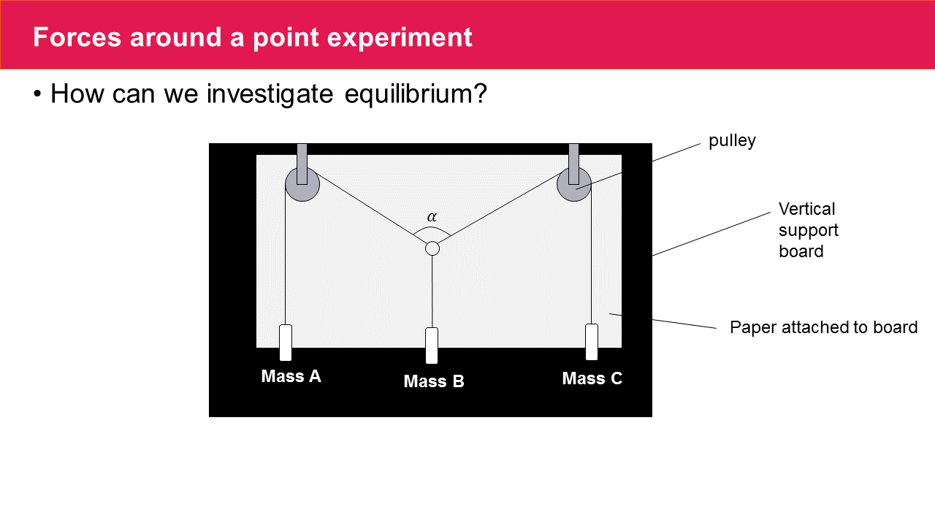

The diagram shows two strings tied to a light ring and passing over smooth pulleys.

Masses A and C are then suspended from the free end of these strings.

A third string is attached to the ring and mass B is hung directly below.

The whole system is mounted on a vertical board.

Good results can be achieved if the pulleys are smooth and the mass of the system is enough to counteract the effect of the friction.

You may want to start with 100g on B and 60g each on A and C.

* What would happen to the angle if we reduced the mass of B by 10g?
* Can you come up with a rule for the angle and the relationship with the mass at A and B (keeping A and C equal)?

What happens if we change the mass at A or C?