Worksheet D: Exit ticket

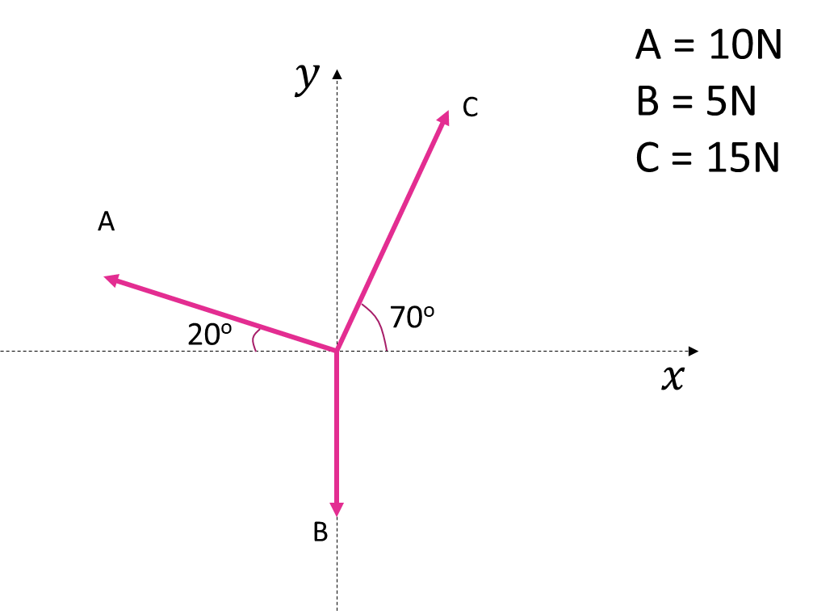

1. Find the *x* and *y* components of force A.
2. Find the sum of the components of all three forces.
3. Find the size and direction of the resultant force.