Worksheet H: Review of linear inequalities

**Part A**

Write down the correct inequalities in *x* which describe the sets of numbers identified on the number line.

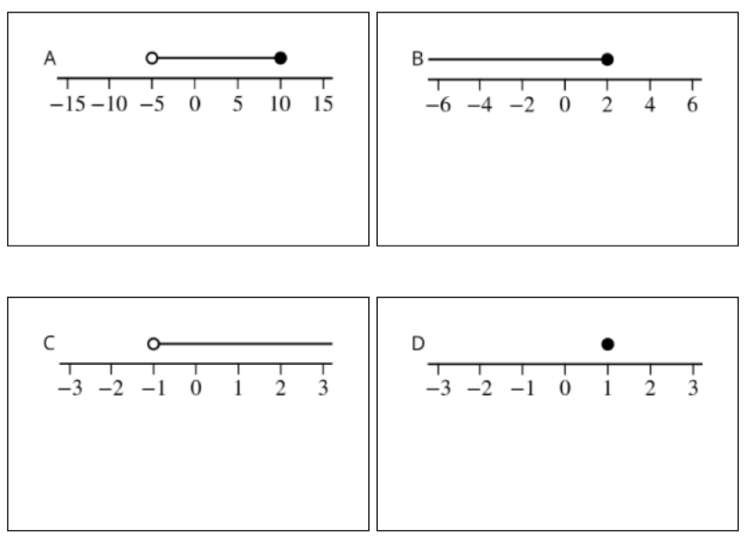

**Part B**

Solve the linear inequalities and write down the solution sets.

(1)

(2)

(3)

(4)