

Teacher Pack

Topic 1.2: Graph Transformations

Cambridge International AS & A Level

Mathematics 9709

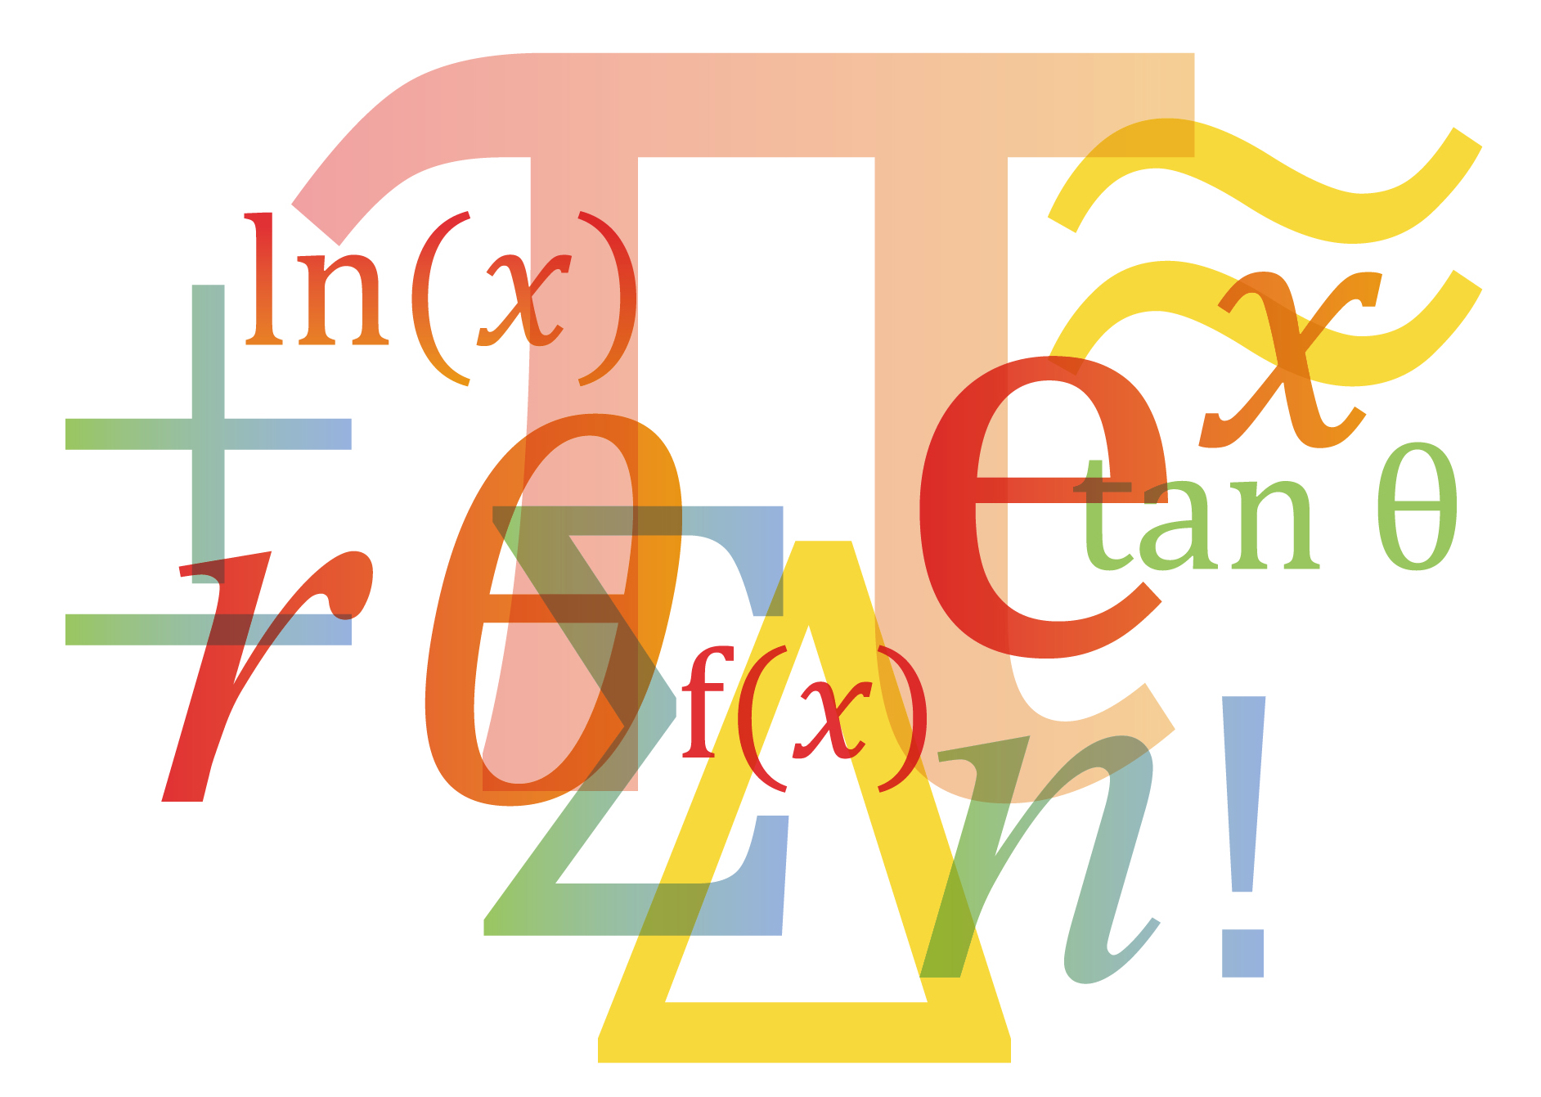

© Cambridge University Press & Assessment 2023 v1

Cambridge Assessment International Education is part of Cambridge University Press & Assessment. Cambridge University Press & Assessment is a department of the University of Cambridge.

Cambridge University Press & Assessment retains the copyright on all its publications. Registered centres are permitted to copy material from this booklet for their own internal use. However, we cannot give permission to centres to photocopy any material that is acknowledged to a third party even for internal use within a centre.

Contents

Contents 3

Introduction 4

Lesson preparation 5

Lesson 1: Translations 7

Lesson plan 2: Enlargements 9

Lesson plan 3: Combining Transformations 11

Planning your own lessons 13

Lesson reflection 14

Worksheets and answers 15

|  |  |
| --- | --- |
| **Icons used in this pack:** | |
|  | **Teacher preparation** |
|  | **Lesson plan** |
|  | **Lesson resource** |
|  | **Lesson reflection** |

Introduction

This pack will help you to develop your learners’ skills in mathematical thinking and mathematical communication, which are essential for success at AS & A Level and in further education.

Mathematical thinking and communication will be developed by focussing on:

These link to the course Assessment Objectives (AOs) which you can find in detail in the syllabus:

**A01 Knowledge and understanding**

**A02 Application and communication**

1. Conceptual understanding – the ‘why’ behind the ‘what’
2. Strategic competence – forming and solving problems
3. Adaptive reasoning – explanations, justifications and deductive reasoning

Throughout all activities, the learners will also develop:

* Procedural fluency – know when, how and which rules to use
* Positive disposition – believe maths can be learned, applied and is useful
* Their skills in writing mathematically – writing working & proofs

Each *Teacher Pack* contains one or more lesson plans and associated resources, complete with a section of preparation and reflection.

**Each lesson is designed to be an hour long but you should adjust the timings to suit the lesson length available to you and the needs of your learners.**

**Important note**

Our *Teacher Packs* have been written by **classroom teachers** to help you deliver topics and skills that can be challenging. Use these materials to supplement your teaching and engage your learners. You can also use them to help you create lesson plans for other topics.

***This content is designed to give you and your learners the chance to explore a more active way of engaging with mathematics that encourages independent thinking and a deeper conceptual understanding. It is not intended as specific practice for the examination papers.***

The *Teacher Packs* are designed to provide you with some example lessons of how you might deliver content. You should adapt them as appropriate for your learners and your centre. A single pack will only contain at most four lessons, it will **not** cover a whole topic. You should use the lesson plans and advice provided in this pack to help you plan the remaining lessons of the topic yourself.

Lesson preparation

This *Teacher Pack* will cover the following syllabus content.

|  |  |
| --- | --- |
| **Candidate should be able to:** | **Notes and examples** |
| * understand and use the transformations of the graph of given by   , ,  , and simple combinations of these. | Including use of the terms ‘translation’, ‘reflection’ and ‘stretch’ in describing transformations. Questions may involve algebraic or trigonometric functions, or other graphs with given features. . |

The remaining 4 bullet points for topic 1.2 are not covered in this *Teacher Pack* (see the syllabus for detail). You will need to write your own lesson plans for these items.

|  |  |
| --- | --- |
| **Candidate should be able to:** | **Notes and examples** |
| * understand the terms function, domain, range, one-one function, inverse function and composition of functions |  |
| * identify the range of a given function in simple cases, and find the composition of two given functions * determine whether or not a given function is one-one, and find the inverse of a one-one function in simple cases * illustrate in graphical terms the relation between a one-one function and its inverse | e.g. range of for and range of  for . Including the condition that a composite function can only be formed when the range of is within the domain of .  Sketches should include an indication of the mirror line . |

Dependencies

For all lesson plans in this *Teacher Pack*, knowledge from the following 9709 syllabus content is required.

|  |  |
| --- | --- |
| **Candidate should be able to:** | **Notes and examples** |
| * know the shapes of graphs of the form * , where is a constant and is an integer (positive or negative) or . * find roots and intercepts of basic polynomial functions. |  |
|  |  |

Prior knowledge and skills

For all lessons, it is assumed that learners have already completed Cambridge IGCSETM Mathematics 0580, or a course at an equivalent level. See the syllabus for more details of the expected prior knowledge for taking Cambridge International AS & A Level Mathematics 9709.

When planning any lesson, make a habit of always asking yourself the following questions about your learners’ prior knowledge and skills:

* Do I need to re-teach this or do learners just need some practice?
* Is there an interesting activity that will efficiently achieve this?

It will be hugely beneficial if learners have practiced good graph sketching skills, and can sketch of range of functions such as quadratics, cubics, quartics and reciprocal graphs.

Key learning objectives

The following list represents the main underlying concepts that you should make sure your learners have understood by the end of this topic.

Function notation can be used to describe transformations. Your learners should know which notation refers to which transformation.

* Learners should be able to sketch any given transformation of a function.
* Given a ‘transformed’ graph, learners should be able to accurately describe all of the transformations applied.
* When applying two transformations in the direction, the stretch/reflection should be applied before the translation.

Why this topic matters

This topic is a key milestone in developing how we can manipulate functions in order to model a wide range of different situations. For example, you can transform a sine graph to model the heights of the tides by applying stretches in both the x and y direction, as well as a vertical translation.

Key terminology and notation

Your learners will need to be confident with the following terminology and notation.

**Transformation** A way of changing the size or shape of an object/graph

**Rotation** A circular movement about a centre or axis

**Reflection** The image of an object in a reflective surface/line

**Sketch** Not as precise as plotting, but still has roots and intercepts

Lesson progression

Lesson 1 covers the first of the three transformations, which is translation. As it is largely to do with addition it is usually the easier one to start with. This lesson also starts to get learners thinking about which direction the transformation is in, and how that affects the function notation used.

Lesson 2 builds in the final two transformations, enlargements and reflections, and also links it to the appropriate function notation.

Lesson 3 will test whether the learners have understood the previous two lessons by making combinations of transformations (2 or more on the same function). You will need to ensure that your learners are secure in their understanding before attempting this lesson.

Going forward

This topic links to modelling real-life situations using functions. We have to use combinations of transformations in order to create functions that perfectly model a given situation. An example of this is using an exponential decay graph to model the temperature of an object cooling over time.

Lesson 1: Translations

|  |  |
| --- | --- |
| **Preparation** | * Use the websites from the PowerPoint if you would like to pre-make any graphs ready to be translated during the lesson. |
|  |  |
| **Resources** | * PowerPoint #1 - Translating * Worksheet A * Graph paper for sketching |
|  |  |
| **Learning objectives** | By the end of the lesson:   * ***all*** learners should understand and be able to apply a vertical translation * most learners should be able to apply any translation, as well as accurately describe one * some learners should be able to sketch a graph that has been translated in both x and y directions. |

Common misconceptions

|  |  |  |
| --- | --- | --- |
| **Misconception** | **Problems this can cause** | **An example way to resolve the misconception** |
| That applying the transformation will translate the graph to the right, instead of the left. | If learners believe this then they will not be able to sketch the subsequent graph correctly. | A graph drawing package will help speed up this process. |

| **Timings** | **Activity** |
| --- | --- |
| 5 min | **Starter/Introduction**  Ask learners to remember what transformations they could apply to 2D shapes (knowledge from Cambridge IGCETM) These are the transformation we will be applying to graphs. |
| 10 mins  10 mins  3 mins  5 mins | **Main lesson**  Work through slide 3, getting learners to think for themselves as to what might happen to the graph if we apply the ‘+1’ to the function. Explain the reason *why* the graph appears to rise vertically.  On slide 4 the learners should be able to predict the outcome based on the previous slide.  Slide 5 is designed to show the learners that the effect works for any value that you add on to the function. Using a DESMOS/Geogebra graph with sliders will show this very clearly.  Slide 6 shows this principle working with a cubic graph. It has key coordinates annotated, so you can emphasise the translation that has occurred.  Slide 7 gives them the key point for their notes.  Slides 9–13 work in a very similar way to slides 3–7, and give learners the grounding and understanding of horizontal translations. There are opportunities on these slides to get the learners to make predictions. There is another key point for their notes on slide 13.  Slide 14 gives a quick example of how you should describe a given translation.  Slides 15 and 16 touch on some of the harder aspects of the lesson. Ask learners to predict what will happen with the graph that is transformed in 2 different directions.   |  | | --- | | **Challenge:** You could challenge your most able learners to apply these translations to other types of graphs they have seen. (Trigonometric graphs, or exponential if they have seen it already). |  |  | | --- | | **Support:** You can support learners with visualising these transformations by allowing them to use graphing software, and letting them apply to the translations one at a time. Using sliders on either Desmos or GeoGebra is a great way for learners to experience the effects of a translation. | |
| 5 mins | **Plenary**  You can quickly use Desmos/GeoGebra to create a few different polynomial graphs, pick one of the roots, and ask the class where that point ends up once a given translation is applied. You could either ask individual learners for answers, or use mini-whiteboards. |

|  |  |
| --- | --- |
| **Reflection** | Reflect on your lesson, use the **Lesson reflection** notes to help you. |
|  |  |

Lesson plan 2: Enlargement and Reflection

|  |  |
| --- | --- |
| **Preparation** | Use the websites from the PowerPoint if you would like to pre-make any graphs ready to be transformed during the lesson. |
|  |  |
| **Resources** | * PowerPoint #2 – Enlargement and Reflection * Worksheet B * Graph paper for sketching |
|  |  |
| **Learning objectives** | By the end of the lesson:   * ***all*** learners should be able to correctly reflect a function in either the x or y axis * most learners should be able to correctly stretch a function in either the x or y direction * some learners should be able to correctly apply any combination of these transformations. |

Common misconceptions

|  |  |  |
| --- | --- | --- |
| **Misconception** | **Problems this can cause** | **An example way to resolve the misconception** |
| For stretches in the direction, that the scale factor is , and not | Learners will draw their sketches incorrectly. | Constantly reinforce with learners the direction always reacts in an ‘inverse’ way. |

| **Timings** | **Activity** |
| --- | --- |
| 10 mins | **Starter/Introduction**  This is a recap from the previous lesson. Learners will sketch a quadratic, then use this to apply the two individual translations in parts c) and d). Answers are on the next slide. |
| 10 mins  5 mins  5 mins | **Main lesson**  Slide 4 shows a quadratic alongside the same quadratic multiplied by 2. Allow learners to discuss what has happened to the graphs, before concluding that it has only stretched vertically by 2, not horizontally. Make sure you highlight the fact that the roots are unaffected by a vertical stretch, as this is always true. Slide 5 explains why this happens in detail, and slide 6 gives another example.  Slide 7 gives your learners the opportunity to predict what will happen for another example.  Slide 8 shows this transformation working for a cubic, and reinforces the point that stretches will work on any function.  Slide 9 asks learners how we could use this technique to make graphs ‘smaller’. It then shows an example of a fractional value, and that it looks like it ‘squashes’ the graph. Remind them that we still call this a stretch, even though the function is multiplied by a number smaller than 1.  Slide 10 gives the key points regarding stretching graphs vertically.  The next 4 slides are very similar to the previous ones, however they show what happens for a horizontal stretch. The key thing to point out is that it is a reciprocal relationship between the value you multiply by, and the stretch that is applied. The key point is on slide 15.  Slides 16–21 go through reflecting functions. Learners typically find this transformation relatively straight forward. Be careful when describing reflections, as learners sometimes write the wrong axis. This is because a horizontal reflection is in the vertical axis, and vice versa.  Now get learners to work through Worksheet B.   |  | | --- | | **Challenge:** Using graphical software, get learners to plot a function, and then use a slider to change the scale factor of the stretch. Get them to investigate when the scale factor goes from being small and fractional, to zero, then to the negative numbers. They could even make the link that a reflection gives the same results as a stretch scale factor -1. |  |  | | --- | | **Support:** If some learners are struggling to apply the enlargements to these graphs, then they could use some graphical software to help them visualise the graphs first. | |
| 5 mins | **Plenary**  You can quickly use Desmos/GeoGebra to create a few different polynomial graphs, pick one of the roots, and ask the class where that point ends up once a given translation is applied. You could either ask individual learners for answers, or use mini-whiteboards. |

|  |  |
| --- | --- |
| **Reflection** | Reflect on your lesson, use the **Lesson reflection** notes to help you. |
|  |  |

Lesson plan 3: Combining Transformations

|  |  |
| --- | --- |
| **Preparation** | Use the websites from the PowerPoint if you would like to pre-make any graphs ready to be translated during the lesson. |
|  |  |
| **Resources** | * PowerPoint #3 ‘Combining Transformations’ * Worksheet C * squared paper would be beneficial for learner sketches |
|  |  |
| **Learning objectives** | By the end of the lesson:   * ***all*** learners should be able to apply any single graph transformation seen in this topic * most learners should be able to correctly apply a simple combination of 2 different transformations that occur in two different directions * some learners should be able to correctly apply any combination of transformations, regardless of type or direction. |

Common misconceptions

|  |  |  |
| --- | --- | --- |
| **Misconception** | **Problems this can cause** | **An example way to resolve the misconception** |
| For stretches in the direction, that the scale factor is , and not . | Learners will draw their sketches incorrectly. | Constantly reinforce with the learners the direction always reacts in an ‘inverse’ way. |

| **Timings** | **Activity** |
| --- | --- |
| 5 mins | **Starter/Introduction**  To test for understanding of the previous lessons, see if your learners can recall all of the graph transformations from the previous lessons, including the accompanying function notation. |
| 5 min per slide  (20 mins total) | **Main lesson**  The main activities in this lesson focus around one particular graph. On the accompanying slides there is a different example of a combination of graph transformations that has taken place. The initial one is just a simple stretch of scale factor 2 in the direction. This teaches the learners to be able to sketch a graph transformation when they are not given the function itself but a selection of critical points such as roots intercepts and turning points. You can get learners to calculate the coordinates and share them before you display them.  The second graph features two different transformations that occur in both the and direction. This example was chosen to show the learners that when you have two transformations that are in different directions then the order in which you apply the transformations is irrelevant. For this example, I applied the translation first. It is a nice idea to get the learners to try the transformations in the other order to reinforce that you do end up with the same graph.  The third graph features a reflection and a stretch in the direction. Again, the order of the two transformations is irrelevant due to them being in different directions.  The final example gives learners an example of what happens when you have two different graph transformations that are both in the direction. When this is the case, ensure you stress that the principles of BIDMAS must be followed and that a stretch must be carried out before a translation. (You will not come across two transformations in the direction at this point in the course). You could get learners to sketch the transformation applied in the wrong order so they can see that it will be incorrect for themselves.  Once learners have understood this, please move on to the worksheet C.   |  | | --- | | **Challenge:** You could give your most able learners an example of 3 different transformations, for example: |  |  | | --- | | **Support:** If some learners are struggling to apply two different transformations to the same graph, then have them go back to the previous worksheets and build their confidence with applying one correctly at a time. Only then should they attempt combinations of transformations. | |
| 5 mins | **Plenary**  You can quickly use Desmos/GeoGebra to create a few different polynomial graphs, pick one of the roots, and ask the class where that point ends up once a given translation is applied. You could either ask individual learners for answers, or use mini-whiteboards. |

|  |  |
| --- | --- |
| **Reflection** | Reflect on your lesson, use the **Lesson reflection** notes to help you. |
|  |  |

Planning your own lessons

You now need to plan lessons to cover the following bullet points:

|  |  |
| --- | --- |
| **Candidate should be able to:** | **Notes and examples** |
| * understand the terms function, domain, range, one-one function, inverse function and composition of functions |  |
| * identify the range of a given function in simple cases, and find the composition of two given functions * determine whether or not a given function is one-one, and find the inverse of a one-one function in simple cases * illustrate in graphical terms the relation between a one-one function and its inverse | e.g. range of for and range of for . Including the condition that a composite function can only be formed when the range of is within the domain of .  Sketches should include an indication of the mirror line . |

Follow the structure of the *Skills Pack*, and use techniques from the ‘How to’ guides, to create your own engaging lessons to cover these bullet points. Consider what preparation you need for each lesson: what prior knowledge is needed, what are the key objectives, what are the dependencies, what common misconceptions are there, and so on.

You will find some activity suggestions in the Scheme of Work.

Lesson reflection

As soon as possible after the lesson you need to think about how well it went.

One of the key questions you should always ask yourself is:

*Did all learners get to the point where they can access the next lesson? If not, what will I do?*

Reflection is important so that you can plan your next lesson appropriately. If any misconceptions arose or any underlying concepts were missed, you might want to use this information to inform any adjustments you should make to the next lesson.

It is also helpful to reflect on your lesson for the next time you teach the same topic. If the timing was wrong or the activities did not fully occupy the learners this time, you might want to change some parts of the lesson next time. There is no need to re-plan a successful lesson every year, but it is always good to learn from experience and to incorporate improvements next time.

**To help you reflect on your lesson, answer the most relevant questions below.**

*Were the lesson objectives realistic?*

*What did the learners learn today? Or did they learn what was intended? Why not?*

*What proportion of the time did we spend on the most important topics?*

*Were there any common misconceptions?*

*What do I need to address next lesson?*

*What was the learning atmosphere like?*

*Did my planned differentiation work well?*

*How could I have helped the lowest achieving learners to do more?*

*How could I have stretched the highest achieving learners even more?*

*Did I stick to timings?*

*What changes did I make from my plan and why?*

Summary evaluation

**What two things went really well? (Consider both teaching and learning.)**

**What two things would have improved the lesson? (Consider both teaching and learning.)**

**What have I learned from this lesson about the class or individuals that will inform my next lesson?**

Worksheets and answers

|  |  |  |
| --- | --- | --- |
|  | **Worksheet** | **Answers** |
| **For use with *Lesson 1*:** |  |  |
| **A:** Translation | **Page 16** | **Page 17** |
|  |  |  |
| **For use with *Lesson 2*:** |  |  |
| **B:** Enlargement and Reflection | **Page 19** | **Page 20** |
|  |  |  |
| **For use with Lesson 3:** |  |  |
| **C:** Combining Transformations | **Page 23** | **Page 24** |

Worksheet A: Translating Functions

**1** Sketch the graph of . Now sketch the following graphs:

**a** **b** **c**

**d** **e** **f**

**2** **a** Sketch the graph of where

**b** On separate diagrams sketch the graphs of and

**3 a** Sketch the graph of where

**b** On a separate diagram draw a sketch of

**c** Find the equation in terms of

**4** **a** Sketch the graph of where

**b** On separate diagrams sketch the graphs of and

**c** Find the equation in terms of

**5** Sketch the graph of . Also sketch the graph of

**6** **a** Sketch the graph of where

**b** On separate diagram draw a sketch of

**7** **a** Sketch the graph of

**b** Describe how the graph in **part a** would be transformed to create

**b** Hence sketch

Worksheet A: Answers

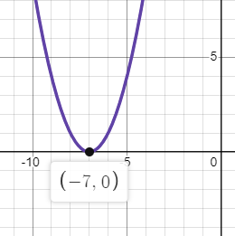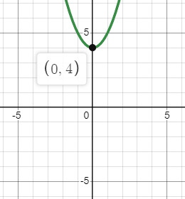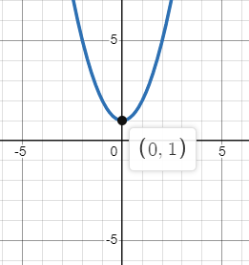**1a** **b c**

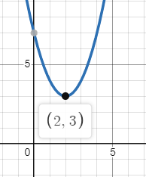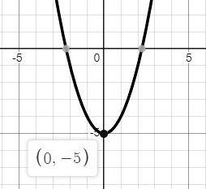

**d** **e 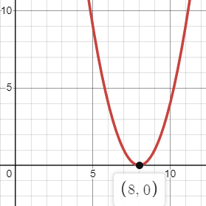 f**

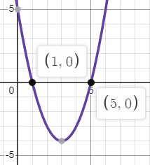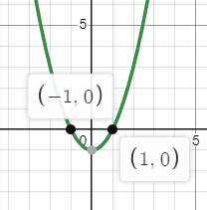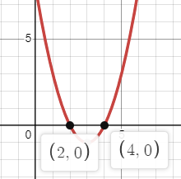

**2a** **b c**

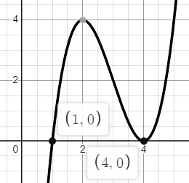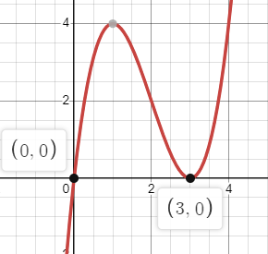

**3a**  **b c**

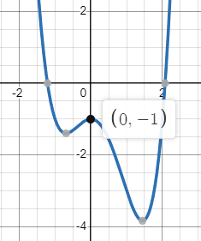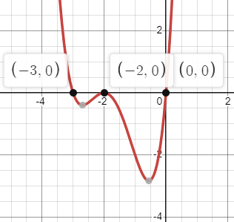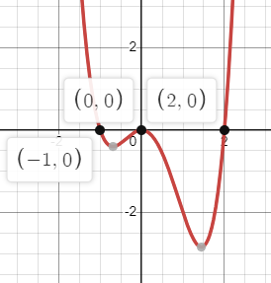**4a** **b**

**4c**

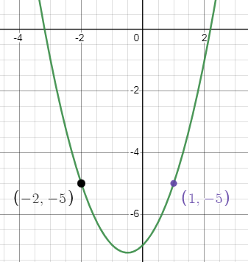**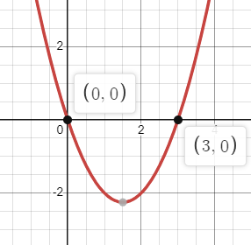5a 5b**

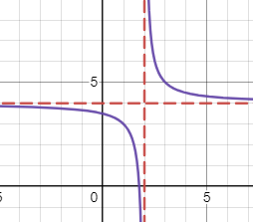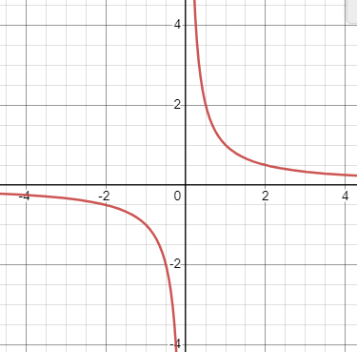

**6a 6b**

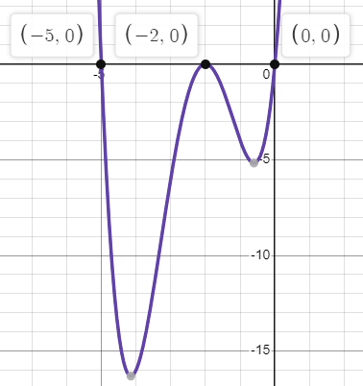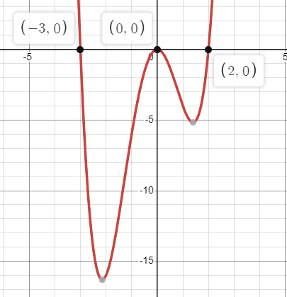

**7a 7b**

Worksheet B: Enlargement and Reflection

**1** Sketch the graphs of . Now sketch the following transformations:

**a** **b** **c**

**d** **e** **f**

**2** **a** Sketch the graph of where

**b** On separate diagrams sketch the graphs of , and

**3 a** Sketch the graph of where

**b** On a separate diagram draw a sketch of and

**c** Find the equation in terms of

**4** **a** Sketch the graph of where

**b** On separate diagrams sketch the graphs of and

**c** Find the equation in terms of

**5** Sketch the graph of . Also sketch the graph of

**6** **a** Sketch the graph of where

**b** On **the same** diagram draw a sketch of

**7** **a** Sketch the graph of

**b** Describe how the graph in **part a** would be transformed to create

**b** Hence sketch )

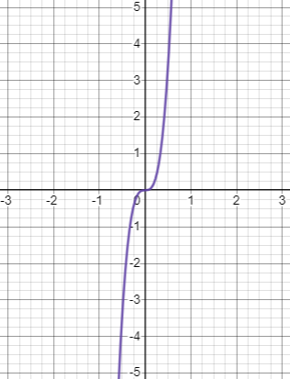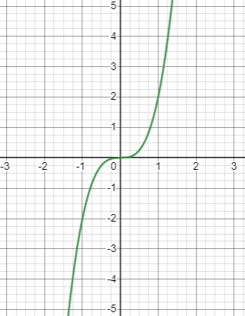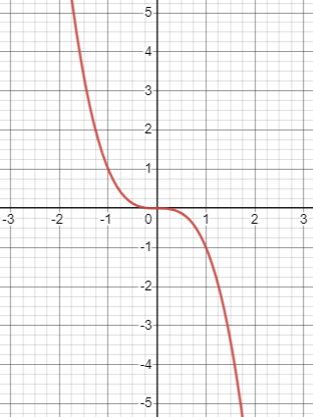Worksheet B: Answers

**1a** **1b 1c**

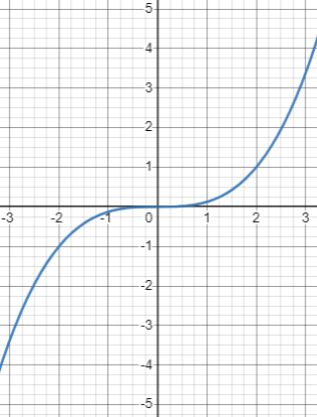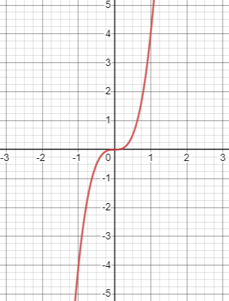

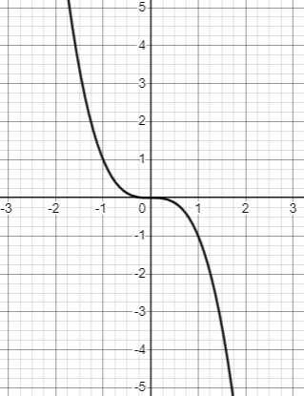**1d 1e 1f**

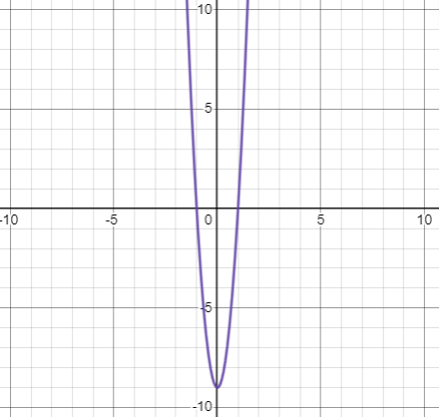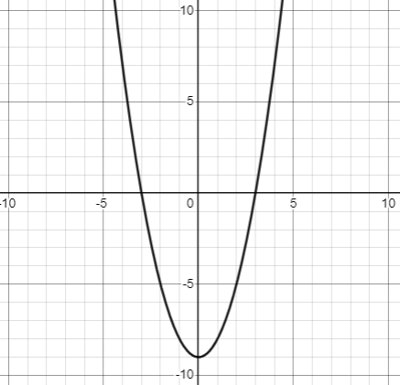

**2 2a**

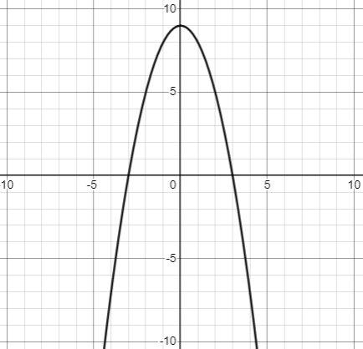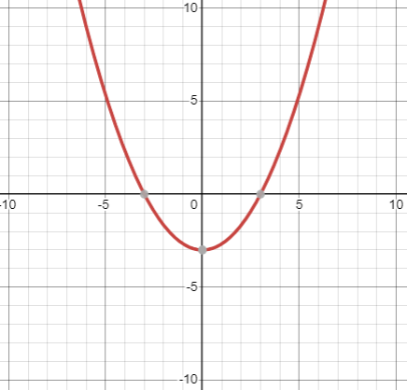**2b 2c**

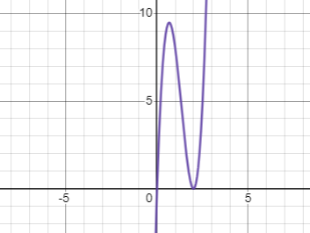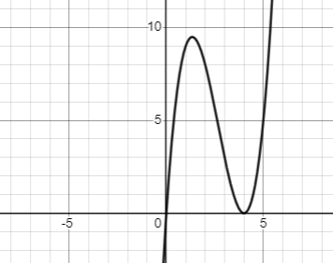**3a 3b**

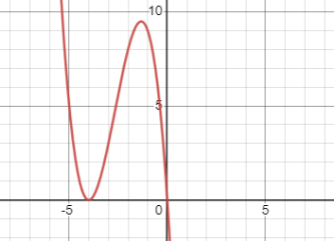

**3b 3c f(2x)**

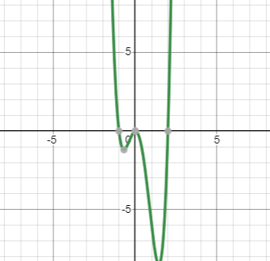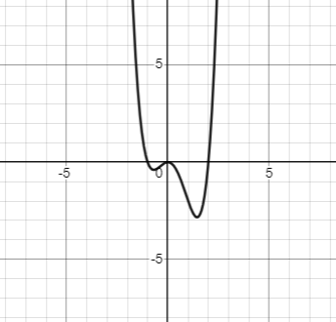

**4a 4b**

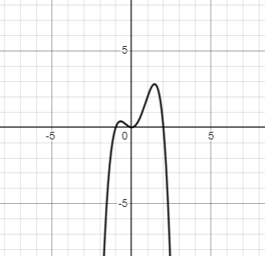

**4b 4c**

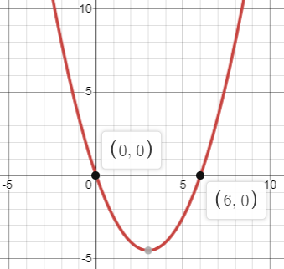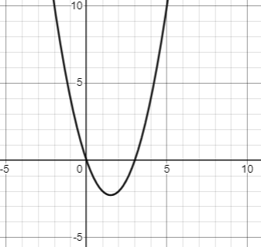**5a 5b**

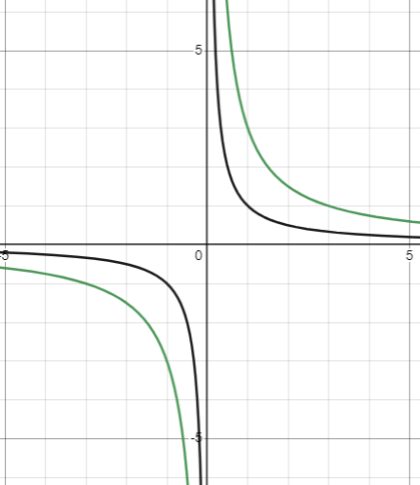**6a and 6b**

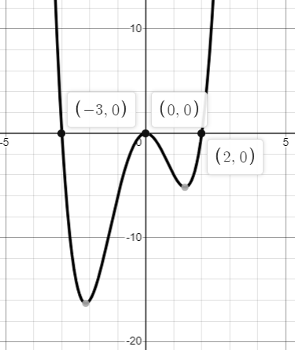

**7a 7b** Stretch, sf ½ in the x direction

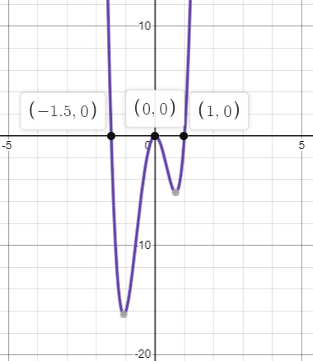

**7c**

Worksheet C: Combining Transformations

The graphs below show three different functions of . For all functions, please sketch the following:

**a** **b**

**c** **d**

**e** **f**

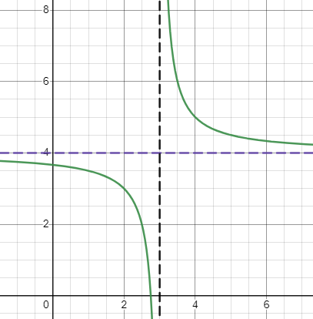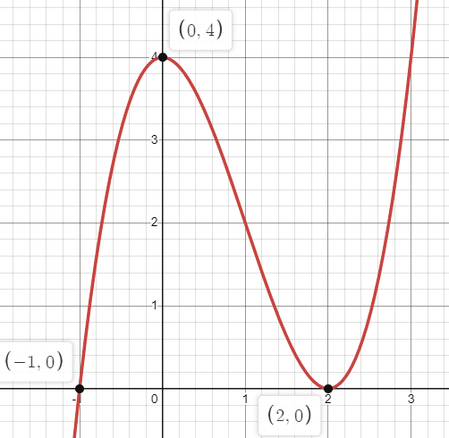

**1 2**

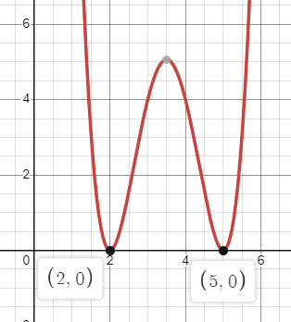

**3**

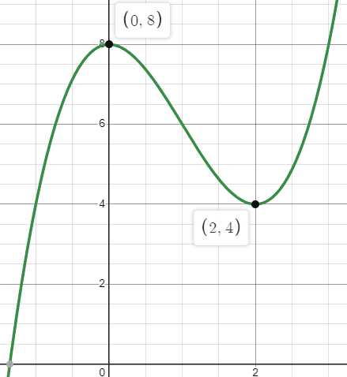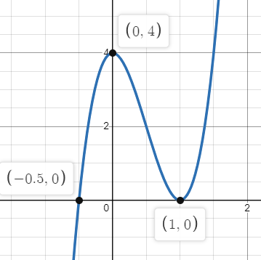Worksheet C: Answers

**1a** **1b**

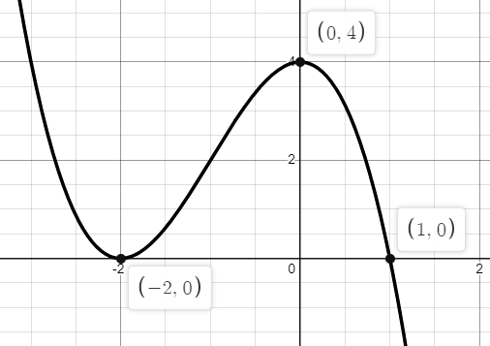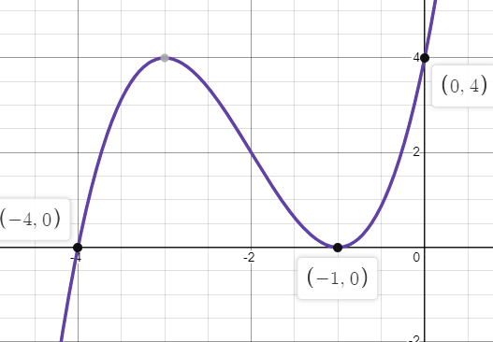

**1c 1d**

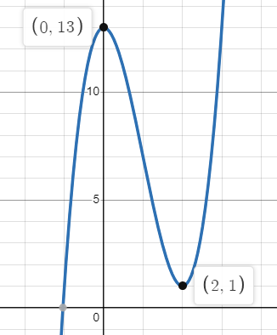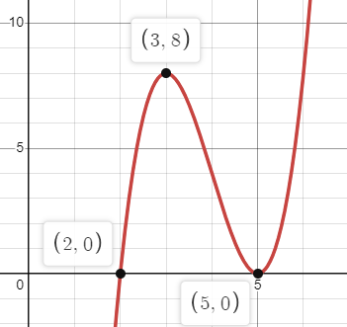

**1e 1f**

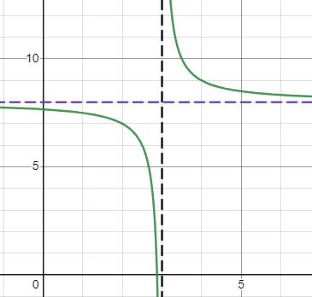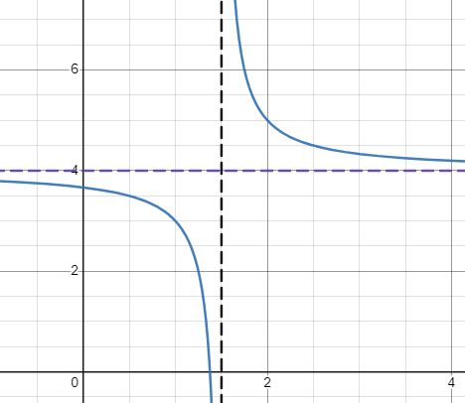

**2a 2b**

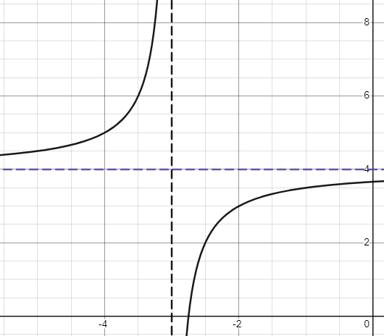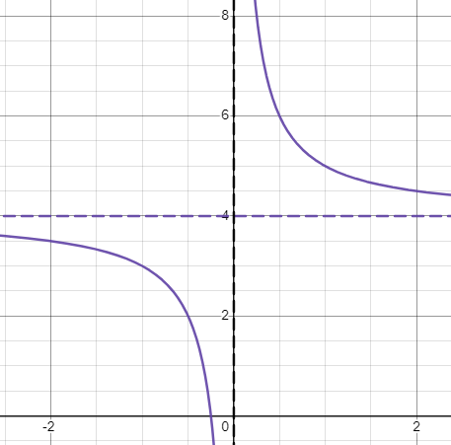

**2c 2d**

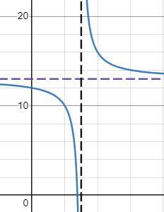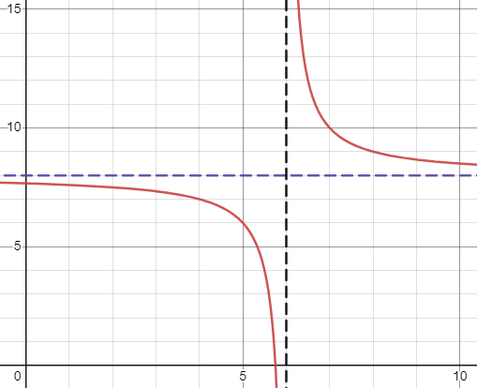

**2e 2f**

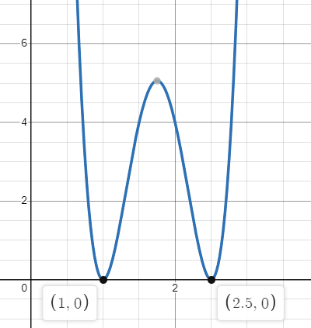

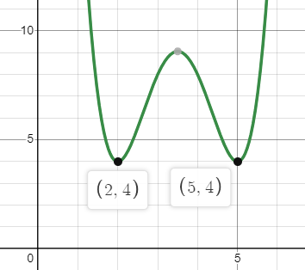**3a 3b**

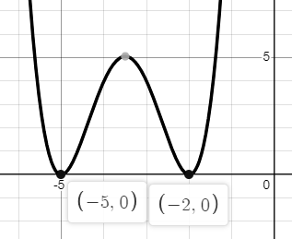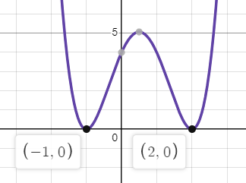**3c 3d**

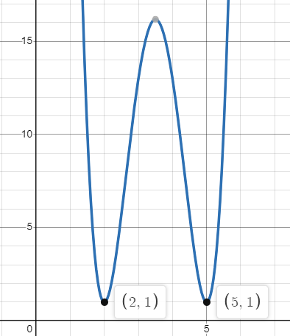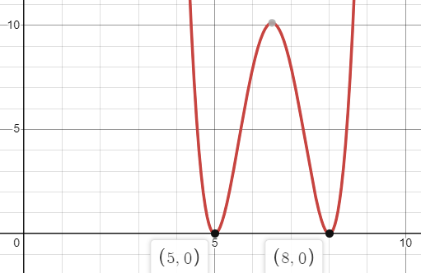**3e 3f**

Cambridge Assessment International Education  
The Triangle Building, Shaftesbury Road, Cambridge, CB2 8EA, United Kingdom  
t: +44 1223 553554     
e: [info@cambridgeinternational.org](mailto:info@cambridgeinternational.org)    [www.cambridgeinternational.org](http://www.cambridgeinternational.org)

© Cambridge University Press & Assessment 2023 v1