

Teaching Pack
Unit conversions
Cambridge IGCSE™
Mathematics 0580

This Teaching Pack can also be used with the following syllabuses:
• Cambridge IGCSE™ (9–1) Mathematics 0980
• Cambridge IGCSE™ International Mathematics 0607
• Cambridge O Level Mathematics 4024

© Cambridge University Press & Assessment 2024
Cambridge Assessment International Education is part of Cambridge University Press & Assessment. Cambridge University Press & Assessment is a department of the University of Cambridge.

Cambridge University Press & Assessment retains the copyright on all its publications. Registered centres are permitted to copy material from this booklet for their own internal use. However, we cannot give permission to centres to photocopy any material that is acknowledged to a third party even for internal use within a centre.
Contents
Introduction 4
Skill: Unit conversions 5
Common misconceptions: Unit conversions 8
Lesson 1: Converting between simple units of measure 9
Lesson 2: Area and volume 12
Lesson 3: Compound measures 13
Lesson 4: Interpreting travel and conversion graphs 15
Lesson 5: Interpreting travel graphs (Extended only) 17
Links to websites: Unit conversions 20
Worksheets and answers 21

Icons used in this pack:
 | Lesson
 | Video
 | Assessment opportunity

Introduction
This pack will help you to develop your learners’ mathematical skills as defined by assessment objective 1 (AO1 Knowledge and understanding of mathematical techniques) in the course syllabus.

Important note
Our Teaching Packs have been written by classroom teachers to help you deliver topics and skills that can be challenging. Use these materials to supplement your teaching and engage your learners. You can also use them to help you create lesson plans for other skills.

This content is designed to give you and your learners the chance to explore mathematical skills. It is not intended as specific practice for exam papers.

This is one of a range of Teaching Packs. Each pack is based on one unit of work related to a mathematical theme. The packs can be used in any order to suit your teaching sequence.

In this pack you will find the lesson plans and worksheets for learners you will need to successfully complete the teaching of this unit.

Skill: Unit conversions
This Teaching Pack links to the following syllabus content (see syllabus for detail):
- C5.1 Use current units of mass, length, area, volume and capacity in practical situations and express quantities in terms of larger or smaller units.
- C1.15 Calculate using money and convert from one currency to another.
- C2.10 Interpret and use graphs in practical situations including travel graphs and conversion graphs. Draw graphs from given data.
- E2.10 Apply the idea of rate of change to simple kinematics involving distance–time and speed–time graphs, acceleration and deceleration. Calculate distance travelled as area under a speed–time graph.
For assessments from 2025
- C/E5.1 Use metric units of mass, length, area, volume and capacity in practical situations and convert quantities into larger or smaller units.
- C/E1.16 Calculate with money. Convert from one currency to another.
- C/E2.9 Use and interpret graphs in practical situations including travel graphs and conversion graphs. Draw graphs from given data.
- E2.9 Apply the idea of rate of change to simple kinematics involving distance–time and speed–time graphs, acceleration and deceleration. Calculate distance travelled as area under a speed–time graph.

The pack covers the following mathematical skills, adapted from AO1: Demonstrate Knowledge and understanding of mathematical techniques (see syllabus for assessment objectives):
- performing calculations by suitable methods, including using a calculator
- understanding systems of measurement in everyday use and making use of these
- estimating, approximating and working to degrees of accuracy appropriate to the context and converting between equivalent numerical forms.
For assessments from 2025
AO1: Knowledge and understanding of mathematical techniques
- perform calculations with and without a calculator
- understand and use measurement systems in everyday use
- estimate, approximate and work to degrees of accuracy appropriate to the context and convert between equivalent numerical forms.

Prior knowledge
Knowledge from the following syllabus topics is useful for the development of skills in this unit.
- C1.8 Use the four rules for calculations with whole numbers, decimals and fractions (including mixed numbers and improper fractions), including correct ordering of operations and use of brackets.
- C1.11 Demonstrate an understanding of ratio and proportion. Calculate average speed. Use common measures of rate.
- C2.1 Use letters to express generalised numbers and express basic arithmetic processes algebraically. Substitute numbers for words and letters in formulae. Rearrange simple formulae. Construct simple expressions and set up simple equations.
- C3.4 Interpret and obtain the equation of a straight-line graph in the form y = mx + c.
- C4.4 Calculate lengths of similar figures.

For assessments from 2025
- C/E1.6 Use the four operations for calculations with integers, fractions and decimals, including correct ordering of operations and use of brackets.
- C/E1.11 Understand and use ratio and proportion to: give ratios in their simplest form, divide a quantity in a given ratio and use proportional reasoning and ratios in context.
- C/E1.12 Use common measures of rate. Apply other measures of rate. Solve problems involving average speed.
- C/E2.1 Know that letters can be used to express generalised numbers Substitute numbers into expressions and formulas.
- C/E2.3 Simplify expressions by collecting like terms.
- C/E2.5 Construct simple expressions, equations and formulas.
- C/E3.5 Interpret and obtain the equation of a straight-line graph in the form y = mx + c.
- C/E4.4 Calculate lengths of similar shapes.

Going forward
The knowledge and skills gained from this Teaching Pack can be used for when you teach learners to:
- C1.11 Demonstrate an understanding of ratio and proportion. Calculate average speed. Use common measures of rate - to include numerical problems involving direct and inverse proportion. Use ratios and scales in practical situations
- E1.11 Demonstrate an understanding of ratio and proportion. Increase and decrease a quantity by a given ratio. Calculate average speed. Use common measures of rate - to include numerical problems involving direct and inverse proportion. Use ratios and scales in practical situations
- E2.8 Express direct and inverse proportion in algebraic terms and use this form of expression to find unknown quantities.
For assessments from 2025
- C/E1.11 Understand and use ratio and proportion to: give ratios in their simplest form, divide a quantity in a given ratio and use proportional reasoning and ratios in context.
- C/E1.12 Use common measures of rate. Apply other measures of rate. Solve problems involving average speed.
- E2.8 Express direct and inverse proportion in algebraic terms and use this form of expression to find unknown quantities.

Before you begin
This Teaching Pack includes a Teacher Introduction video to which you should refer before
using the resources in this pack. The video is available to watch in Resource Plus within the unit relevant to this Teaching Pack.

The video introduces the resources available for teaching this unit, and explains how they can be used to successfully deliver these skills to your learners. In particular, the video highlights typical learner misconceptions and common errors that this Teaching Pack will help you to overcome.

Common misconceptions: Unit conversions
Learners often learn rules without really understanding why these rules work. Work on conversions is sometimes presented as a series of unrelated activities and the link to proportional reasoning is often not made. This means learners have trouble remembering a list of different rules and find it difficult to apply their reasoning in more complex less familiar situations.

Learners often view the graph as a literal representation of something within their everyday experience. For example, a man climbing a mountain and descending on the other side. Generally, learners will suggest ‘time’ for the horizontal axis. When the vertical axis is labelled ‘distance from the starting point’, learners can (be guided to) realise their error in interpreting the graph as a pictorial representation of climbing a mountain.

However, other interpretations that seem to view the graph as a picture might be justifiable. For example, a bird flying into the air, hovering, and then diving into the sea to catch a fish. If the vertical axis is ‘distance above sea level’, then the graph shows the flight as described, although the teacher should check that the learner understands that there is no implication of horizontal displacement.

Lesson 1: Converting between simple units of measure

Resources |  | - Whiteboard  - Lesson 1 Converting between simple units of measure presentation  - How to solve proportional reasoning problems video  - Worksheets 1a, 1b, 1c, 1d.
Learning objectives |  | By the end of the lesson:  - all learners should be able to be able to use units of mass, and length and express quantities in terms of larger or smaller units  - most learners will be able to solve proportional reasoning problems in different contexts.
Timings | Activity
 | Starter/Introduction  Start by using Worksheet 1a True or false conversions to assess learners existing knowledge of the relationships between different units of measurement. This will encourage them to start thinking about the purpose of this first part of this unit which is to convert effectively between different units of measurement.  Note that you may need to adapt this worksheet for your own local circumstances, as it uses Imperial units that may not be familiar to your learners.
 | Main lesson  Work through Lesson 1 Converting between simple units of measure presentation with your learners:  Scaling from p:q (Slide 3)  Question: The ratio of p:q is 4:3 what is the scale factor as a fraction and as a decimal.  This question checks learners’ ability to see the relationship between these two values. In other words that 3 is $\frac{\text{3}}{\text{4}}$ × 4 and 4 is $\frac{\text{4}}{\text{3}}$ × 3. This will help them when they come to solving the problems throughout this unit.  Metric conversions (Slides 4-6)  There should be an emphasis that this system means that there would be no need to use a calculator, and to remind learners about the non-calculator approach to multiplying/dividing by a power of 10  The presentation then provides some history behind the metric system and why we use it. It also introduces the prefixes used and explains how these can help with simple conversion questions between metric measurements of mass length.  Use the activity questions on slide 5 with your class, to check their understanding of the prefixes ‘kilo’, ‘centi’ and ‘milli’.  The presentation works through an example of a simple unit conversion on slide 6.  Before doing the calculation on slide 6 ask learners whether they think the answer in metres will be smaller or bigger than 400? When they finish the calculation ask them if they were correct and how they might have used their answer to this question to decide what mathematical operation they need to perform (division or multiplication).  Follow up with your learners by giving them Worksheet 1b Simple conversions to complete.  Differentiation: When working with more able learners you could miss out the example on slide 6 and move straight to the worksheet.  Converting between metric and non-metric measurements (7-8)  Now show your learners the How to solve proportional reasoning problems video.  Slide 7 of the presentation introduces the example used in the video which is converting between metric and non-metric measurements (miles to kilometres). The video demonstrates a simple way of representing conversion problems that can be used in a range of contexts. This will help learners to understand the key mathematical concept behind conversions which is proportional reasoning. Remember to stress that there is not necessarily a right or a wrong way of solving this type of problem just valid and invalid ways of solving them.  Learners look at the video and then discuss it with a partner. Take any questions they might have.  Learners then work through the example on slide 8. They can use any method they feel comfortable with as long as it is valid. There are one step (Worksheet 1c One step proportional reasoning template) and two-step (Worksheet 1d Two step proportional reasoning template) templates available for learners to use.  Take feedback and questions and then work through the solution with learners either on the board or by using a visualiser and one of the templates provided.  Differentiation: For less able learners you may want to just demonstrate the two-step unitary method. More able learners could use a range of approaches for and be asked to reflect on and compare the different methods. They may also be asked to consider their own informal methods compared to the different approaches presented in the video.
 | Plenary (Slide 9)  Introduce your learners to The Paint Problem on slide 9. In this example learners are asked to consider another proportional reasoning problem in a different context. However, the numbers used are the same as those used for the distance time example in the video. Allow pupils some time to look at this before taking feedback.  Ask your learners:  ‘What is the same and what is different about this problem?  What does this tell you about the approach you’ve been using?’  Make sure learners realise that the values in the problem are the same. This demonstrates that the approach used is not context specific. Emphasise that the method we have been using can be used to solve any similar problem that involves proportional reasoning. Proportion problems like the ones we have looked at in the last 2 activities are just multiplication problems and the approach we have used will give learners strategies they can use confidently and fluently in a range of contexts.

Lesson 2: Area and volume

Resources |  | - Whiteboard  - Lesson 2 Area and volume presentation  - Worksheet 2a.
Learning objectives |  | By the end of the lesson:  - all learners should be able to understand and use scale factors to convert units of length, area and volume.
Timings | Activity
Starter/Introduction (Slides 3-4)
Use the Lesson 2 Area and volume presentation to present this lesson.
The activity on slide 3 reminds pupils that for mathematically similar shapes the ratio of their sides is the same. The solution demonstrates how they can apply the approach used in lesson 1 to this type of problem is well.
Main lesson (Slide 5)
Using slide 5, explain to your learners that they have been learning about linear scale factor, and introduce the activities that follow.
Using Worksheet 2a Area and volume. Learners work through the investigation presented in the worksheet. Start with them completing questions 1 and 2.
Once the learners have completed the questions, share the answers and summarise by stating that two similar shapes have an area ratio, which is equal to the ratio of the squares of their corresponding lengths. Two similar shapes also have a volume ratio, which is equal to the ratio of the cubes of their corresponding lengths.
Differentiation (for Extended): Using question 3 in the worksheet, your pupils are given the opportunity to apply what they have just been exploring in the main activity and are encouraged to explain and justify their responses.

Finish this section of the lesson, by getting your learners to complete questions 4 and 5 on the worksheet. Both questions are IGCSE questions that can be used to assess pupils’ ability to apply what they have learnt in real life contexts. The corresponding answer sheet includes a mark scheme and examiners comments.
Plenary (Slide 6)
Complete this lesson by showing your learners the final slide in the presentation, asking them to answer the following questions:
- Change 45 000 square centimetres (cm²) into square metres (m²)
- Change 5.5 cubic centimetres (cm³) into cubic millimetres (mm³)
- Change 3.5 litres into cubic centimetres (cm³)

Lesson 3: Compound measures

Resources |  | - Whiteboard  - Lesson 3 To work with conversions of compound measures presentation
Learning objectives |  | By the end of the lesson:  - all learners should be able to work with conversions of compound measures.
Timings | Activity
Starter/Introduction (Slide 3)
Start by showing Lesson 3 To work with conversions of compound measures presentation to your learners.
The activity on slide 3 checks pupils’ ability to rearrange and substitute into equations of the form A = $\frac{\text{B}}{\text{C}}$. This is the basic equation used to solve proportional reasoning problems. This can be extended to include non-linear proportional relationships. For example, y is proportional to $\frac{\text{1}}{\text{x}}$.
Main lesson (Slides 4-14)
Using the presentation, in this section of the lesson learners explore more complex problems that require more than one conversion leading to problems involving compound measures, in particular speed. The examples used stress that there are often several ways of approaching these types of problems and again it is more about valid and invalid approaches as opposed to correct or incorrect.
Extension: Provide learners with more examples of compound measures from the internet or in text books. Focus on non-calculator skills.

Differentiation: by level of support/independence. More examples can be provided for learners who struggle. More able learners could be encouraged to write their own examples and be challenged to write questions that are more or less difficult and to explain why a question is more or less difficult.

Plenary (Slide 15)
Finish this lesson by showing your learners the final slide which has an activity for them to complete:
“Express 0.9 metres per second in kilometres per hour?
Amir says 0.9m/s is equal to 0.25km/h. Is he correct?“
In pairs learners plan and present a role play where one learner plays Jack trying to explain why he thinks he is correct and the other learner is explaining to him why he is incorrect.
Learners will need to work out why Amir is wrong and explain what he has done wrong, They will then need to explain what is the correct answer.
Amir has multiplied by 1000 and divided by 3600 to give 0.25. Instead he should be multiplying by 3600 and dividing by 1000. This gives a multiplier of 3.6 so 0.9m/s is equal to 3.24km/h
Differentiation: By support and grouping.

Lesson 4: Interpreting travel and conversion graphs

Resources |  | - Whiteboard  - Worksheets 4a, 4b, 4c, 4d.
Learning objectives |  | By the end of the lesson:  - all learners should be able to interpret and use graphs, travel graphs and conversion graphs.
Timings | Activity
Starter/Introduction (Slides 1-3)
Start by showing your learners Lesson 4 Interpreting travel and conversion graphs presentation.
Slide 3 contains a class activity that can be used to check pupils’ understanding of the equations of a straight line (you can refer back to the materials on straight line graphs also available in Resource Plus if your class need further practice). Using Worksheet 4a Straight line graphs, or the onscreen slide, ask your learners to find the equations for each of the lines on the graph. The answers are provided on the slide and in the back of this Teaching Pack.
Main lesson (Slides 4-14)
Now builds on the work on proportional reasoning in the last three lessons.
Begin by presenting the Currency converter problem which you can work through with your learners in class (Slides 4-7).
On slide 5, ask your learners to calculate the difference paid for the two sweaters in pounds. The difference is £0.36.
Slides 6 and 7 show how a conversion can be represented on a graph and introduces the key characteristics of a graph when solving a proportional reasoning problem. Questions are included on slide 6 which you can give to your class to answer.
Slides 8-10 introduce a new problem (building kennels). Give your learners Worksheet 4b kennels, so that they can discuss why the relationship shown in the table on slide 8 is directly proportional, and draw the graph of the relationship. This is a non-calculator skill.
The answer is shown on slide 9, along with a question about two features of all direct proportion graphs, which you can give to your class.
Next, present slide 11 to your learners where they can apply their understanding by completing a table and drawing the graph of what they have been told is a proportional relationship, given one piece of data. Use Worksheet 4c What goes in the box? For this activity. Slide 12 provides the answers.
On slide 13 learners are reminded that distance is proportional to time and that assuming the speed is constant it will be the constant of proportionality. Follow up by giving your learners Worksheet 4d Interpreting travel and conversion graphs to complete.
Differentiation: can be achieved by the amount of support and challenge given to learners during the presentation and the worksheet can be used to allow more independent work if appropriate.

Complete this section of the lesson by showing learners slide 14. Ask learners to look at the graph. Tell them it is a distance time graph. Ask them what is missing? (Axis labels). Ask learners to describe in words what is happening. Working in pairs, learners design a context and a set of questions around this graph, including a mark scheme. They share their example with another pair who complete the questions. This is returned to the original pair who mark and provide constructive feedback.
Investigation: The following link takes you to a set of seven resources from the Nrich website which will give learners the opportunity to use conversions in more complex multistep problems.

Extension: The Nrich website also has an example of a problem that can be used to challenge more able learners.

Plenary
Use past paper questions (Test Maker) to check your learners’ understanding of this topic.
Differentiation: choice of Core or mixed Core and Extended questions.

Lesson 5: Interpreting travel graphs (Extended only)

Resources |  | - Whiteboard  - Worksheets 5a, 5b.
Learning objectives |  | By the end of the lesson:  - some learners should be able to calculate acceleration and distance travelled using velocity time graphs.
Timings | Activity
 | Starter/Introduction (Slides 1-3)  Begin by showing learners slide 3 in Lesson 5 Interpreting travel graphs (Extension) presentation. As a class activity, ask your learners to answer;  - What is the formula for the area of a Trapezium?  - What is the same and what is different between Speed and Velocity.  - What does acceleration measure?  This gives them the opportunity to do preparatory work for the session independently or in pairs. Answers, and links to web resources with more information if you need them, are included on the slide.
 | Main lesson (Slides 4-11)  Begin by showing your learners slide 4, which uses the graph presented at the end of the lesson 4, but in this case it is presented as a velocity-time graph. You can share Worksheet 5a Velocity time graph with your learners to complete the following activity. A non-calculator skill.  Remind learners of this graph which they met at the end of the last lesson. What is the same and what is different this time? Point out that the x axis is still labelled Time but that in this case the y axis is labelled velocity and measured in ms⁻¹ (or m/s for consistency with Powerpoint)  Ask learners the two questions on the slide:  • How will we show distance travelled using this graph?  • How will we show acceleration using this graph?  Take feedback but don’t comment at this stage, but say that you will come back to it later in the session.  Ask your learners if they can think of a scenario (story) for the graph. Ask them to share their scenario with a partner, but again do not comment on this at this stage.  Slides 5 to 10 work through the characteristics of the graph that can be used to answer the questions above. Give learners time to answer questions/work though the calculation before animating slides. This can be done in pairs.  Slide 5 – Once the class has calculated the distance, ask a learner to point to this part of the journey on the graph. Give learners time to work though the calculation before animating it. Work though the remaining animations giving learners time to think about the questions in pairs before animating.  Slide 6 - Ask a learner to define acceleration before animating. Ask learners:  - What is happening between 0 and 5 seconds? (The cyclist is accelerating)  - What is happening between 5 and 20 seconds? (The cyclist is travelling at a constant velocity)  - What is happening between 30 and 36 seconds? (The cyclist is decelerating or in correct mathematical terms it has a negative acceleration).  Before moving to the next slide ask learners working in pairs to think about how they can work out the acceleration between 0 and 5 seconds and how far the cyclist travels during this period? What is the cyclist’s average speed during this time? Ask for feedback but don't make any comments at this stage.  Ask your learners to reflect on the question posed against the graph on slide 5 – ‘How will we show acceleration using this graph?’  Slide 7 - Ask learners to reflect on their initial scenario. Does it fit with the picture presented by the graph? If not could they make it fit by changing the axes of the measurements used, for example hours instead of seconds, kilometres instead of metres? If they can't make their scenario fit ask them to explain why not? So for example it is difficult to show acceleration for a car along with a reasonable distance travelled?  Slides 8-10 – Now ask your learners to calculate the distance travelled between 22 and 36 seconds on the graph. The two methods that could be used are introduced on slides 9 and 10.  Now ask your learners to reflect on the question posed against the graph on slide 5 – ‘How will we show distance travelled using this graph?’  Slide 11 considers the case where the graph of the journey doesn’t involve straight lines but looks more like a parabola.  You can present the questions on the slide on screen, or use Worksheet 5b Area under the curve with your learners:  - How might you describe what is happening in this journey?  - Why do you think the graph has been separated into strips?  - Why do you think the strips labelled A, B, C, D, E, F?  - How will this help to find the area?  - What will this calculation of the area tell you?  Discuss the questions, the questions are also on the worksheet.  Differentiation: the activity can be differentiated depending on the amount of support that is given to answer the questions and do the calculations.  To assess their understanding, ask learners to complete the Past paper questions. The document also includes a mark scheme and examiners comments.  Differentiation: learners are expected to contribute regularly to discussion at this level and to do independent research. Differentiation can be achieved throughout this lesson not only as a direct result of the content but by increasing or decreasing the level of independent thought and research required. You can decrease or increase the level of challenge by providing more or less support during the presentation and while learners working on the supporting material.
 | Plenary (Slide 12)  Ask your learners the following questions:  - Explain why using triangles and trapezia to find the area under a curve only gives an estimate of the actual distance travelled?  - When is an estimate smaller than the actual value? When is it larger?  - How can you improve the estimate?  - How well do you think the graphs you have studied model the actual speed of real cars?  - In what way would graphs showing actual speeds differ from those used in this session?

Links to websites: Unit conversions
The following links to websites provide further opportunities to create activities related to this topic are:

http://www.nanotech-now.com/metric-prefix-table.htm

https://www.socrative.com/index.html
https://www.mathsisfun.com/geometry/triangles-similar.html
https://nrich.maths.org/

Worksheets and answers

 | Worksheets | Answers
For use in Lesson 1:
1a: True or false conversions? | 21 | 44
1b: Simple conversions | 22-23 | 45
1c: One step proportional reasoning template | 24
1d: Two step proportional reasoning template | 25
For use in Lesson 2:
2a: Area and volume | 26-33 | 46-53
For use in Lesson 4:
4a: Straight line graphs | 34 | 54
4b: Pet kennels | 35
4c: What goes in the box? | 36-37
4d: Interpreting travel and conversion graphs | 38-39 | 55
For use in Lesson 5:
5a: Velocity time graph | 40
5b: Area under the curve | 41-43

Worksheet 1a: True or false conversions

Answer true or false to the following unit conversion statements:

- A metre is longer than a millimetre
 | True |  |  | False

- There are 100 cm in a metre?
 | True |  |  | False

- A centimetre is a unit of length?
 | True |  |  | False

- A litre is a measurement of mass?
 | True |  |  | False

- A metre is longer than a kilometre?
 | True |  |  | False

- A centilitre is 100 litres
 | True |  |  | False

- There are 1000 m in a kilometre
 | True |  |  | False

- There are 1000 minutes in a day
 | True |  |  | False

- 100 g is lighter than 1 kg
 | True |  |  | False

- 100 US Dollars is equivalent to 1 British pound
 | True |  |  | False

- 1 600 000 mm is equivalent to 1.6 kilometres
 | True |  |  | False


Worksheet 1b: Simple conversions
Answer the following questions:

1. Complete the following conversions:

a. 132mm = ______cm
b. 735cm = ______mm
c. 5.8m = ______cm
d. 2.3m = ______cm
e. 650mg = ______g
f. 170g = ______kg

2. How many pieces of ribbon, each 40 cm long, can be cut from a roll 3.5 m long?

3. How do the names of units like millimetres, centimetres, metres, kilometres help you to convert from one unit to another?

4. What is the area of this rectangle?
0.5m

256mm

Worksheet 1b: Simple conversions continued

Extension: Write your own set of questions that involve converting from one metric unit to another. You should include between three and six questions and include some easy examples to start with and then some more difficult questions. Your set of questions should include a mark scheme that explains how many marks you would give for each question and why you would give these marks.

In your mark scheme you should include an explanation of why each question is easy or more difficult and some explanations or examples of the mistakes that you think people may make when completing your set of questions.

Worksheet 1c: One step proportional reasoning template

Worksheet 1d: Two step proportional reasoning template

Worksheet 2a: Area and volume
Task 1 Area
C
B
A

Imagine that these three squares are made up of individual one centimetre squares. Use this information to complete this table
Square | Side length | Area
A | 1 cm | 1 cm²
B
C

Now work out the length ratio compared to the area ratio using the table below.
Squares | Length ratio | Area ratio
A : B | 1 : 2
A : C
B : C

Can you see a relationship? Could you explain it verbally? For example, if you double the length what happens to the area? What about if you treble the length?

Worksheet 2a: Area and volume continued
Question 1
12cm

4cm

  - A rectangle is 4cm by 12 cm.
    - Calculate the perimeter of the rectangle
    - Calculate the area of the rectangle
  - The sides of the rectangle are increased using a linear scale factor of four.
    - Calculate the perimeter of the enlarged rectangle using a linear scale factor.
    - Calculate the area of the enlarged rectangle.

Worksheet 2a: Area and volume continued
Task 2 Volume
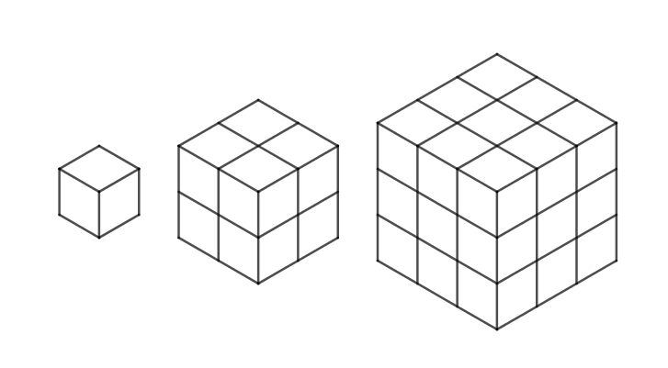
Imagine that these three cubes are made up of individual one centimetre cubes. Use this information to complete the table below.
C
B
A

Cube | Side length | Volume
A | 1 cm | 1 cm³
B
C

Now work out the length ratio compared to the area ratio using the table below.

Cubes | Length ratio | Volume ratio
A : B | 1 : 2
A : C
B : C

Can you see a relationship? Could you explain it verbally? For example, if you double the length what happens to the Volume? What about if you treble the length?

Worksheet 2a: Area and volume continued
Question 2
  - A cuboid has dimensions 5 cm x 3 cm x 8 cm.
    - Calculate the surface area of the cuboid.
    - Calculate the volume of the cuboid.
  - The sides of the cuboid are enlarged by scale factor of three.
    - Calculate the surface area of the new cuboid using a calculator.
    - Calculate the volume of the new cuboid.
Worksheet 2a: Area and volume continued
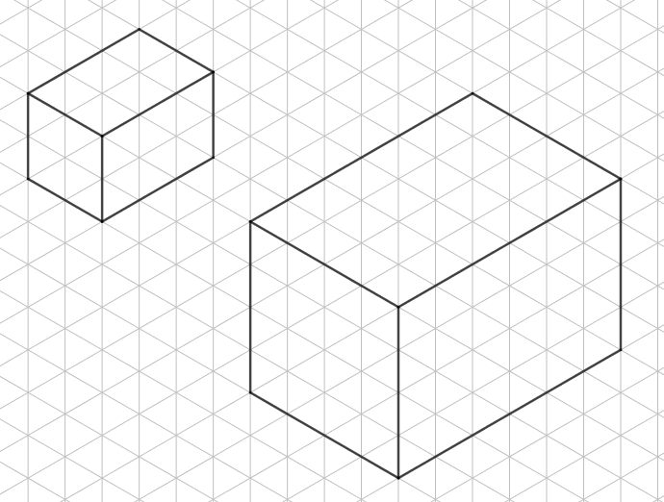
Question 3
A
B
  - Explain why these two cuboids are similar.

  - What is the ratio of their surface areas?__________________________________________
  - What is the ratio of their volumes?______________________________________________

Worksheet 2a: Area and volume continued
  - Now draw a cuboid that is $\frac{\text{1}}{\text{8}}$ of the volume of the cuboid A.


  - Explain why the volume of your new cuboid is one-eighth of the volume of the first cuboid.

Worksheet 2a: Area and volume continued
Question 4
A model of a ship is made to a scale of 1: 200. The surface area of the model is 7500 cm²
Calculate the surface area of the ship, giving your answer in square metres.

Worksheet 2a: Area and volume continued
Question 5
A map is drawn to a scale of 1 : 1 000 000. A forest on the map has an area of 4.6 cm². Calculate the actual area of the forest in square kilometres.

Worksheet 4a: Straight line graphs
The equation of a straight-line is given by this formula, where m is the gradient of the line and c is the y coordinate of the point where the line crosses the y-axis.
Use this information to find the equation for the lines in this graph.
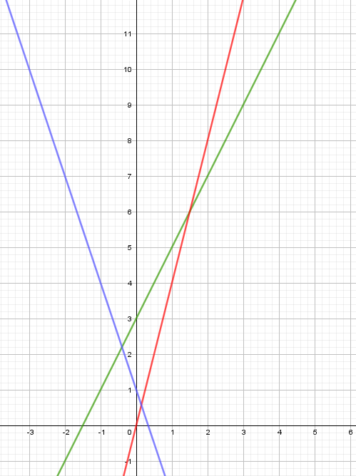

Worksheet 4b: Kennels
A company builds kennels. It takes 2 hours to build each kennel.

Number of kennels | 0 | 1 | 2 | 3 | 4 | 5
Hours | 0 | 2 | 4 | 6 | 8 | 10

      - Discuss with your partner why this relationship is directly proportional.
      - Then draw a graph of this relationship.

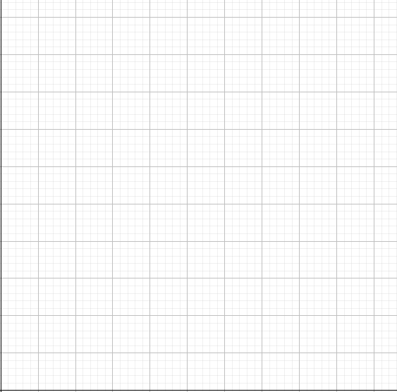

Worksheet 4c: What goes in the box?
You are told that x and y in this example are in direct proportion.
Complete the table and draw the graph.
x | 0 | 1 | 2 | 3 | 4 | 5
y |  |  |  |  | 16

Then answer the following questions:
- What is the constant of proportionality for this example? ____________________________
- Could you write a context to go with this problem?

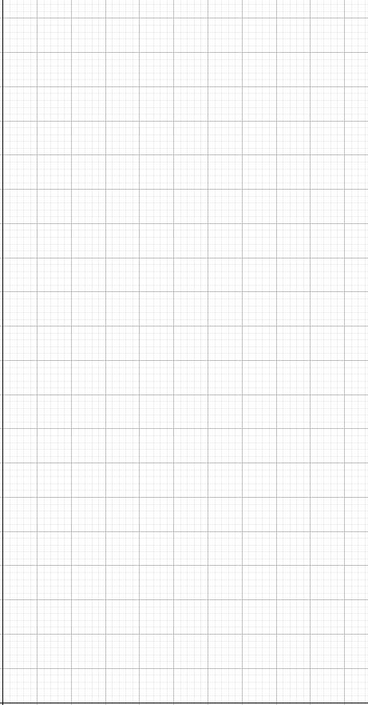
Worksheet 4c: What goes in the box? continued

Worksheet 4d: Interpreting travel and conversion graphs
Question 1
Look at this graph of the first two hours of a journey. You are told that the car will continue to travel at the same constant speed for the whole journey.
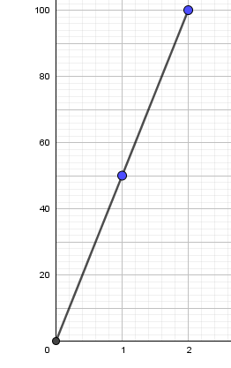
Distance (km)
Time (hours)

- What is the speed of the car?
- The journey takes 5 hours how far has the car travelled?

Worksheet 4d: Interpreting travel and conversion graphs continued
Question 2
In this question 1 pound is equal to 1.8 AUD (Australian dollars). Complete the table and on graph paper plot a conversion graph. Draw your x-axis from 0 to 100 and your y-axis from 0 to 200

£ | 0 | 5 | 10 | 15 | 20 | 25 | 30 | 35 | 40
AUD

Use your graph to change:
- £18 into AUD
- 52AUD in pounds
- £78 into AUD
- 146 AUD in pounds

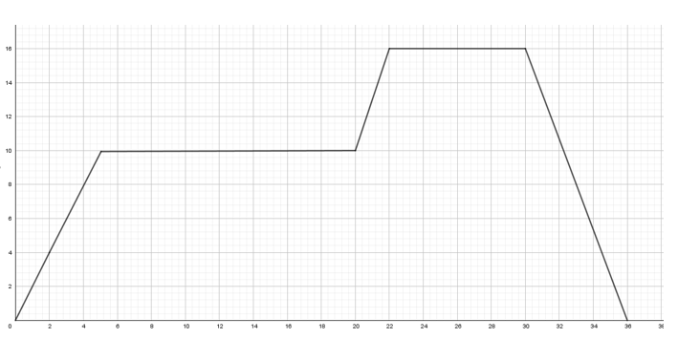
Worksheet 5a: Velocity time graph
Time (seconds)
Velocity (ms-1)

Worksheet 5b: Area under the curve
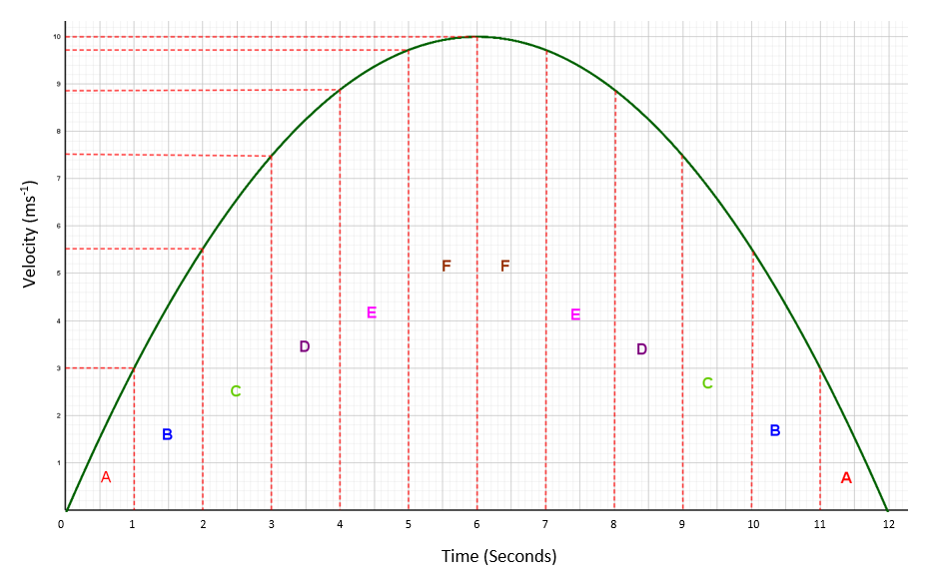
Worksheet 5b: Area under the curve continued
      - Why do you think the graph has been separated into strips?

      - Why do you think the strips are labelled A, B, C, D, E, F? How will this help to find the area under the graph?

      - What will this calculation of the area tell you?

Worksheet 5b: Area under the curve continued
      - Calculate the area under the graph?

      - What does this tell you?

      - Is this a good estimate? How could it be improved? Is the graph realistic?

Worksheet 1a: Answers
When checking answers ask learners to give practical examples to explain their thinking

- True e.g. A metre is the length of an arm. A millimetre is about the thickness of a fingernail
- True
- True
- False A litre is a measurement of capacity
- False A kilometre is 1000m.
- False There are 100 centilitres in a litre
- True
- False Time is not typically measured in metric units
- True
- False Although $1 US is worth just less than £1, $100 US would be much more
- True

Worksheet 1b: Answers
1a 132mm = 13.2cm
1b 735cm = 7350mm
1c 5.8m = 580cm
1d 2.3m = 230cm
1e 650mg = 0.65g
1f 170g = 0.17kg
2. 8 pieces of ribbon 40cm long from a roll 3.5m long (with 30 cm left over)
3. "kilo" (a thousand), “centi” (one hundredth) and "milli" (one thousandth)
4. 0.5m x 256mm = 50cm x 25.6cm = 1280cm²

Worksheet 2a: Answers
Task 1 Area
C
B
A

Imagine that these three squares are made up of individual one centimetre squares. Use this information to complete this table
Square | Side length | Area
A | 1 cm | 1 cm²
B | 2 cm | 4 cm²
C | 3 cm | 9 cm²

Now work out the length ratio compared to the area ratio using the table below.
Squares | Length ratio | Area ratio
A : B | 1 : 2 | 1 : 4
A : C | 1 : 3 | 1 : 9
B : C | 2 : 3 | 4 : 9

Can you see a relationship? Could you explain it verbally? For example, if you double the length what happens to the area? What about if you treble the length?

Worksheet 2a: Answers continued
Question 1
12cm

4cm

  - A rectangle is 4cm by 12 cm.
    - Calculate the perimeter of the rectangle

32cm

    - Calculate the area of the rectangle
48cm²
  - The sides of the rectangle are increased using a linear scale factor of four.
    - Calculate the perimeter of the enlarged rectangle using a linear scale factor.
128 cm
    - Calculate the area of the enlarged rectangle.

768 cm²

Worksheet 2a: Answers continued
Task 2 Volume
Imagine that these three cubes are made up of individual one centimeter cubes. Use this information to complete the table below.
C
B
A

Cube | Side length | Volume
A | 1 cm | 1 cm³
B | 2 cm | 8 cm³
C | 3 cm | 27 cm³

Now work out the length ratio compared to the area ratio using the table below.

Cubes | Length ratio | Volume ratio
A : B | 1 : 2 | 1 : 8
A : C | 1 : 3 | 1 : 27
B : C | 2 : 3 | 8 : 27

Can you see a relationship? Could you explain it verbally? For example, if you double the length what happens to the Volume? What about if you treble the length?

Worksheet 2a: Answers continued
Question 2
  - A cuboid has dimensions 5 cm x 3 cm x 8 cm.
    - Calculate the surface area of the cuboid.
158 cm²

    - Calculate the volume of the cuboid.
120 cm³

  - The sides of the cuboid or enlarged by scale factor of three.
    - Calculate the surface area of the new cuboid.
1422 cm²

    - Calculate the volume of the new cuboid.
3240 cm³

Worksheet 2a: Answers continued
Question 3
A
B
  - Explain why these two cuboids are similar.

B is and enlargement of A with scale factor 2. The length ratio is 1 : 2

  - What is the ratio of their surface areas?
1 : 4
  - What is the ratio of their volumes?
1 : 8

Worksheet 2a: Answers continued
  - Now draw a cuboid that is $\frac{\text{1}}{\text{8}}$ of the volume of cuboid A.

  - Explain why the volume of your new cuboid is one-eighth of the volume of the first cuboid.

Each of the lengths are $\frac{\text{1}}{\text{2}}$ of the length of the first cuboid
$\frac{\text{1}}{\text{2}}$ x $\frac{\text{1}}{\text{2}}$ x $\frac{\text{1}}{\text{2}}$ = $\frac{\text{1}}{\text{8}}$

Worksheet 2a: Answers continued
Question 4
A model of a ship is made to a scale of 1: 200. The surface area of the model is 7500 cm²
Calculate the surface area of the ship, giving your answer in square metres.
7500 cm² x 200² = 300 000 000 cm²
300 000 000 cm² ÷ 100² = 30 000 m²

Worksheet 2a: Answers continued
Question 5
A map is drawn to a scale of 1 : 1 000 000. A forest on the map has an area of 4.6 cm². Calculate the actual area of the forest in square kilometres.
4.6 cm² x 1 000 000² = 4 600 000 000 000 cm²
4 600 000 000 000 cm² ÷ 10 000 000 000 = 460 km²

Worksheet 4a: Answers

y = 4x
y = 2x + 3
y = −3x + 1

Worksheet 4d: Answers
Question 1
        - 50 km/h
        - 250 km
Question 2
              - AUD 32.40
              - £28.89
              - AUD 140.40
              - £81.10

Worksheet 5b: Answers
Question 1
Combining the area of separate strips helps to find the area under the curve.
Question 2
We can label Area A, Area B etc. We can see that we need 2 lots of Area A, 2 lots of Area B etc.
Question 3
The distance travelled (in metres).
Question 4
Consider A, B C, D, E, F as trapezia, each with height 1
b
a
h

 | A | B | C | D | E | F
a | 0 | 3 | 5.5 | 7.5 | 8.9 | 9.7
b | 3 | 5.5 | 7.5 | 8.9 | 9.7 | 10
Trapezium area  $$\frac{\text{h}}{\text{2}}\text{(a+b)}$$ | $$\frac{\text{1}}{\text{2}}\text{(0+3)}$$ | $$\frac{\text{1}}{\text{2}}\text{(3+5.5)}$$ | $$\frac{\text{1}}{\text{2}}\text{(5.5+7.5)}$$ | $$\frac{\text{1}}{\text{2}}\text{(7.5+8.9)}$$ | $$\frac{\text{1}}{\text{2}}\text{(8.9+9.7)}$$ | $$\frac{\text{1}}{\text{2}}\text{(9.7+10)}$$
Area | 1.5 | 5.75 | 6.5 | 8.2 | 9.3 | 9.85

Total area $\text{≈}$ 2 $\text{×}$ (A + B + C + D + E + F)
$\text{≈}$ 2 $\text{×}$ 41.1
$\text{≈}$ 82.2
Question 5
The distance travelled was approximately 82.2 m.
Question 6
This is a better estimate than using rectangles to approximate the area. The approximation could be improved by dividing the area under the curve into thinner strips. The graph is not realistic as a real journey. The velocity may be best described as a curve but the real journey is unlikely to follow such a symmetrical pattern and would probably be skewed.

Cambridge Assessment International Education
The Triangle Building, Shaftsbury Road, Cambridge, CB2 8EA, United Kingdom
t: +44 1223 553554
e: info@cambridgeinternational.org www.cambridgeinternational.org

© Cambridge University Press & Assessment 2024

