
Worksheet D: Calculating probabilities jigsaw
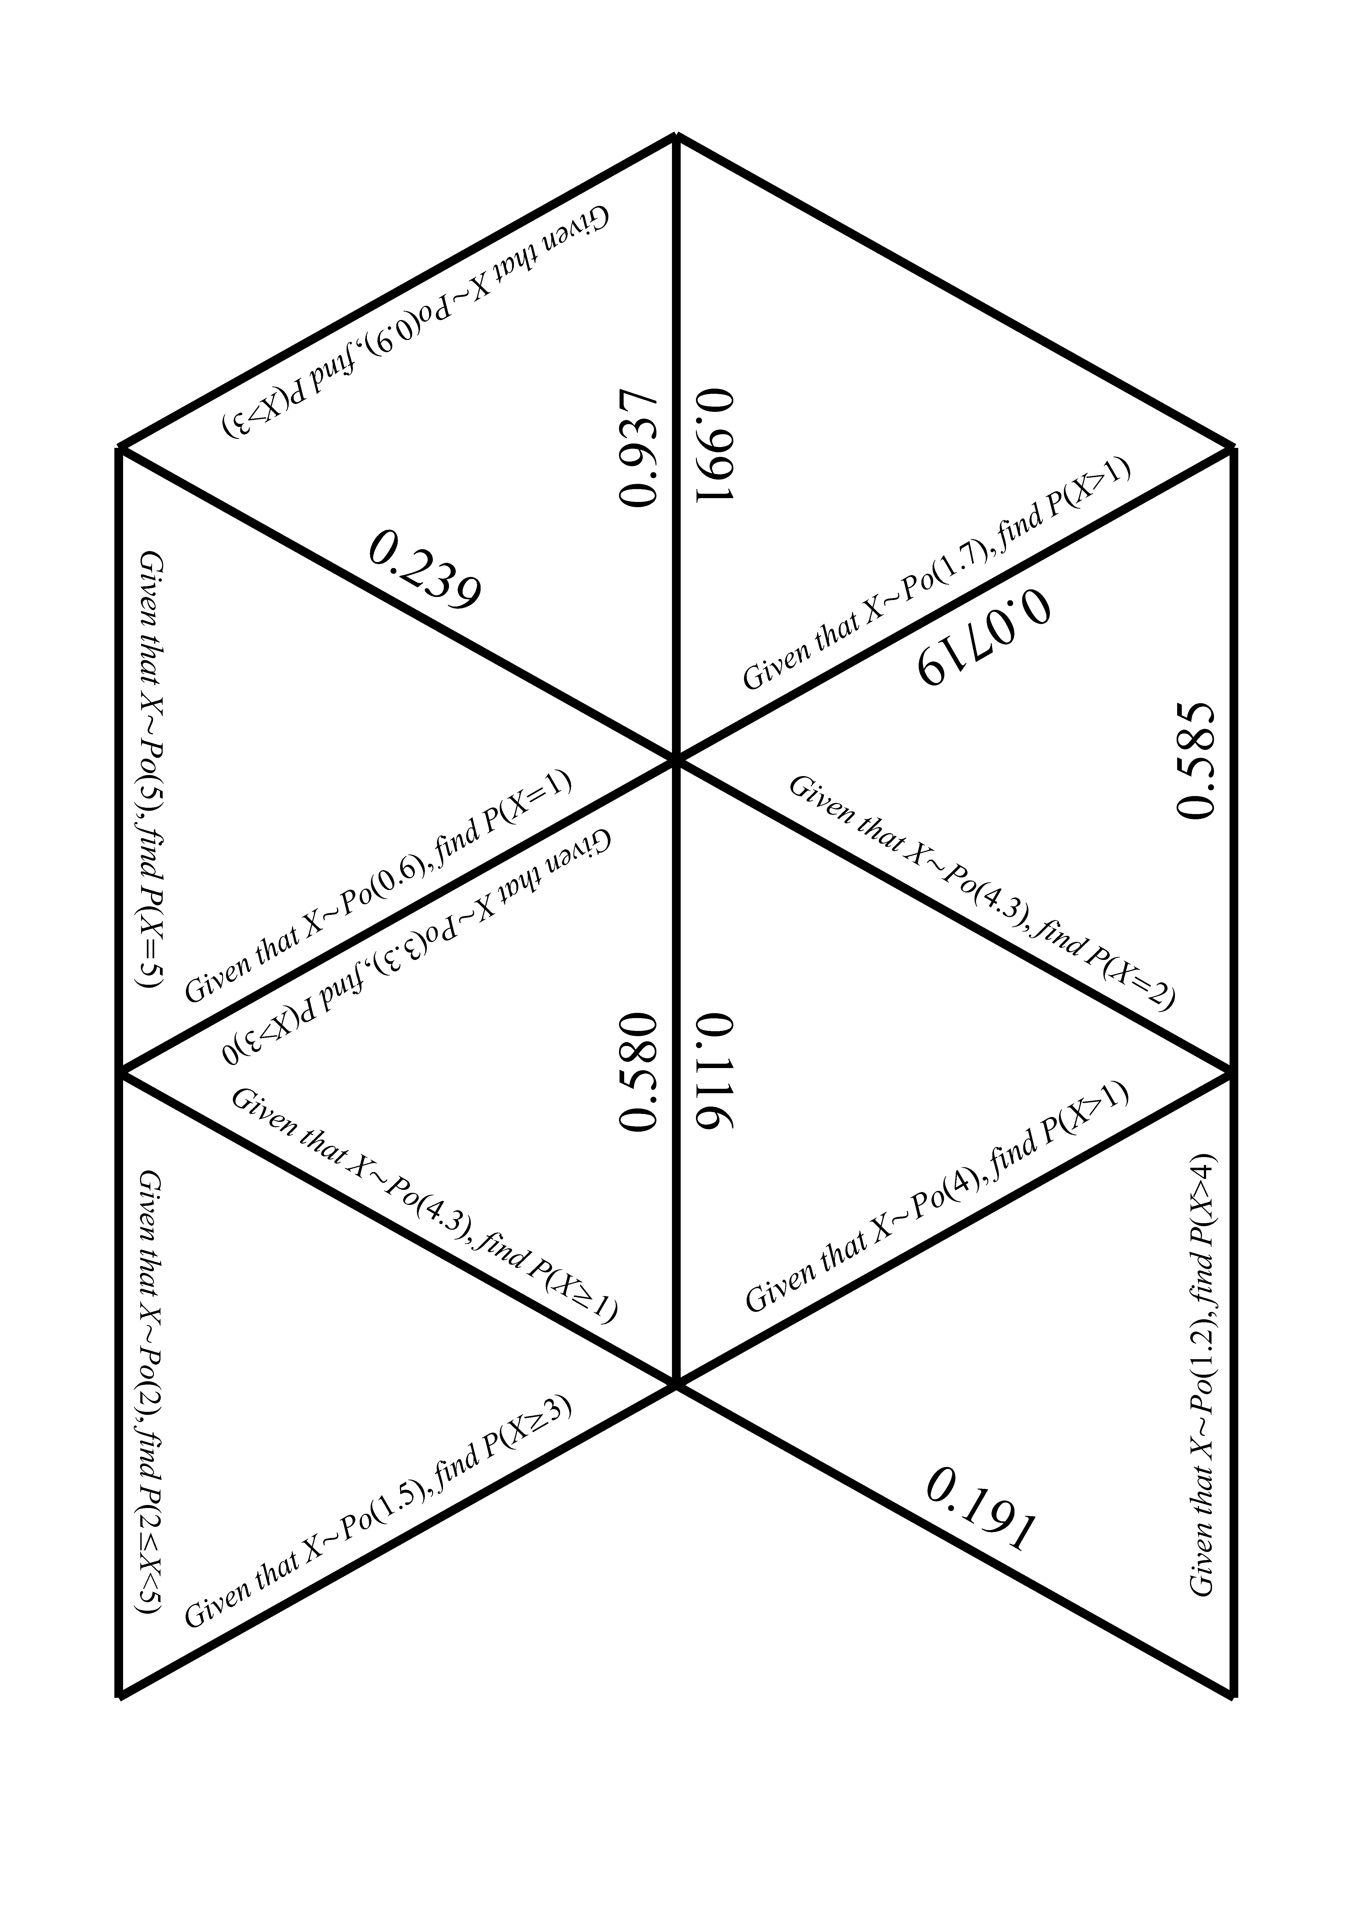
Worksheet D: Calculating probabilities jigsaw continued

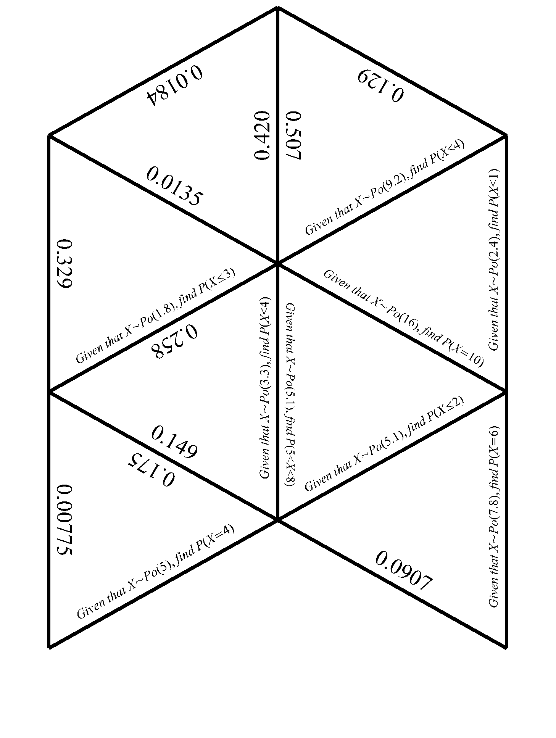
Worksheet D: Calculating probabilities jigsaw continued

